**Task1**

**1,1**

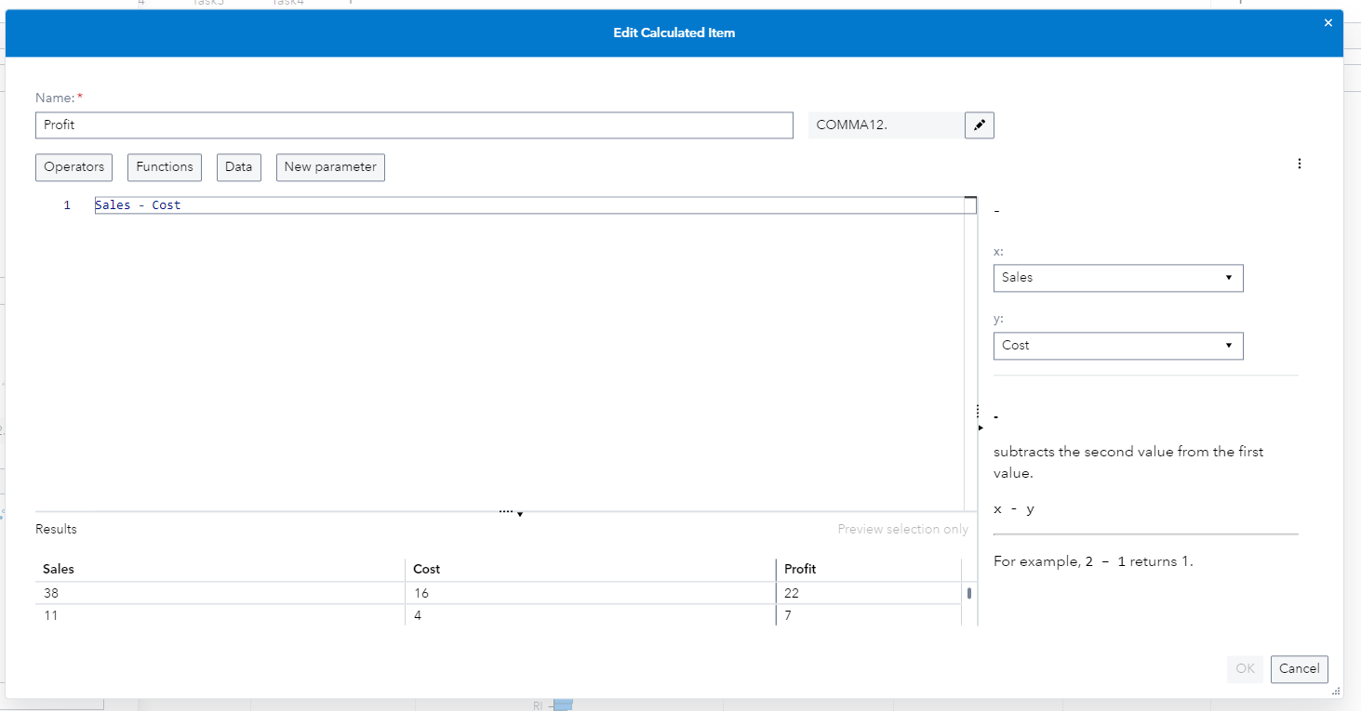

**1.2**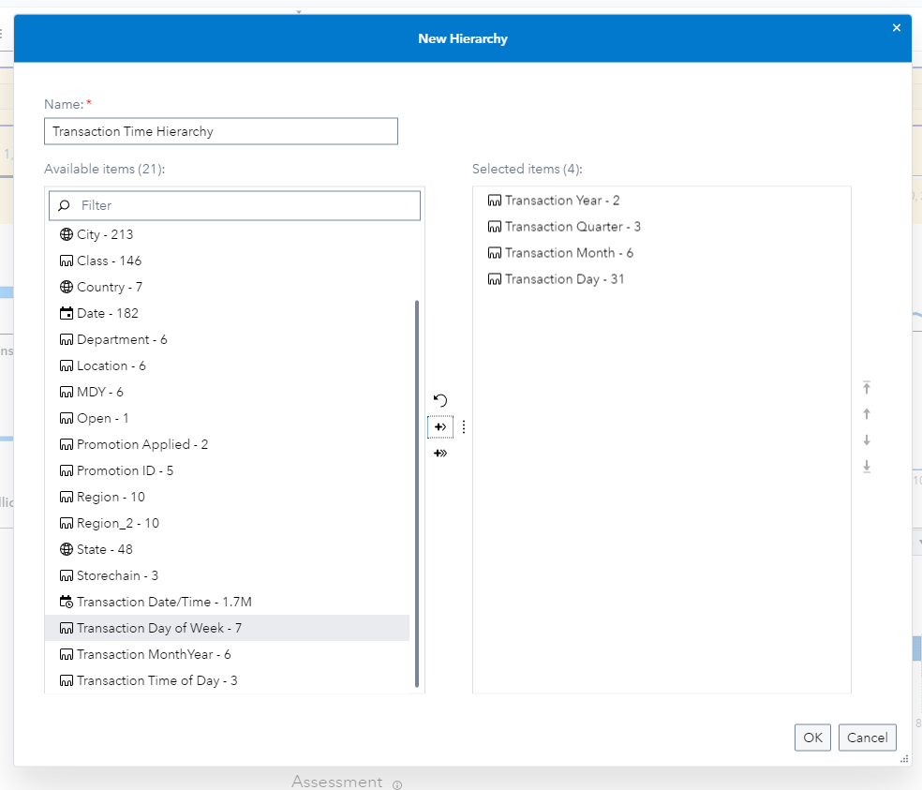

Creating the transaction hierarchy.

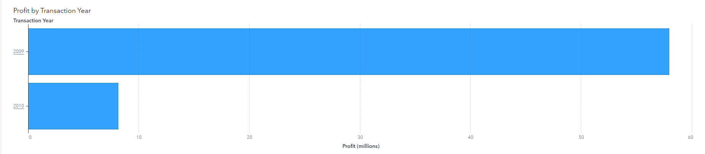

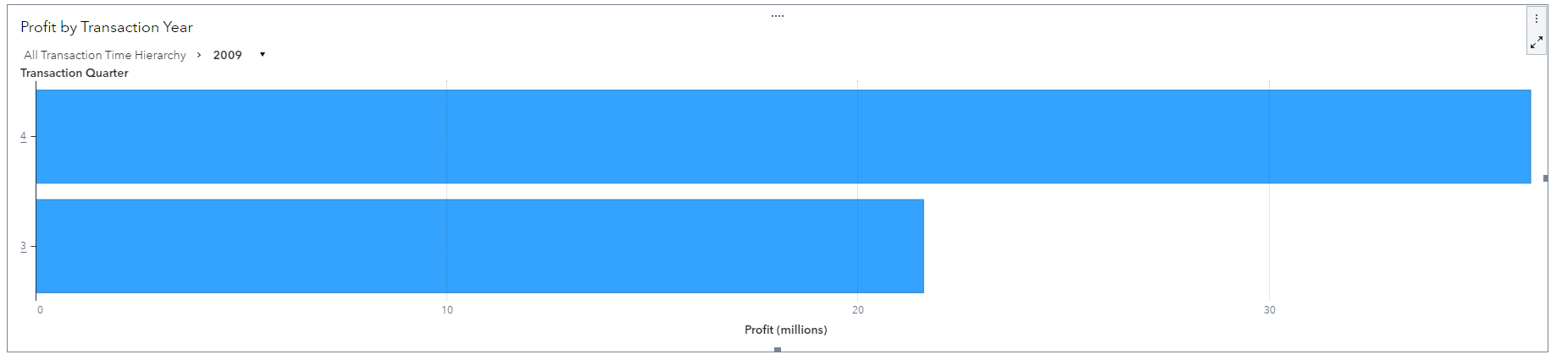

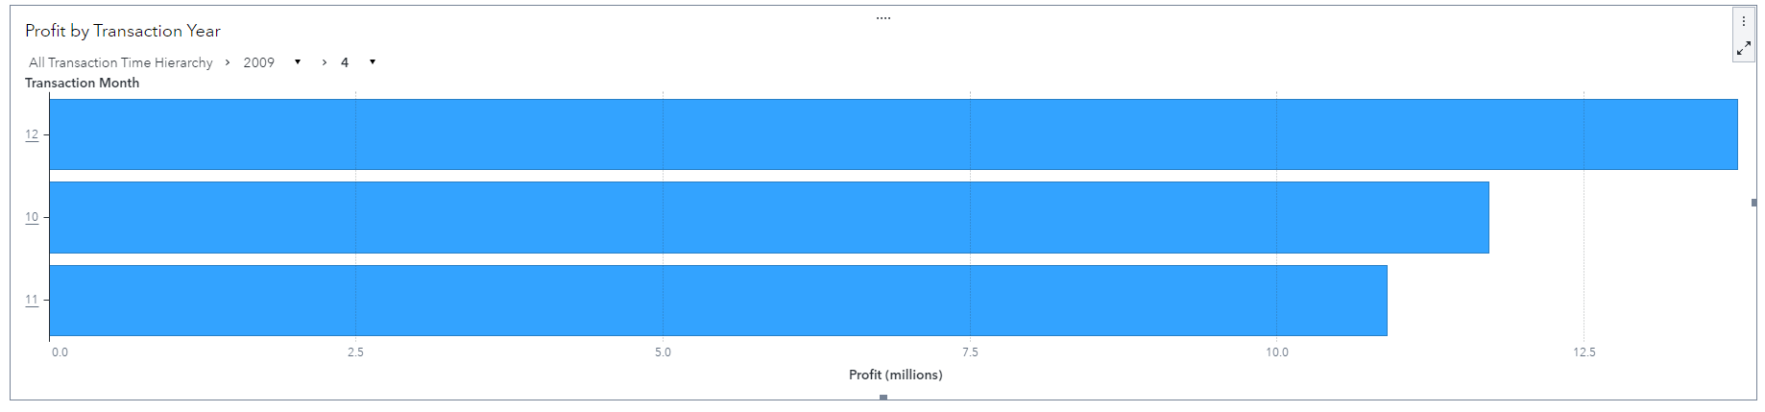

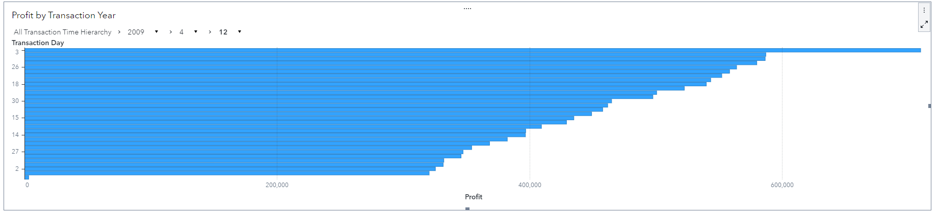

Drillable bar chart for transaction time hierarchy showing profit for the selected hierarchical stage.

**1.3**

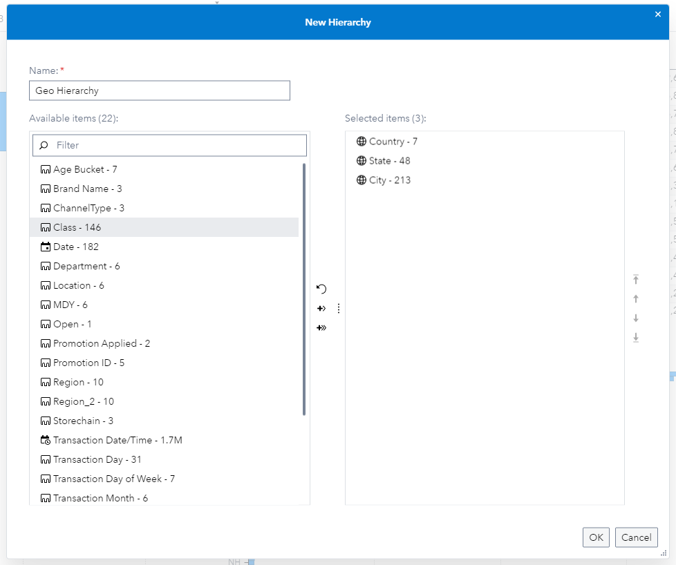

Creating Geo Hierarchy.

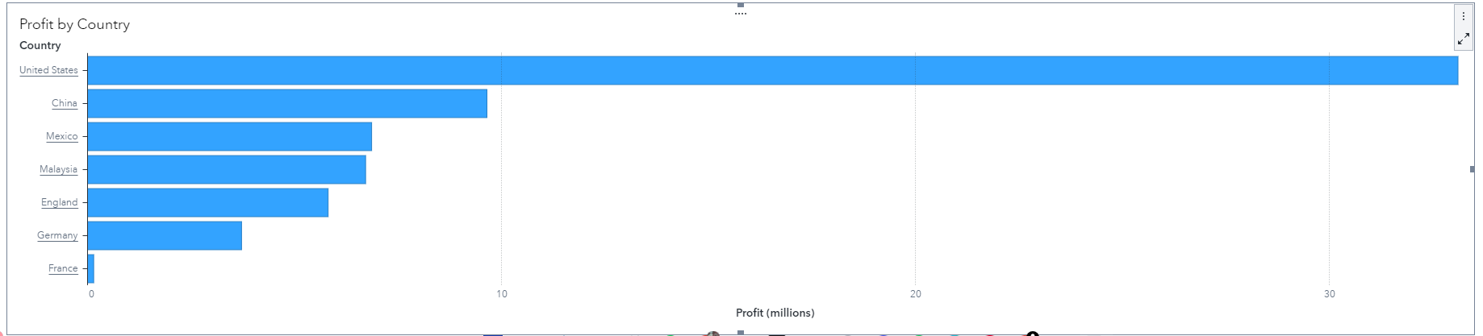

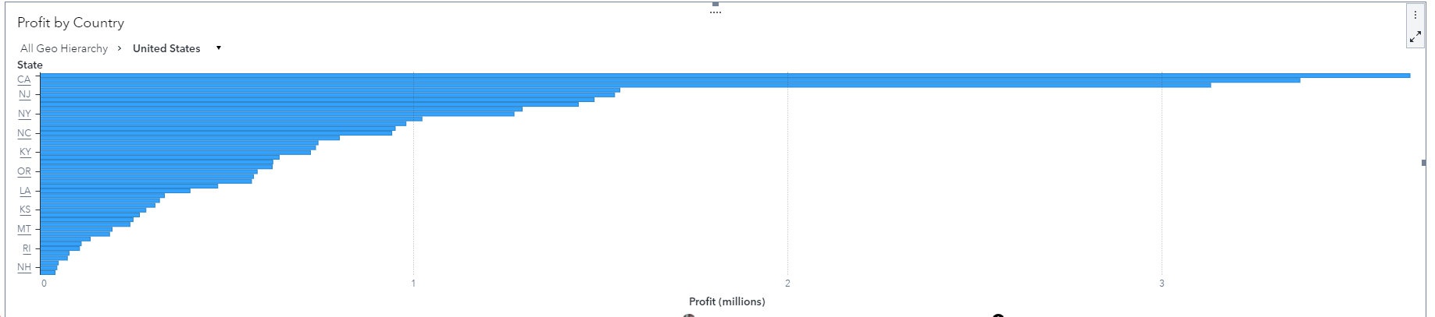

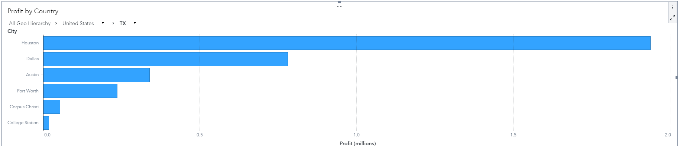

Drillable bar chart for geo hierarchy showing profit for the selected hierarchical stage.

**Task2**

**2.1**

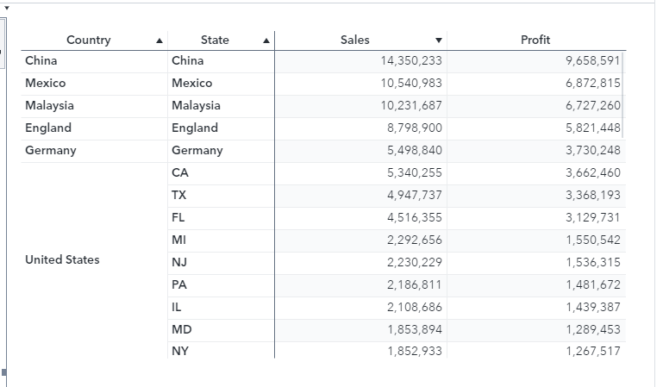

The crosstab offers a comparative analysis of sales and profit figures across various geographical regions. It compares the performance of different countries and states, with China standing out as the top performer with significant sales and profits. For the United States, the data is broken down by individual states, showing California (CA) as the leading state in terms of sales and profits. This format facilitates easy comparison between regions, making it particularly useful for identifying market trends and making informed business decisions.

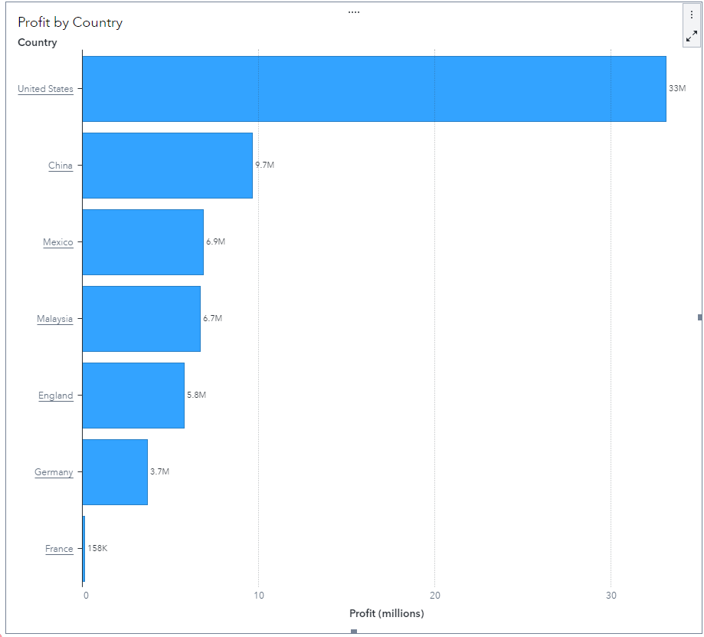

The bar chart illustrates profit comparisons among seven countries. The United States leads with nearly 30 million in profits, followed by China with over 10 million. Mexico and Malaysia are close, each with around 6-7 million. England has slightly more than 5 million in profits, Germany has about 3.7 million, and France has the lowest at 158K. This visual presentation clearly and concisely highlights economic disparities and market strengths**.**

**2.2**

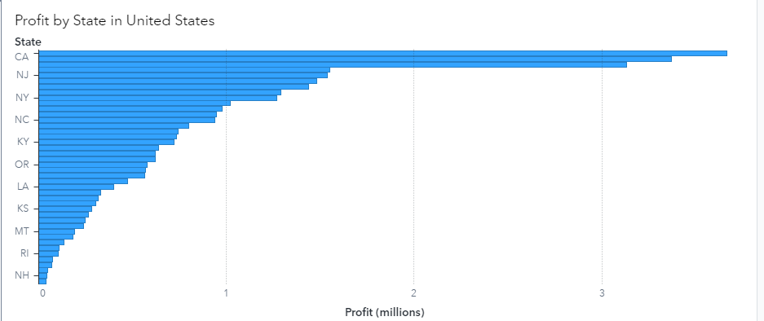

The provided bar graph visually presents the spectrum of profit variations across various states in the United States. Notably, California emerges as the state with the most substantial profit margin, while the District of Columbia (DC) portrays the lowest profitability. This choice of graphical representation offers a clear delineation of the profit rankings among the different states, facilitating easy comprehension of the disparities in profit generation. Through the vertical bars, viewers can discern the relative magnitudes of profits, enabling a comparative analysis of state-level economic performance within the context of the depicted dataset.

**2.3**

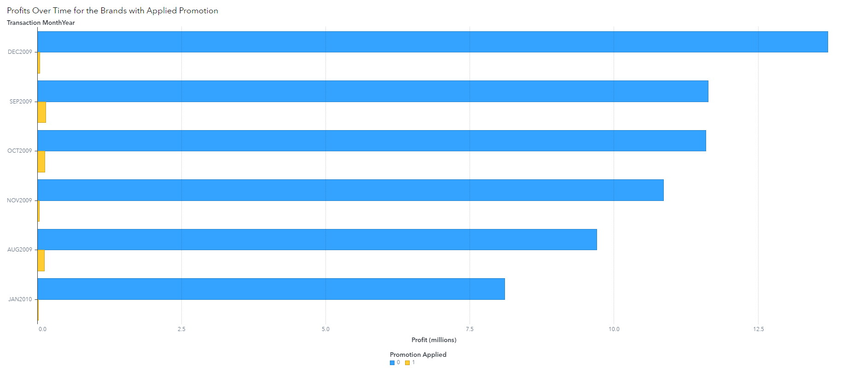

The bar chart indicates that transaction modifiers of 1.2 have the longest bars, reflecting higher predictive values, particularly during 'Promotion Applied' at T3. In contrast, lower transaction modifiers such as 0.2 have shorter bars, indicating lower predictive values. This pattern suggests that promotions have a greater impact on transactions as the modifier increases.

**2.4**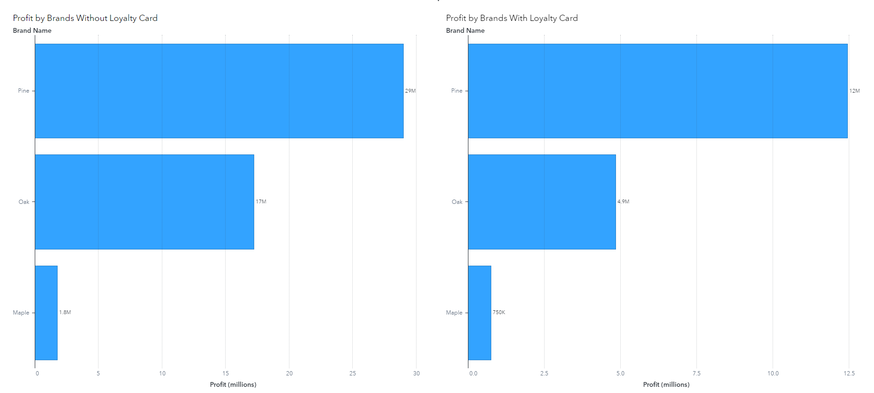

The two bar graphs compare profits across brands with and without a loyalty card. The left graph illustrates different profit levels among brands, suggesting that some perform better without a loyalty program. The right graph, also shows varied profits but emphasizes that certain brands experience increased profits when a loyalty card is implemented, as indicated by higher bars. These graphs are valuable for examining how loyalty programs influence brand profitability. Where Pine was seen to outperform other brands with or without loyalty card.

**Task3**

**3.1**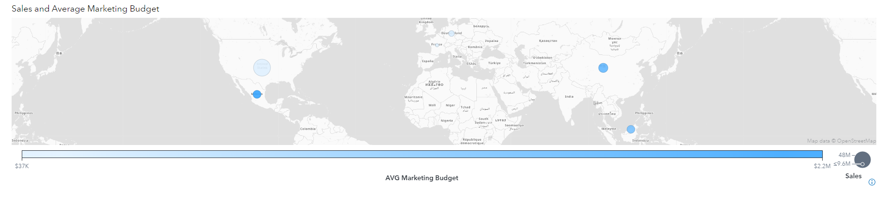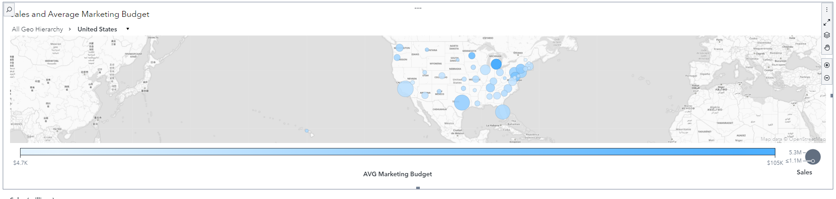

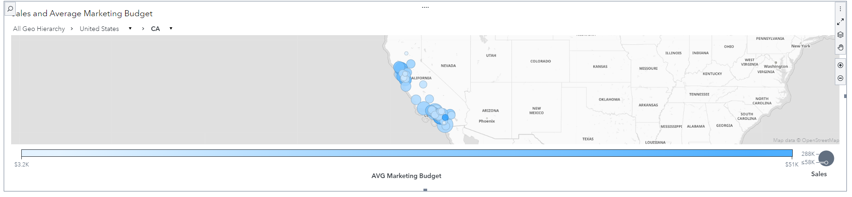

The above figures show a geo map that is drillable to the city and colored by average marketing budget and sized by sales

**3.2**

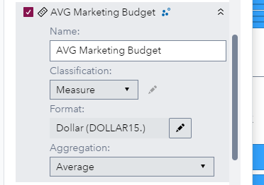

Creating a new calculated item called “Average Marketing Budget”.

**3.3**

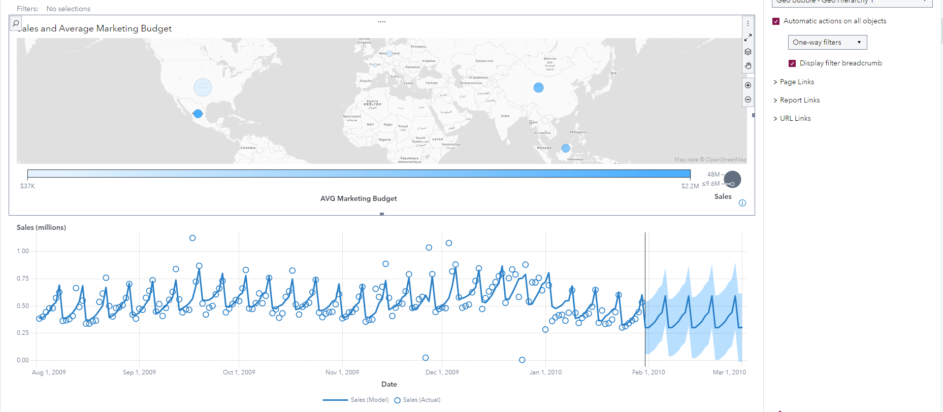

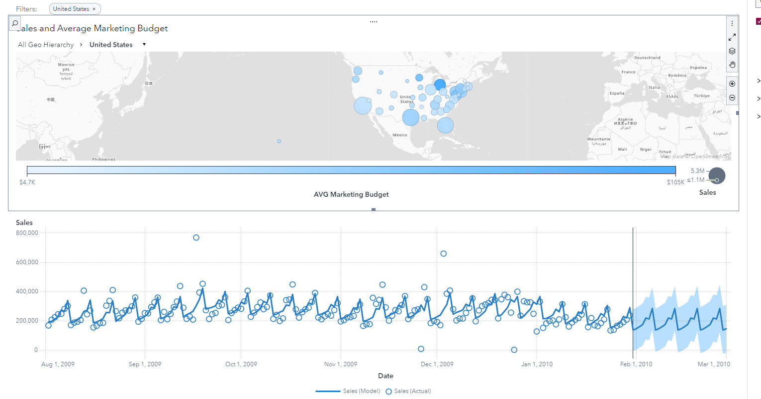

The time series analysis chart delineates sales trends over a specified period, with the horizontal axis representing dates spanning from 01/04/2009 to approximately 01/03/2010, and the vertical axis measuring sales in millions. Connected by a line, individual data points (depicted as circles) illustrate the evolving trend over time, with the blue line tracing the historical sales trajectory, showcasing peaks and troughs denoting fluctuations in sales. Towards the right end of the graph, a shaded area forecasts future sales, with its width expanding as time progresses, indicating escalating uncertainty in the predictions. The broader the shaded region, the less confident the forecast becomes. This visual aid equips organizations with valuable insights to comprehend past sales performance, anticipate future trends, and make well-informed decisions concerning inventory management, budget allocation, and strategic planning, leveraging the comprehensive data analysis provided by the chart.

**Task4**

**4.1**

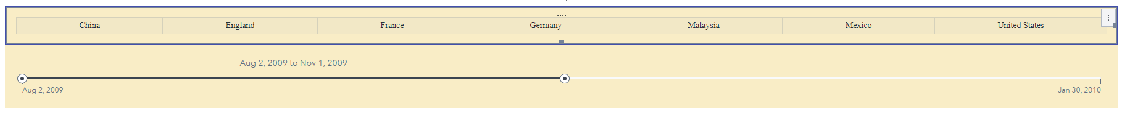

A button bar to filter transactions by country and a slider to filter transactions by date.

**4,2**

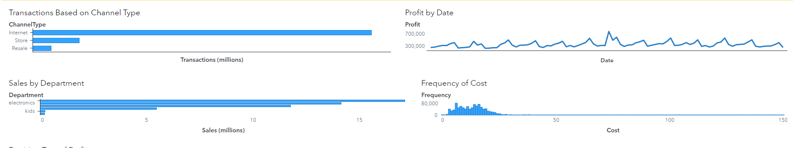

1. Transactions Based on Channel Type: This graph categorizes transactions into Online, In-store, and Mobile channels. The 'Online' category exhibits the highest transaction volume, as represented by its longest bar, surpassing both In-store and Mobile channels.
2. Profit by Date: Presented as a line graph, this visualization tracks profit fluctuations over time, revealing noticeable peaks and troughs. These fluctuations indicate varying levels of profitability on different dates, potentially influenced by seasonal trends or specific business events.
3. Sales by Department: This bar graph compares sales performance across two departments: Electronics and Grocery. The 'Electronics' category prominently features a longer bar than 'Grocery,' suggesting significantly higher sales within the Electronics department compared to Grocery.
4. Frequency of Cost: Displayed as a histogram, this graph illustrates the distribution of costs across different ranges. It shows a concentration of data points towards the lower end of the cost spectrum, indicating that lower costs occur more frequently within the dataset.

**4.4**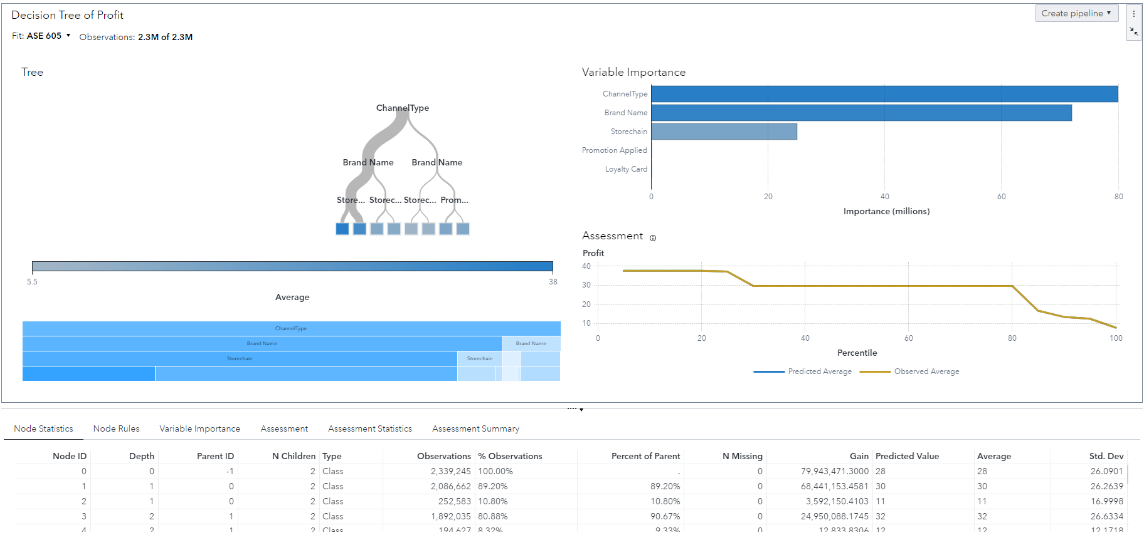

**Marketing Strategy Based on Decision Tree Analysis**

**Channel Focus**

The decision tree analysis indicates that Internet and Resale channels are significantly more profitable compared to Store channels. Specifically, products sold through the Internet and Resale channels tend to yield higher predicted profits. This insight should guide the allocation of marketing budgets and resources. Emphasizing these channels can enhance overall profitability. Therefore, a substantial portion of marketing efforts should be directed toward online advertising campaigns, leveraging social media, search engine marketing, and partnerships with popular resale platforms. By doing so, the company can capitalize on the higher profit margins associated with these channels.

**Brand Emphasis**

The analysis also highlights the performance of different brands within the channels. For the Internet and Resale channels, Oak and Pine brands emerge as the top performers, followed by Maple. This indicates that these brands should be at the forefront of marketing efforts. Highlighting Oak and Pine brands in marketing materials can attract more customers and drive sales. Customer testimonials, reviews, and success stories can be utilized to promote the quality and value of these brands. Special offers and targeted promotions for Oak and Pine brands in online and resale environments can further enhance their appeal and profitability.

**Optimizing Store Chain Partnerships**

Another key insight from the decision tree model is the performance of different store chains. FAST and MODA store chains show better performance for both online and resale channels. Conversely, the GRAND store chain predicts lower profits, suggesting that it might not be as effective. This insight should inform partnership strategies. Strengthening relationships with FAST and MODA store chains can enhance sales and profitability. It may also be beneficial to renegotiate terms with GRAND store chains or consider reducing reliance on this chain. Focusing on store chains that align with higher profitability can streamline operations and improve overall performance.

**Promotion Strategies**

Promotion strategies need careful consideration, especially for Pine brands sold in Store channels. The decision tree model suggests that promotions might not always lead to increased profitability. In some cases, no promotion yields higher predicted profits compared to when promotions are applied. This calls for a nuanced approach to promotions. Testing different types of promotions, such as discounts, bundle deals, or loyalty programs, and analyzing their impact on sales and profit margins will be crucial. This data-driven approach can help determine the most effective promotional strategies that boost sales without eroding profit margins.