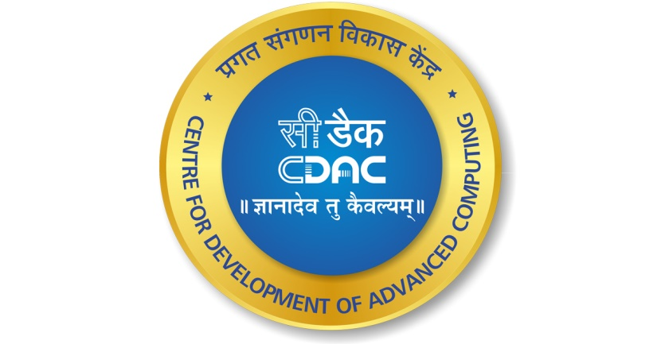

**Acts C-DAC Chennai**

**8th floor, D Block, Tidel Park, No. 4, SH 49A,**

**Tharamani, Chennai, Tamilnadu – 600113**

**Software Requirement**

**Specification**

**On**

**"CAREERBOOST"**

**Project Mentor**

**Ms. Sumitra**

**Submitted By**

**Reetesh Halwa – 230360820039**

**In The Partial Fulfillment Of**

**Post Graduate Diploma in Advanced Computing**

**PG DAC MAR 2023**

**CERTIFICATE**

**This is to certify that the project entitled “CareerBoost” App is a bonafide work of Reetesh Halwa (230360820039) the bonafide student of Centre for Development of Advanced Computing, Tidel Park, Chennai from 15th March 2023-15th September 2023. The Course End Project work is carried out under my direct supervision and 100% completed.**

**Miss. Sumitra Ma’am**

**Name of Supervisor**

**C-DAC, TIDEL PARK,**

**Chennai - 600113, India**

**ACKNOWLEDGEMENT**

**We would like to express our sincere gratitude to Sumitra Ma'am for her invaluable guidance, unwavering support, and continuous encouragement throughout the duration of this project. Her insights, expertise, and feedback have played a pivotal role in shaping the direction and quality of this endeavor.**

**We are truly thankful for the time and effort she dedicated to reviewing our progress, providing constructive suggestions, and helping us navigate through challenges. Her mentorship has not only enhanced my technical skills but also enriched our understanding of project management and best practices.**

**We extend our appreciation to Sumitra Ma'am for her commitment to nurturing our growth and learning experience. This project wouldn't have reached its current state without her patient mentorship and belief in our capabilities.**

**Once again, thank you, Sumitra Ma'am, for being an exceptional mentor and guiding light in this journey.**

**From**

**Reetesh Halwa (230360820039)**

**Abstract**

CareerBoost is a comprehensive out-campus placement management web application designed to streamline the placement process for students, HR professionals, and educational institutions. The application offers a centralized platform with a wide range of features to enhance the placement experience, bridge the gap between skill development and industry requirements, and foster collaborative data contribution.

Placement management plays a crucial role in educational institutions, serving as a bridge between academic learning and real-world employment opportunities.

In conclusion, effective placement management is pivotal in shaping students' careers and bridging the gap between education and employment. It contributes to the overall growth of educational institutions and empowers students to succeed in the competitive job market.

**TABLE OF CONTENTS**

|  |  |  |
| --- | --- | --- |
| SR No. | INDEX | PAGE NO |
| 1 | Introduction | 1-1 |
| 1.1 | Project Scope | 1-1 |
| 1.2 | Project Overview | 2-2 |
| 1.3 | Project Objective | 3-3 |
| 2 | System Analysis | 4-4 |
| 2.1 | Feasibility Study | 4-4 |
| 2.2 | Software Specification | 5-5 |
| 3 | System Design | 6-6 |
| 3.1 | Module Design | 6-6 |
| 3.2 | Input Design | 6-6 |
| 3.3 | Output Design | 7-7 |
| 3.4 | Database Design | 7-10 |
| 4 | Software Development | 11-11 |
| 4.1 | Technologies Used | 11-12 |

**TABLE OF CONTENTS**

|  |  |  |
| --- | --- | --- |
| SR No. | INDEX | PAGE NO |
| 5 | Software Testing and Implementation | 13-13 |
| 5.1 | Test Case | 13-14 |
| 6 | Conclusion | 15-15 |
| 7 | Bibliography | 15-15 |
| 7.1 | References | 15-15 |
| 8 | Appendices | 16-16 |
| 8.A | ER Diagram | 16-16 |
| 8.B | Data Flow Diagram | 17-17 |
| 8.C | Table Design | 17-17 |
| 8.D | Snapshot | 18-21 |

**Project Title - CareerBoost**

1. **Introduction**

CareerBoost is a comprehensive and innovative out-campus placement management web application designed to revolutionize the placement process for students, HR professionals, and educational institutions. With a mission to bridge the gap between academia and industry, CareerBoost offers a centralized platform that empowers users to efficiently manage job postings, applications, skill enhancement, and collaborative data contribution. By addressing the challenges faced in the placement process, CareerBoost aims to enhance the placement experience and contribute to the success of both students and employers.

In summary, CareerBoost is poised to transform the placement process by offering an integrated and user-centric platform that empowers students, HR professionals, and institutions alike. With its wide range of features and commitment to bridging the gap between education and industry, CareerBoost is set to become a valuable asset for all stakeholders in the placement ecosystem.

**1.1 Project Scope**

CareerBoost's scope encompasses the following key aspects:

1. **User Management:** The application facilitates user registration, authentication, and role-based access control, catering to different user categories such as students and HR professionals.
2. **Job Management:** Users can post job listings, manage job applications, and track the progress of job postings. Real-time updates on application statuses are provided.
3. **Coding Platform:** CareerBoost includes a coding platform where users can practice coding skills, receive real-time evaluation of coding submissions, and enhance their programming proficiency.
4. **Skills Enhancement:** The application offers access to extensive programming documentation and tracks users' skill development over time.
5. **Data Contribution:** Users can collaboratively contribute company, job, and salary data, building a comprehensive database that benefits both students and employers.

**DELIVERABLES**

The deliverables of CareerBoost include:

1. A fully functional web application with an intuitive user interface.
2. User authentication and role-based access control mechanisms.
3. Job posting, application management, and real-time updates.
4. A coding platform with programming documentation and skill tracking.
5. Collaborative data contribution features.
6. Integration of industry-aligned skills and technologies.
7. Comprehensive user guides and documentation for seamless usage.
   1. **Overview**

CareerBoost is a comprehensive out-campus placement management web application designed to streamline the placement process for students, HR professionals, and educational institutions. The application offers a centralized platform with a wide range of features to enhance the placement experience, bridge the gap between skill development and industry requirements, and foster collaborative data contribution.

**1.3 Project Objectives:**

1. **Enhanced Placement Experience:** CareerBoost aims to provide a user-friendly and feature-rich platform that simplifies job posting, application management, and skills enhancement, thereby enhancing the overall placement experience for all stakeholders.
2. **Skill-Industry Alignment:** The project intends to bridge the gap between skills acquired by students and the demands of the industry. It includes a real-time coding platform and extensive programming documentation to ensure students are better prepared for industry-specific challenges.
3. **Collaborative Data Contribution:** CareerBoost encourages users to contribute valuable company, job, and salary data, creating a repository of information that benefits both students and HR professionals in making informed decisions.

**2.SYSTEM ANALYSIS**

**2.1 Feasibility Study**

**Technical Feasibility:**

* Assessment of the technical resources required, including hardware, software, and development tools.
* Evaluation of the chosen technology stack (e.g., React, Node.js, MongoDB) in terms of its compatibility, scalability, and performance.
* Consideration of any potential technical challenges or risks that might impact the development process.

**Financial Feasibility:**

* Estimation of development costs, including software development, design, testing, and infrastructure expenses.
* Calculation of ongoing operational costs such as hosting, maintenance, and potential marketing expenses.
* Comparison of the estimated costs against the potential revenue or benefits the application could generate.

**Operational Feasibility:**

* Analysis of how well the application aligns with the existing operational processes and workflows.
* Examination of the impact the application will have on the daily operations of job seekers, employers, and administrators.
* Consideration of training needs for users to effectively utilize the application.

**Schedule Feasibility:**

* Development timeline estimation based on the complexity of the features, available resources, and potential setbacks.
* Evaluation of whether the project can be completed within the desired timeframe, considering any external dependencies or constraints.

**Legal and Regulatory Feasibility:**

* Evaluation of legal considerations, including data protection laws, privacy regulations, and intellectual property concerns.
* Identification of any legal barriers that might hinder the development or deployment of the application.

**2.2 Software Specification**

* **Node JS - v18.14.2**
* **VsCode - July 2023 (version 1.81)**
* **npm - 9.6.4**
* **MongoDB - 7.0**
* **Git - 2.41.0**
* **Express.js - 4.18.2**

**3. SYSTEM DESIGN**

**3.1. Module Design**

The CareerBoost application is designed with modularity in mind to ensure a seamless and organized development process. The system is divided into several interconnected modules, each responsible for specific functionalities:

* **User Management Module:** Handles user registration, authentication, and role-based access control.
* **Job Management Module:** Facilitates job posting, application management, and real-time updates on application statuses.
* **Coding Platform Module:** Offers a coding platform for users to practice coding skills, receive evaluations, and track their progress.
* **Skills Enhancement Module:** Provides access to extensive programming documentation and tracks users' skill development.
* **Data Contribution Module:** Allows users to collaboratively contribute company, job, and salary data to build a comprehensive repository.
* **Dashboard Module:** Presents a dashboard to users with summarized data and access to various modules.

**3.2. Input Design**

The input design focuses on creating user interfaces that are intuitive, user-friendly, and aligned with the application's objectives. Elements such as forms, buttons, and interactive components are strategically placed to enhance the user experience. Input validation ensures that users provide accurate and required information during registration, job posting, coding submissions, and data contribution.

**3.3. Output Design**

The output design aims to present information to users in a clear and organized manner. Dynamic outputs include job listings, application updates, coding results, skills summaries, and data contribution acknowledgments. Each output screen is designed to display relevant data and allow users to interact with the application seamlessly.

**3.4. Database Design**

The database design follows the principles of normalization and aims to efficiently store and manage data. The system's database consists of several interconnected tables representing entities and their relationships:

* **Users Table:** Stores user information, including user IDs, roles, names, emails, and terms and conditions acceptance status.
* **Skills Table:** Stores details about various skills, including skill IDs, names, and descriptions.
* **Jobs Table:** Contains information about job postings, including job IDs, titles, descriptions, requirements, creation timestamps, and last update timestamps.
* **Applications Table:** Stores data about job applications, including application IDs, user IDs, job IDs, statuses, creation timestamps, and last update timestamps.
* **Companies Table:** Holds company details, including company IDs, names, descriptions, and industry classifications.
* **Salaries Table:** Stores information about job salaries, including salary IDs, job IDs, average salary values, and salary ranges.
* **Coding Submissions Table:** Contains data about coding submissions, including submission IDs, user IDs, job IDs, submission times, and evaluation results.

The relationships between these tables are defined using foreign keys to establish associations among entities.

In conclusion, the system design of CareerBoost emphasizes modularization, intuitive user interfaces, organized data presentation, and an efficient database structure. These elements work in tandem to create a comprehensive and user-friendly out-campus placement management application.

**Database Table Collections**

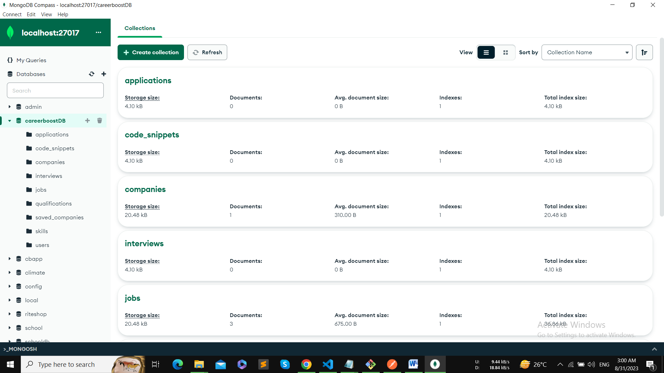

**USERS**

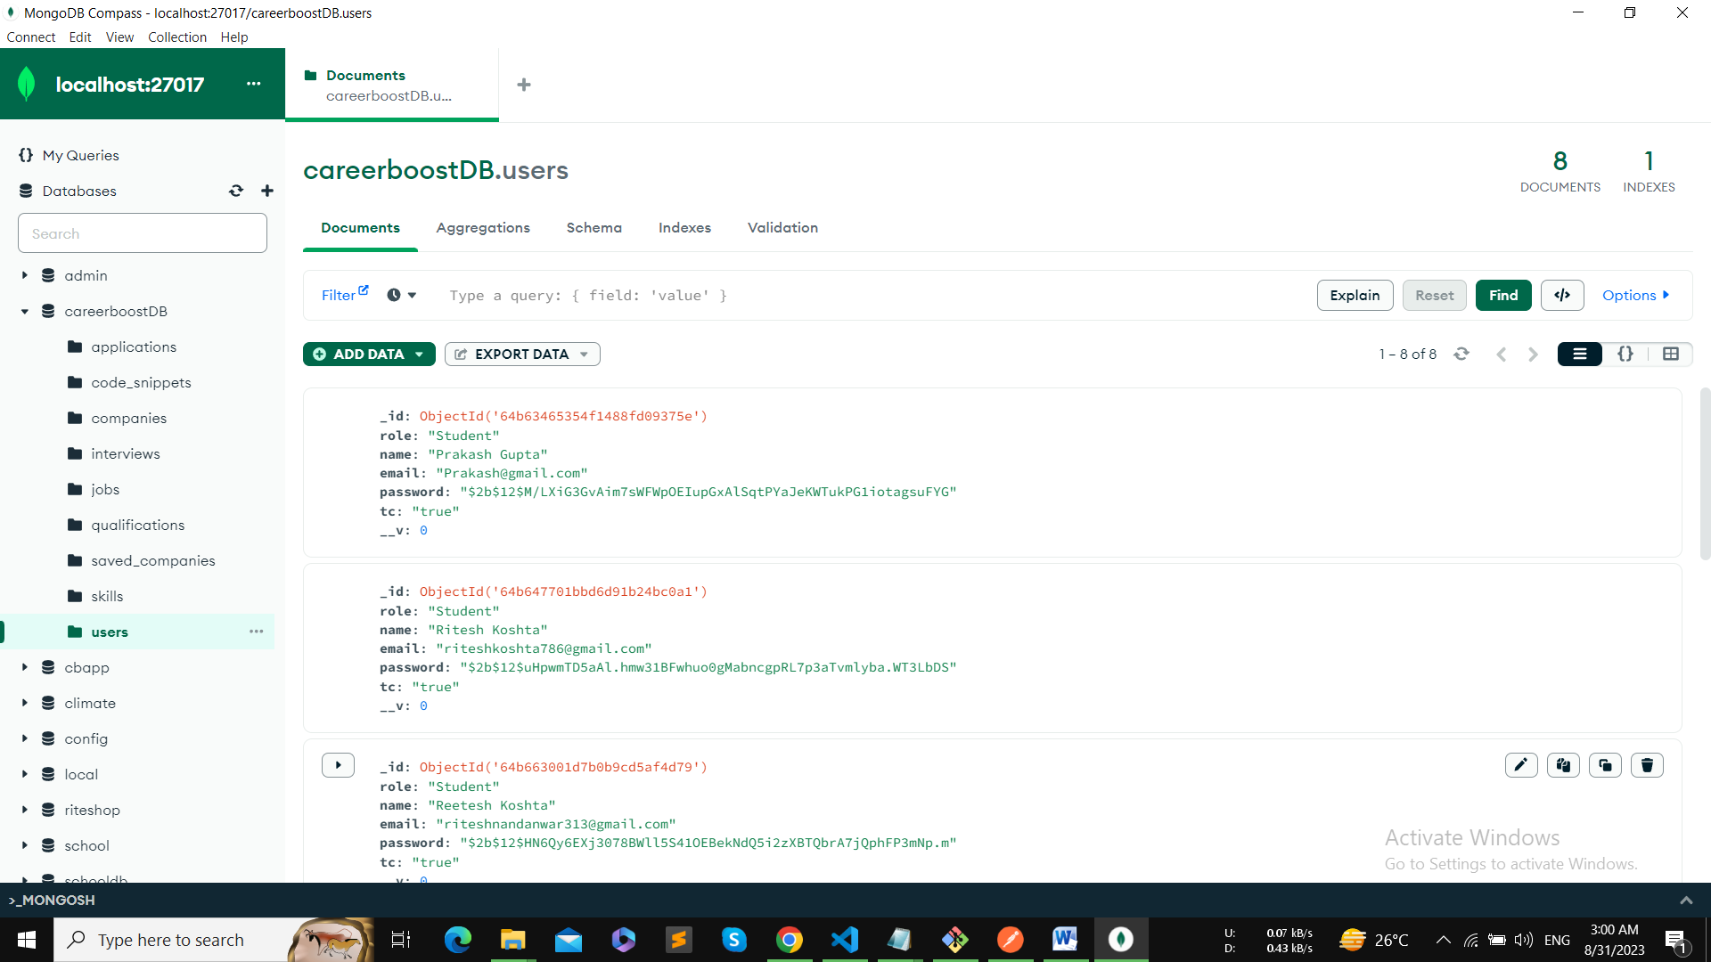

**JOBS**

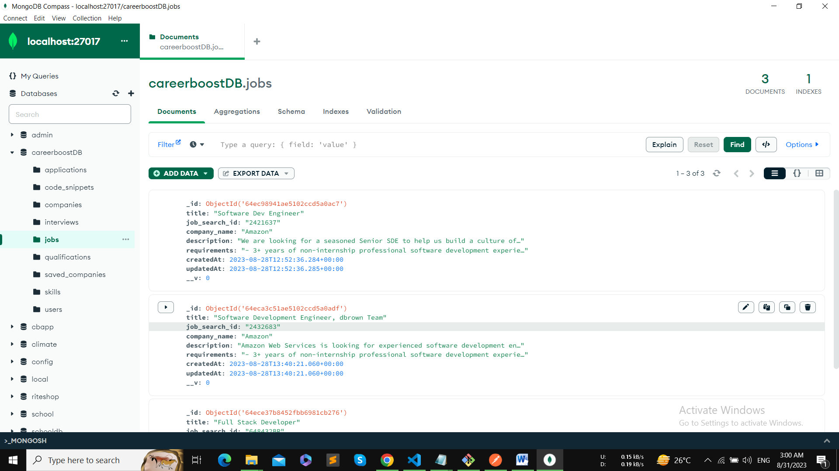

**COMPANIES**

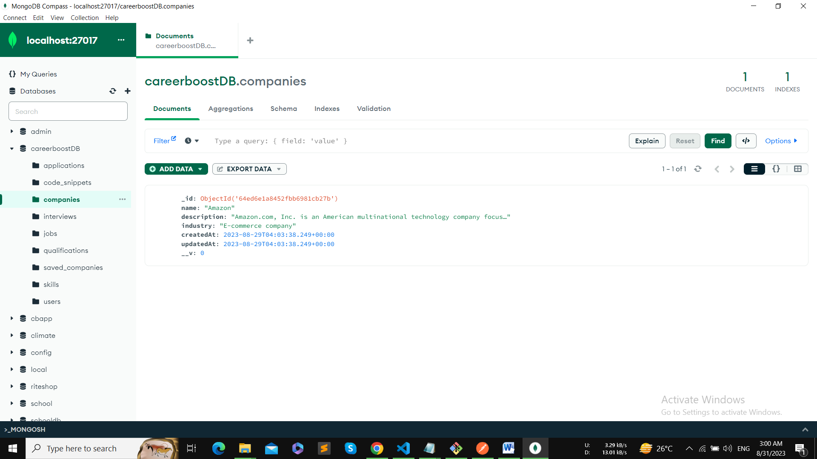

1. **System Developments**

**4.1 Technologies**

The development of the CareerBoost system is built on a robust stack of technologies that ensure efficient and effective implementation of its features and functionalities. The choice of technologies is aligned with modern web development practices to create a scalable, secure, and user-friendly application. Here are the key technologies used in the development of CareerBoost:

**1. Backend Technologies:**

* **Node.js:** Node.js is used as the backend runtime environment due to its asynchronous and event-driven architecture, which enables efficient handling of concurrent requests.
* **Express.js:** Express.js is a minimal and flexible Node.js web application framework that simplifies routing, middleware integration, and API development.
* **MongoDB:** MongoDB serves as the application's database, providing a scalable and flexible NoSQL data storage solution.
* **Mongoose:** Mongoose is used as an Object Data Modeling (ODM) library for MongoDB, allowing seamless interaction with the database using JavaScript objects.
* **JSON Web Tokens (JWT):** JWT is employed for user authentication and authorization, ensuring secure access to the application's features.
* **Nodemailer:** Nodemailer is used to handle sending emails, enabling functionalities like account verification and notifications.

**2. Frontend Technologies:**

* **React:** React is the frontend library used for building the user interface, providing component-based development and efficient rendering.
* **React Router:** React Router is employed for handling navigation and routing within the application, ensuring a smooth user experience.
* **Axios:** Axios is used for making HTTP requests from the frontend to the backend, facilitating seamless communication between the two parts of the system.

**5. SYSTEM TESTING AND IMPLEMENTATION**

5.1 Test Cases

| **SR No.** | **Test Case** | **Description** | **Error** | **Passed (Desktop)** | **Passed (Mobile)** |
| --- | --- | --- | --- | --- | --- |
| 1 | Sign Up | User account should be created on signup | No Error | PASSED | PASSED |
| 2 | Sign In | User should be able to login with credentials | No Error | PASSED | PASSED |
| 3 | Authentication | Unauthorized user access should be restricted | No Error | PASSED | PASSED |
| 4 | Role-based Access | Different user roles should have proper access | No Error | PASSED | PASSED |
| 5 | Job Posting | HR professional should be able to post a job | No Error | PASSED | PASSED |
| 6 | Apply for Job | Users should be able to apply for a job | No Error | PASSED | PASSED |
| 7 | Coding Platform | Coding platform should execute code correctly | No Error | PASSED | PASSED |
| 8 | Skills Tracking | Skills updates should reflect in user profile | No Error | PASSED | PASSED |
| 9 | Data Contribution | Users should be able to contribute job data | No Error | PASSED | PASSED |
| 10 | Companies Listing | Users should see a list of companies | No Error | PASSED | PASSED |
| 11 | Salaries Listing | Users should see a list of average salaries | No Error | PASSED | PASSED |
| 12 | Error Handling | Graceful handling of errors and exceptions | Appropriate error messages | PASSED | PASSED |

These test cases cover a wide range of functionalities and scenarios to ensure that the CareerBoost system is thoroughly tested and meets the desired quality standards. The "Passed (Desktop)" and "Passed (Mobile)" columns indicate whether the test cases were successfully passed on desktop and mobile platforms, respectively.

**6 . Conclusion**

CareerBoost offers a holistic solution to the challenges faced in the placement process. By providing a user-friendly interface, skill enhancement resources, and a collaborative data platform, the project empowers students, HR professionals, and educational institutions to achieve successful placements and better alignment between academia and industry demands.

**7. BIBLIOGRAPHY**

**7.1 References**

* React
* Node
* MongoDB
* Express js
* Bootstrap
* FontAwasome API
* Java Web Token
* NPM

**8.APPENDICES**

**A. ER-Diagram**

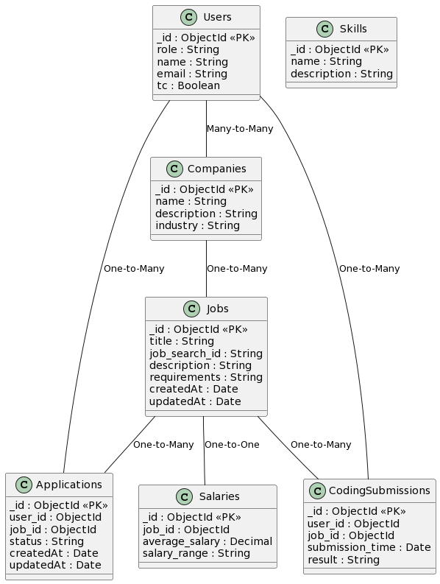

**B. Data Flow Diagram**

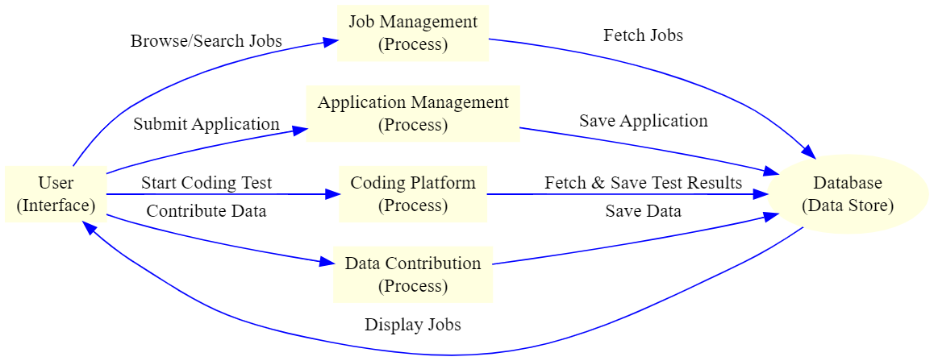

**D. SNAPSHOTS OF PROGRESS**

