

ChatGPT- is it really a super bot? will it change the ground state of this working environment?

ChatGPT Friend or Foe?



Univesity of Northampton

Affiliated Nami College





ChatGPT- is it really a super bot? will it change the ground state of this working environment?

Author: Ritesh Koirala

Student ID: 21422051

Abstract

1. INTRODUCTION

Artificial intelligence has gradually increased over the past decade with the advancement of computing power and deep learning. With this, Open AI Inc. launched a generative pre-trained (GPT) model-based chatbot called chatGPT[1]. ChatGPT is an advanced artificial technology-powered chatbot that has transformed the way people think, live, and behave in this era. Unlike any other search engine which provides the result of the question by giving multiple links similar to the question given like Google, Yahoo, etc. here, the chatGPT provides an immediate response to the question that has been given to it as instructions. Let’s start with a chatbot.

* 1. Chat-bot

Chatbots are software applications designed to interact with users on online platforms through text or text-to-speech methods, providing immediate responses that enhance the user experience in real-time. The story of chatbots dates back to the 1960s, when Joseph Weizenbaum, a computer scientist at MIT, set up ELIZA's first chatbot. By analyzing users' input and generating responses on preprogrammed patterns, ELIZA could simulate a conversation. It's been designed to resemble the therapist, answer questions, and provide empathetic responses to mimic a genuine conversation[2]. The development of chatbots over the year has evolved particularly with the advent of artificial intelligence and machine learning in the 1990s and 2000s. which resulted in the development of a more advanced chatbot that can understand and respond to natural language input in a more intelligent and human-like way. The general work-flow can be described by the figure below

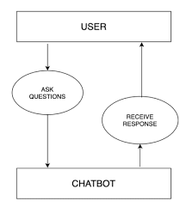

Figure 1: IRJETS. Photograph by Shravan, Mridula, Shreya, and Anala. [public access], via the journal. (https://www.irjmets.com/uploadedfiles/paper/volume2/issue_7_july_2020/2518/1628083093.pdf)

1.2 Types of Chatbot

The chatbot can be of several categories and can be featured or made according to the necessity. Here are some of the chatbots that I found while researching it:

1. Rule-based chatbot:

This type of chatbot has a static response that has been set by the programmer and responds to the queries which exist in the database. These types of chatbots include buttons, and keywords to make users follow the predefined path. An example of this is the chatbot that can be found in customer service[3].

1. Artificially intelligent chatbot:

Chatbot which has the knowledge to develop themselves by learning the previous conversation and can interact with the user more freely are artificially intelligent chatbot. An example of this is Chat-GPT[3]

1. Hybrid Chatbot:

Those chatbots use both tree and Ai-based chatbot which can communicate with the user and also remains as designed by the developer[3]

1. Fun Generalist chatbot:

The chatbot has general knowledge and we can ask them directly like Siri, Cortana, Alexa, etc. which can solve the general problem like location, music, etc.[3]

1.3 Significance of Chatbot

Since, the advancement of technology the use of the chatbot has become one of the most important factors in some fields like customer service, marketing, and many others fields. Some of the key factors which make it truly useful are that it can operate for 24/7 hours with a fast response to the queries it gets which increases the user's satisfaction, it can also handle multiple conversations at once which makes them a cost-effective way to manage the users and saves a lot of time for the customer to get the help, by including artificial intelligence we can also create a more engaging and personalized experience for the users, it can collect the data which make it most compatible to collect the data from the user which can help to improve the business decision.

overall, chatbots are having a significant positive impact on businesses by increasing efficiency, reducing costs, and improving customer satisfaction. Chatbots are likely to become even more important in the future, as technology continues to advance.[2]

1.4 ChatGPT

ChatGPT (Chat Generative pre-Trained Transformer) is created using the NLP (Natural Language Processing), aiming to best the field of a chatbot using Artificial intelligence which can understand and produce human-interactive speech/text[4]. This has been developed by a non-profit organization called Open AI and made an announcement/launched in November 2022. ChatGPT is a large language model based on the GPT-3 architecture. The development of chatGPT is part of Open Ai’s ongoing effort to advance artificial intelligence and natural language processing[5].

The history of ChatGPT can be traced back to the year 2018 when Open AI released the first version of the GPT (Generative Pretrained Transformer Language) Model. GPT-1 has been a significant breakthrough in natural language processing by demonstrating the capability to generate coherent and contextually relevant text[4]. Then the company continued to improve GPT-3 model, which has been shown by releasing GPT-2 IN 2019 and GPT-3 in 2020. Among these GPT-3 is valued as the most advanced language model to date, having the ability to complete a large natural language task, including language translation, text completion, and question-answering. The beta version of GPT-3 API, which helped the developers to integrate the gp4-3 API to create a chatbot with an interactive user experience was released in June 2020. Then, the chatGPT which was released in 2021 is being used worldwide as a web application for free and being utilized by people to make their search easier.[5]

As we have seen other chatbot like, customer service, WhatsApp, and Facebook, these chatbot uses and follow the set of instruction given to them by the user. And other chatbots like gitaGPT provide a piece of information on only one specific topic like the one selected. But in the case of the chatGPT, it can provide the answer to any question that has been asked to it. It provides the accurate answer to the question that has been asked and also keeps track of the previous conversation which make the user interaction easy and makes it usable in many ways like fixing box, asking general knowledge question, writing content, and many more[6].

1.5 How chatGPT works?

ChatGPT works by trying to understand the prompt and then, based on its training it predicts what will be the best answer for the prompt given and shows the answer. About its training, the method involves giving the developing AI some guidelines before subjecting it to scenarios or providing it with a ton of data to formulate in order to create its own algorithms. It has been trained on roughly 500 billion tokens because of which this language model can easily assign meaning and predict follow-on text. Though larger or more complicated words sometimes decompose into numerous tokens, many words map to a single token. Tokens are typically four characters long. Although GPT-4's inner workings are unknown to Open AI, given how powerful it is, we may reasonably conclude that it was trained using the same dataset[5, 6].

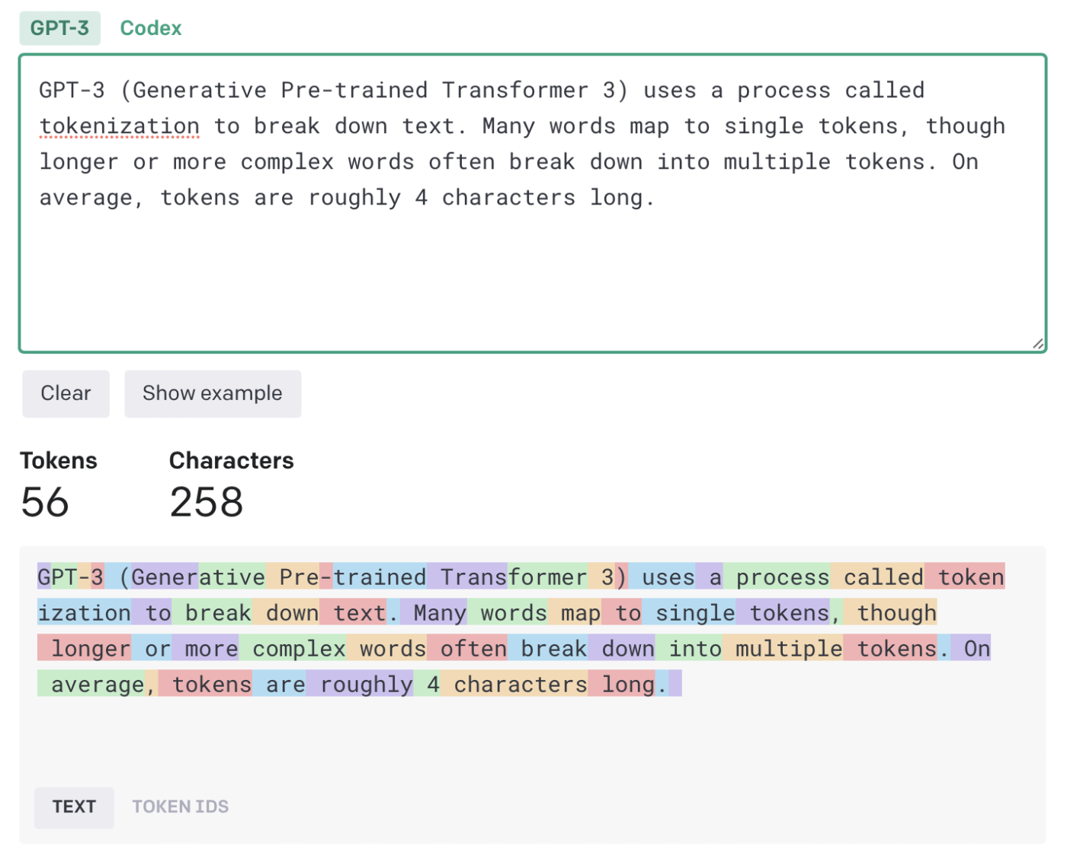Figure 2: Zapier. Photograph by Harry Guinness (public domain), via the article. (https://zapier.com/blog/chatgpt-marketing-writing/)

All of these tokens were obtained from the massive data written by humans which include various things like books, articles, and other many documents and journals, and which were used to create a large dataset used to form a complex, multiple-layered and weighted algorithm deep learning neural network because of which chatGPT was able to learn pattern and relationship to text and got the ability to predict what comes next which makes responses like humans[5], [6].

But it doesn’t work on the sentence level so to further push its ability to respond to the different prompts, a method known as reinforcement learning with human feedback (RLHF) was optimized for the script. In general, humans built a comparison dataset with reward models (where more than one model response was graded by AI trainers) so that the AI could figure out which response was the best.[6]

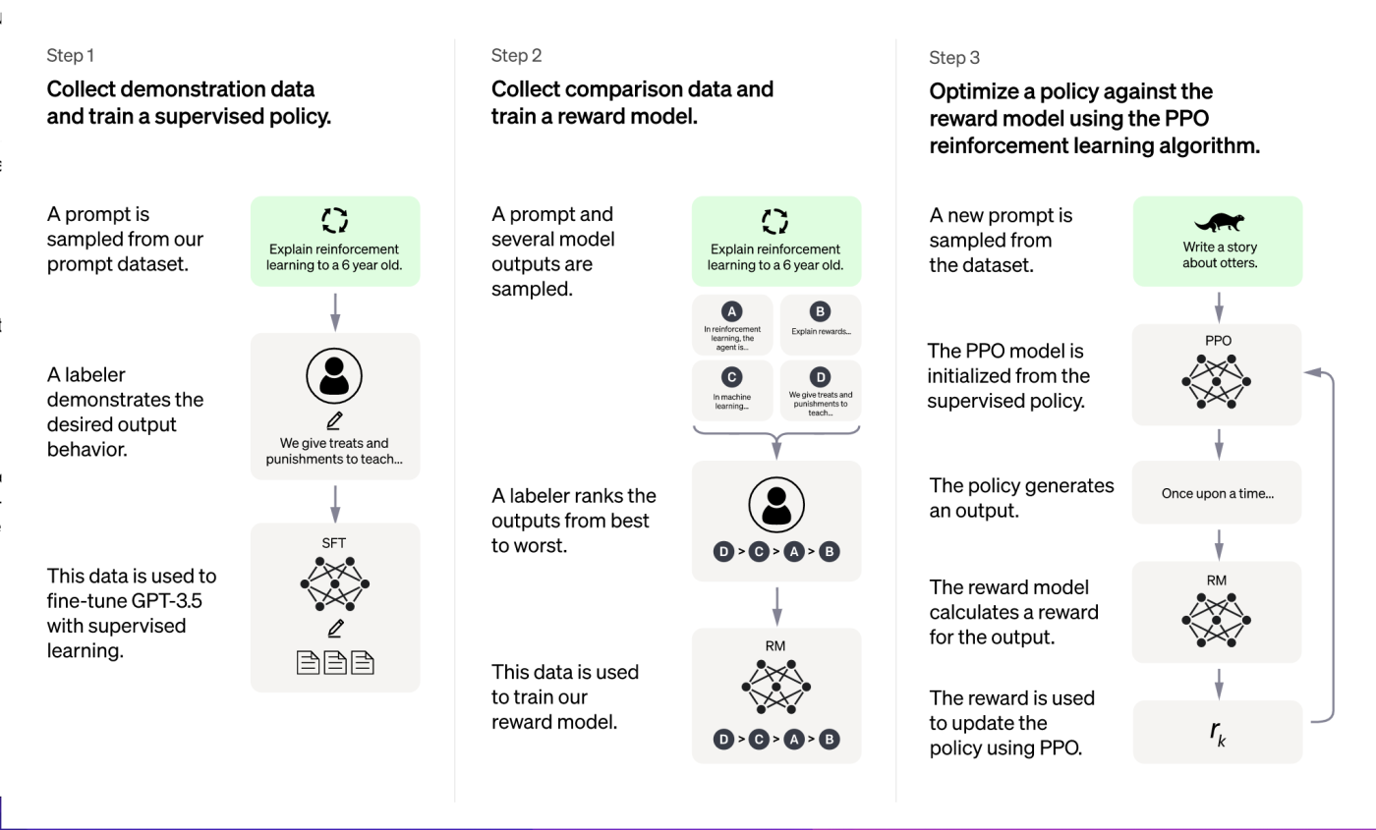

Figure 3: Medium. photograph by Renu Khandelwal (public domain), via the article. (https://arshren.medium.com/a-basic-understanding-of-the-chatgpt-model-92aba741eea1)

It has been trained on Azura AI supercomputing infrastructure. It’s a fine-tuned model in the GPT series which has completed training in early 2022.

Literature Review

References

[1] R. Vaishya, A. Misra, and A. Vaish, “ChatGPT: Is this version good for healthcare and research?,” *Diabetes & Metabolic Syndrome: Clinical Research & Reviews*, p. 102744, Apr. 2023, doi: 10.1016/j.dsx.2023.102744.

[2] C. W. Okonkwo and A. Ade-Ibijola, “Chatbots applications in education: A systematic review,” *Computers and Education: Artificial Intelligence*, vol. 2. Elsevier B.V., Jan. 01, 2021. doi: 10.1016/j.caeai.2021.100033.

[3] N. Haristiani, “Artificial Intelligence (AI) Chatbot as Language Learning Medium: An inquiry,” in *Journal of Physics: Conference Series*, Institute of Physics Publishing, Dec. 2019. doi: 10.1088/1742-6596/1387/1/012020.

[4] M. Halaweh, “ChatGPT in education: Strategies for responsible implementation,” *Contemp Educ Technol*, vol. 15, no. 2, p. ep421, Mar. 2023, doi: 10.30935/cedtech/13036.

[5] A. Tlili *et al.*, “What if the devil is my guardian angel: ChatGPT as a case study of using chatbots in education,” *Smart Learning Environments*, vol. 10, no. 1, Dec. 2023, doi: 10.1186/s40561-023-00237-x.

[6] B. D. Lund, T. Wang, N. Reddy Mannuru, B. Nie, S. Shimray, and Z. Wang, “ChatGPT and a New Academic Reality: AI-Written Research Papers and the Ethics of the Large Language Models in Scholarly Publishing.”