**EARTHQUAKE PREDICTION USING MACHINE LEARNING**

**A Project Submitted**

**In Partial Fulfillment of the Requirements**

**for the Degree of**

**BACHELOR OF TECHNOLOGY**

**IN**

**Computer Science**

**by**

RITESH KUMAR PANDEY

**1601010114**

**Under the Supervision of**

**Mr.Ashish Tiwari**

**Assistant Professor of Computer Science Department**

**United College of Engineering and Research, Prayagraj**



**to the**

**Faculty of Computer Science Engineering**

**Dr. A.P.J. ABDUL KALAM TECHNICAL UNIVERSITY**

**LUCKNOW**

**May ,2020**

**CERTIFICATE**

**Certified that RITESH KUMAR PANDEY (1601010114) has carried out the project work presented in this project entitled “EARTHQUAKE PREDICTION USING MACHINE LEARNING” for the award of Bachelor of Technology (COMPUTER SCIEMCE) from Dr. A.P. J. Abdul Kalam Technical University, Lucknow under our supervision. The project embodies results of original work, and studies are carried out by the student and the contents of the project do not form the basis for the award of any other degree to the candidate or to anybody else from this or any other University/Institution.**

**Signature**

**CANDIDATE’S DECLARATION**

**We, RITESH KUMAR PANDEY (1601010114) a student of B.Tech of Computer Science hereby declare that we own the full responsibility for the information, results etc. provided in this PROJECT titled EARTHQUAKE PREDICTION USING MACHINE LEARNING submitted to Dr. A.P.J Abdul Kalam University, Lucknow for the award of B.Tech (branch) degree. I have taken care in all respect to honor the intellectual property right and have acknowledged the contribution of others for using them in academic purpose and further declare that in case of any violation of intellectual property right or copyright we, as a candidate, will be fully responsible for the same. My supervisor should not be held responsible for full or partial violation of copyright or intellectual property right.**

**NAME :RITESH KUMAR PANDEY**

**Roll No.:- 1601010114**

**DATE:12/05/2020**

**PLACE:PRAYAGRAJ**

**ACKNOWLEDGEMENT**

**I would like to express my special thanks of gratitude to my teacher Mr.Ashish Tiwari Sir as well as our Department faculty of Computer Science of United College of Engineering And Research Prayagraj , who gave me the golden opportunity to do this wonderful project on the topic EARTHQUAKE PREDICTION USING MACHINE LEARNING which also helped me in doing a lot of Research and i came to know about so many new things I am really thankful to them.Secondly i would also like to thank my team-mates and friends who helped me a lot in finalizing this project within the limited time frame.**

**TABLE OF CONTENTS**

|  |  |  |  |  |  |  |
| --- | --- | --- | --- | --- | --- | --- |
|  |  | |  | | | Page No. |
|  | Certificate | |  | | | i |
|  | Declaration | |  | | | ii |
|  | Acknowledgements | | | | | iii |
|  |  | |  | | |  |
|  |  | |  | | |  |
| **CHAPTER 1 : INTRODUCTION** | | | | | | **1** |
| 1.1 | GENERAL | |  | | | 2 |
| 1.2 | USE OF PROJECT | | | | |  |
| **CHAPTER 2 : ANALYSIS 3 -5** | | | | | |  |
| **CHAPTER 3 : DESIGN 6-8**  **CHAPTER 4 : CODING 9-11**  **CHAPTER 5 :TESTING 9- 11**  **REFERENCES 12**  **BIBLIOGRAPHY 12** | | | | | |  |
|  | | | |  |
|  | |
|  | |
|  | | | |  |
|  | | | |  |
|  | |
|  | |
|  | |
|  |  | |  | | |  |
|  |  | |  | | |  |
|  |  | |  | | |  |
|  |  | |  | | |  |

1

**INTRODUCTION**

**Earthquake prediction is a branch of the science of**[**seismology**](https://en.wikipedia.org/wiki/Seismology)**concerned with the specification of the time, location, and**[**magnitude**](https://en.wikipedia.org/wiki/Seismic_scale)**of future**[**earthquakes**](https://en.wikipedia.org/wiki/Earthquake)**within stated limits, and particularly "the determination of parameters for the *next* strong earthquake to occur in a region.Earthquake prediction is sometimes distinguished from**[***earthquake forecasting***](https://en.wikipedia.org/wiki/Earthquake_forecasting)**, which can be defined as the probabilistic assessment of *general* earthquake hazard, including the frequency and magnitude of damaging earthquakes in a given area over years or decades**

**Earthquake prediction is an immature science—it has not yet led to a successful prediction of an earthquake from first physical principles. Research into methods of prediction therefore focus on empirical analysis, with two general approaches: either identifying distinctive *precursors* to earthquakes, or identifying some kind of geophysical *trend* or pattern in seismicity that might precede a large earthquake.Precursor methods are pursued largely because of their potential utility for short-term earthquake prediction or forecasting, while 'trend' methods are generally thought to be useful for forecasting, long term prediction (10 to 100 years time scale) or intermediate term prediction (1 to 10 years time scale).**

**In the 1970s, scientists were optimistic that a practical method for predicting earthquakes would soon be found, but by the 1990s continuing failure led many to question whether it was even possible.**[**[4]**](https://en.wikipedia.org/wiki/Earthquake_prediction#cite_note-6)**Demonstrably successful predictions of large earthquakes have not occurred and the few claims of success are controversial. For example, the most famous claim of a successful prediction is that alleged for the**[**1975 Haicheng earthquake**](https://en.wikipedia.org/wiki/Earthquake_prediction#1975:_Haicheng,_China)**.A later study said that there was no valid short-term prediction.**[**[6]**](https://en.wikipedia.org/wiki/Earthquake_prediction#cite_note-8)**Extensive searches have reported many possible earthquake precursors, but, so far, such precursors have not been reliably identified across significant spatial and temporal scales. While part of the scientific community hold that, taking into account non-seismic precursors and given enough resources to study them extensively, prediction might be possible, most scientists are pessimistic and some maintain that earthquake prediction is inherently impossible.**

**Use of project**

2

**Predict the next earthquake**

**prediction methods are primarily focused on probabilistic earthquake forecasting, which is the statistical assessment of general earthquake hazard in a given area over a certain time frame.**[**Probabilistic forecasting**](http://www.wgcep.org/ucerf3)**concerns the odds at which an earthquake might occur, while the earlier technique of deterministic prediction involves specifying exactly when an earthquake will occur. Probabilistic forecasting can provide warnings to areas that may be more prone to earthquake risk, allowing them to bolster their earthquake resistance with improved infrastructural designs and emergency measures before a potential future ‘quake occurs**

3

**ANALYSIS**

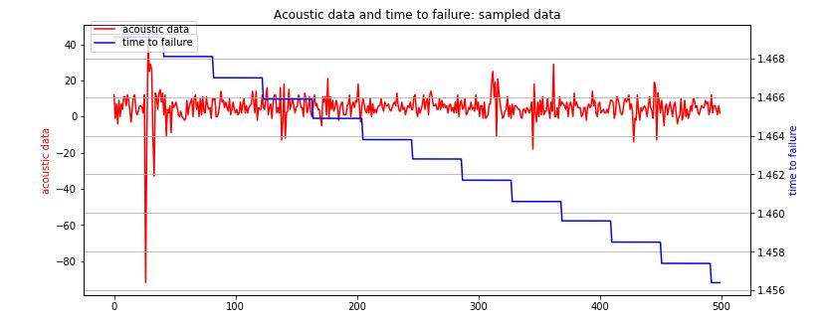

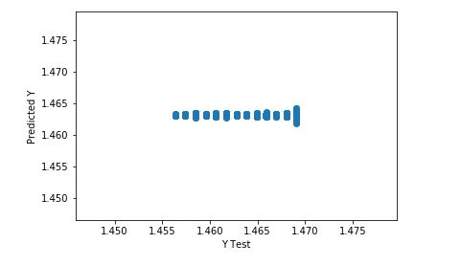

4

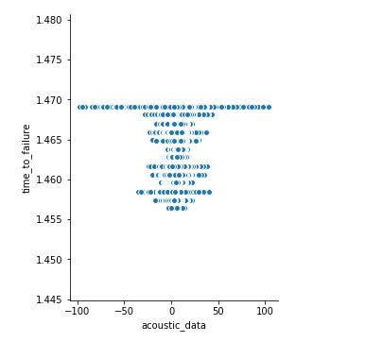

5

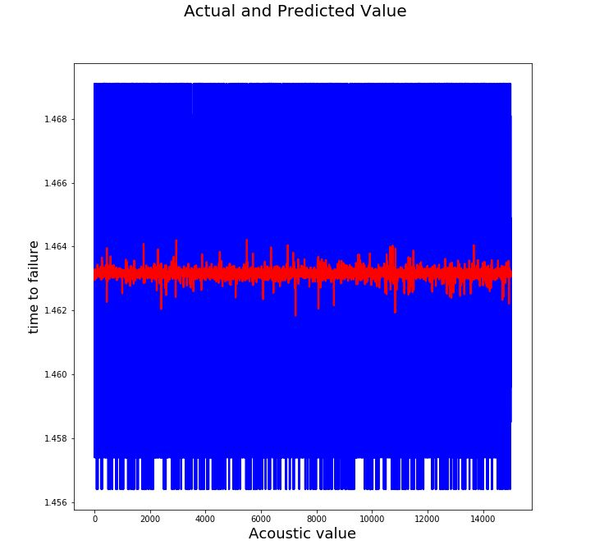

6

**DESIGNING**

**MACHINE LEARNING MODEL**

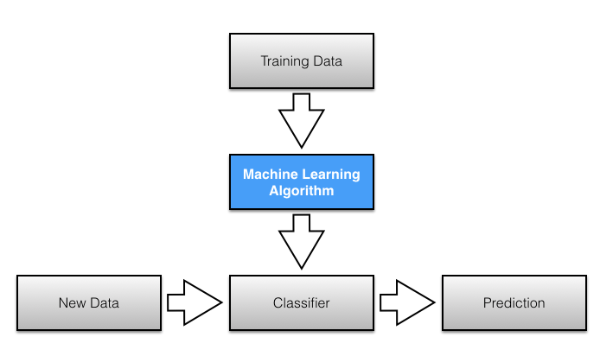

**MACHINE LEARNING ALGORITHM USED:-**

* **LINEAR REGRESSION**
* **RIDGE REGRESSION**
* **LASSO REGRESSION**
* **LOGISTIC REGRESSION**

7

**DATA FLOW DIAGRAM OF INTERFACE**

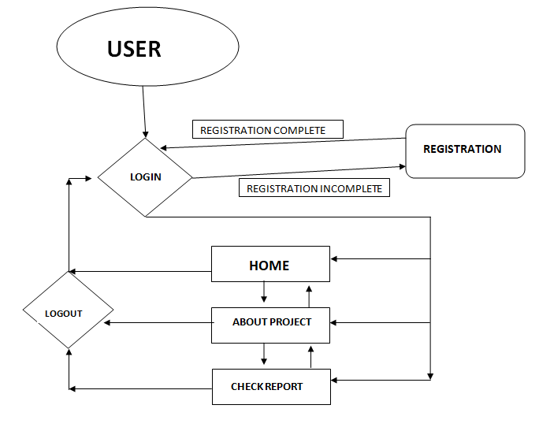

**USER INTERFACE DIAGRAM**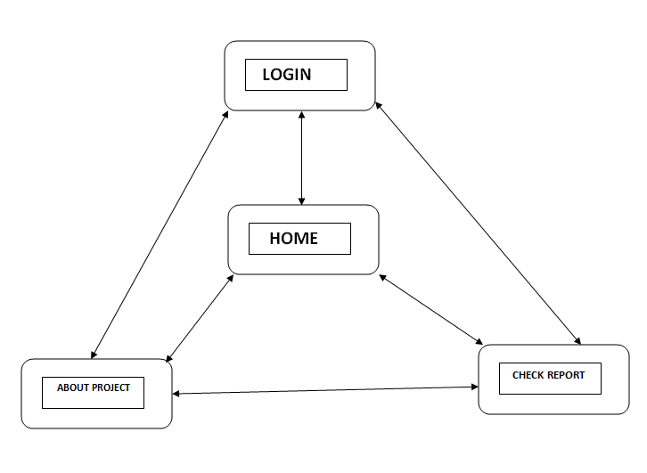

8

**CODING AND TESTING**

9

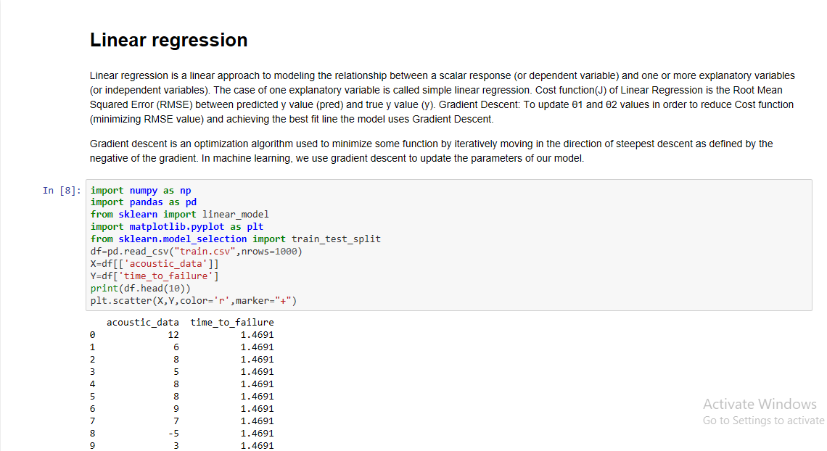

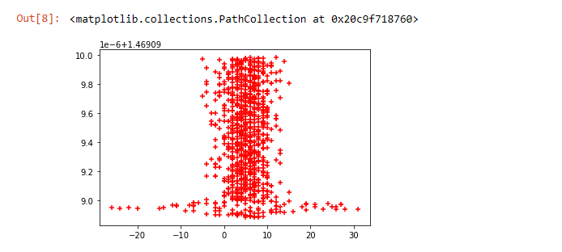

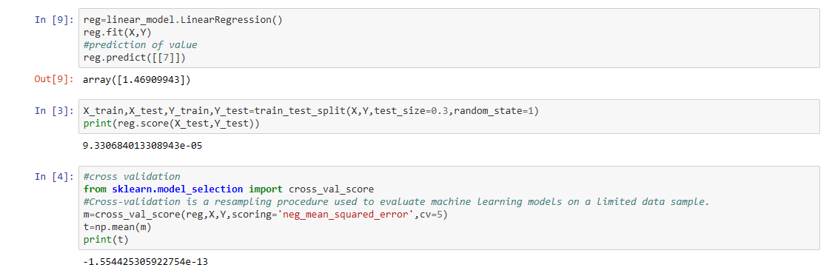

10

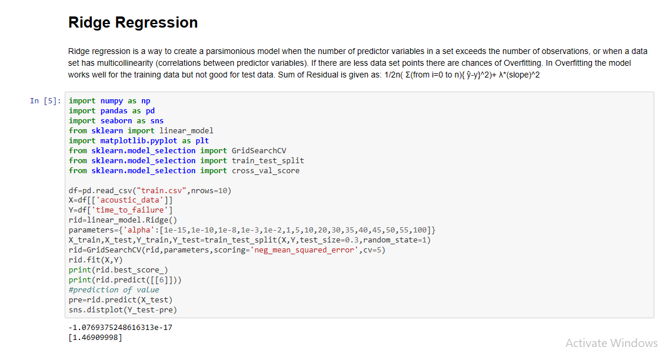

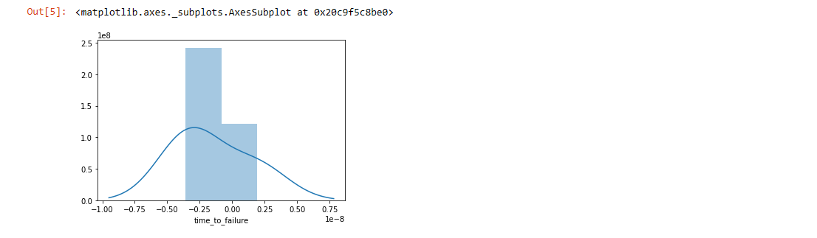

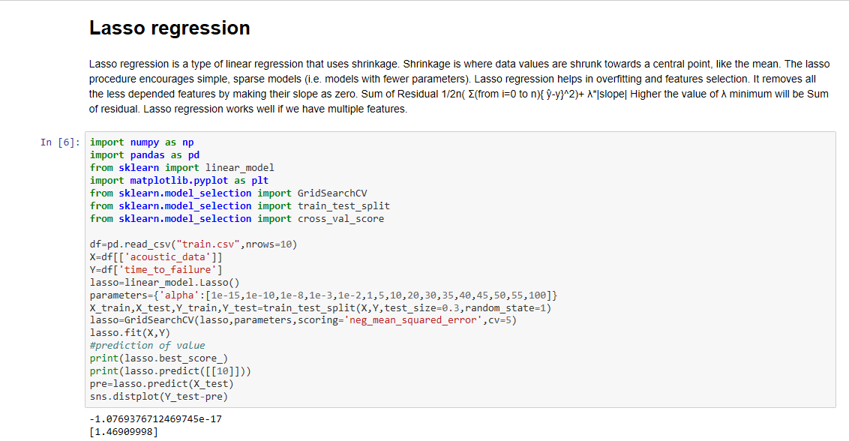

11

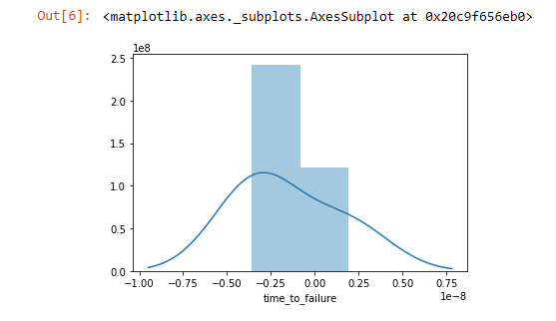

**REFERENCES**

12

KAGGLE-<https://www.kaggle.com/c/LANL-Earthquake-Prediction>

HARVAD UNIVERSITY-<http://sitn.hms.harvard.edu/flash/2019/predicting-next-big-earthquake/>

WIKIPEDIA-<https://en.wikipedia.org/wiki/Earthquake_prediction>

TOWARDS DATA SCIENCE-<https://towardsdatascience.com/earthquake-prediction-faffd7160f98>

**BIBLIOGRAPHY**

**MACHINE LEARNING ANDREW NG COURSE ON COURSERA**

**SOFTWARE-**

**DJANGO FOR WEB DEVELOPMENT**

**JUPYTER NOTEBOOK FOR MACHINE LEARNING MODEL**