Name:-Ritesh Kumar Sahoo

GitHub Link:-https://github.com/Riteshksahoo/Cognizant_6364581_RiteshCognizantDotNet

**-----------------------------------------------------------------------------------------**

**1. ReactJS-HOL  
  
Create a new React Application with the name “myfirstreact”**  
  
import logo from './logo.svg';

import './App.css';

function App() {

return (

<h1> Welcome the first session of React </h1>

);

}

export default App;

**OUTPUT**

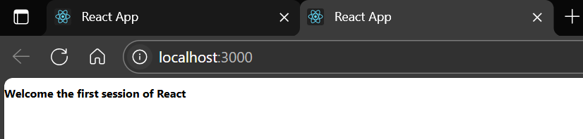

**Since VS Code is no longer allowing the use of capital letters, I'll use **"studentapp"** instead.**  
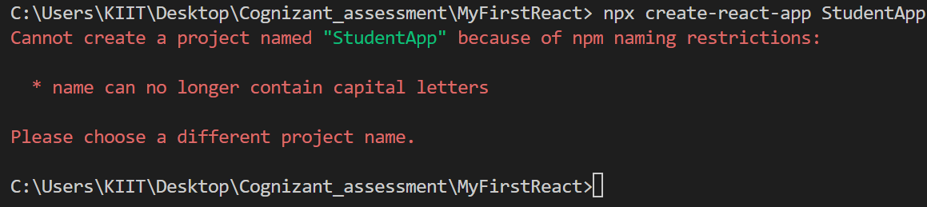  
  
**2. ReactJS-HOL**  
  
**Create a React project named “StudentApp**  
**Components/Home.js**  
  
import React, { Component } from 'react';

class Home extends Component {

render() {

return (

<div>

<h3>Welcome to the Home page of Student Management Portal</h3>

</div>

);

}

}

export default Home;

**Components/About.js**  
  
import React, { Component } from 'react';

class About extends Component {

render() {

return (

<div>

<h3>Welcome to the About page of the Student Management Portal</h3>

</div>

);

}

}

export default About;

**Components/Contact.js**  
  
import React, { Component } from 'react';

class Contact extends Component {

render() {

return (

<div>

<h3>Welcome to the Contact page of the Student Management Portal</h3>

</div>

);

}

}

export default Contact;  
  
**App.js**import './App.css';

import Home from './Components/Home';

import About from './Components/About';

import Contact from './Components/Contact';

function App() {

return (

<div className="container">

<Home />

<About />

<Contact />

</div>

);

}

export default App;

**OUTPUT**

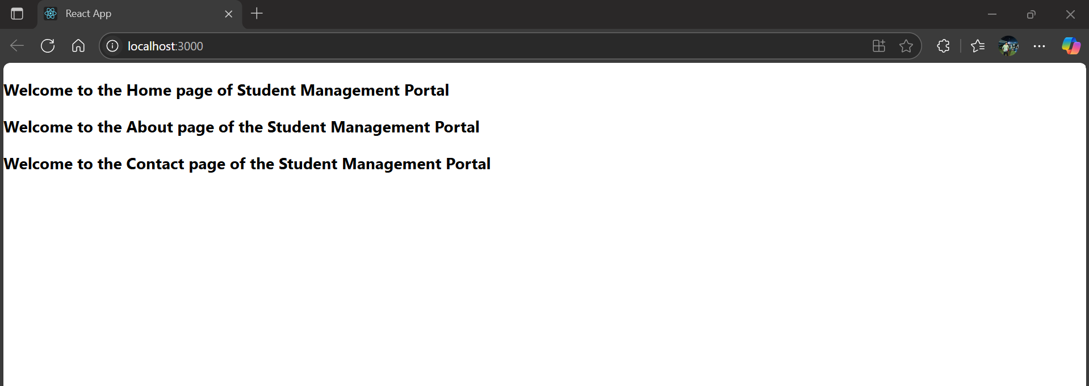

(Zoom in)

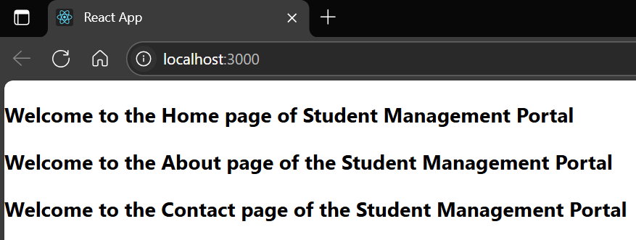

**3. ReactJS-HOL**

**Create a react app for Student Management Portal named scorecalculatorapp  
  
Components/CalculateScore.js**import React from 'react';

import '../Stylesheets/mystyle.css';

const percentToDecimal = (decimal) => {

return (decimal).toFixed(2) + "%";

};

const calcScore = (total, goal) => {

return percentToDecimal(total / goal);

};

export const CalculateScore = ({ Name, School, total, goal }) => (

<div className="formatstyle">

<h1><font color="Brown">Student Details:</font></h1>

<div className="Name">

<b><span>Name: </span></b>

<span>{Name}</span>

</div>

<div className="School">

<b><span>School: </span></b>

<span>{School}</span>

</div>

<div className="Total">

<b><span>Total: </span></b>

<span>{total}</span>

<span>Marks</span>

</div>

<div className="Score">

<b>Score: </b>

<span>

{calcScore(total, goal)}</span>

</div>

</div>

);  
  
**Stylesheets/mystyle.css**

.Name {

font-weight: 300;

color: blue;

}

.School {

color: crimson;

}

.Total {

color: darkmagenta;

}

.formatstyle {

text-align: center;

font-size: large;

}

.Score {

color: forestgreen;

}

**App.js**import './App.css';

import { CalculateScore } from './Components/CalculateScore';

function App() {

return (

<div>

<CalculateScore

Name={"Steeve"}

School={"DNV Public School"}

total={284}

goal={3}

/>

</div>

);

}

export default App;

**OUTPUT**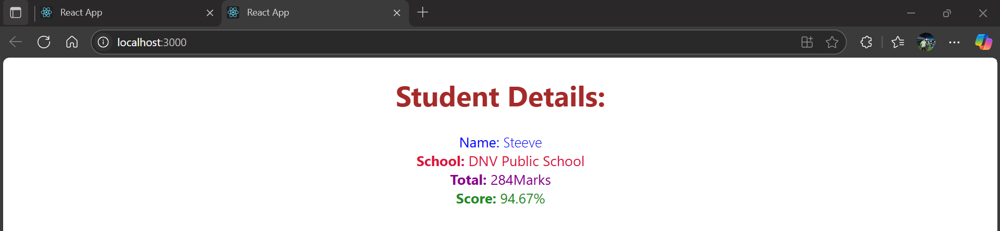

(Zoom in)

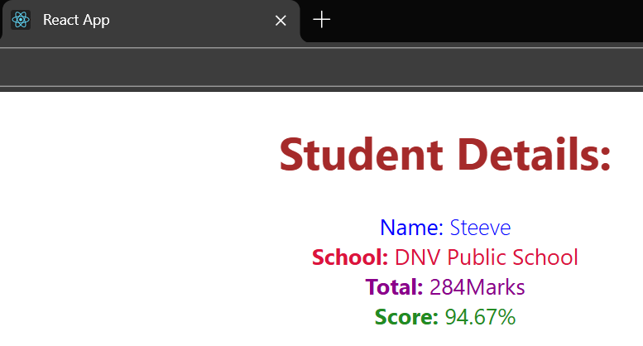

**4. ReactJS-HOL**

**Create a new react application using *create-react-app* tool with the name as “blogapp”  
  
Post.js**

class Post {

constructor(id, title, body) {

this.id = id;

this.title = title;

this.body = body;

}

}

export default Post;  
  
**Posts.js**  
  
import React from "react";

import Post from "./Post";

class Posts extends React.Component {

constructor(props) {

super(props);

this.state = {

posts: [],

hasError: false,

};

}

loadPosts() {

fetch("https://jsonplaceholder.typicode.com/posts")

.then((response) => response.json())

.then((data) => {

const postObjects = data.map(

(item) => new Post(item.id, item.title, item.body)

);

this.setState({ posts: postObjects });

})

.catch((error) => {

console.error("Error fetching posts:", error);

this.setState({ hasError: true });

});

}

componentDidMount() {

this.loadPosts();

}

componentDidCatch(error, info) {

alert("An error occurred in the Posts component!");

console.error("Error boundary caught: ", error, info);

}

render() {

return (

<div>

<h1>Blog Posts</h1>

{this.state.posts.map((post) => (

<div key={post.id}>

<h2>{post.title}</h2>

<p>{post.body}</p>

</div>

))}

</div>

);

}

}

export default Posts;  
  
**App.js**import React from "react";

import "./App.css";

import Posts from "./Posts";

function App() {

return (

<div className="App">

<Posts />

</div>

);

}

export default App;

**OUTPUT**

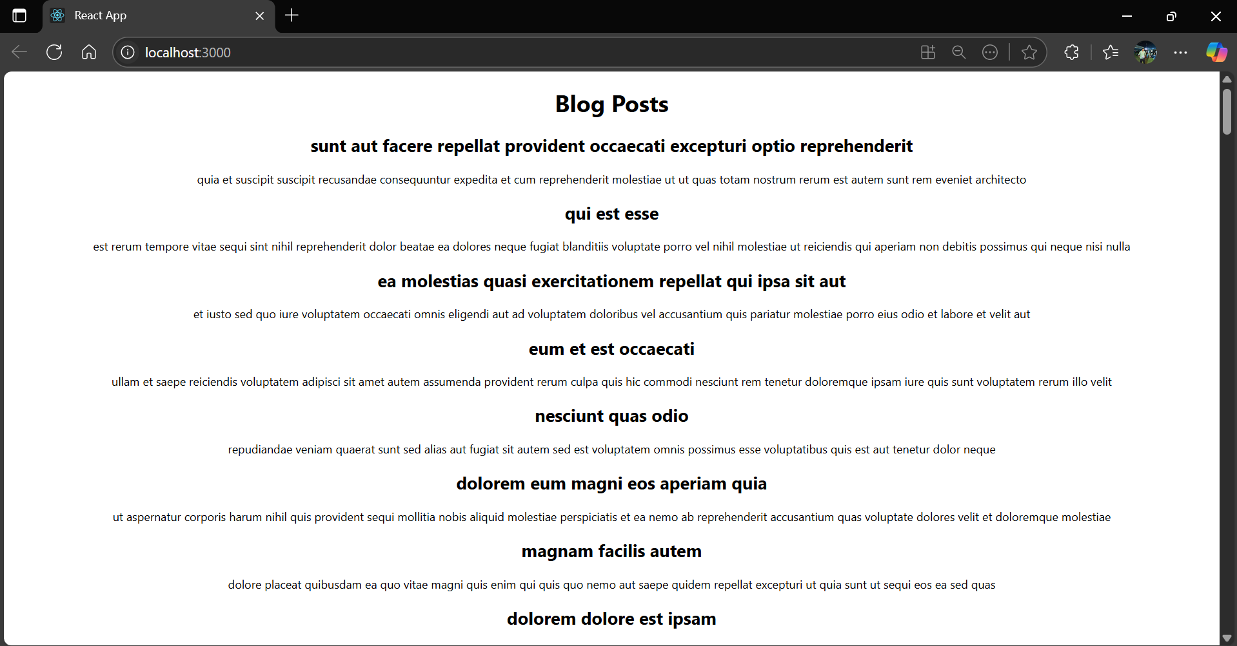  
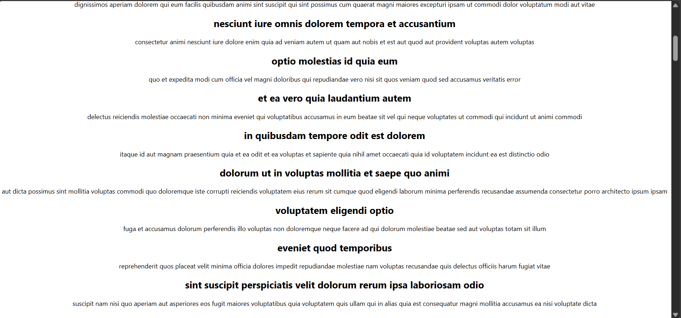

**5.ReactJS-HO**

**My Academy team at Cognizant want to create a dashboard containing the details of ongoing and completed cohorts. A react application is created which displays the detail of the cohorts using react component.  
  
CohortDetails.js**  
  
import styles from './CohortDetails.module.css';

function CohortDetails(props) {

const isOngoing = props.cohort.currentStatus === "Ongoing";

return (

<div className={styles.box}>

<h3 style={{ color: isOngoing ? "green" : "blue" }}>

{props.cohort.cohortCode} -

<span> {props.cohort.technology}</span>

</h3>

<dl>

<dt>Started On</dt>

<dd>{props.cohort.startDate}</dd>

<dt>Current Status</dt>

<dd>{props.cohort.currentStatus}</dd>

<dt>Coach</dt>

<dd>{props.cohort.coachName}</dd>

<dt>Trainer</dt>

<dd>{props.cohort.trainerName}</dd>

</dl>

</div>

);

}

export default CohortDetails;

**App.js (already given in the package)**

import logo from './logo.svg';

import './App.css';

import { CohortsData} from './Cohort'

import CohortDetails from './CohortDetails';

function App() {

return (

<div>

<h1>Cohorts Details</h1>

{CohortsData.map(cohort => <CohortDetails cohort={cohort}/>)}

</div>

);

}

export default App;

**OUTPUT**  
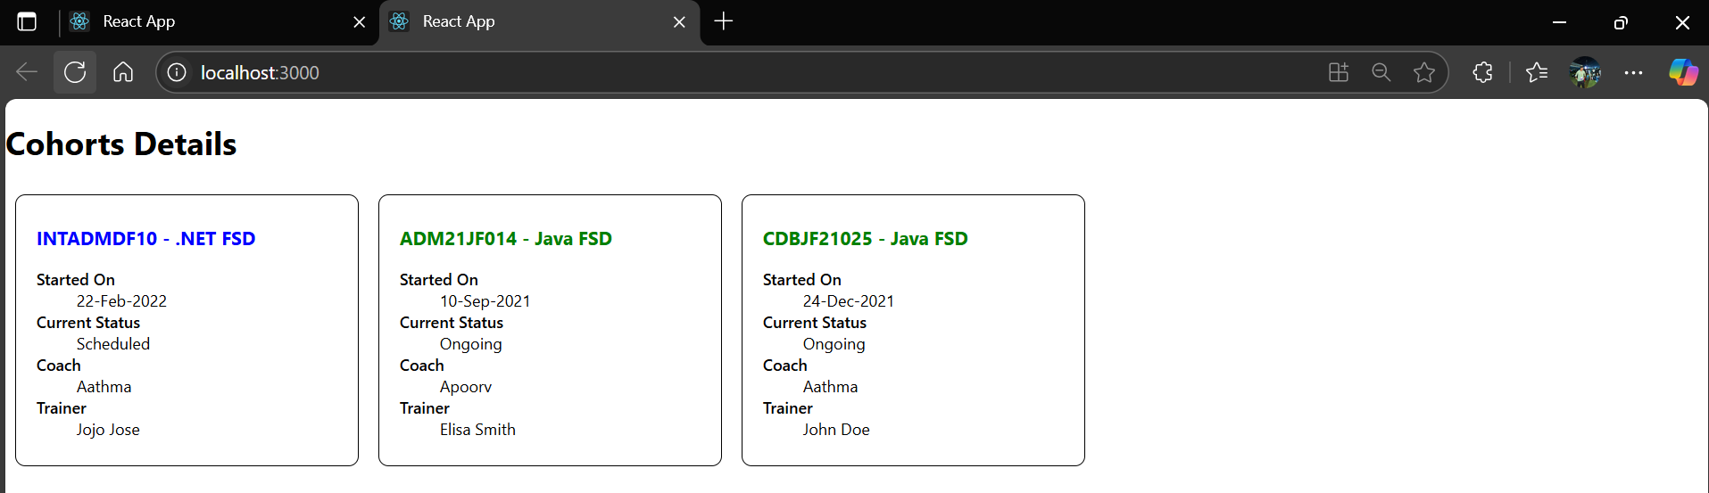  
  
  
(zoom in)  
  
