MOOLCHAND ACADEMY

# Kotdwar Road, Najibabad

# Session - 2025-2026

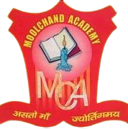

# PROJECT WORK

COMMUNICATION AND GREEN SKILLS

Submitted by: Submitted to:

Name – Pushkar Miss. Princi Verma

Class – IX

Section – A

Subject - IT



