MOOLCHAND ACADEMY

# Kotdwar Road, Najibabad

# Session - 2025-2026

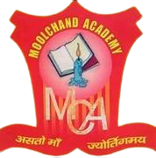

# HOLIDAY HOMEWORK

Submitted by:

Nane – Pushkar

Class – IX

Section - A

