ASSIGNMENT 1

Q1.
Ans. On linux start up, when we to log into an another user name it will then give an "incorrect password error." Then we have to select specific known existent user and type in the password to log in.

Q2.
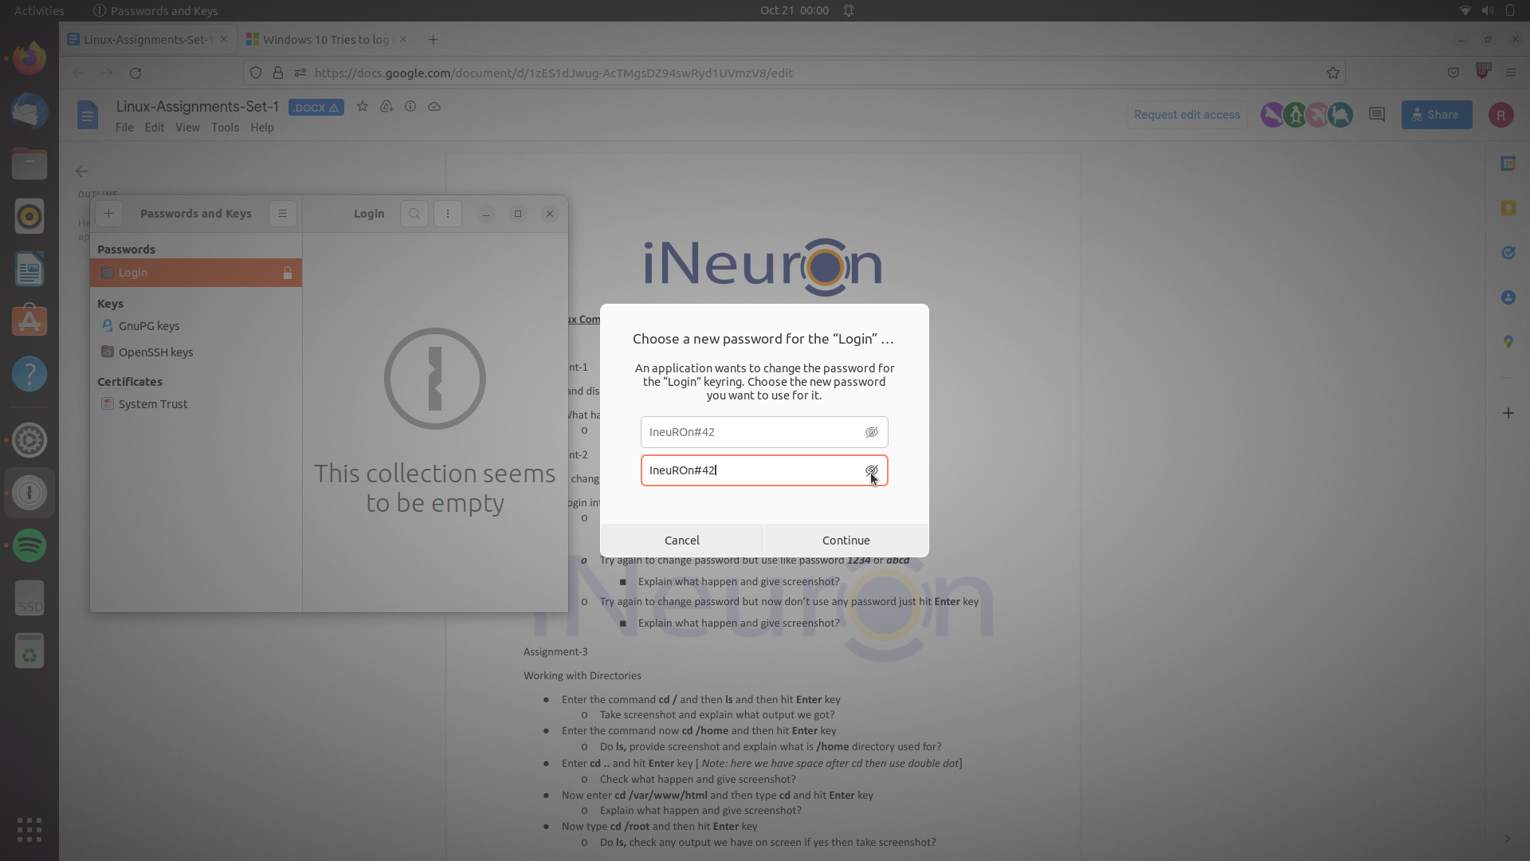
Ans. It changes the password to Ineuron#42 without any error.

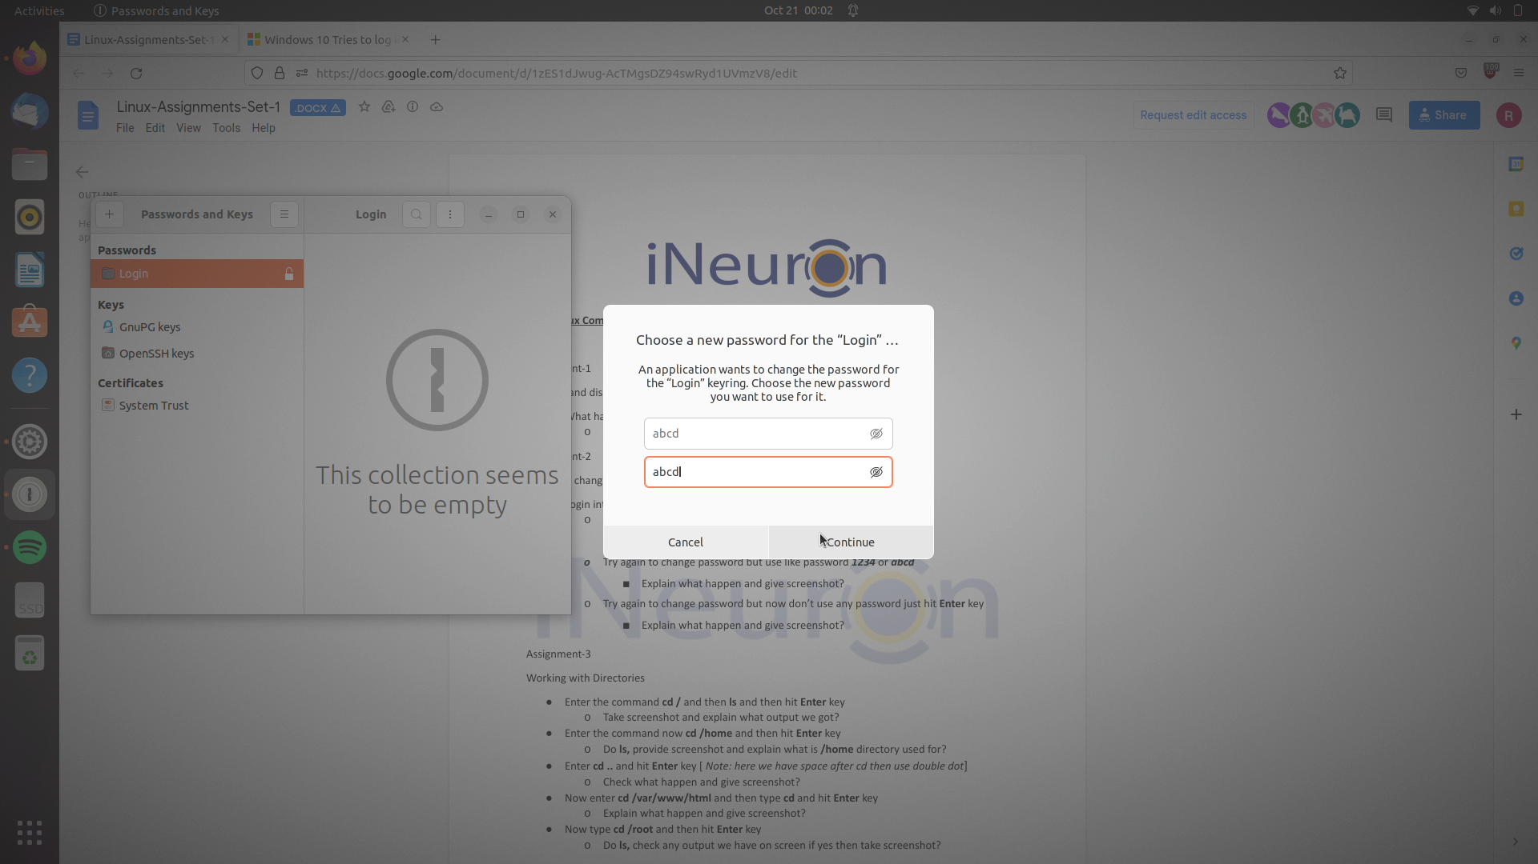
:- here also password changes to abcd without any error

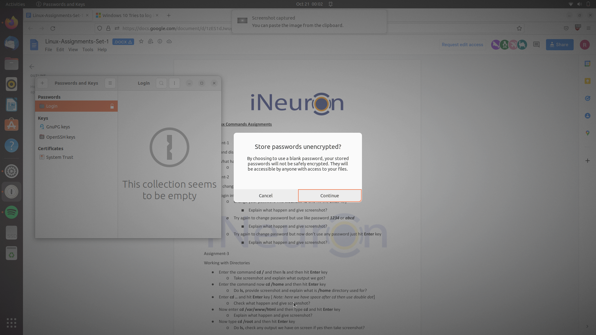
:- When we don’t use any password it show that is it nnot secure to leave blank in password. Our saved password will not be encrypted, it will be open to all.

Q3.
Ans.
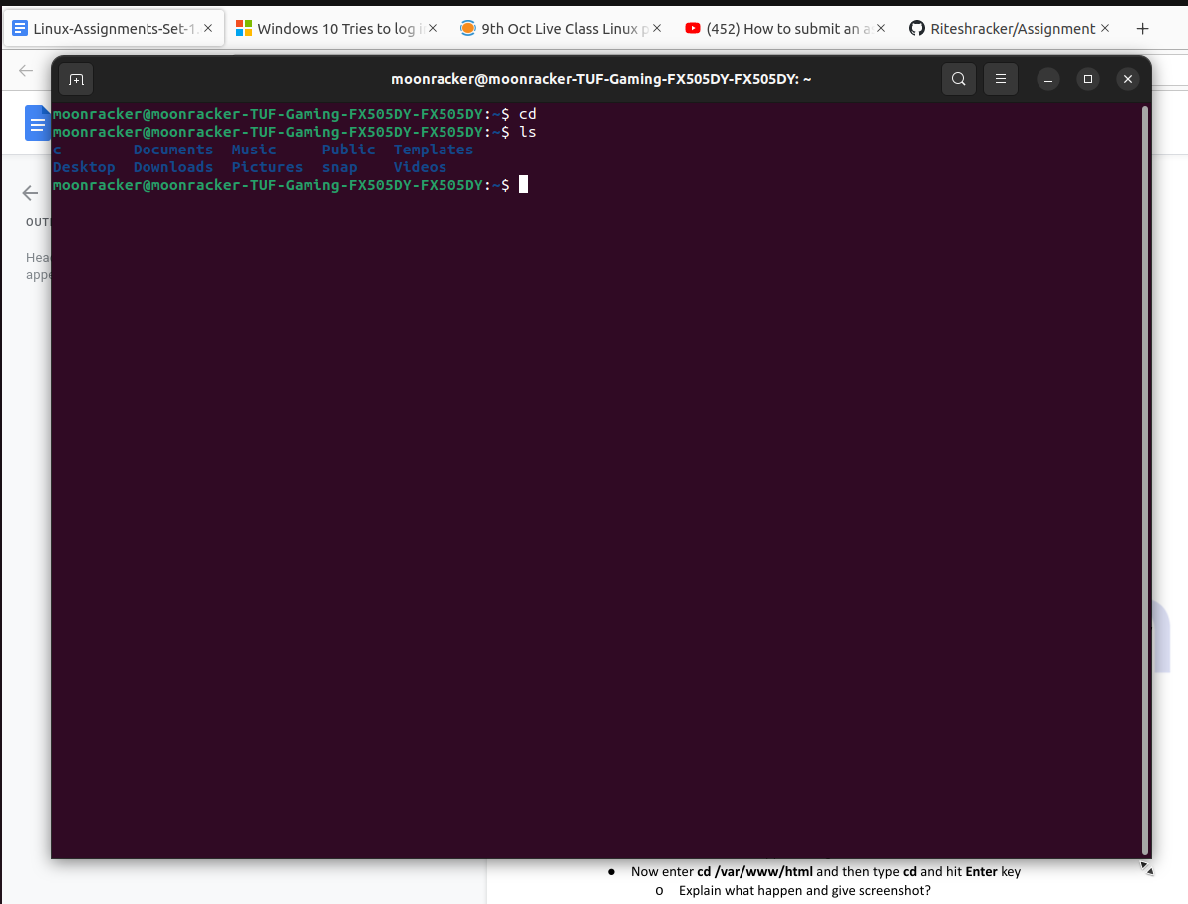
A :-By this command we change directory and list out all the things available inside the directory.Here we have got c , documents, music , public, template, desktop, downloads etc. Which are present in the base home directory.

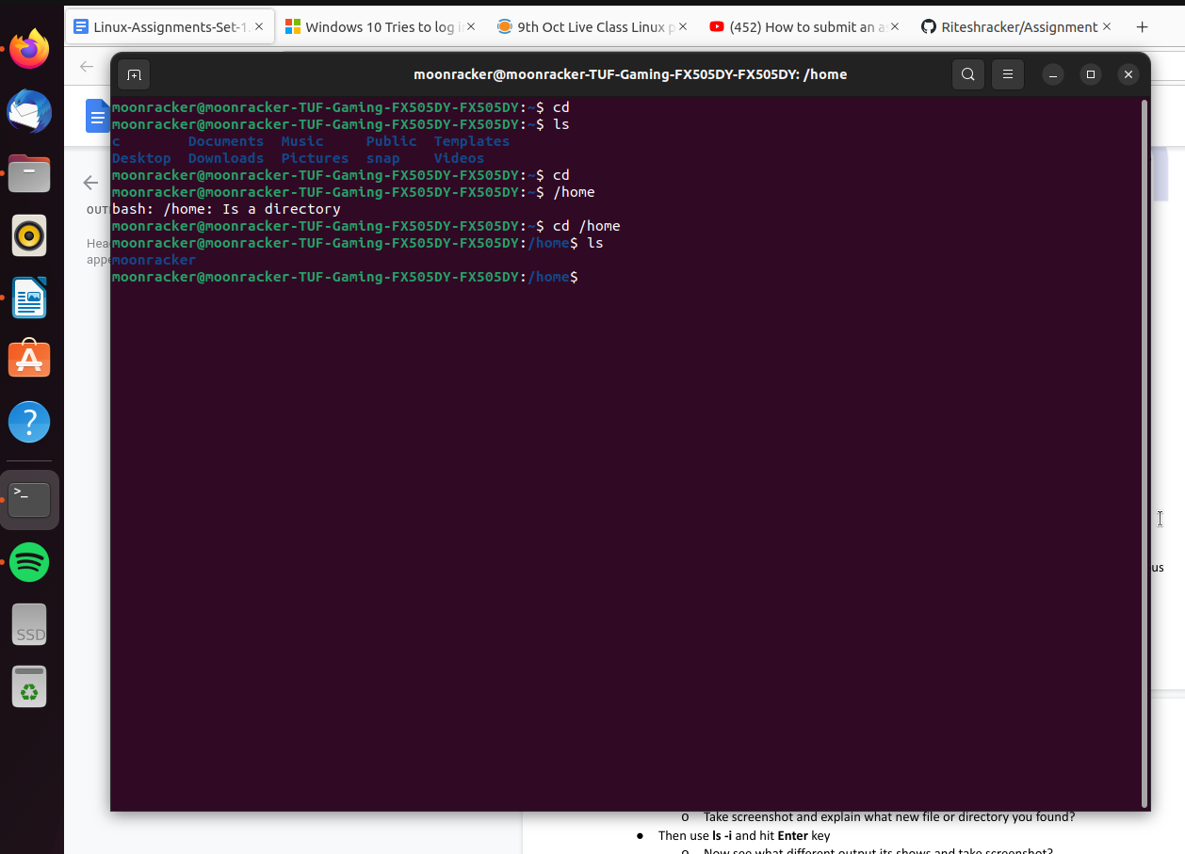

B.:-
Here the main directory has been changed by cd /home to home directory .Current working directory is changed.
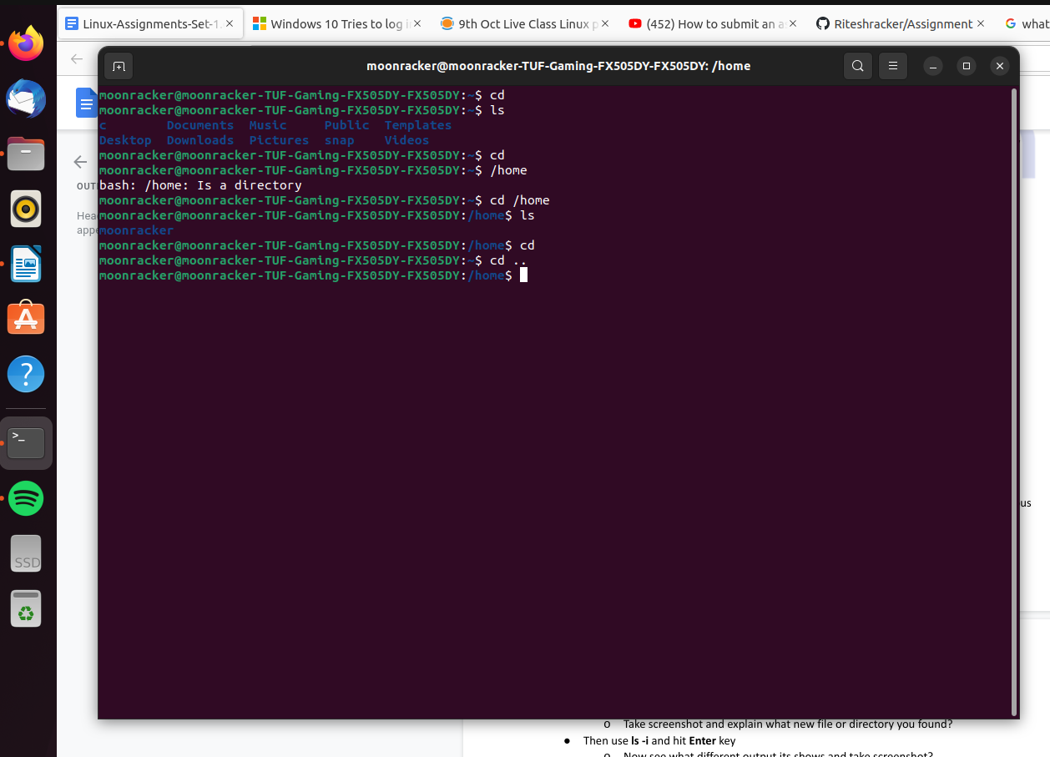
:- cd .. command is also used for changing current directory

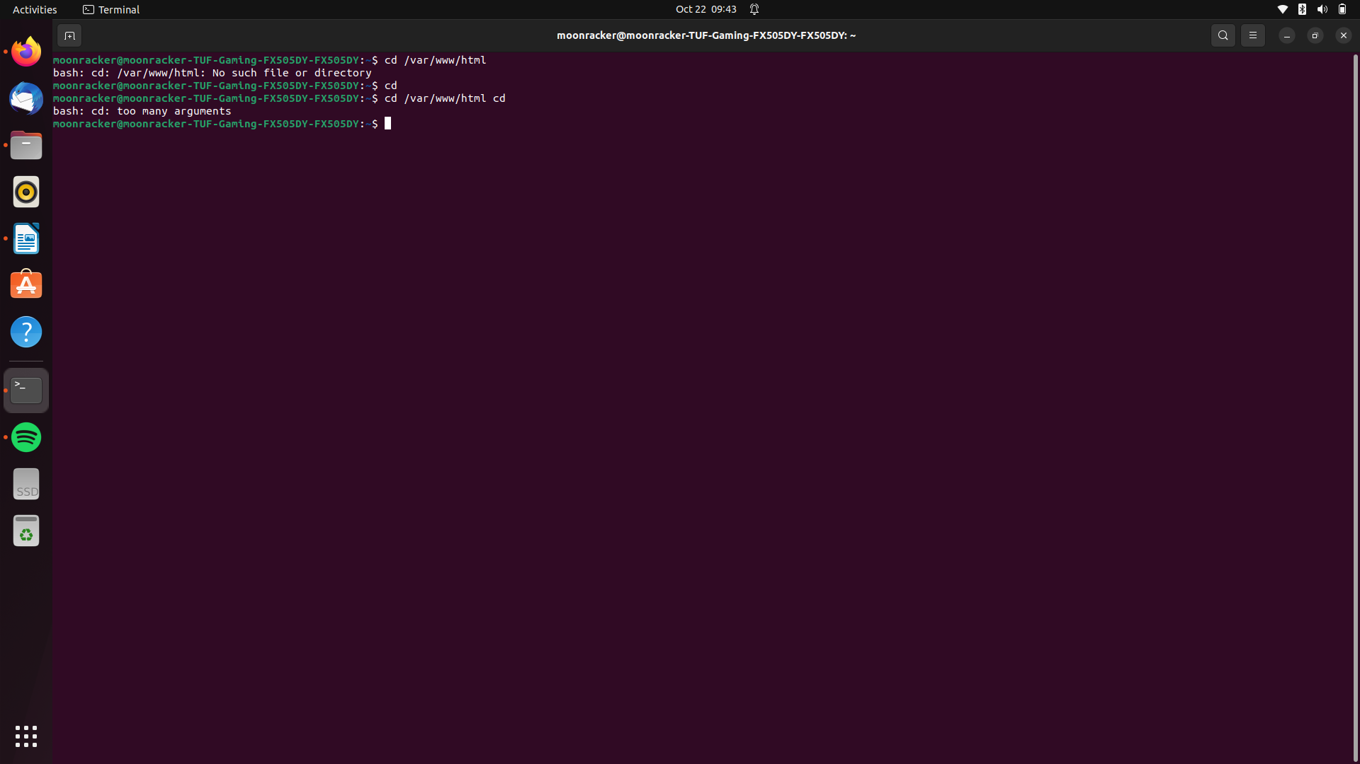
This command shows too many arguments. As after the command cd var/www/html we have written another command of change directory cd.So it wont take multiple command at a time and line.

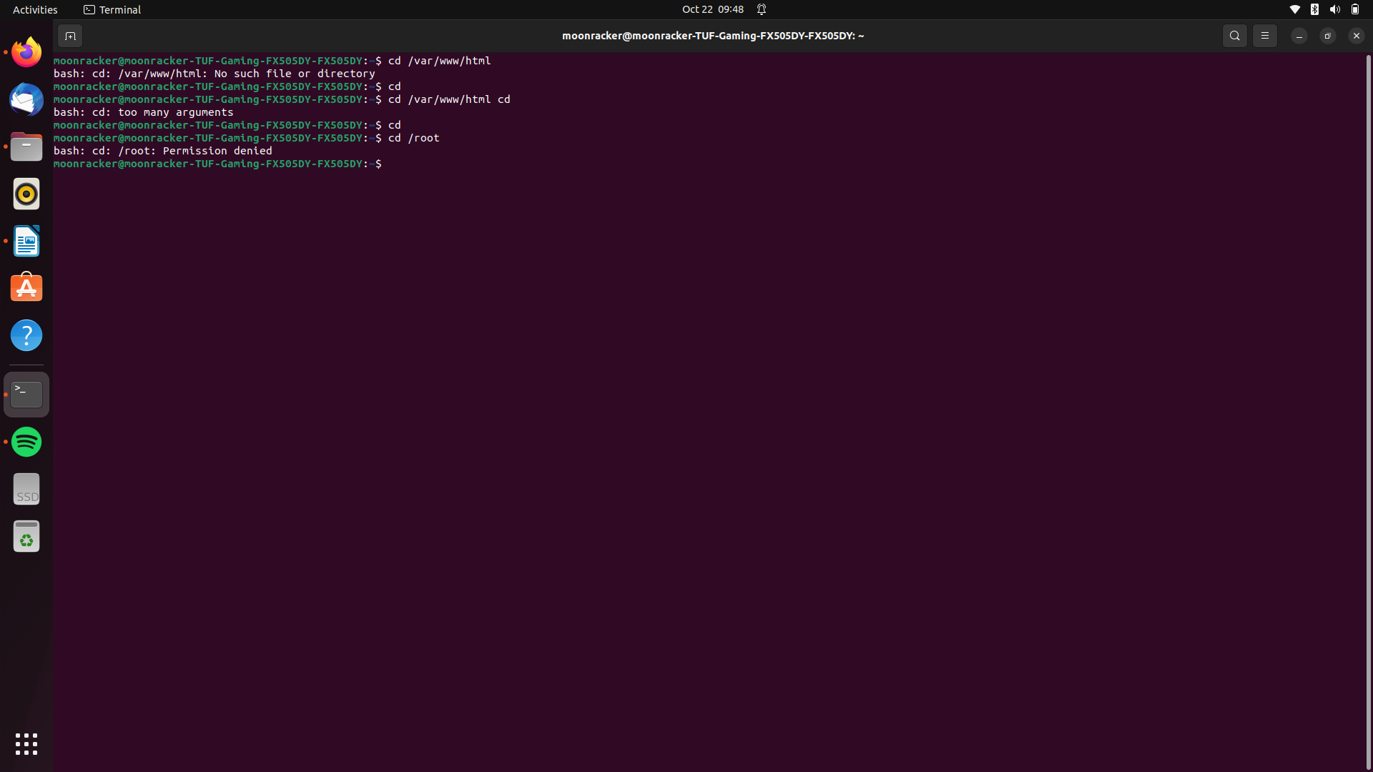
cd /root :- This command shows permission denied . We dont have permission to execute this ommand. Maybe after goind sudo mode it will be accessible.

Q4.
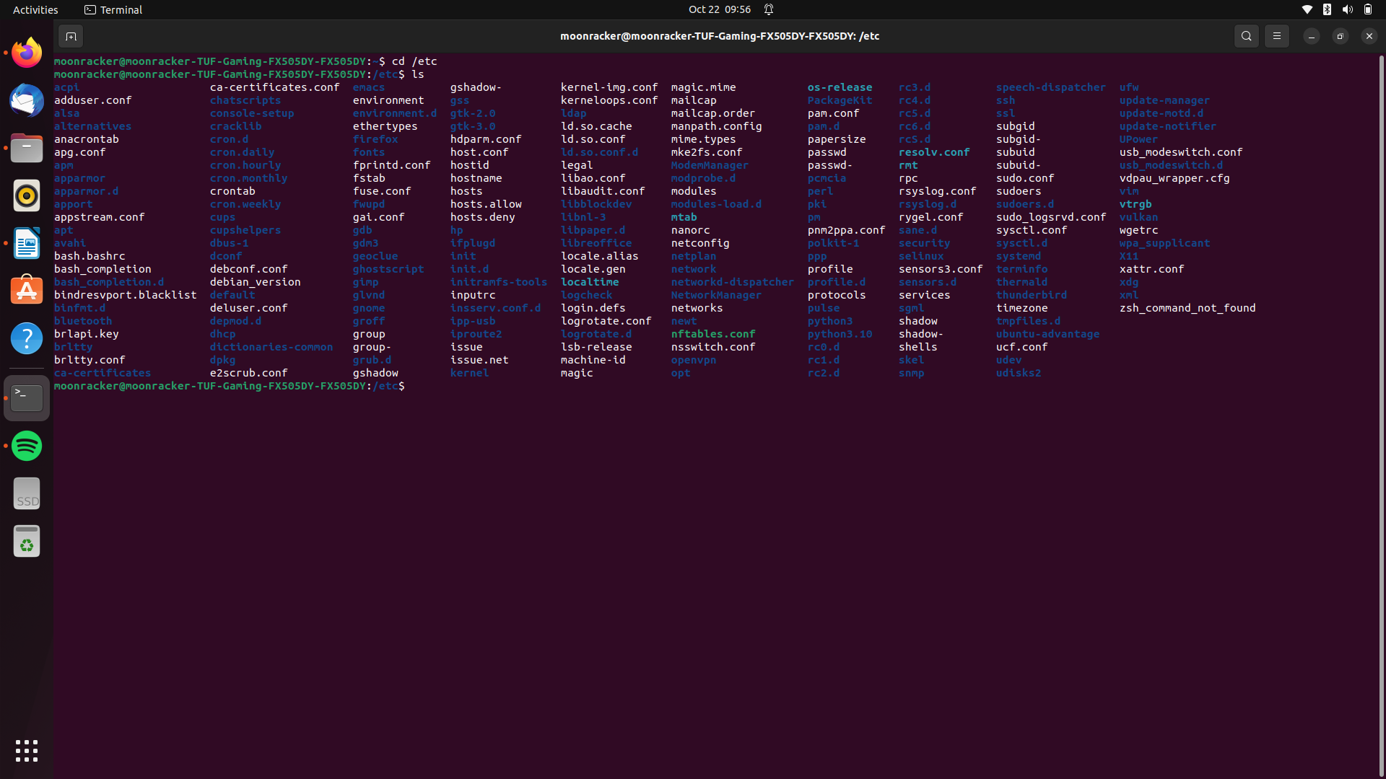
Ans.

We see all the files from root folder. Etc is a root folder in linux.
The /etc folder consists all system-wide configuration files are available.

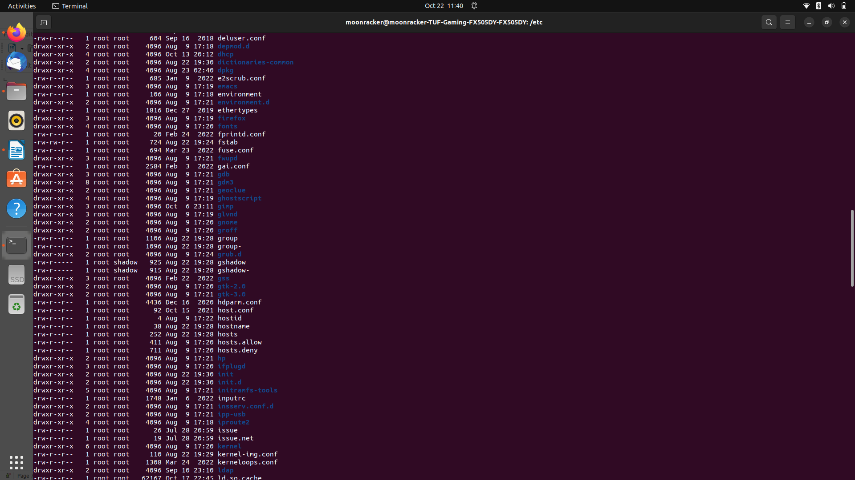
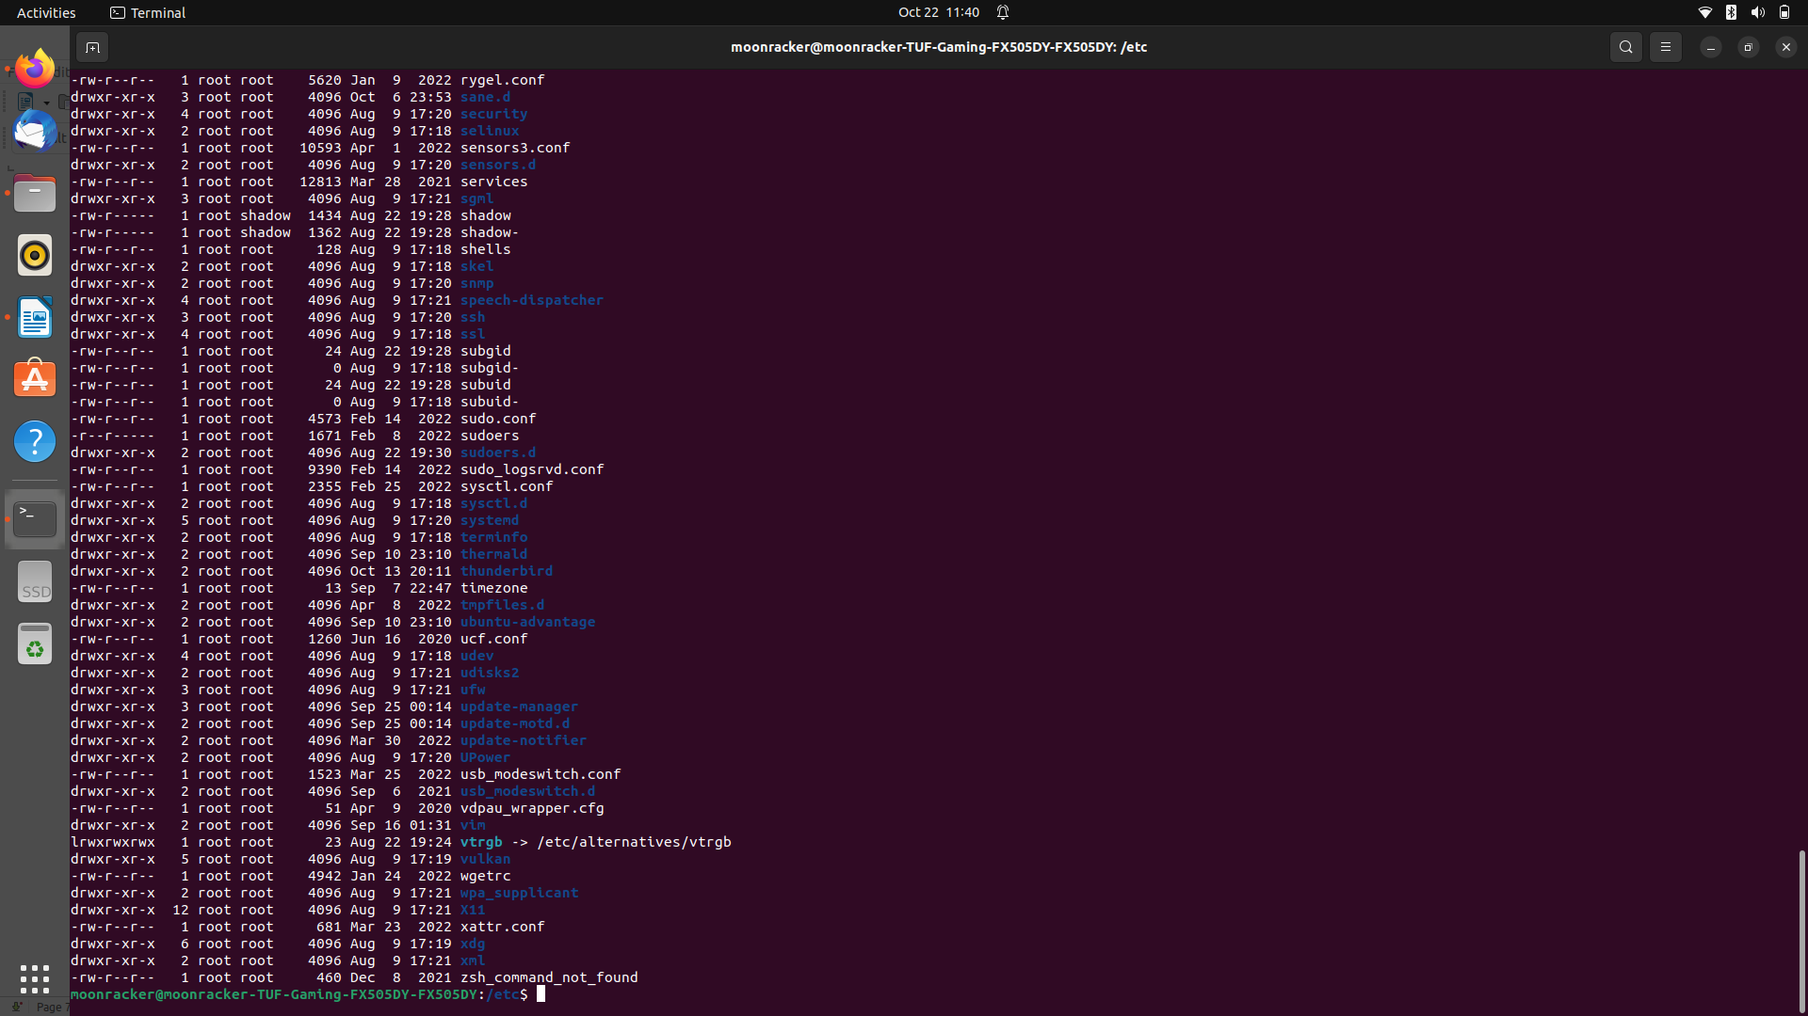
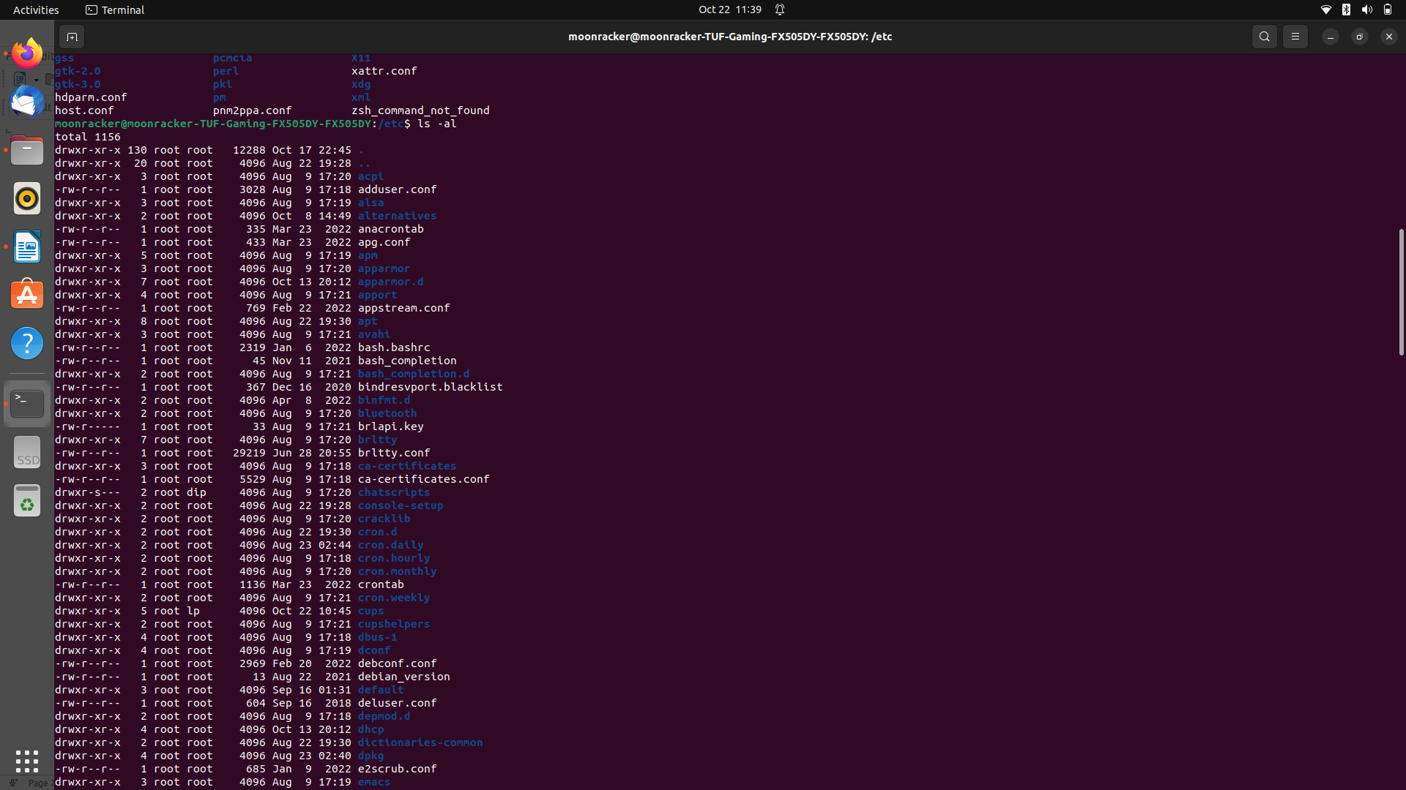
:-These are also root folder but with detailed listing. Likewise this command shows those root folders with memory, date and time.

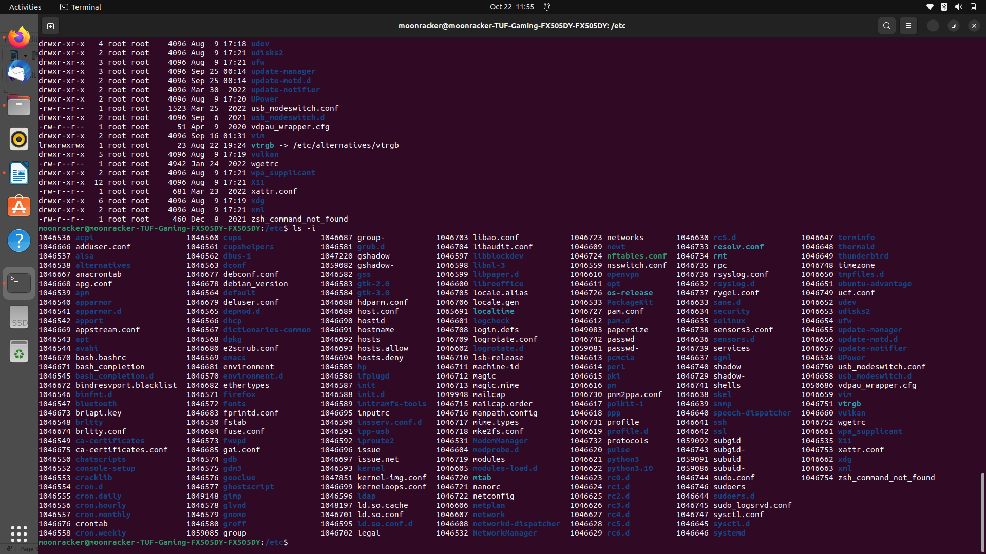

Q5.
Ans.


