CA-2

Q1. Generate a model in Python for representation of a bank account of type savings and balance along with transactions of deposit and withdrawals and currently create a program to generate 100 accounts with Random balance and transactions for no. of months and no. of transactions with a seed value of amount. Print all 100 accounts with the last balance and organize them by lowest to highest balance.

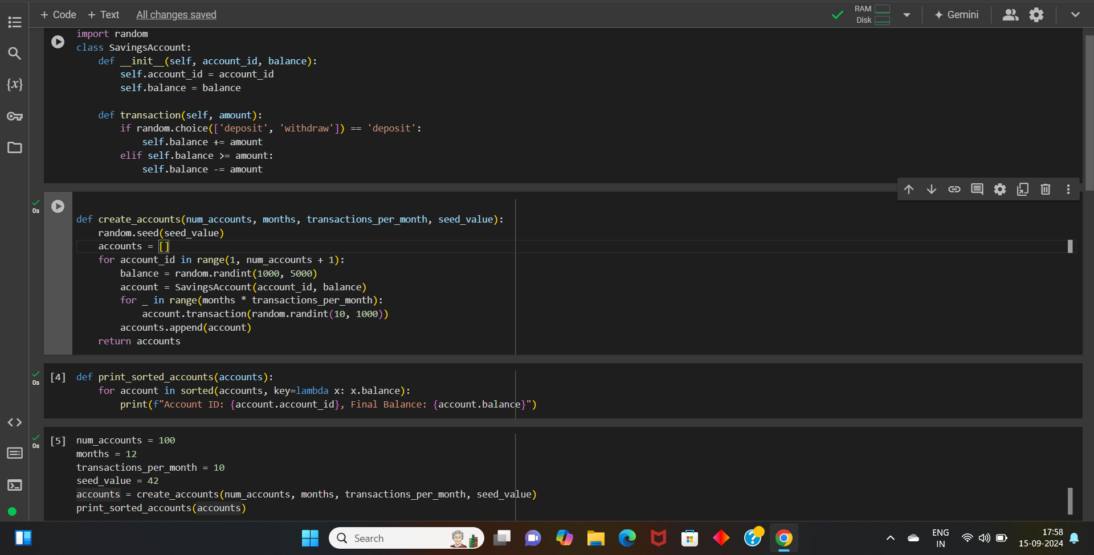

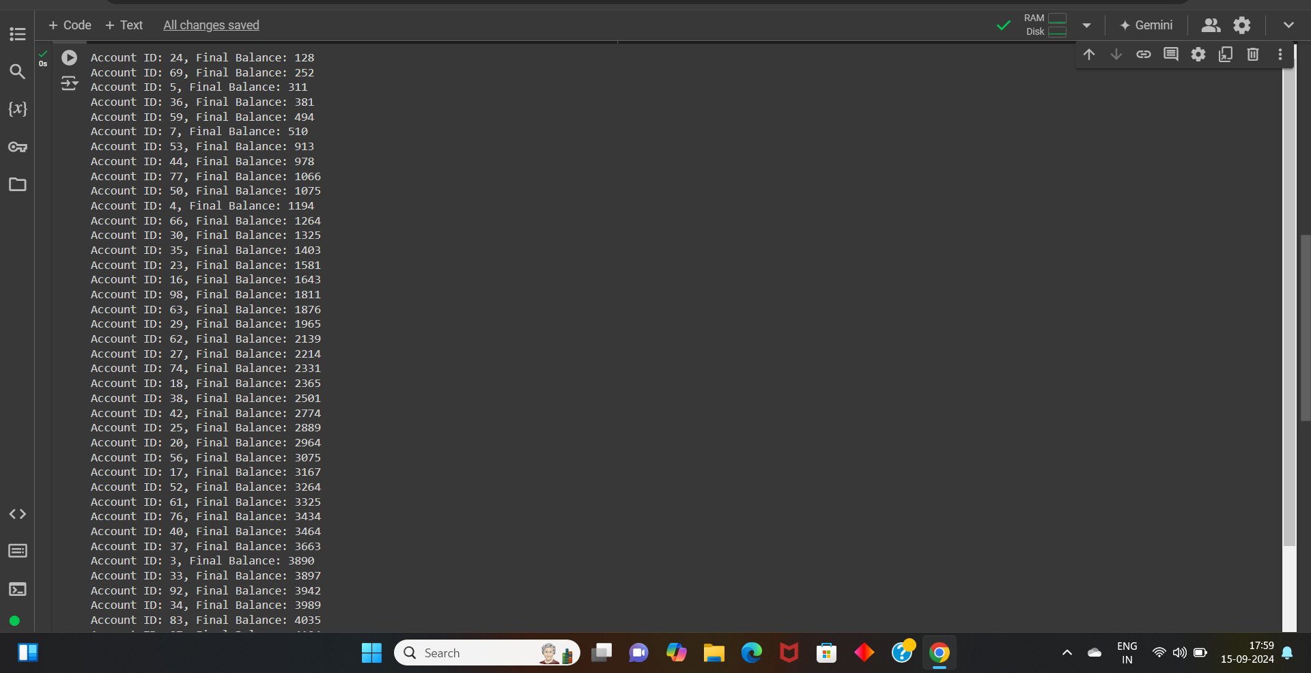

Q:4 Generate a model to represent interest calculations of a Bank account where the process of calculating interest for 6 months is a. Find minimum balance for each month b. Make a total of all minimum balances c. Calculate interest based on interest rate d. Divide interest by 12 to find one-month interest e. Multiply interest by 6 to show interest in the account. Generate a model to represent transactions and interest calculations for 6 months.

