IMMORTAL FUTURE INFOTECH
SERVICES PAGE — COMPLETE CLAUDE REDESIGN PROMPT
Combined visual, text-placement, image-placement, interaction, responsive and performance specification

How to use this document
Copy the prompt in Section 8 into Claude after opening the existing Immortal Future Infotech project. This version combines the earlier image/asset implementation brief with the detailed text, spacing, hierarchy, carousel, filtering, interaction, responsive, accessibility and performance requirements from the supplied prompt. The intention is to avoid conflicting or duplicated instructions: each requirement appears in the section where Claude should implement it.

1. Non-negotiable content rule
- Do NOT remove, rename, rewrite, summarize, or lose existing service content.
- Keep all 32 service offerings across AI & Banking, Cloud & Infra, Development and Business.
- Keep existing service names, descriptions, technology tags, outcomes, categories, navigation, footer and other page information.
- The redesign is a VISUAL/UX redesign, not a content rewrite.
- Keep the existing brand identity and mint/teal atmosphere.

2. Reference screenshots
Use the current Services page as the content/layout baseline. The redesigned result should feel like an evolution of it, not an unrelated template.
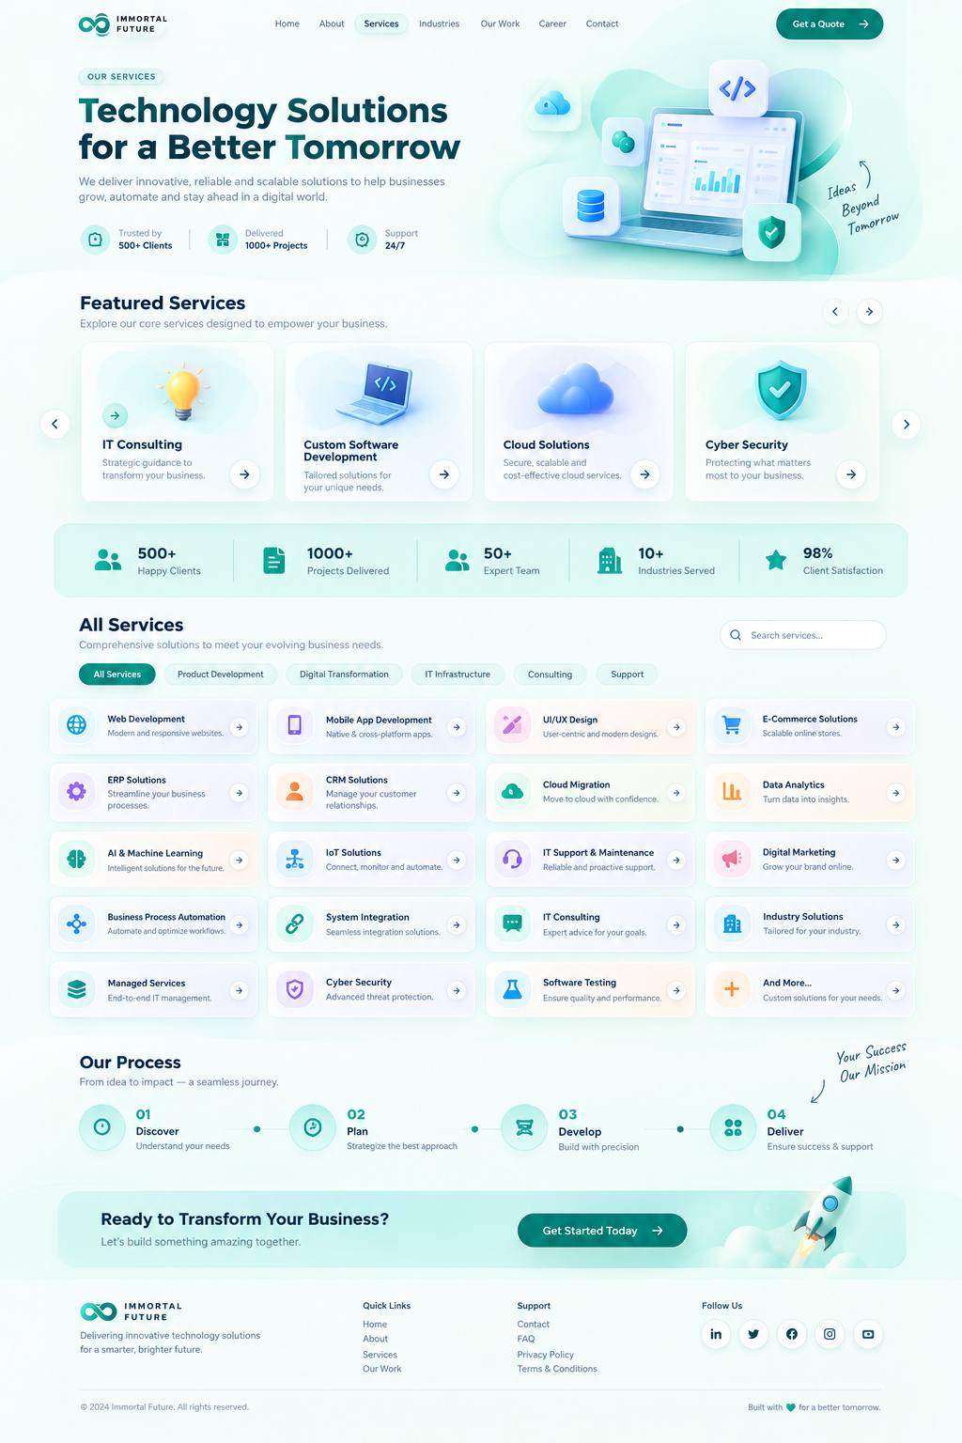
Existing Services page reference
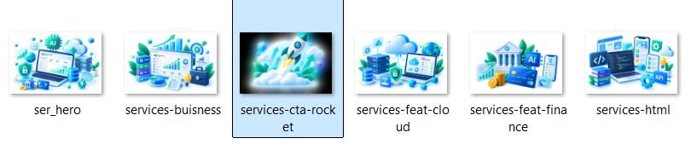
Current manually supplied image assets reference

3. Exact image assets and paths
Asset | Exact local path | Where it goes | Recommended display size | Notes
services-hero-3d.png | D:\immortal-future-infotech\src\assets\services-hero-3d.png | Hero, right side | 500–650 px wide desktop | Primary visual; preserve aspect ratio
category-ai-banking.png | D:\immortal-future-infotech\src\assets\category-ai-banking.png | Featured carousel card 1 | 180–250 px visual area | AI & Banking
category-cloud-infra.png | D:\immortal-future-infotech\src\assets\category-cloud-infra.png | Featured carousel card 2 | 180–250 px visual area | Cloud & Infra
category-development.png | D:\immortal-future-infotech\src\assets\category-development.png | Featured carousel card 3 | 180–250 px visual area | Development
category-business.png | D:\immortal-future-infotech\src\assets\category-business.png | Featured carousel card 4 | 180–250 px visual area | Business
services-cta-rocket.png | D:\immortal-future-infotech\src\assets\services-cta-rocket.png | CTA, right side | 250–350 px wide | Keep CTA compact
The supplied images are high-resolution 1536×1024 PNGs. Claude should preserve the aspect ratio and may optimize them to WebP/AVIF for production without changing their composition.

4. Text, spacing and layout blueprint
A. HERO — exact text and placement
Top/left eyebrow: "OUR SERVICES" — small pill/eyebrow above the main heading.
Main heading: "Thirty-two offerings. One delivery bar." — large, dominant headline on the left. Keep it to approximately 2 lines on desktop.
Supporting text: KEEP THE EXISTING SUPPORTING DESCRIPTION from the current Services page. Do not rewrite it.
Hero image: services-hero-3d.png on the right. It is the main visual anchor.
Layout: approximately 50/50 two-column composition on desktop, with the text block vertically aligned around the center of the image. Keep controlled whitespace around the image. Do not make the hero unnecessarily tall.
Hero visual language: technology + enterprise + innovation + multiple capabilities. The illustration can visually suggest laptop/dashboard, cloud, database, cybersecurity shield, AI/code and network elements.
Do not use people photography.
B. FEATURED SERVICES — text + image placement
Section heading: "Featured Services" — left aligned above the carousel.
Supporting line: "Explore our core services designed to empower your business." — directly below the heading.
Carousel cards: use the four supplied category images:
1. category-ai-banking.png — AI & Banking
2. category-cloud-infra.png — Cloud & Infra
3. category-development.png — Development
4. category-business.png — Business
Each card contains, in visual order:
1) image/3D visual
2) category/service title
3) short existing description
4) "View services →" action
Desktop: approximately 4 cards visible.
Tablet: 2 cards visible.
Mobile: 1 card visible.
Add left arrow, right arrow and pagination dots. Enable touch/swipe on mobile. Keep a fixed compact card height so the carousel does not significantly increase page height.
Important: the large category images belong here. Do not reuse them as huge images in all 32 service cards.
C. STATS STRIP — exact text and placement
Keep the existing statistics, presented as a slim horizontal strip.
Use these values/text where they correspond to the existing page:
500+ — Happy Clients
1000+ — Projects Delivered
50+ — Expert Team
10+ — Industries Served
98% — Client Satisfaction
Use small visual symbols. Place value above or beside the short label. Keep equal spacing and vertical alignment. Do not make this section tall.
D. ALL SERVICES — text hierarchy and spacing
Section heading: "All Services" — dominant heading above the service grid.
Supporting line: "Comprehensive solutions to meet your evolving business needs." — immediately under the heading.
Place the search field on the right side of this section header on desktop:
"Search services..."
Below the heading/subheading, place compact category filter pills:
All Services
AI & Banking
Cloud & Infra
Development
Business
Then display all 32 existing services.
Every service tile should keep the existing service name and existing short description. Add the small category label and arrow without deleting existing useful information.
Recommended visual order inside a tile:
[small icon/mini visual] [Service Name] [→]
one-line/two-line description
small category label
The small visual should occupy about 20–25% of the tile. It must never be larger than the service name.
Desktop: 4 columns.
Tablet: 2 columns.
Mobile: 1 column.
Keep card heights compact and consistent where practical.
E. OUR PROCESS — text and placement
Keep the existing process information and present it as a visual timeline.
Sequence:
01 Discover
02 Design
03 Develop
04 Test
05 Deploy
06 Improve
Each step should have:
number
small visual/icon
step title
existing supporting text
Desktop: horizontal timeline.
Mobile: vertical timeline.
Use small icons/3D mini visuals, not large illustrations. Keep the section compact.
F. CTA — exact text and placement
Main CTA heading: "Let's build something remarkable together."
Keep the existing supporting CTA text if it is already present in the current page.
CTA action: "Discuss your requirement →" (or preserve the current equivalent CTA label if the project already uses a different approved label).
Text/button: left side.
Image: services-cta-rocket.png on the right side.
Recommended image display: 250–350 px wide.
The CTA should be visually rich but compact and must not become a tall banner.
G. HEADER + FOOTER
Preserve the existing header/navigation and footer branding. Do not redesign them as unrelated components.
Keep the Immortal Future Infotech identity, navigation behavior, logo and footer information.
The Services page redesign begins with the hero and continues through Featured Services, Stats, All Services, Process and CTA while retaining the existing shell.

5. Visual design system
- Soft mint/teal background.
- White glassmorphism surfaces.
- Subtle blue/lavender accents.
- Premium 3D illustrations.
- Soft gradients.
- Subtle depth and sophisticated shadows.
- Rounded corners.
- Clean professional typography.
- Generous but controlled whitespace — never empty space that unnecessarily increases page height.
- Modern SaaS/enterprise aesthetic suitable for enterprise clients.
- Visually impressive without looking childish or overly colorful.
- Do not simply put a large icon inside every existing card; create a clear visual hierarchy.

6. Interaction, filtering, animation and responsive rules
- Service hover: card lifts approximately 3–5 px; mini visual subtly tilts/rotates; gradient becomes slightly stronger; arrow moves a few pixels; soft glow/border emphasis appears.
- Avoid bouncing, flashing, excessive rotation or distracting effects.
- Category filtering: selecting a pill displays only relevant services without page reload, smoothly transitions, preserves scroll position and clearly marks the active filter.
- Search: 'Search services...' filters service cards instantly.
- Carousel: smooth slide, previous/next controls, pagination, touch/swipe and keyboard accessibility.
- Hero: subtle floating/parallax motion only.
- CTA: subtle floating illustration only.
- Section entry: soft reveal when entering the viewport.
- Do not animate every element.
- Use performant CSS transform/opacity animations.
- Respect prefers-reduced-motion.
- Desktop: 4-column services grid, 4-card featured carousel, horizontal process, spacious two-column hero.
- Tablet: 2-column services grid, 2-card carousel, responsive process.
- Mobile: 1-column service list, 1-card swipe carousel, compact cards, vertical process, stacked hero/CTA.
- No horizontal page overflow at any breakpoint.

7. Visual library strategy for the 32 services
The four large category illustrations establish the main visual identity. The 32 individual services should use small, consistent icons/mini visuals rather than 32 large illustrations. Keep one coherent visual family.
AI & Banking: AI brain, banking card, financial analytics, digital wallet, payment, data chart
Cloud & Infra: cloud, server, database, network, cybersecurity, DevOps
Development: code, laptop, mobile phone, UI design, e-commerce, API, software testing
Business: CRM, ERP, business analytics, marketing, HR/payroll, consulting, document management
If existing service icons already exist in the codebase, keep them and restyle them to match the new visual system. Do not create random unrelated styles. For additional assets, prefer licensed Icons8 Ouch 3D illustrations, LottieFiles 3D animations, or custom SVG/3D assets. Verify licensing/attribution before use.

8. COPY-PASTE MASTER PROMPT FOR CLAUDE
REDESIGN OUR EXISTING SERVICES PAGE — MODERN 3D, PREMIUM, COMPACT, INTERACTIVE AND CONTENT-PRESERVING
PROJECT:
Immortal Future Infotech website.
You are working inside our existing website project. Redesign ONLY the visual presentation and UX of the existing Services page.
==================================================
NON-NEGOTIABLE CONTENT RULE
==================================================
DO NOT remove, rename, rewrite, summarize, or lose existing service content.
The existing Services page contains 32 service offerings across:
- AI & Banking
- Cloud & Infra
- Development
- Business
The existing content, service names, descriptions, technology tags, outcomes, categories, navigation, footer and other page information must remain available.
This is a VISUAL/UX REDESIGN, NOT a content rewrite.
==================================================
MANUALLY PROVIDED IMAGE ASSETS
==================================================
I am using a Claude version that cannot generate images.
DO NOT generate images.
DO NOT invent replacement images.
DO NOT use random stock images.
DO NOT hotlink random Google images.
All manually supplied images are in:
D:\immortal-future-infotech\src\assets
Use these exact assets:
HERO:
D:\immortal-future-infotech\src\assets\services-hero-3d.png
AI & BANKING:
D:\immortal-future-infotech\src\assets\category-ai-banking.png
CLOUD & INFRA:
D:\immortal-future-infotech\src\assets\category-cloud-infra.png
DEVELOPMENT:
D:\immortal-future-infotech\src\assets\category-development.png
BUSINESS:
D:\immortal-future-infotech\src\assets\category-business.png
CTA:
D:\immortal-future-infotech\src\assets\services-cta-rocket.png
These supplied source images are high-resolution 1536×1024 PNGs.
Preserve aspect ratio. For production you may optimize them to WebP/AVIF, but do not change their composition.
If the project uses Vite/React, follow the existing asset-import conventions. Example concept only:
import heroImage from '@/assets/services-hero-3d.png';
Use the actual alias/path convention already used in this project.
==================================================
REFERENCE DESIGN DIRECTION
==================================================
Use the existing Services page as the content reference.
The new page must feel like a premium modern technology/enterprise website:
- soft mint/teal background
- white glassmorphism surfaces
- subtle blue/lavender accents
- premium 3D illustrations
- soft gradients
- subtle depth
- rounded corners
- clean typography
- generous but controlled whitespace
- sophisticated shadows
- smooth micro-interactions
- modern SaaS/enterprise aesthetic
- professional enough for enterprise clients
- visually impressive without looking childish or overly colorful
Do not simply place a large icon inside every existing card.
The current page feels text-heavy because similar text cards repeat everywhere.
Create a stronger visual hierarchy while preserving all content.
==================================================
1. HEADER AND PAGE SHELL
==================================================
Preserve the existing header/navigation and footer branding.
Do not turn the page into an unrelated template.
Keep:
- Immortal Future Infotech branding
- existing logo
- navigation
- footer
- brand identity
- existing mint/teal atmosphere
==================================================
2. HERO SECTION — TEXT + IMAGE + SPACING
==================================================
Create a controlled two-column hero.
LEFT SIDE:
Eyebrow:
"OUR SERVICES"
Make this a small rounded/pill eyebrow above the heading.
Main heading:
"Thirty-two offerings. One delivery bar."
Make this the dominant heading.
Desktop:
approximately 2 lines.
Do not make the heading so large that it forces excessive hero height.
Supporting description:
KEEP THE EXISTING SUPPORTING DESCRIPTION FROM THE CURRENT SERVICES PAGE.
Do not rewrite it.
Place the description immediately below the main heading with comfortable line-height.
Keep any existing hero stats/actions that are part of the current Services page.
RIGHT SIDE:
Use:
D:\immortal-future-infotech\src\assets\services-hero-3d.png
Recommended desktop display:
approximately 500–650 px wide.
Do not stretch or crop it incorrectly.
The hero illustration should be the main visual anchor.
It should communicate:
technology + enterprise + innovation + multiple capabilities.
The visual can naturally suggest:
- laptop/dashboard
- cloud
- database
- cybersecurity shield
- AI/code
- network elements
Use the supplied illustration rather than generating another image.
Add only subtle floating/parallax movement.
Do not use photographs of people.
Do not make the hero full-screen unnecessarily.
Keep controlled whitespace between the text and image.
==================================================
3. FEATURED SERVICES — COMPACT HORIZONTAL CAROUSEL
==================================================
Create a section immediately after the hero.
HEADING:
"Featured Services"
SUPPORTING TEXT:
"Explore our core services designed to empower your business."
Place heading above the carousel and supporting text directly below it.
CAROUSEL CARDS:
CARD 1:
Title/category: AI & Banking
Image:
D:\immortal-future-infotech\src\assets\category-ai-banking.png
CARD 2:
Title/category: Cloud & Infra
Image:
D:\immortal-future-infotech\src\assets\category-cloud-infra.png
CARD 3:
Title/category: Development
Image:
D:\immortal-future-infotech\src\assets\category-development.png
CARD 4:
Title/category: Business
Image:
D:\immortal-future-infotech\src\assets\category-business.png
Each card must contain, in this hierarchy:
1. small category label
2. 3D visual
3. category/service title
4. short existing description
5. "View services →"
Use the supplied large category image in the featured card.
Recommended visual image area:
approximately 180–250 px.
Do not make the card unnecessarily tall.
DESKTOP:
show approximately 4 cards.
TABLET:
show 2 cards.
MOBILE:
show 1 card.
Add:
- left arrow
- right arrow
- pagination dots
- touch/swipe
- keyboard accessibility
Use smooth sliding.
The carousel MUST NOT significantly increase the current page height.
==================================================
4. CATEGORY VISUAL IDENTITY
==================================================
Maintain one consistent 3D illustration family.
AI & Banking visual language:
- AI brain
- fintech/banking card
- analytics
- financial data
- digital banking
Cloud & Infra:
- cloud
- servers
- network
- database
- infrastructure
Development:
- laptop
- code
- mobile
- UI/UX
- software
Business:
- analytics
- CRM
- ERP
- marketing
- consulting
The four supplied category images already establish this identity.
Do not introduce 32 unrelated illustration styles.
==================================================
5. STATS SECTION — SLIM AND COMPACT
==================================================
Keep the existing statistics and present them as a slim horizontal strip.
Use the existing values/content, including where applicable:
500+
Happy Clients
1000+
Projects Delivered
50+
Expert Team
10+
Industries Served
98%
Client Satisfaction
Use small 3D/duotone symbols.
Recommended hierarchy:
large value first, small label below/beside it.
Keep equal spacing and vertical alignment.
DO NOT make this section tall.
==================================================
6. ALL SERVICES — TEXT-FIRST COMPACT GRID
==================================================
SECTION HEADING:
"All Services"
SUPPORTING TEXT:
"Comprehensive solutions to meet your evolving business needs."
Place the supporting text directly below the heading.
SEARCH:
Place a compact search field on the right side of the section heading area on desktop.
Placeholder:
"Search services..."
FILTER PILLS:
Place directly below the heading/search area:
All Services
AI & Banking
Cloud & Infra
Development
Business
The active filter must be visually distinct.
==================================================
7. ALL 32 SERVICES — EXACT CONTENT PRESERVATION
==================================================
KEEP ALL 32 EXISTING SERVICES.
Do not remove services to make the layout easier.
Do not replace existing descriptions with generic placeholder text.
Use a compact grid:
DESKTOP:
4 columns
TABLET:
2 columns
MOBILE:
1 column
Each service tile should contain:
[small 3D/duotone visual]
Service Name
one-line or short existing description
small category label
→ arrow
Recommended visual order:
small visual/icon + Service Name + arrow
description
category label
The visual should occupy approximately 20–25% of the tile.
The visual MUST NOT be larger than the service name.
Keep the text as the primary information.
Do not put the large 1536×1024 category illustrations into these 32 cards.
If the current codebase already has service icons, keep them and restyle them to match the new visual language.
==================================================
8. SERVICE HOVER INTERACTION
==================================================
On hover:
- card lifts approximately 3–5 px
- mini visual subtly tilts/rotates
- background gradient becomes slightly stronger
- arrow moves a few pixels
- soft glow appears
- border becomes slightly more visible
Keep the effect subtle and professional.
Avoid:
- bouncing
- flashing
- excessive rotation
- distracting effects
Use performant CSS transforms.
==================================================
9. FILTERING
==================================================
When the user selects:
All Services
AI & Banking
Cloud & Infra
Development
Business
Only relevant services should be displayed.
Requirements:
- no page reload
- smooth transition
- preserve scroll position
- active filter is visually obvious
- filtering must remain usable on mobile
==================================================
10. SEARCH
==================================================
Add:
"Search services..."
Search must filter the service cards instantly.
Search should work with service names and relevant searchable service data.
Do not reload the page.
==================================================
11. 3D VISUAL LIBRARY STRATEGY
==================================================
Do not use a different random large image for every service.
Use a controlled visual library.
AI & Banking mini visuals may represent:
- AI brain
- banking card
- financial analytics
- digital wallet
- payment
- data chart
Cloud & Infra:
- cloud
- server
- database
- network
- cybersecurity
- DevOps
Development:
- code
- laptop
- mobile phone
- UI design
- e-commerce
- API
- software testing
Business:
- CRM
- ERP
- business analytics
- marketing
- HR/payroll
- consulting
- document management
If additional assets are required, prefer licensed:
- Icons8 Ouch 3D illustrations
- LottieFiles 3D animations
- custom SVG/3D assets
Verify licensing and attribution requirements.
Prefer:
SVG
WebP
WebM
Lottie
dotLottie
Avoid unnecessarily large PNG/JPG files.
==================================================
12. OUR PROCESS
==================================================
Keep the existing process information.
Display as:
01 Discover
02 Design
03 Develop
04 Test
05 Deploy
06 Improve
Each step should include:
- number
- small visual/icon
- title
- existing supporting text
DESKTOP:
horizontal visual timeline.
MOBILE:
vertical visual timeline.
Keep compact.
Do not use large illustrations here.
Use small 3D/animated icons where appropriate.
==================================================
13. CTA SECTION — TEXT + IMAGE
==================================================
Use this heading:
"Let's build something remarkable together."
Keep the existing supporting CTA text where already present.
CTA action:
"Discuss your requirement →"
If the current project already has an approved equivalent CTA label, preserve that instead of unnecessarily changing it.
LEFT:
heading
supporting text
button
RIGHT:
D:\immortal-future-infotech\src\assets\services-cta-rocket.png
Recommended display:
approximately 250–350 px wide.
The CTA must be visually rich but compact.
==================================================
14. ANIMATION SYSTEM
==================================================
Use animation carefully.
Hero:
slow floating/parallax 3D movement.
Featured carousel:
smooth slide transitions.
Featured cards:
small hover lift and image scale.
Service cards:
small hover tilt/lift.
Icons:
very subtle floating/rotation only where appropriate.
CTA:
slow floating illustration.
Page:
soft reveal animations as sections enter the viewport.
DO NOT animate every element.
The site should feel premium, not distracting.
Use CSS transforms/opacity and lightweight Lottie/dotLottie where appropriate.
Respect:
prefers-reduced-motion.
==================================================
15. RESPONSIVE DESIGN
==================================================
DESKTOP:
- 4-column service grid
- 4-card featured carousel
- horizontal process
- two-column hero
- two-column CTA
- search aligned with All Services heading
TABLET:
- 2-column service grid
- 2-card carousel
- responsive process
- controlled hero layout
- CTA remains balanced
MOBILE:
- 1-column service list
- 1-card horizontal swipe carousel
- compact cards
- vertical process
- hero stacked
- CTA stacked
- search full/comfortable width
No horizontal page overflow.
==================================================
16. SPACE-SAVING RULE
==================================================
This is critical.
The redesign MUST NOT simply make the current Services page much longer.
The goal is:
MORE VISUAL IMPACT
+
LESS VISUAL CLUTTER
+
LESS REPETITION
+
BETTER INFORMATION HIERARCHY
+
MORE INTERACTION
+
SAME CONTENT
+
LESS UNNECESSARY HEIGHT
Do not increase card height just to accommodate images.
Use:
- compact cards
- carousel
- category filtering
- search
- horizontal layouts
- large visuals only where they matter
- small service visuals
- progressive disclosure where appropriate
==================================================
17. COMPONENT / DATA STRUCTURE
==================================================
Create reusable components where appropriate:
ServicesHero
FeaturedServicesCarousel
ServiceStats
ServiceFilters
ServiceSearch
ServiceGrid
ServiceCard
ProcessTimeline
ServicesCTA
Keep the 32 services in structured data rather than duplicating markup.
Each service should support:
name
category
description
technologies
outcomes
icon/visual
link/action
Create a reusable ServiceVisual component.
Map service/category → visual asset/icon.
Do not hardcode 32 unrelated card implementations.
==================================================
18. IMAGE PERFORMANCE
==================================================
The supplied large images are 1536×1024 PNGs.
For production:
- optimize to WebP/AVIF where appropriate
- lazy-load below-the-fold images
- use responsive image sizing
- preserve aspect ratio
- use object-fit: contain where appropriate
- use CSS transforms for animation
- avoid unnecessary re-renders
- do not load 32 huge 3D files simultaneously
Only load visual assets when needed.
==================================================
19. ACCESSIBILITY
==================================================
Maintain good accessibility.
Carousel:
- keyboard accessible
- clear focus states
- usable touch controls
- meaningful labels for arrows
Images:
- appropriate alt text
Reduced motion:
- respect prefers-reduced-motion
Filters:
- clear active state
- keyboard usable
Do not sacrifice accessibility for visual effects.
==================================================
20. FINAL QUALITY CHECK
==================================================
Before completing the implementation verify:
[ ] All 32 services are still present.
[ ] No existing service content was removed.
[ ] No service was renamed unnecessarily.
[ ] Existing descriptions remain available.
[ ] Technology tags/outcomes remain available.
[ ] All four categories remain.
[ ] Existing header/navigation remains.
[ ] Existing footer remains.
[ ] Hero uses services-hero-3d.png.
[ ] Hero heading is "Thirty-two offerings. One delivery bar."
[ ] Hero eyebrow is "OUR SERVICES".
[ ] Hero supporting description remains from the existing page.
[ ] AI & Banking featured card uses category-ai-banking.png.
[ ] Cloud & Infra featured card uses category-cloud-infra.png.
[ ] Development featured card uses category-development.png.
[ ] Business featured card uses category-business.png.
[ ] Featured carousel works.
[ ] Desktop shows approximately 4 featured cards.
[ ] Tablet shows 2.
[ ] Mobile shows 1 with swipe.
[ ] Stats remain present.
[ ] All Services heading and supporting text are present.
[ ] Search works.
[ ] Category filters work.
[ ] All 32 services display in a compact grid.
[ ] Service cards remain text-first.
[ ] Service card hover effects are subtle.
[ ] Process shows Discover → Design → Develop → Test → Deploy → Improve.
[ ] CTA heading is present.
[ ] CTA uses services-cta-rocket.png.
[ ] No horizontal overflow.
[ ] No broken image imports.
[ ] No console errors.
[ ] Images preserve aspect ratio.
[ ] Images are optimized.
[ ] Page is not significantly longer than the current version.
[ ] Animations are smooth.
[ ] prefers-reduced-motion is respected.
[ ] Keyboard accessibility is maintained.
[ ] Mobile layout is polished.
[ ] Final visual result feels premium, modern and enterprise-ready.
MOST IMPORTANT:
Do not treat this as a simple card redesign.
Treat it as a complete visual UX redesign of the Services page while preserving 100% of the existing service content.
The final result should feel like a modern 2026 technology/enterprise website with:
3D visuals
+
glassmorphism
+
subtle motion
+
compact information architecture
+
interactive carousel
+
search/filtering
+
premium typography
+
controlled whitespace
+
professional enterprise credibility.

9. Visual asset previews

Hero — services-hero-3d.png
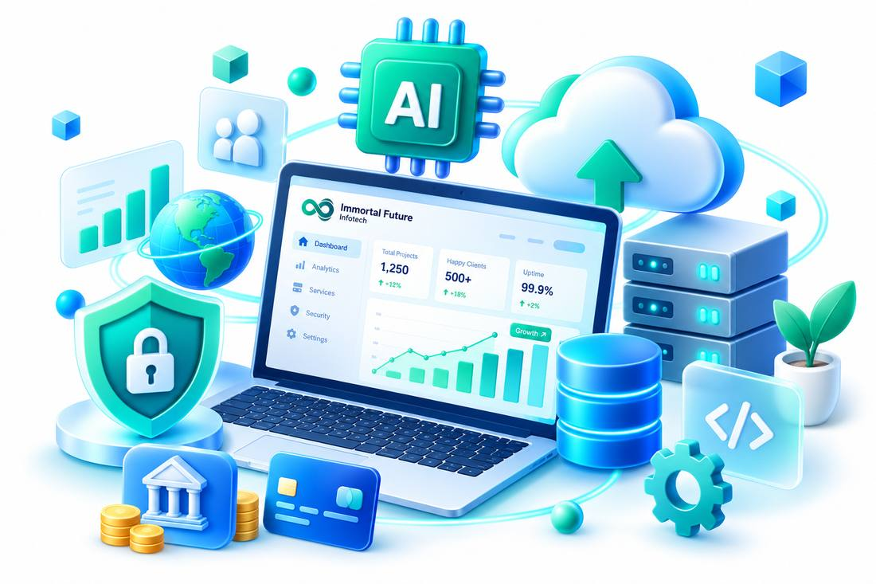
Placement: 500–650 px desktop.

AI & Banking — category-ai-banking.png

Placement: 180–250 px.

Cloud & Infra — category-cloud-infra.png

Placement: 180–250 px.

Development — category-development.png
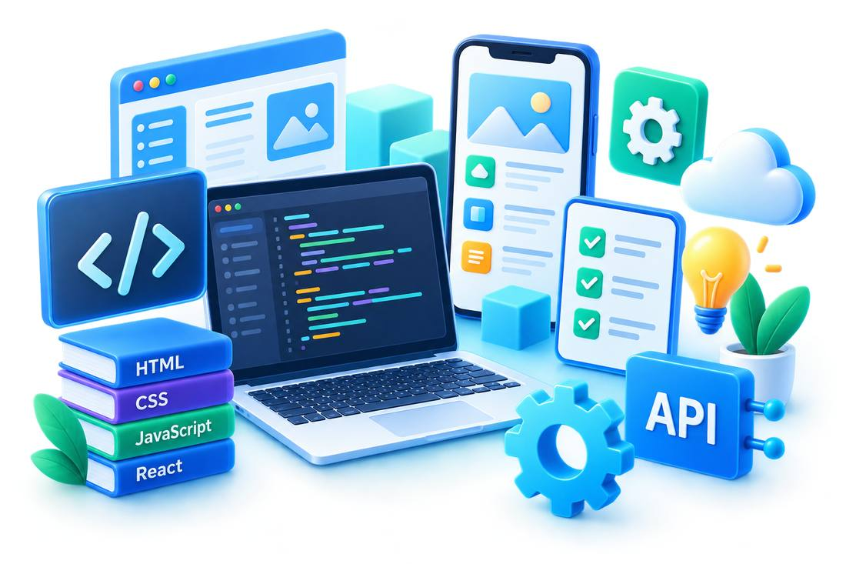
Placement: 180–250 px.

Business — category-business.png

Placement: 180–250 px.

CTA — services-cta-rocket.png

Placement: 250–350 px.

