AWS CLOUD COMPUTING LABORATORY
COMPLETE PRACTICAL DOCUMENTATION
Submitted by:
Name | Rithanya.S
Register Number | 722824148077
Class | III B CCT
Department | Artificial Intelligence and Machine Learning (AIML)
Academic Year | 2026–2027
Subject | AWS Cloud Computing Lab / Practical

TABLE OF CONTENTS
S.No | Question Title | Page
1 | Handling a 50× traffic increase for 24 hours on a website running on a single t2.micro instance | 3

Note: Only this question was available. The AWS question bank file was not received, so the remaining questions will be added in the same format once it is provided.

Question 1
Rithanya.S | 722824148077 | III B CCT | AIML | 2026–2027

1. Title
Scalable and highly available AWS architecture to handle a 50× temporary traffic surge for a website.

2. Aim
To design an AWS architecture using Route 53, CloudFront, an Application Load Balancer and EC2 Auto Scaling across two Availability Zones, so that a website running on one t2.micro instance can handle 50 times its normal traffic for 24 hours without downtime, and then scale back down to save cost.

3. Problem Description
- Scenario: A website runs on a single t2.micro EC2 instance. Traffic will rise 50× for 24 hours.
- Problem: A single small instance is a bottleneck (limited CPU credits, memory and network) and a single point of failure (one instance, one AZ).
- Requirements: high availability, automatic scaling, fast content delivery, security, controlled cost.
- Expected outcome: the site stays responsive during the surge, capacity grows and shrinks automatically.

4. Requirements
- Amazon Route 53 (DNS), Amazon CloudFront (caching/CDN), Amazon S3 (static assets).
- Application Load Balancer (ALB) with target group and health checks.
- Launch Template and EC2 Auto Scaling Group (minimum 2 AZs).
- Amazon CloudWatch metrics, alarms and scaling policies.
- VPC with public subnets (ALB) and private subnets (EC2); security groups; IAM role for EC2.
- Load-testing tool (for example Apache JMeter or Locust) for validation.

5. Cloud Infrastructure / Architecture Diagram
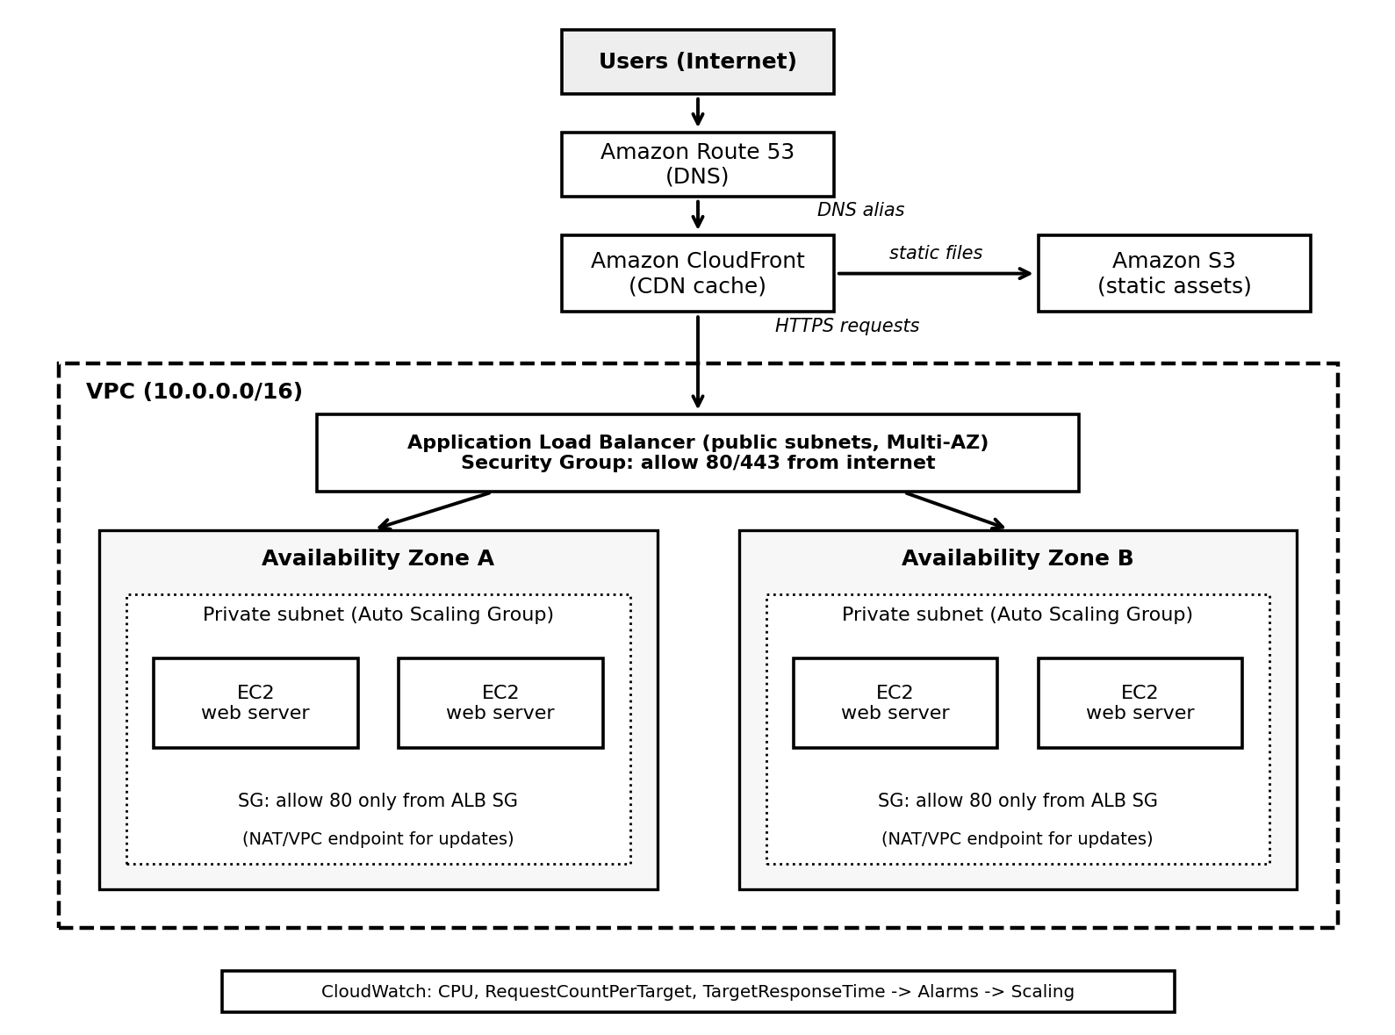
Figure 1: Highly available architecture for the traffic surge.
Role of main components:
- Route 53 – routes the domain name to CloudFront/ALB using an alias record.
- CloudFront – caches static and cacheable content at edge locations, reducing requests reaching EC2.
- S3 – stores images, CSS and JS served through CloudFront.
- ALB – spreads requests across healthy instances in both AZs and runs health checks.
- Auto Scaling Group – adds or removes EC2 instances automatically; replaces unhealthy ones.
- CloudWatch – collects metrics and triggers scaling alarms.
- Security groups – ALB accepts 80/443 from the internet; EC2 accepts traffic only from the ALB.

6. Procedure / Implementation Steps
- VPC: Open VPC console. Use a VPC with two public subnets (for ALB) and two private subnets (for EC2) in two different AZs. Add an Internet Gateway for the public subnets and a NAT gateway (or VPC endpoints) for the private subnets.
- Security groups: Create ALB-SG (inbound 80/443 from 0.0.0.0/0). Create EC2-SG (inbound 80 only from ALB-SG).
- S3: Create a private bucket and upload static assets. Keep Block Public Access on; give CloudFront access using Origin Access Control.
- AMI and Launch Template: Configure the web application on the existing instance, create an AMI from it, then create a Launch Template (AMI, instance type chosen after load testing, EC2-SG, IAM role, user data if needed). Avoid depending on t2.micro; use a larger or non-burstable type if tests show CPU credit exhaustion.
- Target group and ALB: Create a target group (HTTP:80) with a health check path such as /health. Create an internet-facing ALB in the public subnets and add a listener forwarding to the target group.
- Auto Scaling Group: Create the ASG from the Launch Template in both private subnets. Set minimum 2, desired 2, maximum based on load-test results. Attach the target group and enable ELB health checks with a health-check grace period matching application start-up time.
- Scaling policy: Add a target tracking policy, for example average CPUUtilization or ALBRequestCountPerTarget set to a value found through load testing. Optionally add a scheduled action to raise minimum capacity shortly before the expected surge.
- CloudFront: Create a distribution with the ALB as the dynamic origin and S3 as the static origin. Set cache behaviours so static paths are cached for longer.
- Route 53: Create an alias A record pointing the domain to the CloudFront distribution.
- CloudWatch: Create alarms for TargetResponseTime, HTTPCode_Target_5XX_Count, UnHealthyHostCount and CPUUtilization; set up a billing budget alert.
Console screens (illustrative mock-ups; placeholders shown in < >):
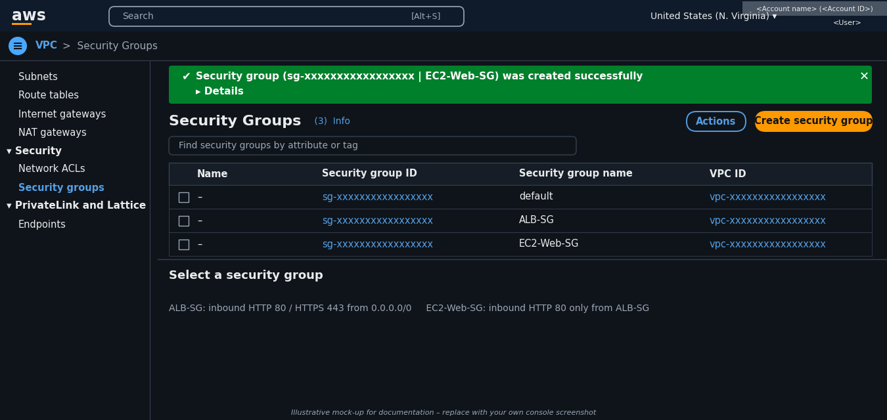
Figure 2: Security groups ALB-SG and EC2-Web-SG created
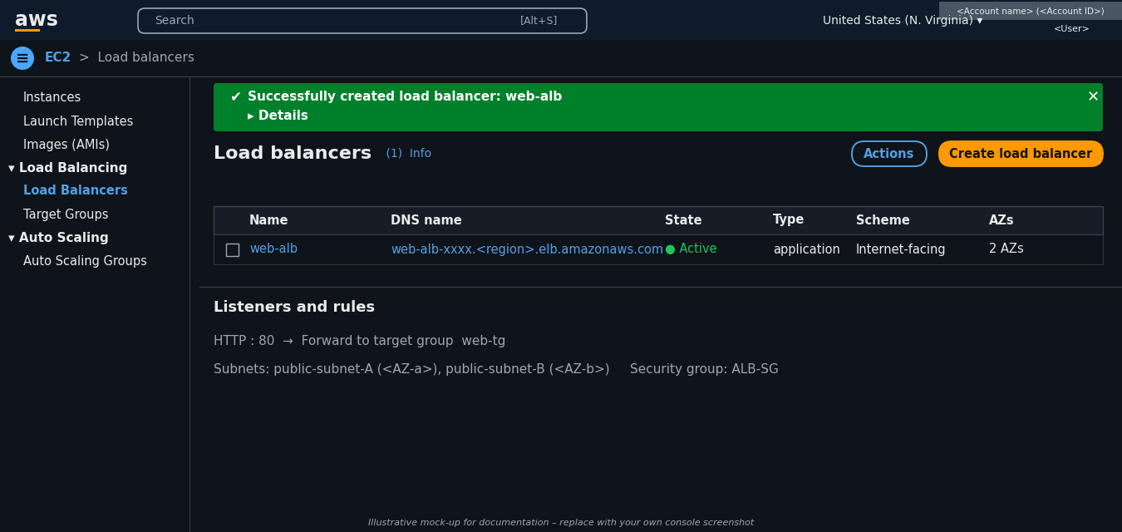
Figure 3: Application Load Balancer web-alb (Active)
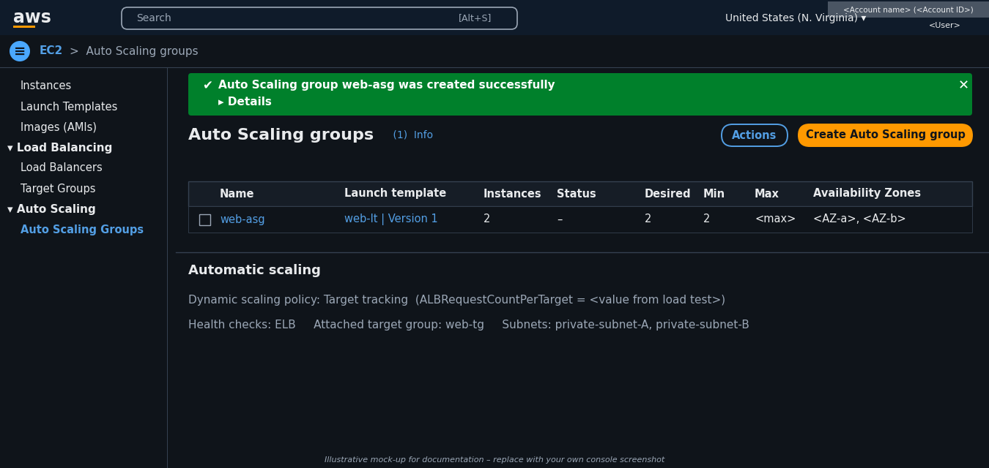
Figure 4: Auto Scaling group web-asg with scaling policy
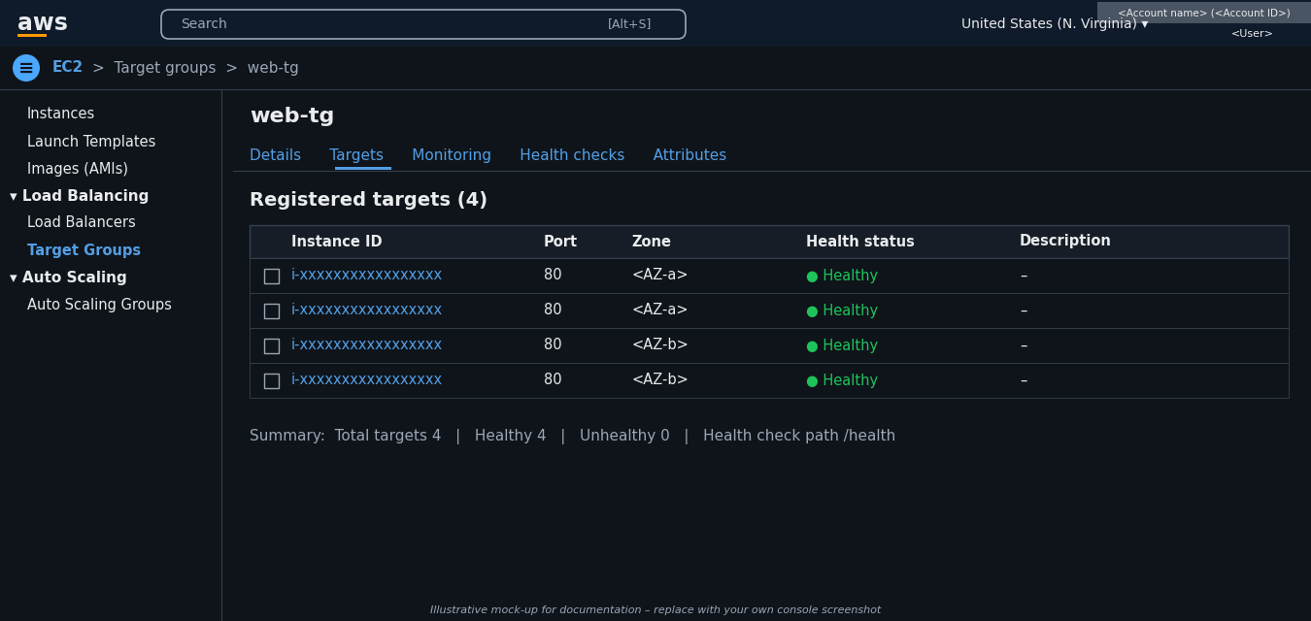
Figure 5: Target group web-tg with healthy targets in both AZs

7. Important Configurations
- Multi-AZ: at least two AZs so one AZ failure does not stop the site.
- Metrics: CPUUtilization, RequestCountPerTarget, TargetResponseTime.
- Thresholds, minimum/maximum capacity and instance type are not fixed values; they must be decided from load-test results.
- Health checks plus health-check grace period and instance warm-up prevent new instances from being counted or replaced too early.
- Scale-in cooldown/stabilization avoids repeated adding and removing of instances.
- Security: least-privilege IAM role, EC2 in private subnets, HTTPS with an ACM certificate, no credentials in code.
- Cost: cache more at CloudFront, use Auto Scaling instead of permanently large capacity, set a budget alarm.

8. Testing and Verification
- Check that the ALB target group shows all instances as Healthy in both AZs.
- Open the domain name in a browser and confirm the page loads through CloudFront.
- Run a load test, increasing requests step by step towards 50× normal traffic.
- In CloudWatch watch CPUUtilization, RequestCountPerTarget and TargetResponseTime; confirm the alarm fires and the ASG launches new instances (check Activity history).
- Stop one instance to confirm the ALB stops sending traffic to it and the ASG replaces it.
- After the surge, confirm the ASG scales in gradually, then lower the minimum/maximum back to normal values and delete temporary resources.

9. Expected Output / Result
Expected (not yet measured): the site stays available during the surge, response time stays within the acceptable limit, instances are added automatically when load rises and removed when it falls, and traffic continues if one AZ or instance fails. Actual figures can be recorded only after the load test is performed.

10. Conclusion
The single-instance bottleneck is removed by using CloudFront caching, an ALB and an Auto Scaling Group across two Availability Zones with CloudWatch-based scaling. This gives a scalable, available and cost-efficient solution for the 24-hour 50× traffic spike.

