**Solution Submission Template**

**CT/DT Number: CT20192633115**

**Contestant Name: RITHEESH Baradwaj YELLENKI**

**College Name: VNR Vignana Jyothi Institute of Engineering and Technology**

# Automatic Vehicle Number Plate

# Recognition

# Background

Automatic Vehicle Number Plate recognition (ANPR) plays a significant role in this busy world. Stealing of vehicles, unlimited increase of vehicles and transportation systems, coming into restricted space also are increasing linearly, thus the need for this approach is intended. It is a key technique in most of traffic related applications which is automated, fast, accurate and robust. Larger portion of vehicles nowadays are equipped with dash cameras, which continuously record and store traffic. Also, there are multiple cctv cameras placed along highways and other paths which are used by government and private organizations to monitor traffic activities, illegal activities. Also, the self-driving vehicles like Tesla use camera and few other sensors for automating driving and parking. Different types of methods and algorithms have been developed for Vehicle Number Plate recognition. This helps in prevention of accidents, better utilization of resources, automation and could lead to monetary gains. We use dash camera videos, relevant cctv footages and images to implement our algorithm.

# Your Understanding

 Number plate recognition systems are having varieties of application such as traffic maintenances, tracing stolen cars, automatic electronic Toll collection system etc. But the main aim is to control the traffic management system which can be achieved using ANPR.

ANPR is a computer vision technology that uses Optical Character Recognition (OCR) capable of reading vehicle number plates without human intervention using high-speed image capture to extract the license number of vehicles from those images. It supplies this information to a next stage of computer processing through which the information can be interpreted, stored or matched to create an ANPR based application. The major steps include detection of number plate, segmentation of characters and recognition of each characters, segmentation plays an important art, since the accuracy of recognition is based on how perfect the segmentation is done.

# Scope

# **The elements considered in the solution are:**

1. Camera (to capture the image required for the test)
2. ANPR model using OCR (Python) (Computer Software)
3. Test Data

The algorithm determines the position of the plate on the image taken by the camera and determine the characters on it by character analysis and then combine them. When the plate position is found and after the character analysis on the image, the pixel image processing methods are used. The output is shown in a window with the detected number plate.

# Out of Scope

 The solution does not consider the following elements:

1. Illumination
2. Frame Grabber
3. Hardware
4. Database

The solution is ready for an already stored image in database or newly update one.

# Assumptions

1. Users need to upload the test image and run the simulation(model) which involves steps (character recognition, segmentation etc.) and output will show in the form of a report. The present solution is assumed that images of the vehicle to be considered for the test are taken by webcam. Any Camera or Hardware components are not taken into consideration.
2. Due to the varying characteristics of the license plate from country to country like numbering system, colours, language of characters, style (font) and sizes of license plate, further research is still needed in this area.

# Solution Approach

 The Automatic Number Plate Recognition with OCR is computer vision technology which works by capturing the images and detecting the license numbers on the plate. This involves simply highlighting the numbers on the image and separating them from the other objects on the screen.

For a system of the automatic number plate recognition with OCR, it needs to have four algorithm processes to detect the plate data properly.

The first algorithm would be the plate extraction where the captured image is in capital RGB format which is converted into grayscale image into binary image.

 The second would be the Character Segmentation. This stage is meant for segmentation of the characters from the plate. The output of this stage is a set of monochrome images for each candidate character in plate. This part will divide the character individually from the extracted number plate. After getting input image the first process is to crop out the whole number plate characters leaving all the extra wide spaces from top to below and from right to left as it is. Characters need to be equally fit in the plate region. The result is normalized into the character set as the size of the images in the database for better comparison.

Next would be Optical Character Recognition in which the input would be an image and the output is a string of characters. OCR is a process which separates the different characters from each other taken from an image. Template matching is one of the approaches of OCR. The cropped image is compared with the template data stored in database. OCR automatically identifies and recognizes the characters without any indirect input. The characters on the number plate have uniform fonts then the OCR for number plate recognition is less complex as compared to other methods.

Also Pre-Processing can be used to enhance the input image and making it more suitable for the next processing steps.

The proposed solution is:

1. Capturing the image approximately one meter from the number plate with camera. The purpose is to get a clear image without distortion.
2. Cropping the number plate from captured image by Plate Extraction algorithm. The cropped image is the input for the Character Recognition.
3. OCR technique is used to recognize the character.

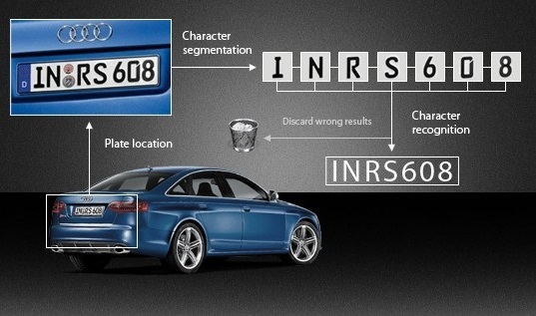

# Implementation Framework

Software requirements:

1. Should support Open-CV, Framework.
2. Libraries required: tkinter (to display text or image), PIL, OS, NumPy, imutils.
3. Online capturing of the images of the vehicles number plates.
4. Online optical character recognition (OCR) of the captured vehicles number plates.
5. Restart of the ANPR application or Reboot of the operating system.

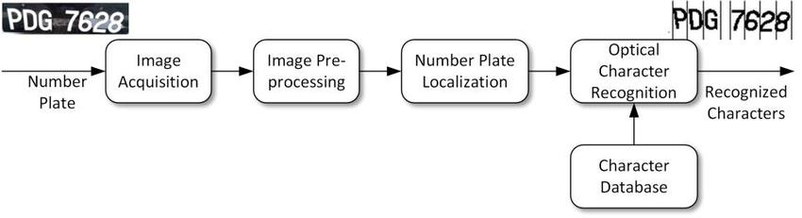

1. Solution Submission

<https://github.com/RitheeshBaradwaj/VehicleNumberPlateRecognition.git>

1. Appendix

APPENDIX A

**Publications:**

1. Amri Mohd Yasin, Mohamed Rehan Karim, Ahmad Saifizul Abdullah (2008). Algorithm Development for Automatic Number Plate Recognition System. EASTS International Symposium on Sustainable Transportation incorporating Malaysian Universities Transportation Research Forum Conference 2008(MUTRFC08). 12 - 13 August 2008
2. Amri Mohd Yasin, Mohamed Rehan Karim, Ahmad Saifizul Abdullah (2009). Development of Automatic Number Plate Recognition Software for Malaysian Environment. Proceeding of International Conference for Technical Postgraduate 2009 (TECHPOS 2009). 14 – 15 December 2009.
3. References
4. <https://blog.devcenter.co/developing-a-license-plate-recognition-system-with-machine-learning-in-python-787833569ccd>
5. <https://pdfs.semanticscholar.org/1b86/f3a3589239e4cd50464e1e0a772613a688fc.pdf>
6. <https://www.pyimagesearch.com/2018/09/17/opencv-ocr-and-text-recognition-with-tesseract/>