Company Campus Network
Network Design & Implementation Report
using Cisco Packet Tracer

1. Overview
This report documents the design of a multi-floor company local area network (LAN) built and simulated in Cisco Packet Tracer. The network spans a Ground Floor, First Floor, Second Floor, and a dedicated Server Room, connected through a central router and distribution-layer switching. Each department or functional zone is isolated on its own VLAN with its own IP subnet and DHCP-assigned addressing, enabling logical segmentation, controlled inter-VLAN routing, and simplified administration.

2. Network Topology
The overall physical and logical layout of the network is shown below.
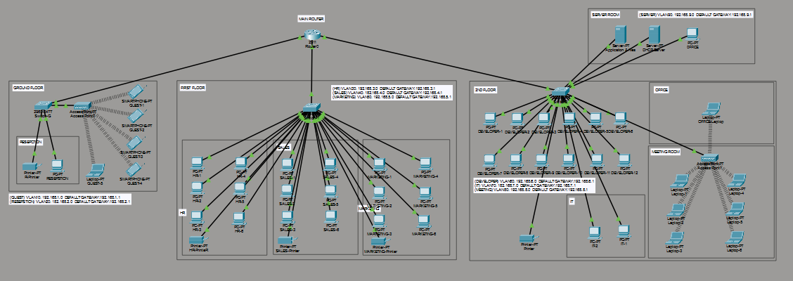

2.1 Core Devices
- MAIN ROUTER — central router providing inter-VLAN routing and uplink to the Server Room, Ground Floor, First Floor, and Second Floor distribution switches.
- A multilayer/distribution switch on the First Floor handles routing and switching for HR, Sales, and Marketing VLANs.
- A distribution switch on the Second Floor connects Developer workstations, the IT area, the Office, and the Meeting Room wireless access point.
- A Ground Floor switch connects Reception and a wireless access point serving Guest Wi-Fi clients.
- The Server Room hosts an Application Server and a DHCP Server on their own VLAN, uplinked directly to the main router.

3. VLAN & IP Addressing Scheme
Each zone is assigned a dedicated /24 subnet with the router (or multilayer switch, where applicable) acting as the default gateway for that VLAN.
Department / Zone | VLAN Subnet | Default Gateway | Floor / Location
Guest Wi-Fi | 192.168.1.0/24 | 192.168.1.1 | Ground Floor
Reception | 192.168.2.0/24 | 192.168.2.1 | Ground Floor
HR | 192.168.3.0/24 | 192.168.3.1 | First Floor
Sales | 192.168.4.0/24 | 192.168.4.1 | First Floor
Marketing | 192.168.5.0/24 | 192.168.5.1 | First Floor
Developers | 192.168.6.0/24 | 192.168.6.1 | Second Floor
IT | 192.168.7.0/24 | 192.168.7.1 | Second Floor
Meeting Room | 192.168.8.0/24 | 192.168.8.1 | Second Floor
Server Farm | 192.168.9.0/24 | 192.168.9.1 | Server Room

4. Floor-Wise Breakdown

4.1 Server Room
Connects directly to the main router, outside the departmental switching layer.
Device | Role
Server-PT (Application Server) | Hosts company application services
Server-PT (DHCP Server) | Issues DHCP leases to network clients
PC-PT (office) | Which have access of entire network

4.2 Ground Floor
Serves Reception staff and Guest Wi-Fi users via an access switch and a wireless access point.
Device | Role
Reception PC + Printer | Front-desk workstation and shared printer, on the Reception VLAN
Wireless Access Point | Provides Guest Wi-Fi to visitor laptops (Guest VLAN)
Guest Laptops (x4) | Visitor devices connected wirelessly to the Guest VLAN

4.3 First Floor
A multilayer switch distributes traffic to three department groups, each wired to its own access switch segment.
Department | Endpoints
HR | 6 PCs (HR-1 to HR-6) + shared printer
Sales | 6 PCs (Sales-1 to Sales-6) + shared printer
Marketing | 6 PCs (Marketing-1 to Marketing-6) + shared printer

4.4 Second Floor
The largest segment, hosting the Developer team, IT support, a private Office, and a Meeting Room with wireless access.
Zone | Endpoints
Developers | Multiple developer workstations (Developer-1 through Developer-10) on the Developer VLAN
IT | IT support PCs and a shared printer on the IT VLAN
Office | A dedicated office laptop
Meeting Room | Wireless access point serving 4 laptops for meetings, on the Meeting VLAN

5. Design Notes
- Each VLAN is scoped to its own /24 network with the gateway address ending in .1, keeping addressing consistent and easy to remember across departments.
- Wireless zones (Guest Wi-Fi and Meeting Room) are kept on separate VLANs from wired department traffic to limit broadcast domains and improve security isolation.
- DHCP services are centralized in the Server Room so all VLANs receive address leases from a single, dedicated server.
- The topology follows a hierarchical design: a core router at the top, a multilayer switch for inter-VLAN routing on busier floors, and access-layer switches/access points closest to end devices.

6. Conclusion
The simulated network provides logical separation between departments, guests, servers, and shared infrastructure, while remaining centrally routed and manageable from a single main router. This design can be extended with additional floors, VLANs, or redundancy (e.g., a second uplink or router) as the organization grows.

