EduMatrix: Institutional Academic and Placement Intelligence System
Adithya C S¹, Manikanta¹, Pushanth S B¹, Rithesh N D¹, Nidhishree M P²
¹Department of Artificial Intelligence and Machine Learning,
²Assistant Professor, Department of Artificial Intelligence and Machine Learning,
Vivekananda College of Engineering and Technology, Puttur, Karnataka, India
Email: pushanthsb@gmail.com

Abstract—In higher educational institutions, academic notices, examination schedules, and placement updates are often shared through fragmented channels, causing missed deadlines and administrative delays. To solve this, EduMatrix is developed—a centralized institutional platform integrating academic communication with automated document and placement intelligence. Built using React and FastAPI, the system provides role-based dashboards for students, faculty, HODs, and placement officers. It employs OCR and text processing to extract schedules and deadlines from uploaded circulars, while an ATS-based resume module evaluates student profiles against job criteria to identify skill gaps. Real-time messaging and notifications via WebSockets, ensure prompt communication, significantly reducing manual coordination across departments.
Keywords—Academic Management, Placement Intelligence, OCR, Resume Parsing, ATS Scoring, Role-Based Access Control, FastAPI, React, WebSocket.

Introduction
Higher educational institutions face persistent communication gaps due to uncoordinated channels. Academic notices, internal exam schedules, and placement notifications are frequently shared across informal messaging groups, emails, and physical notice boards. This decentralized approach leads to missed deadlines, scheduling conflicts in faculty exam duty allocation, and high administrative overhead during manual placement screening. To solve these challenges, EduMatrix is developed as a centralized institutional intelligence system that combines academic management, document processing, and placement support into a unified web platform. Built using React and FastAPI, it provides secure, role-based dashboards for students, faculty, HODs, and placement officers. The system automates circular parsing, invigilation duty assignment, and student resume evaluation, bridging institutional administration with automated student career support.
Several studies have utilized machine learning and Natural Language Processing (NLP) to streamline institutional workflows. Swami et al. [1] and Sai Hitharth and Dhanya [2] applied ensemble models including Random Forest and Gradient Boosting to identify academic indicators linked to placement outcomes. For resume parsing, Adap et al. [3] and Wings et al. [4] extracted technical competencies from unstructured CVs to automate candidate-job matching. Furthermore, Palshikar et al. [5] introduced entity-extraction pipelines to process diverse resume layouts without manual screening.
In automated academic scheduling and support, Elizabeth Rani et al. [6] used neural networks on timetable data to automate class intimation without manual faculty intervention.
Additionally, Kathole et al. [7] and Okonkwo and Ade-Ibijola [8] showed that NLP models and conversational agents provide rapid query resolution for institutional schedules, exams, and syllabi. Integrating these techniques, EduMatrix unifies document intelligence, placement analytics, and real-time interaction into a single platform.
By going through these literature survey, we have implemented objectives as follows:
- Timetable and Circular Processing- Automatically extracts examination dates, subjects, timings, and deadlines from uploaded circulars and timetables using OCR and text processing.
- Faculty Examination Duty Management- Assists HODs in assigning invigilation duties, identifying timetable scheduling conflicts, and notifying faculty members.
- Resume ATS Scoring and Skill-Gap Analysis- Parses uploaded student resumes, extracts technical skills and project details, evaluates them against placement requirements, and provides an ATS score with skill-gap recommendations.
- Real-Time Communication and Reminders-Delivers instant in-app alerts, deadline reminders (upcoming, due today, missed), and student-faculty messaging using WebSocket communication.
- Role-Based Institutional Dashboards- Provides dedicated, secure web interfaces for Students, Faculty, HODs, Placement Officers, and Administrators with role-based access control.

Methodology
The operational effectiveness of EduMatrix depends on the processing and integration of heterogeneous institutional data. To support automated academic management, exam duty allocation, and intelligent placement analysis, multiple data components were collected and structured. These include unstructured academic circulars, examination timetables, faculty rosters, candidate resumes in PDF format, and company job requirement descriptions.

Dataset
The system processes multiple data types across its academic and placement modules. For the academic management module, a collection of institutional documents-such as circulars, examination timetables, holiday notices, and internal test schedules-was gathered in both PDF and image formats. For the placement intelligence module, student resumes across different engineering disciplines were assembled, containing educational credentials, technical skills, certifications, and project descriptions. In addition, recruitment criteria and job descriptions from multiple hiring companies were structured into required skill sets, eligibility criteria, and minimum CGPA thresholds. Departmental faculty lists, course codes, and semester schedules were also organized to establish baseline records for examination duty scheduling and conflict detection. Data across documents, student profiles, and placement records were sanitized, normalized, and validated to ensure reliable information extraction and role-based presentation.

Preprocessing
The input to the system consists of uploaded PDF or image documents, including examination timetables, circulars, and student resumes. For uploaded image circulars and scanned timetables, preprocessing is conducted using OpenCV for grayscale conversion, adaptive thresholding, and noise removal. The cleaned document images are then passed to Tesseract OCR to extract raw textual content. Regular expressions and text-parsing routines identify and structure critical entities such as dates, session timings, course codes, and deadlines. For student resumes, textual data is parsed from PDF files, converted to lower case, and stripped of punctuation and common stop words. Technical keywords, frameworks, and programming proficiencies are mapped against a predefined technical taxonomy to generate a student skill vector. To evaluate candidate compatibility against company recruitment requirements, the similarity between the student profile vector and the target job requirement vector is calculated using the cosine similarity measure:
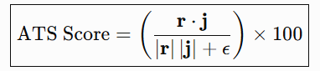
where r represents the extracted student resume feature vector, j represents the company job requirement vector, and ε prevents division by zero.

Implementation

Table 1: Model Comparison

Parameter | Table Transformer | Resume Parser (LayoutLMv3) | Intent Classifier (BERT) | Sentiment Classifier
Model Type | Vision Transformer | Multimodal Document NLP | Fine-tuned Transformer | Deep Learning NLP
Train / Test (%) | 96.50 / 94.20 | 96.20 / 93.90 | 97.80 / 95.60 | 95.40 / 93.10
Task Focus | Timetable Extraction | ATS Resume Parsing | Query Intent Routing | Feedback Polarity
Key Advantage | Grid boundary detection | Multi-column skill parsing | Fast student query routing | Accurate sentiment scoring
Table 2: Hardware and Software Requirements
Component | Category | Specification / Tool
Hardware | Processor | Intel Core i5 / AMD Ryzen 5 or higher
 | Memory (RAM) | 8 GB minimum (16 GB recommended)
 | Storage | 20 GB SSD available storage
Software | Operating System | Windows 10/11 or Ubuntu 20.04+
 | Frontend | React.js, Vite, Tailwind CSS, Zustand
 | Backend API | Python 3.10+, FastAPI, WebSockets
 | Database & Cache | PostgreSQL 15, SQLAlchemy, Redis
 | AI / ML Frameworks | PyTorch, HuggingFace, spaCy, OpenCV

Workflow Description
The complete workflow of EduMatrix follows a step-by-step process that begins with user authentication and document ingestion, ending with AI-assisted analysis and role-based visualization:
- User Authentication and Role Dispatch:
The user logs into the system through the React and Vite frontend. The FastAPI backend verifies credentials using secure JWT token authentication and directs the user to their respective dashboard (Student, Faculty, HOD, Placement Officer, or Admin) based on assigned role permissions.
- Document Upload and Ingestion:
Authorized users upload institutional documents such as circulars, examination timetables, and student resumes in PDF or image format. The backend registers document metadata in PostgreSQL and queues files for processing.
- Table Detection and Extraction (Table Transformer):
Uploaded examination timetables and duty schedules are analyzed using the Table Transformer model. It identifies table boundaries, rows, and columns, enabling accurate extraction of subject codes, examination dates, and session timings from complex layouts.
- Resume Parsing and ATS Scoring (LayoutLMv3/spaCy):
When a student uploads a resume, the document is processed by the Resume Parser using LayoutLMv3 and spaCy NLP. It extracts education, projects, and technical skills into structured profiles, calculates an ATS match score against active job descriptions using vector similarity, and flags missing skill gaps.
- Query Processing and Intent Classification (BERT):
Student inquiries and messages submitted through the platform are classified by the BERT-based Intent Classifier. The model identifies the specific query category (such as examination schedules, internal marks, or placement eligibility) to provide immediate, automated guidance.
- Feedback and Sentiment Analysis:
Student messages and academic feedback are evaluated by the Sentiment Classifier to assess tone and urgency. This enables the administration to identify critical concerns and prioritize student support requests.
- Real-Time Notification and Dashboard Visualization:
Extracted examination schedules, assigned faculty invigilation duties, placement drive alerts, and ATS scores are broadcast via WebSockets. The results are displayed dynamically on the respective role-based dashboards for interactive tracking.
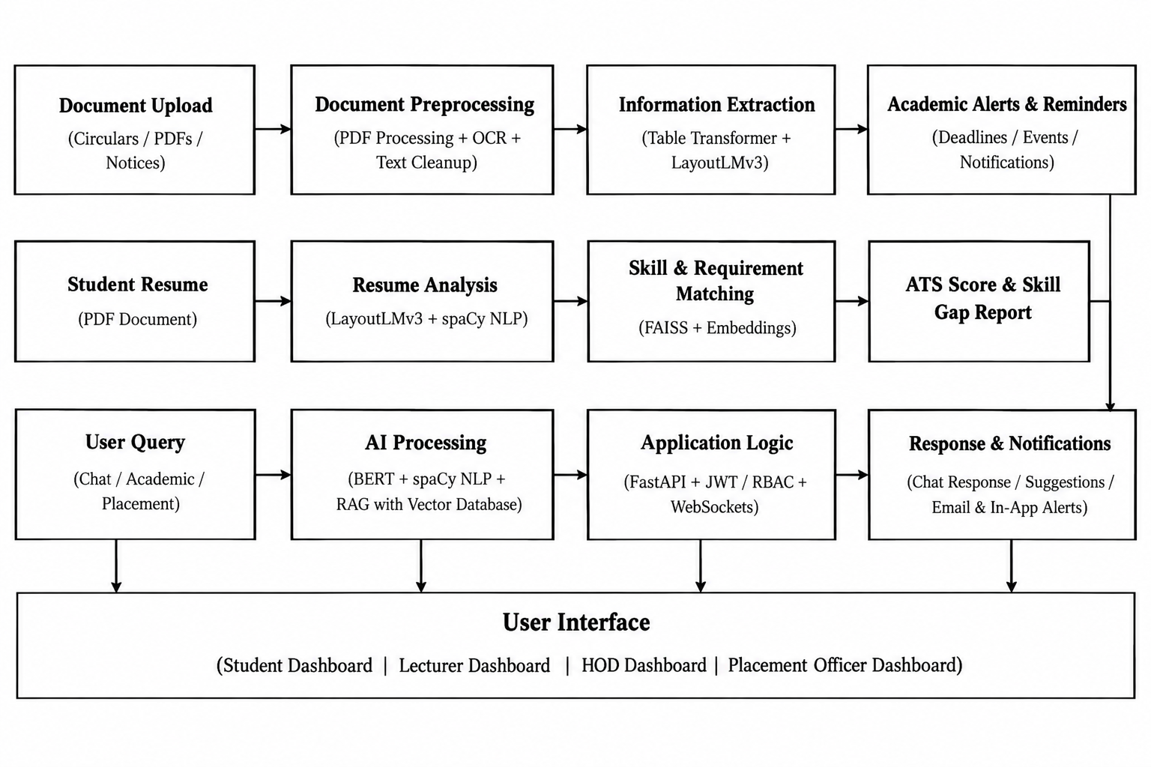
Fig. 1: Block Diagram of the EDUMATRIX System

RESULTS AND DISCUSSION

EduMatrix is an intelligent institutional academic and placement platform integrating machine learning, document processing, and real-time web services. The Table Transformer model detects tabular boundaries from uploaded circulars and extracts examination schedules, automatically assigning faculty invigilation duties through the HOD interface (Fig. 4). For placement assistance, the Resume Parser extracts candidate credentials and technical proficiencies to generate an objective ATS match score and highlight detected skills (Fig. 2). The placement dashboard centralizes institutional recruitment by tracking company drives, job openings, and candidate applications (Fig. 3). Furthermore, an automated reminder module tracks institutional timelines and displays categorized deadline alerts (Fig. 5). Overall, EduMatrix provides centralized communication, automated document extraction, and data-driven placement preparation through a unified web platform.

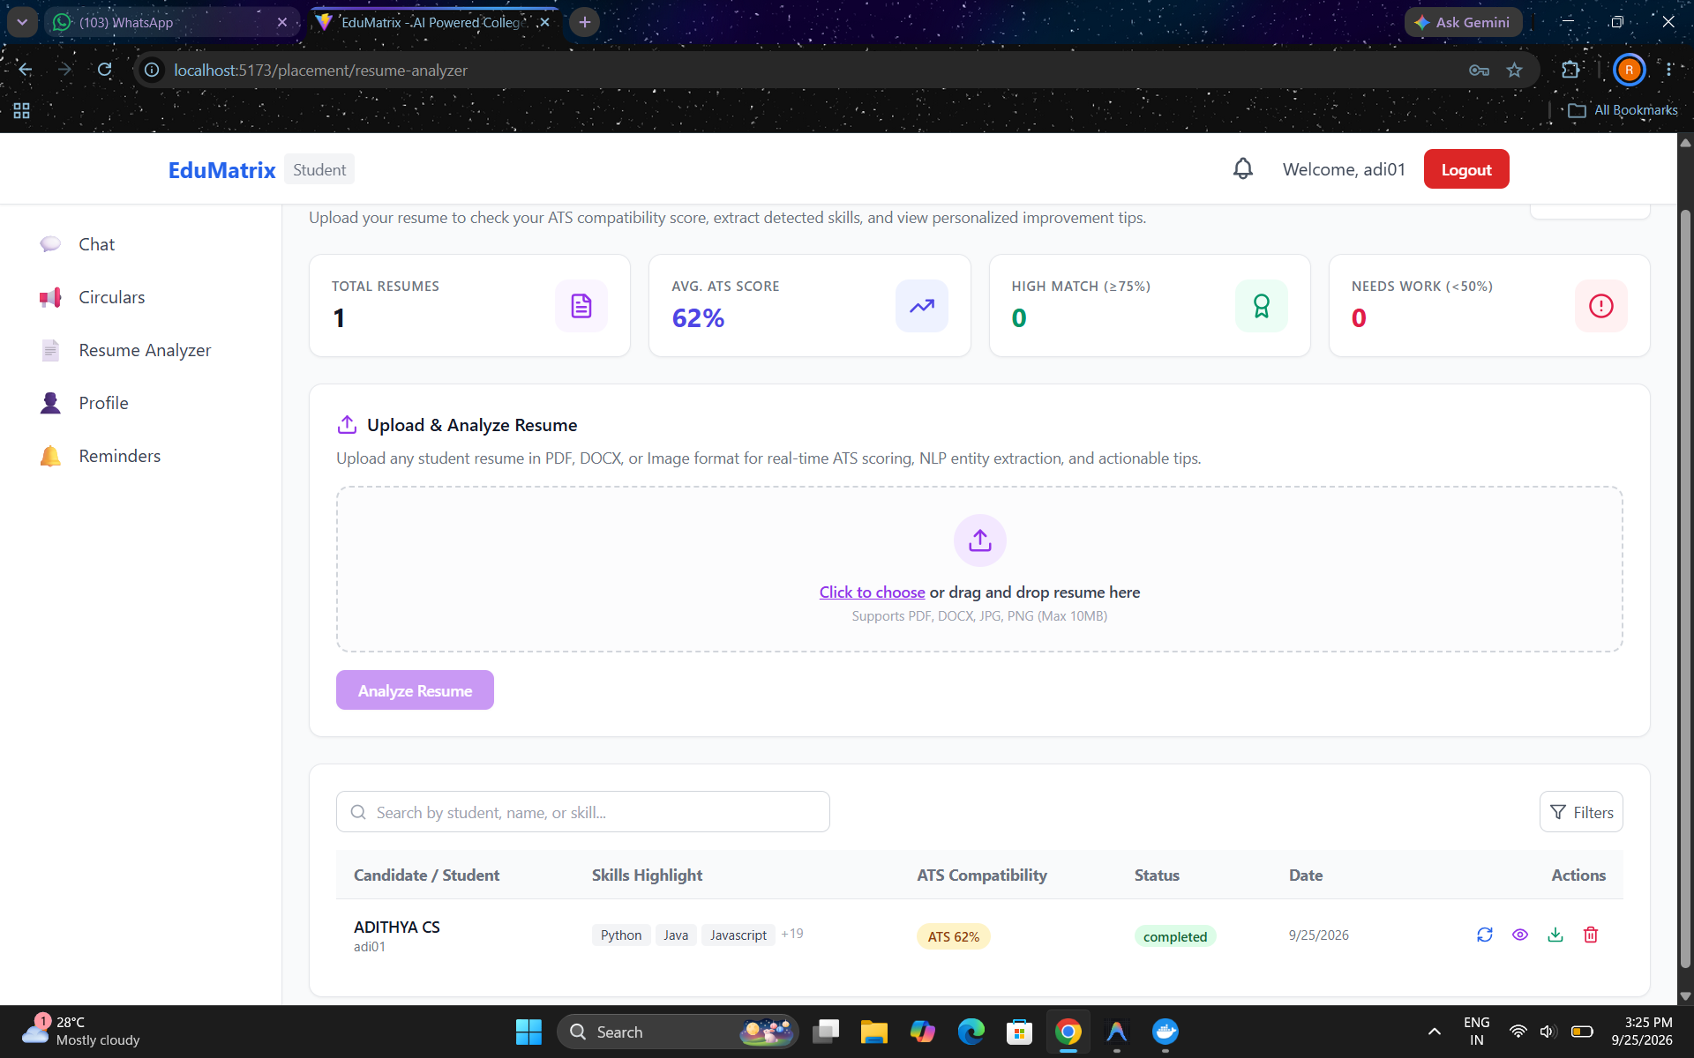
Fig. 2: AI Resume Analyzer and ATS Scoring Interface

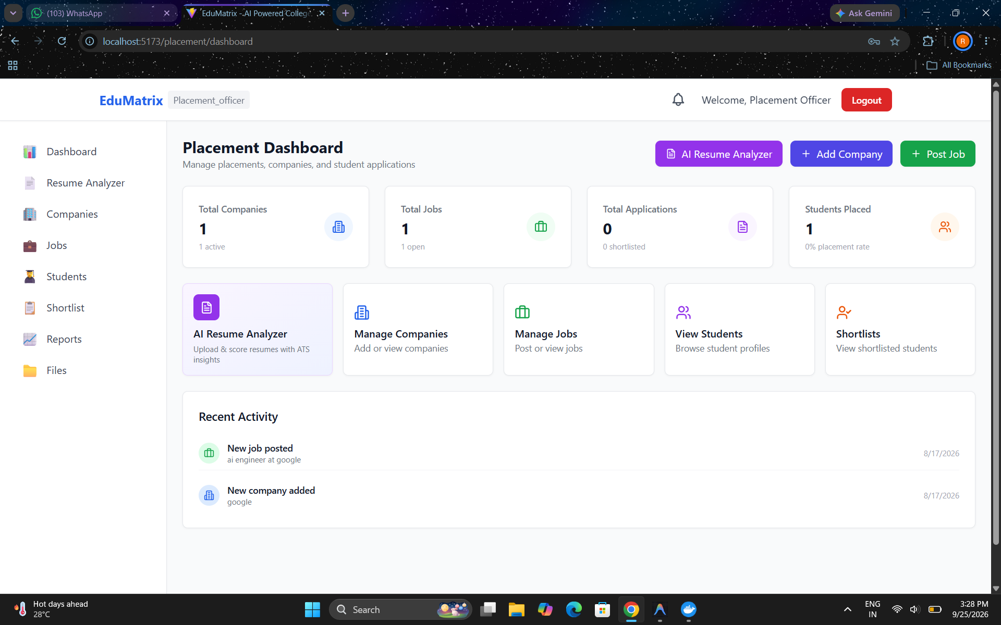
Fig. 3: Placement Officer Dashboard

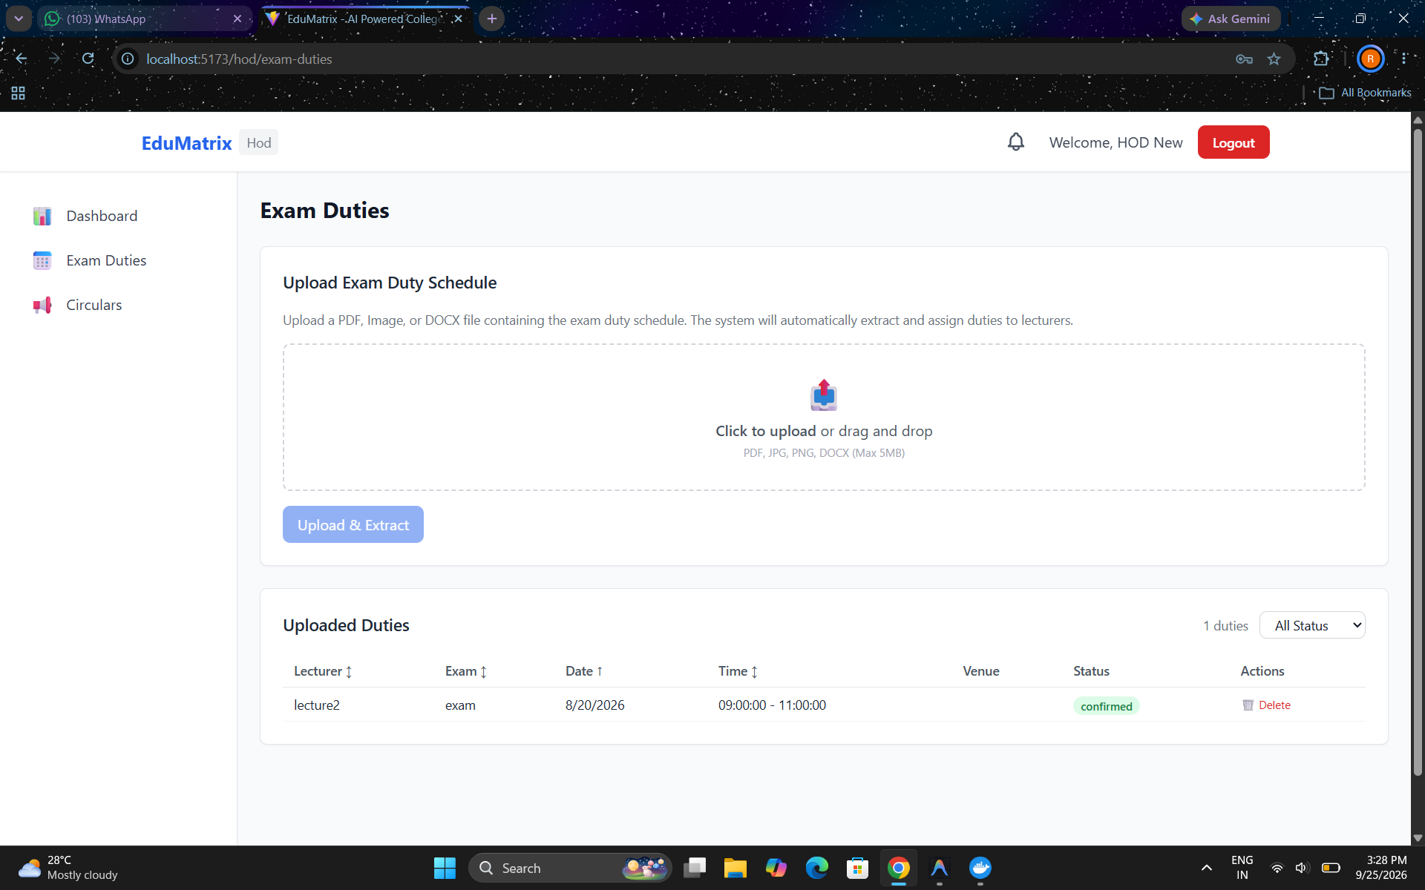 Fig. 4: HOD Examination Duty
Extraction and Allocation Interface

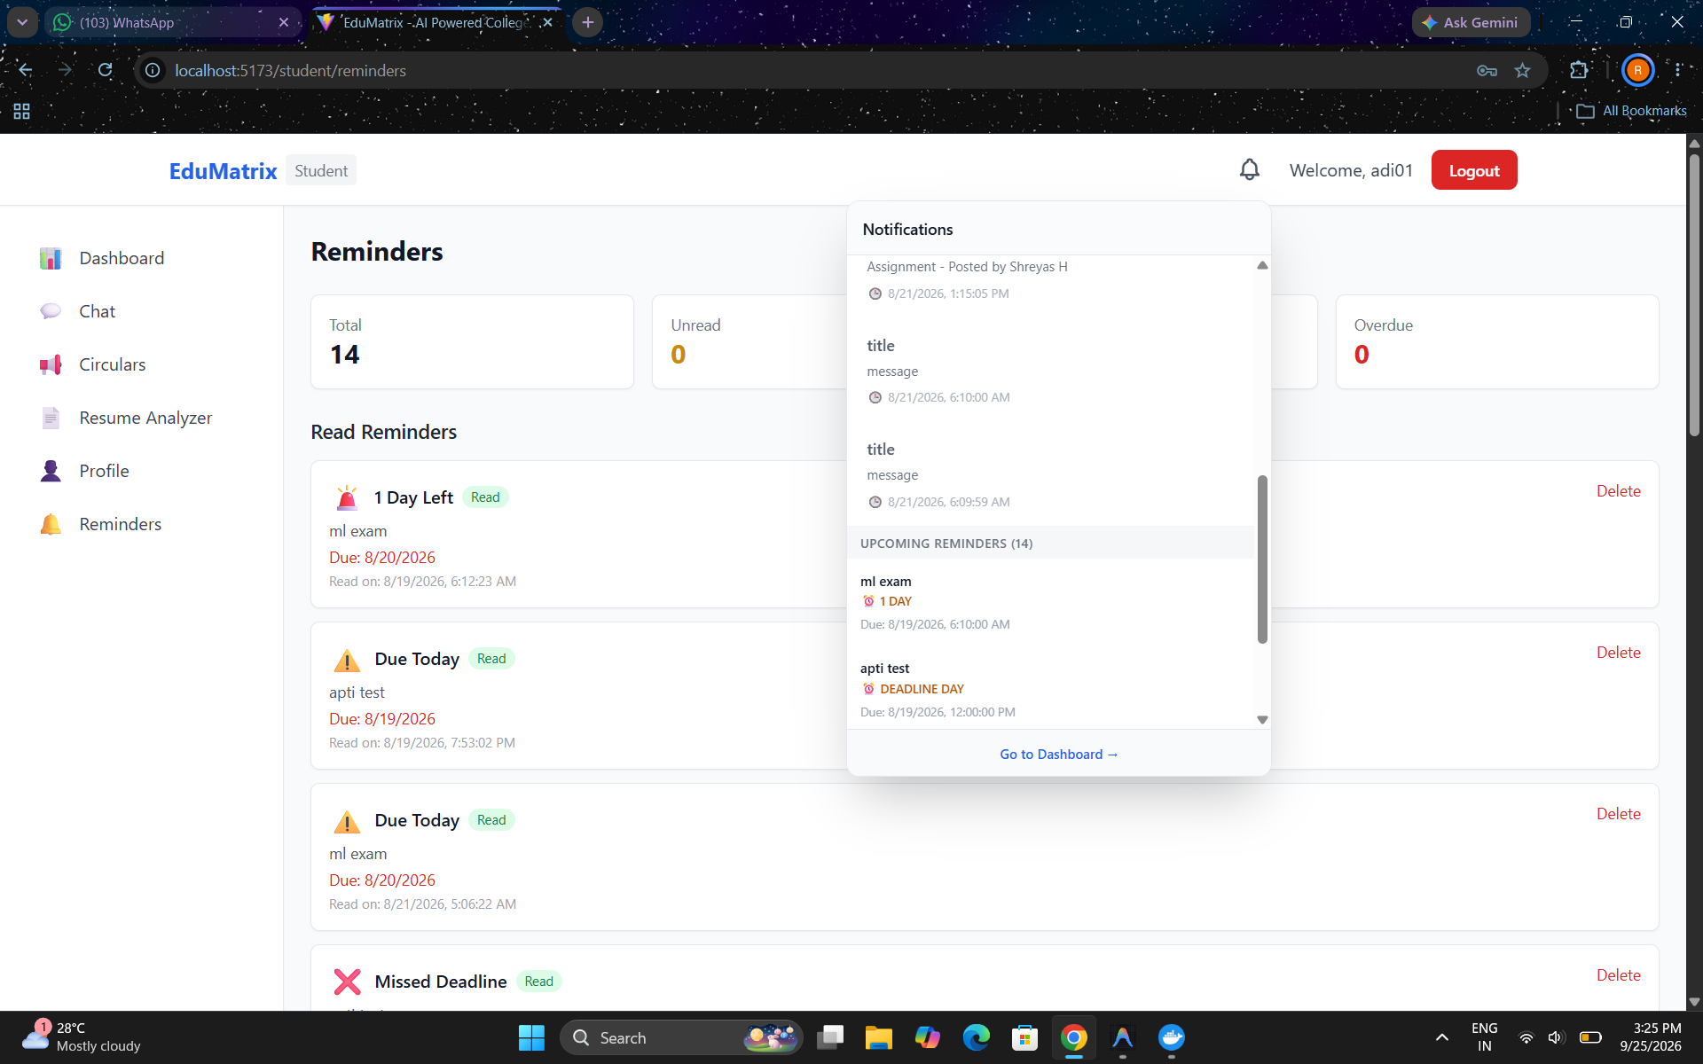
Fig. 5: Reminders & Deadline Notification Module

Conclusion
EduMatrix successfully provides an intelligent, centralized platform for institutional academic management and automated placement intelligence using FastAPI, React, and integrated machine learning models. By automating timetable circular extraction, faculty examination duty allocation, and ATS-based resume analysis with skill-gap identification, the system significantly reduces manual administrative workload and prevents communication delays. Overall, it delivers an accessible, role-based digital solution for streamlining campus operations and improving student placement readiness.

Acknowledgement
We express our heartfelt gratitude to Prof. Radhika Shetty D S, Head of the Department of Artificial Intelligence and Machine Learning, for her continuous support, leadership, and encouragement throughout this project.
We also extend our sincere appreciation to our project guide, Prof. Nidhishree M P, Assistant Professor, Department of Artificial Intelligence and Machine Learning, for her invaluable guidance, constructive feedback, and mentorship during the development of this work.

References
- T. Nguyen, P. Le, and T. Vo, “Skill extraction from job postings and resumes using LLMs,” IEEE Access, vol. 11, pp. 84210–84223, 2023, doi: 10.1109/ACCESS.2023.3298412
- L. Labadze, M. Grigolia, and L. Machaidze, “Role of AI chatbots in education: Systematic review,” Int. J. Educ. Technol. High. Educ., vol. 20, no. 56, 2023, doi: 10.1186/s41239-023-00426-1
- V. Swami, A. Sharma, and R. Joshi, “Student placement readiness prediction using ML algorithms,” Int. J. Inf. Educ. Technol., vol. 13, no. 5, pp. 789–796, 2023, doi: 10.18178/ijiet.2023.13.5.1874
- S. Kathole, S. Pote, and M. Gunde, “Intelligent student query handling and intent classification using DL and NLP,” in Proc. IEEE ICAAI, 2022, pp. 112–117, doi: 10.1109/ICAAI55818.2022.9862341
- R. Roslan and Y. Chen, “EDM techniques for predicting student academic performance: A review,” IEEE Trans. Learn. Technol., vol. 15, no. 4, pp. 512–525, 2022, doi: 10.1109/TLT.2022.3185074
- J. Zhang, H. Gao, and Y. Liu, “Review of student performance prediction via ML and EDM,” Comput. Educ. Artif. Intell., vol. 3, Art. no. 100068, 2022, doi: 10.1016/j.caeai.2022.100068
- A. Ertuğrul, N. Erdil, and C. Keskin, “A systematic review of job recommender systems,” Inf. Process. Manage., vol. 59, no. 3, Art. no. 102924, 2022, doi: 10.1016/j.ipm.2022.102924
- S. Batool, J. Rashid, and M. Nisar, “Educational data mining to predict students’ academic performance,” IEEE Access, vol. 9, pp. 90214–90231, 2021, doi: 10.1109/ACCESS.2021.3090425
- E. Wings, K. Bauer, and M. Leyer, “Context-aware extraction of hard and soft skills from resumes,” Comput. Ind. Eng., vol. 162, Art. no. 107725, 2021, doi: 10.1016/j.cie.2021.107725
- P. S. Hitharth and S. Dhanya, “Predicting engineering graduate employability using ensemble ML,” Int. J. Comput. Appl., vol. 183, no. 14, pp. 35–41, 2021, doi: 10.5120/ijca2021921478
- F. Okonkwo and A. Ade-Ibijola, “Chatbots in education: Applications, challenges, and benefits,” Comput. Educ. Artif. Intell., vol. 2, Art. no. 100031, 2021, doi: 10.1016/j.caeai.2021.100031
- G. Palshikar, M. Pawar, and N. Ramrakhiyani, “RINX: Information extraction from resumes,” J. Intell. Inf. Syst., vol. 55, no. 3, pp. 483–509, 2020, doi: 10.1007/s10844-020-00609-3
- R. Adap, A. Bhole, and K. Patil, “Intelligent college placement system using resume parsing,” in Proc. IEEE ICCMC, 2020, pp. 620–625, doi: 10.1109/ICCMC48092.2020.9130644
- I. Lahoud, H. Daher, and D. Gomez, “Recommender systems for higher education career guidance,” in Proc. IEEE EDUCON, 2020, pp. 1294–1301, doi: 10.1109/EDUCON45650.2020.9125345
- S. Elizabeth Rani, R. Malathy, and K. Shanmugam, “Automated timetable intimation system using ANN,” Procedia Comput. Sci., vol. 165, pp. 412–418, 2019, doi: 10.1016/j.procs.2020.01.037
- M. Acuna, J. Tan, and G. Ramos, “MARA: Academic reminder and deadline notification system,” Int. J. Interact. Mob. Technol., vol. 13, no. 8, pp. 54–65, 2019, doi: 10.3991/ijim.v13i08.10624

