# Cryptocurrency Analysis Report

## 1. Top 5 Cryptocurrencies by Market Capitalization

Bitcoin: $1,937,661,824,737

Ethereum: $419,723,201,776

Tether: $139,264,580,749

XRP: $131,156,323,585

BNB: $102,506,909,400

## 2. Average Price of Top 50 Cryptocurrencies

The average price of the top 50 cryptocurrencies is $4,327.80.

## 3. 24-hour Price Change Analysis

Cryptocurrency with the highest 24-hour percentage change: Bitget Token (bgb): 13.24%.

Cryptocurrency with the lowest 24-hour percentage change: Sui (sui): -1.01%.

## 4. EDA Visualizations

**1) Data Distribution (Histograms) :**

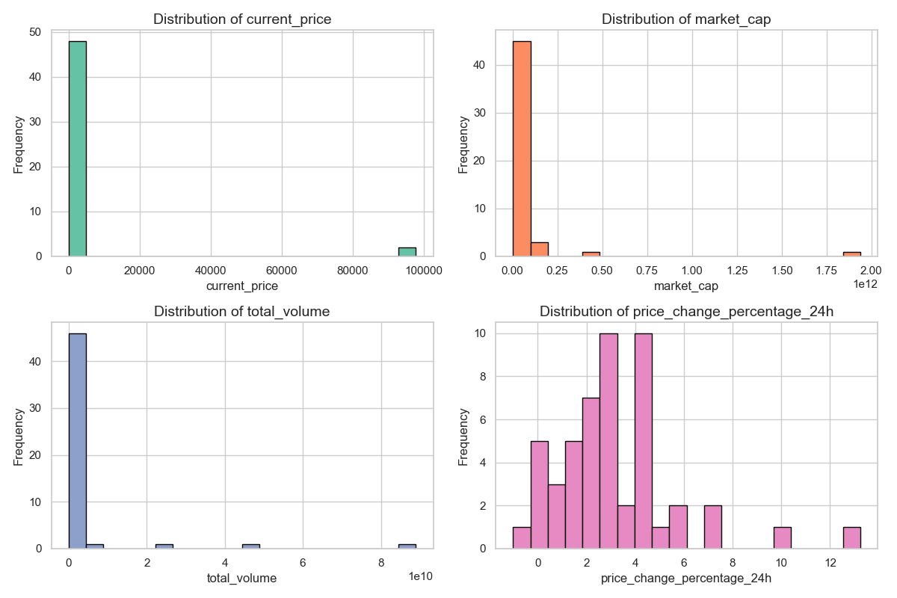

**Current Price Distribution:**

Most cryptocurrencies have a current price less than 20,000, meaning most cryptocurrencies are relatively cheap for retail investors.

A few cryptocurrencies with very high prices (almost 100,000) imply market leaders or scarce assets with high perceived value, such as Bitcoin.

**Market Capitalization Distribution:**

Market cap distribution implies that most cryptocurrencies have relatively low market valuation, that is, less than (below 2.5×10^11) .

A few cryptocurrencies are heavily dominant in the market, with significantly higher market caps (up to 2.0×10^12), possibly representing established cryptocurrencies with robust investor confidence, such as Bitcoin and Ethereum.

**Distribution of Total Volume:**

Trading volumes are low for most cryptocurrencies (below 2×10^10).

High-volume outliers show that a few cryptocurrencies are actively traded, possibly showing strong market interest or speculative activity.

**Price Change Percentage (24h):**

The 24-hour price change percentages are mostly positive, signifying a general upward trend or recovery in the market during the observed period.

The range of changes from 0% to 12% suggests moderate price volatility, with some cryptocurrencies showing significant short-term growth.

**2)Correlation Matrix :**

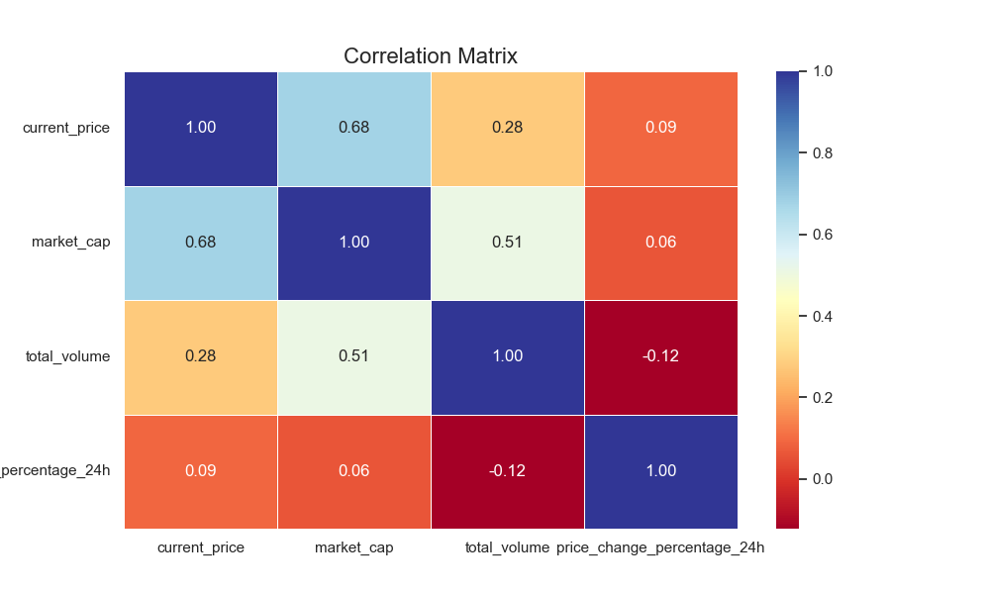

* Market Leaders Dominate: High-priced cryptocurrencies strongly correlate with larger market caps, indicating dominance by a few assets.
* Volume Reflects Market Size: Higher market caps moderately correlate with higher trading activity.
* Volatility is External: Short-term price changes are driven by external factors, not intrinsic metrics.
* Focus areas: high market-cap asset analysis, drivers of volatility through external influences.

**3)Distribution of Cryptos by Market Cap**

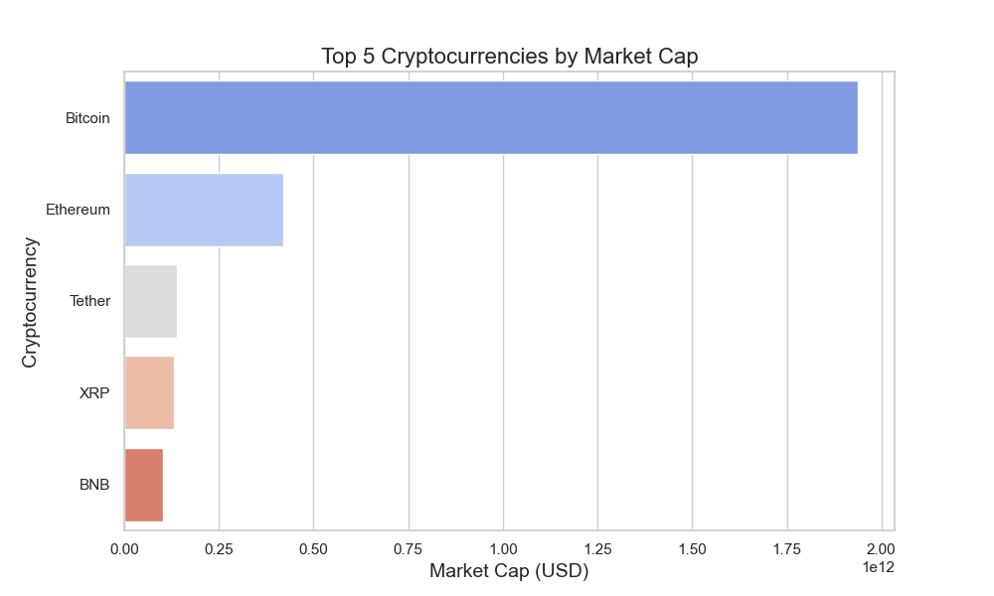

* Bitcoin has the highest market capitalization, significantly more than all other cryptocurrencies, which shows that it is the leading cryptocurrency in the crypto market.
* Ethereum is at the second position with a market cap significantly smaller than Bitcoin but far ahead of the remaining cryptocurrencies.
* Tether, XRP, and Binance Coin (BNB) make up the top five, with much smaller market caps compared to Bitcoin and Ethereum.
* There is a steep drop in market cap from Bitcoin to Ethereum and an even sharper drop from Ethereum to the rest, which shows a highly concentrated market.

4) **Scatter Plot: Price vs Market Cap**

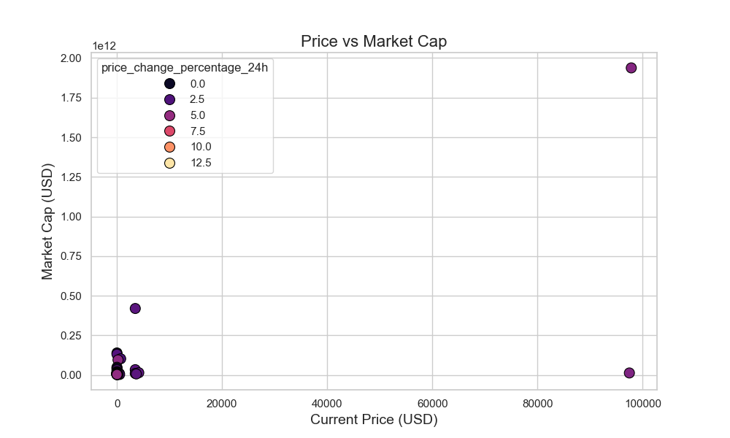

* Most Cryptocurrencies: Clustering with low prices (<$20,000) and low market caps (<$250 billion).
* Outliers: Two leading tokens—one with a high price (~$100,000, probably Bitcoin) and another with a high market cap (> $1 trillion, probably Ethereum).
* Price Change: Most tokens record a slight change in prices within 24 hours except for a few.
* Market Dominance: A few cryptocurrencies dominate the market in terms of valuation.