**ITCS 6150**

**Project Statement**

1. Write a program which solves N queens puzzle (8 < N < 13).
2. Input: N (number of queen)
3. Output: N×N Boolean array with 1’s showing final position of queens.
4. Program should use heuristics minimizing the search space.

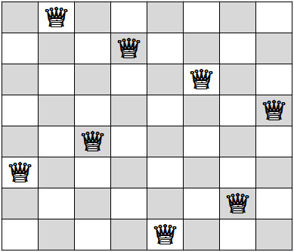

**Project Members**

**Name Student ID**

Shravanti Bugade 801076033

Pratik Kontamwar 801076690

Rithesh Shetty 801058230

**INDEX**

**Content Sr No.**

**Program Structure 3**

**Global Variables In Program 4**

**Function to Compute Heuristic Function 5**

**Language and Compiler 6**

**Project Execution Steps 6 - 7**

**Program Structure**

The N-Queens Algorithm contains a logic of Random restart hill climbing search method for a given input using Python 3 compiler:

The structure of the program can be visualized as follows:

1. def generate_board(): Function to generate board
2. def set_variables(): Function to initialize all required variables
3. def restart_random(): Function to run the random restart algorithm technique with sideways package
4. def next_board(board): Function to find the next board for further processing
5. def find_heur_count(check_board): Function to find the heuristics of the current board
6. def steep_ascent_board(board): Function to run the board on the steepest ascent algorithm
7. def output_restart_final(board): Function to output next stat on the screen
8. Main function: Begin program execution function. Need to enter the number of queens for which we want to apply heuristic logic

**Global Variables in Program**

1. queen_count
2. min_prior
3. pass_count
4. failure_count
5. violations
6. moves_success
7. moves_fail
8. moves
9. run_count
10. counter
11. heur_count
12. optimal_pos

**Function to Compute Heuristic Function**

def find_heur_count(check_board):

1. violations = 0
2. global queen_count
3. for i in range(queen_count):
   * 1. for j in range(i+1,queen_count):
4. threat = abs(j-i)
5. diagonal_threat = abs(check_board[i] - check_board[j])
6. if(check_board[i]==check_board[j] or threat == diagonal_threat):

violations += 1

1. return violations

**Language and Compiler**

Python Language with use of Anaconda Compiler Tools

**Project Execution Steps**

Input : Enter number of queens – 12

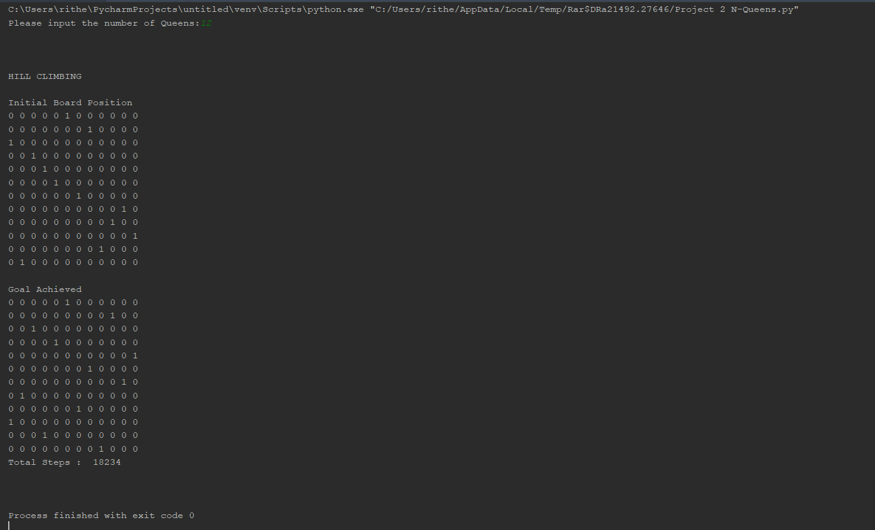

Input : Enter number of queens – 11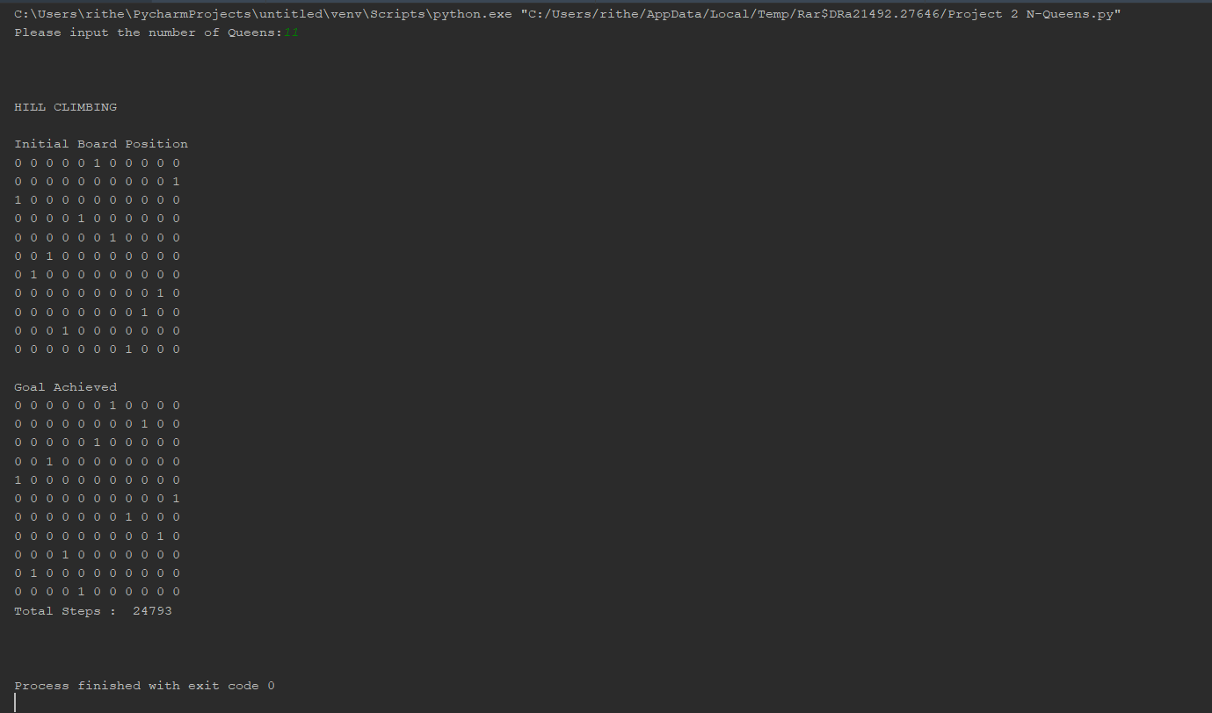

Input : Enter number of queens – 10

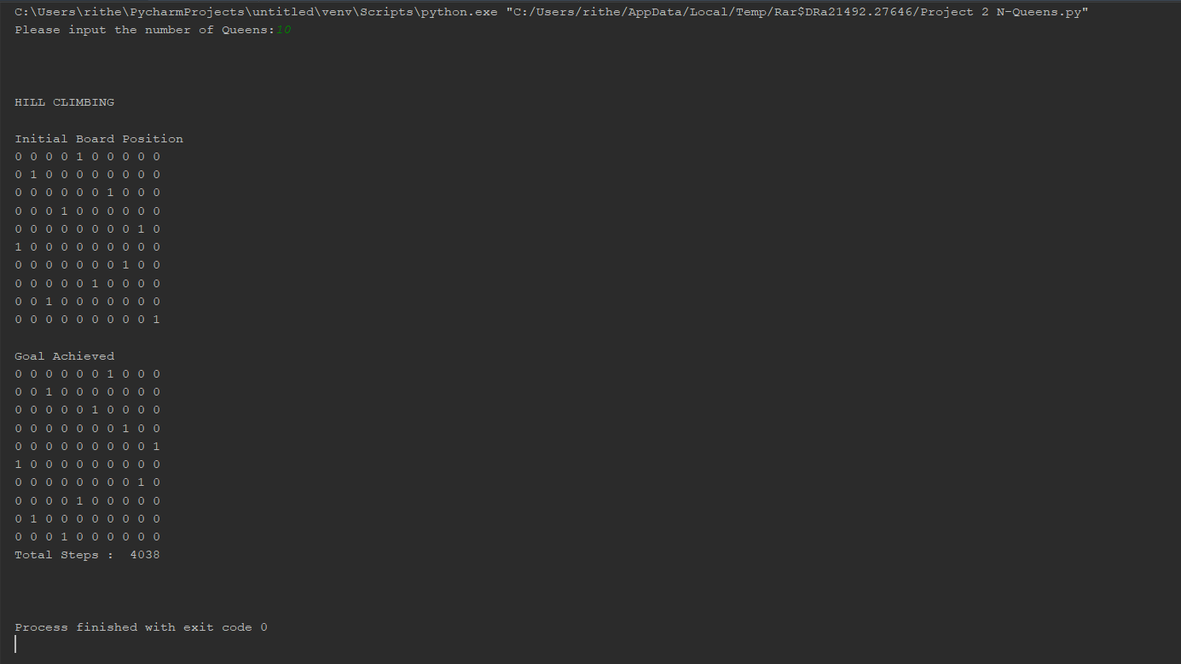

Input : Enter number of queens – 9

