**Day 01:**

**Program:**

class First{

public static void main(String args[])

{

System.out.println("Hello");

}

}

**Output:**

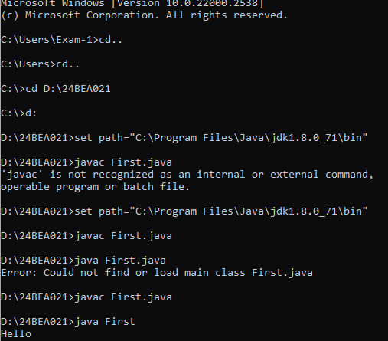

**Program 2:**

class First{

public static void main(String args[])

{

System.out.println("Hello");

}

}

class Second{

public static void main(String args[])

{

System.out.println("Hi");

}

}

Output:

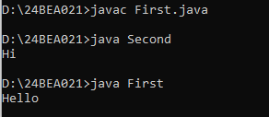

In the above code the java file First as 2 classes-First and Second

So when compiling the above java file we get two class files

Since both the class have main method we can execute both classes separately like java First java Second

**Program:3**

class First{

public static void main(String args[])

{

System.out.println("Hello");

}

}

public class Second{

public static void main(String args[])

{

System.out.println("Hi");

}

}

Output :(error)

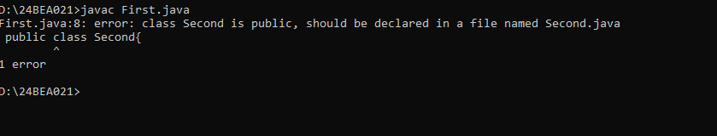

**Program4:**

class Third{

public static void main(String args[]){

int a=20;

int b=30;

char ch='A';

String name="rithika";

float c=56.68f;

System.out.println(a+b);

System.out.println(a+ch);

System.out.println("The value of a is:"+a);

System.out.println("the value of a+b is:"+a+b);

System.out.println("the value of a+b is:"+(a+b));

System.out.println(a+c);

System.out.println();

System.out.println("Hello");

System.out.println(40+60);

System.out.println(a);

}

}

Output:

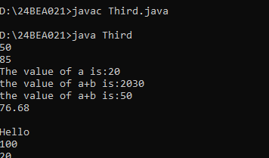

**Program5:**

class Fourth{

public static void main(String args[]){

int a=10;

System.out.println("Hello\"");

System.out.println("Hello\tnice day");

System.out.println("Hello\b");

System.out.print("world");

System.out.println("Java");

System.out.printf("the value of A is %d:",a);

}

}

Output:

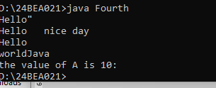

Program 6:

import java.util.Scanner;

class Sixth{

public static void main(String args[]){

Scanner sc = new Scanner(System.in);

if(sc.hasNextInt()){

System.out.println("Entered a number");

}

else if(sc.hasNext()){

System.out.println("Entered a char");}

}

}

Output:

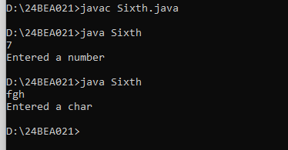

Program 7:

import java.util.Scanner;

class Five{

public static void main(String args[]){

Scanner scan = new Scanner(System.in);

System.out.println("Enter your full name");

String name=scan.nextLine();

System.out.println("Enter empid:");

int empId=scan.nextInt();

//scan.nextLine();

System.out.println("Enter your salary");

float salary =scan.nextFloat();

System.out.println("enter your gender:");

char gender =scan.next().charAt(0);

System.out.println("emp Details:");

System.out.println("empid: "+empId);

System.out.println("Name: " +name);

System.out.println("gender:" +gender);

System.out.println("salary: " +salary);

}

}

Op:

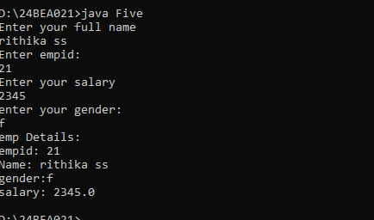

In the above code reading of input happens in gradual reducing of data size hence no empty pass is required ,the data also read correctly.

Program 8:

import java.util.Scanner;

class Five{

public static void main(String args[]){

Scanner scan = new Scanner(System.in);

System.out.println("Enter empid:");

int empId=scan.nextInt();

System.out.println("enter your gender:");

char gender =scan.next().charAt(0);

//scan.nextLine();

System.out.println("Enter your salary");

float salary =scan.nextFloat();

System.out.println("Enter your full name");

String name=scan.nextLine();

System.out.println("emp Details:");

System.out.println("empid: "+empId);

System.out.println("Name: " +name);

System.out.println("gender:" +gender);

System.out.println("salary: " +salary);

}

}

Op:

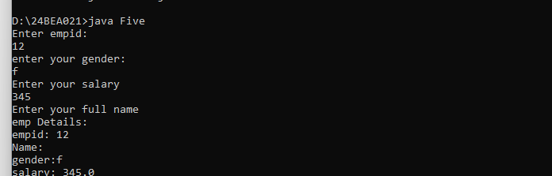

In the above code the string is read after reading small data sizes hence the scanner miss interrupts the space as name value to avoid this we have to pass a empty scanner sc.nextLine();