**Day 01:**

**Program:**

class First{

public static void main(String args[])

{

System.out.println("Hello");

}

}

**Output:**

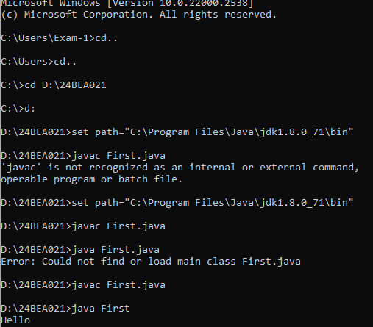

**Program 2:**

class First{

public static void main(String args[])

{

System.out.println("Hello");

}

}

class Second{

public static void main(String args[])

{

System.out.println("Hi");

}

}

Output:

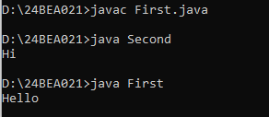

In the above code the java file First as 2 classes-First and Second

So when compiling the above java file we get two class files

Since both the class have main method we can execute both classes separately like java First java Second

**Program:3**

class First{

public static void main(String args[])

{

System.out.println("Hello");

}

}

public class Second{

public static void main(String args[])

{

System.out.println("Hi");

}

}

Output :(error)

