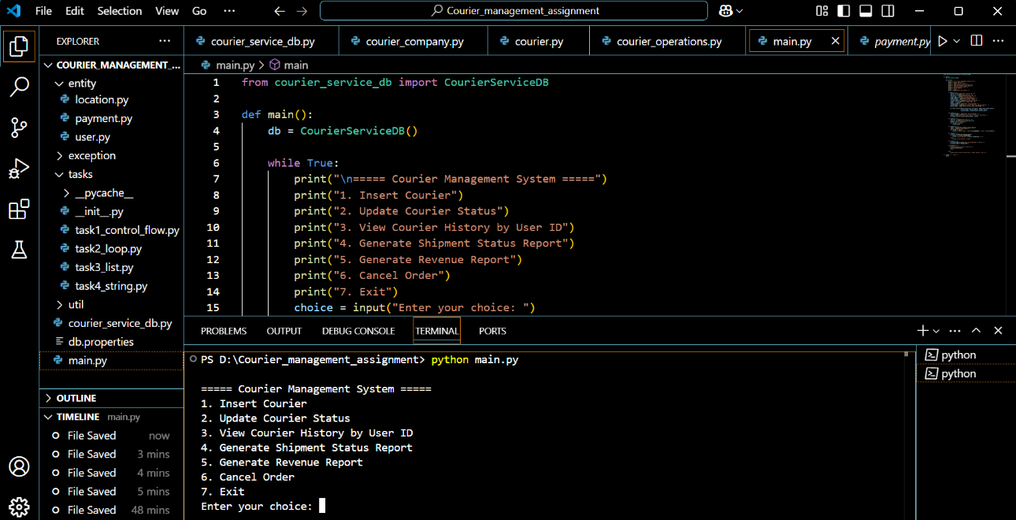
COURIER MANAGEMENT SYSTEM
1.INSERT COURIER
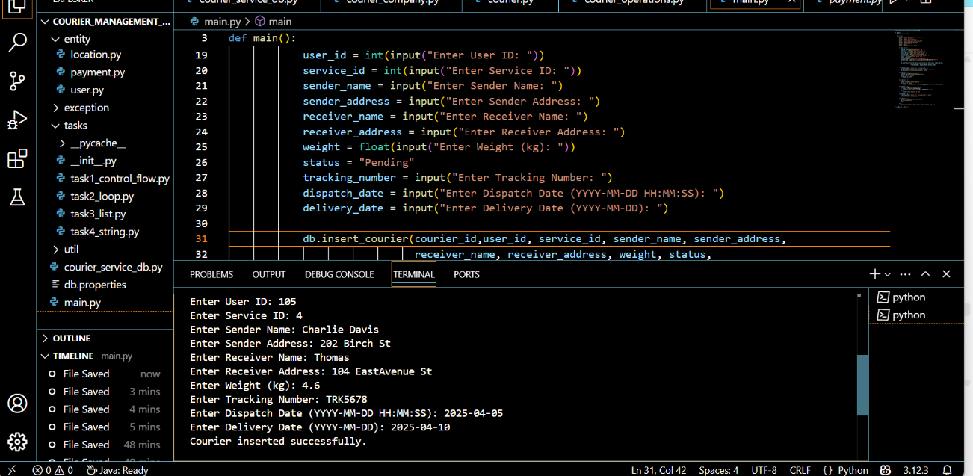
OUTPUT: INSERTED COURIER ID 105
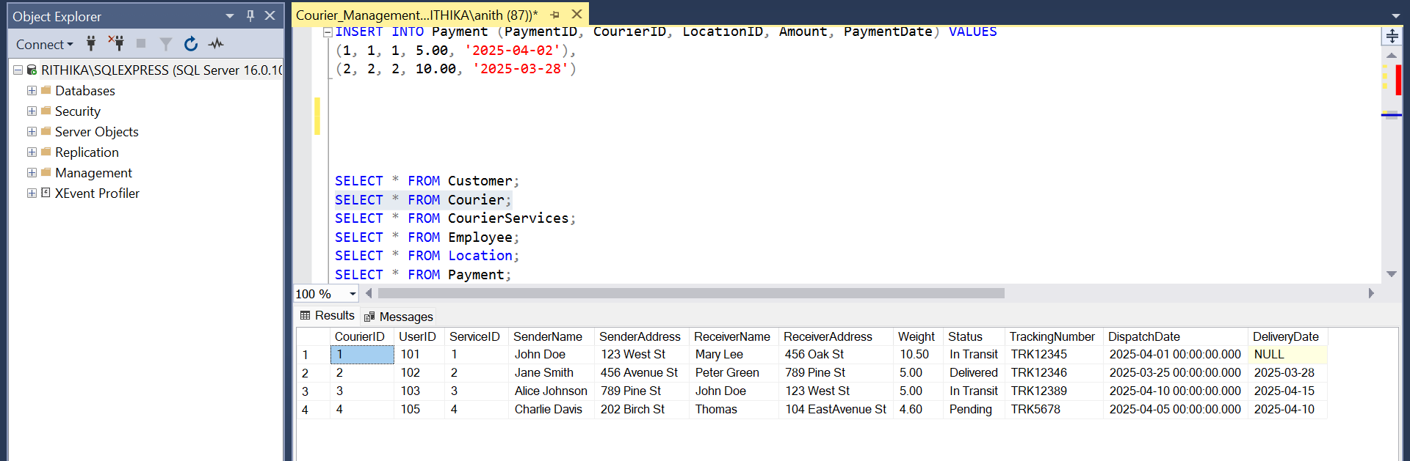

2.UPDATE COURIER STATUS
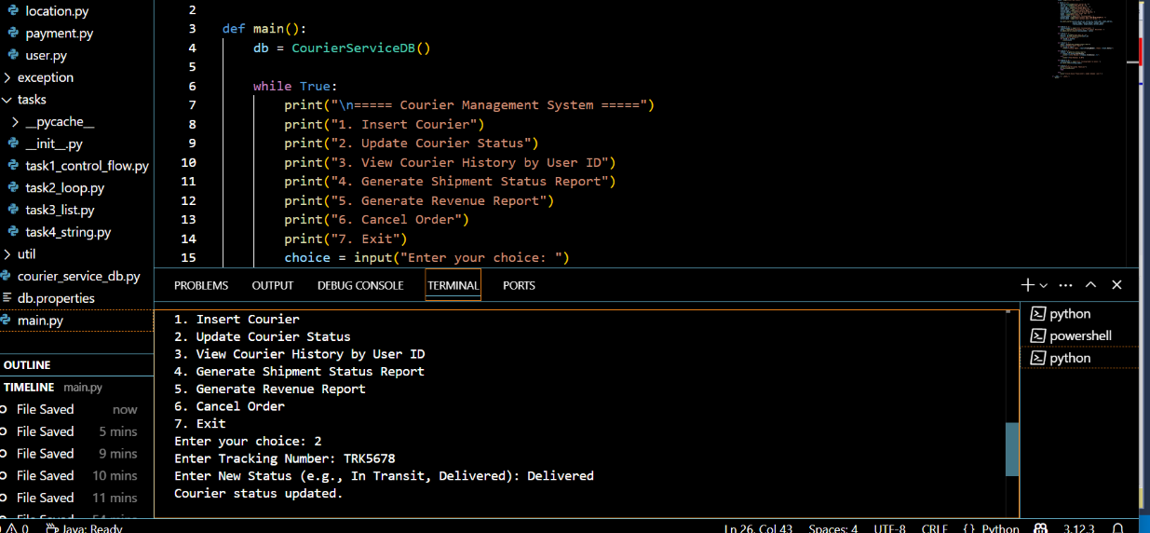
3. VIEW COURIER HISTORY:
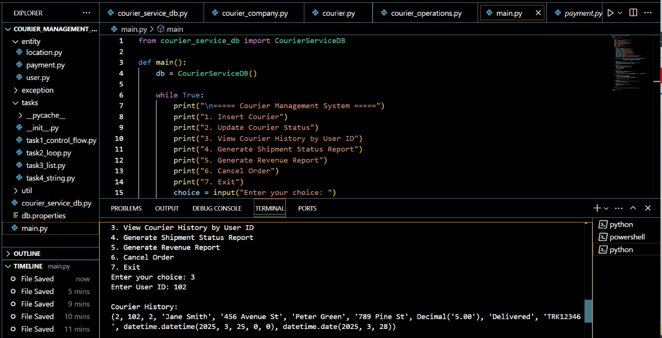

4.GENERATE SHIPMENT STATUS REPORT:
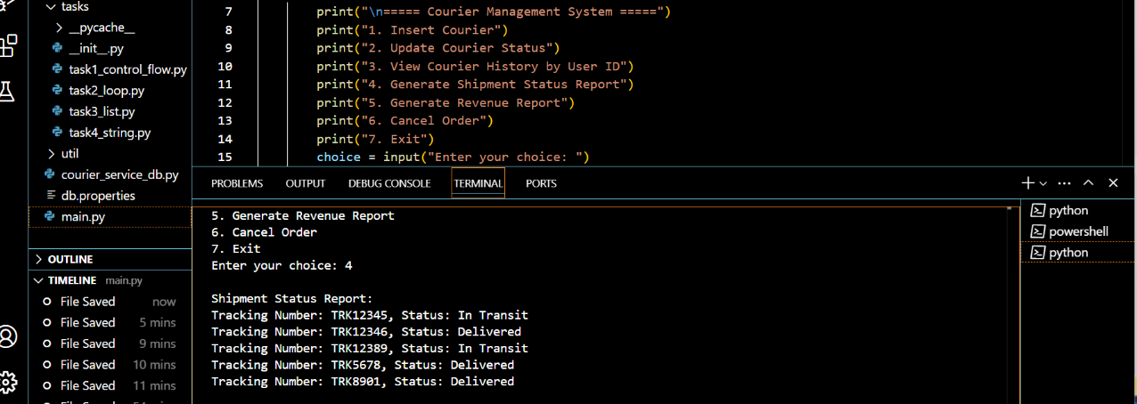
5.GENERATE REVENUE REPORT

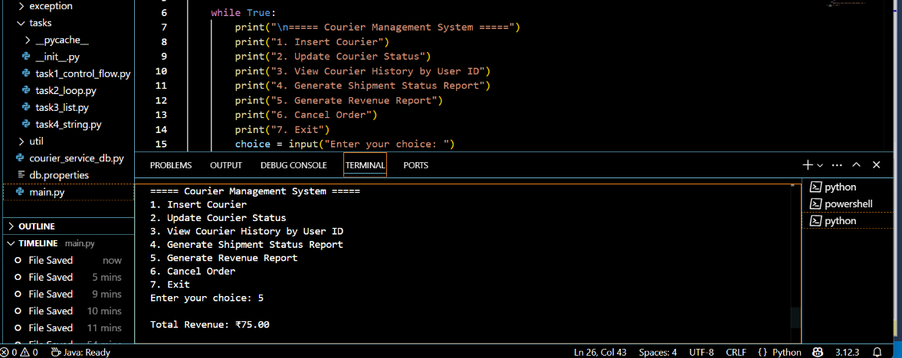
6.CANCEL ORDER
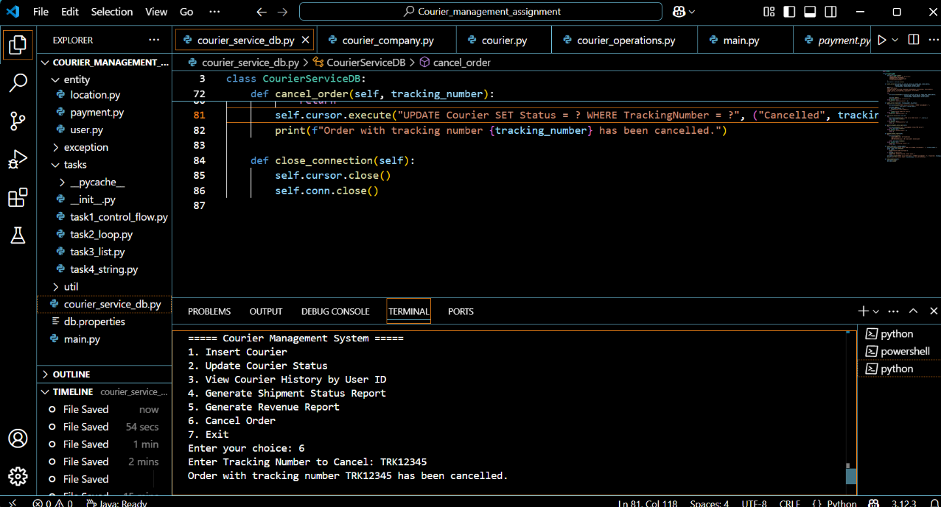
7.EXIT
