**INSURANCE MANAGEMENT SYSTEM**

**MAIN MODULE:**

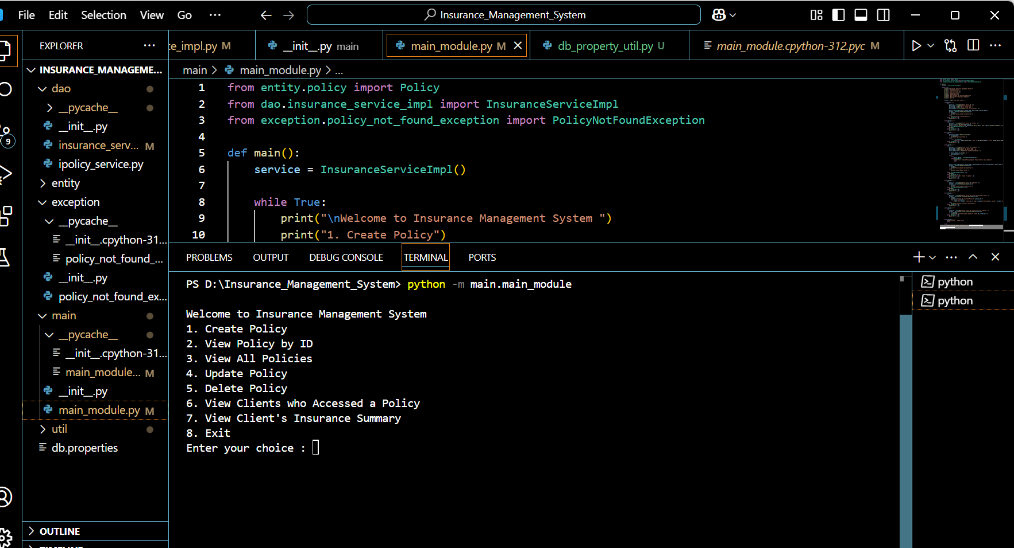

**1.CREATING POLICY:**

BEFORE ADDING POLICY ID 103:

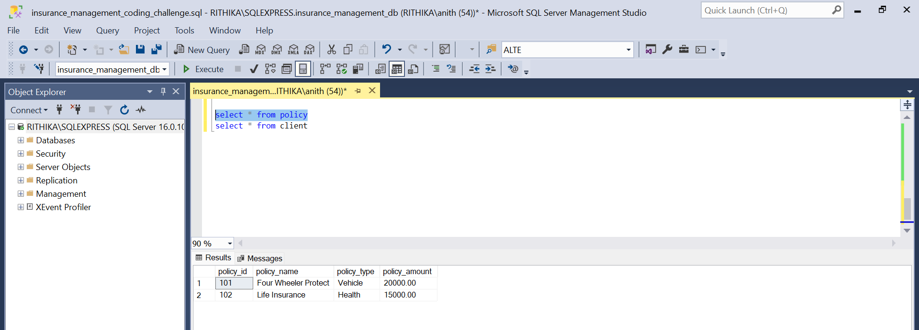

AFTER CREATING POLICY ID 103:

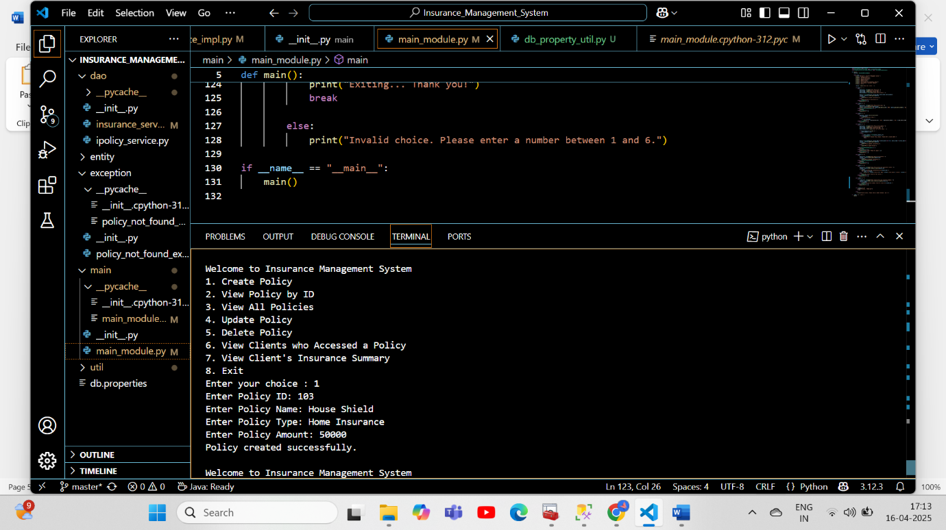

NEW POLICY ADDED TO DATABASE:

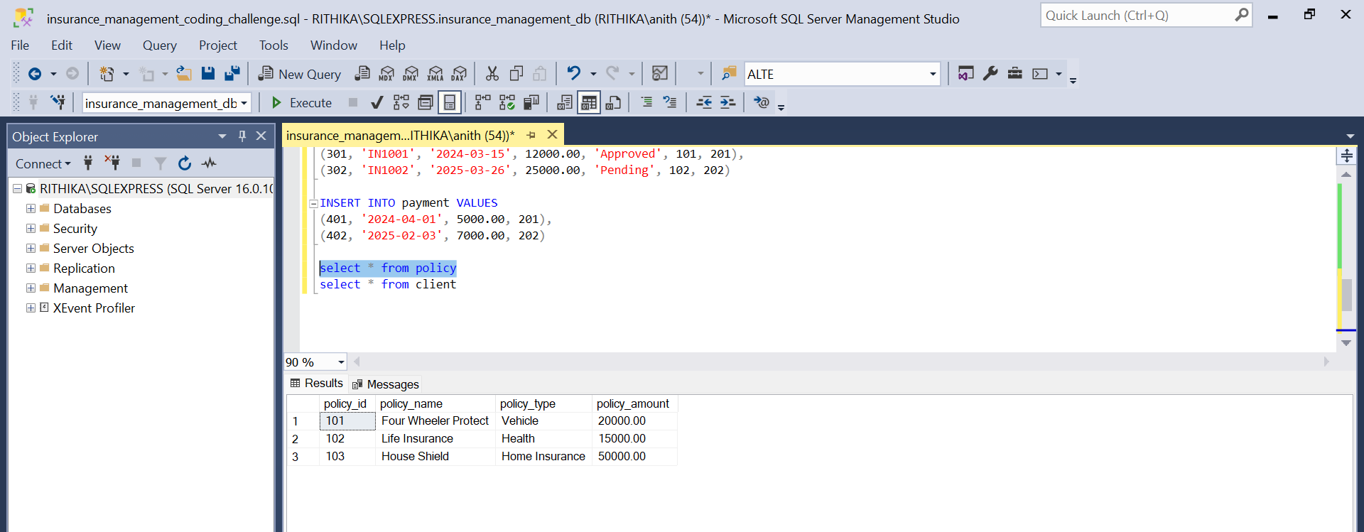

**2.VIEW POLICY BY POLICY ID:  
Input taken from User**

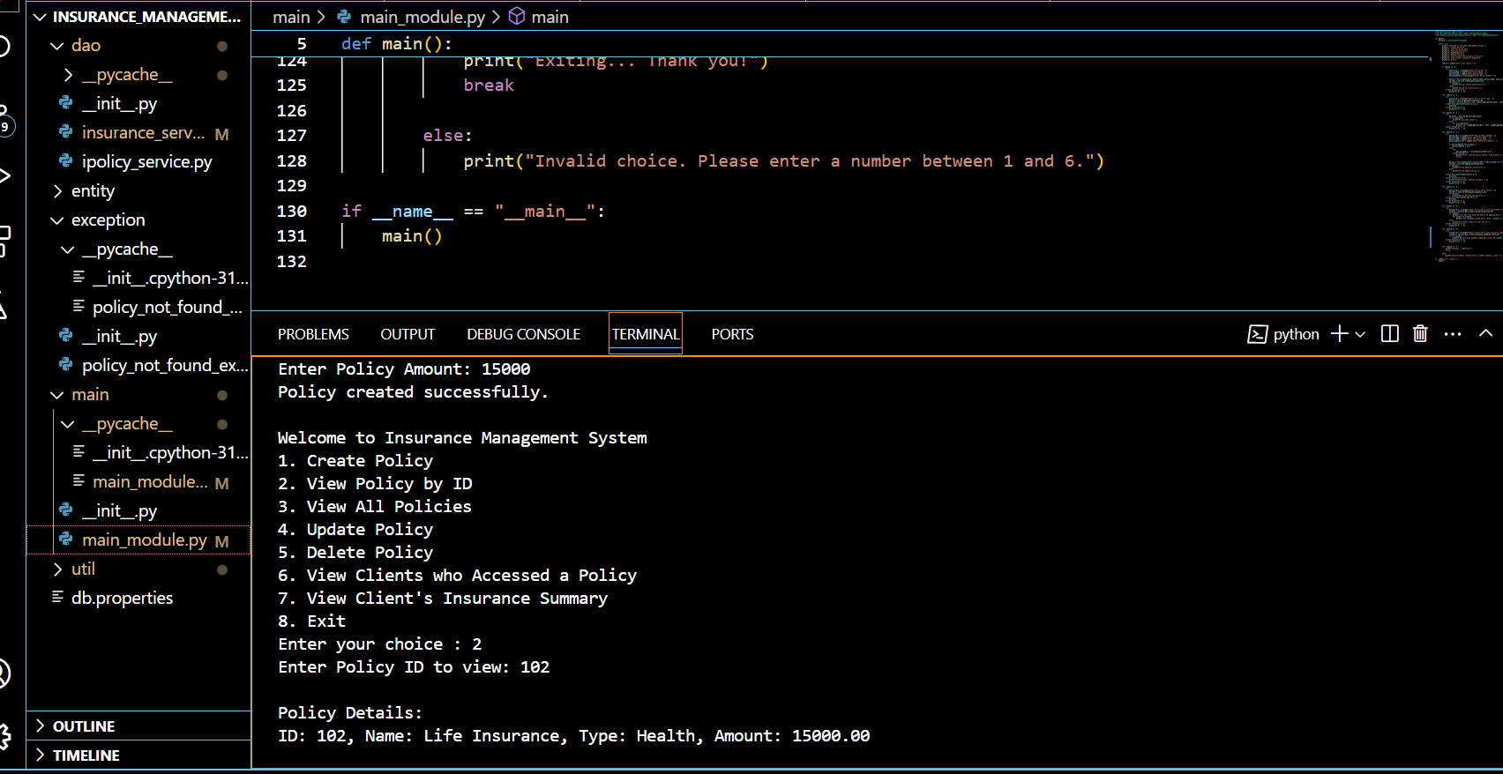

**3.VIEW ALL THE POLICIES IN DATABASE**

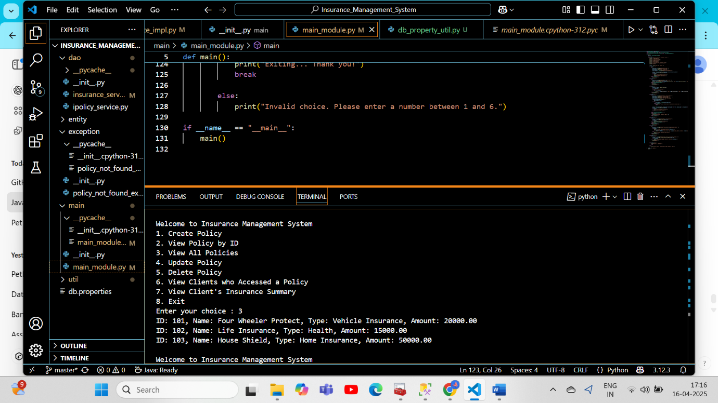

**4.UPDATING POLICY:**

**Update needed fields and leave other attributes empty**

Here Updating the Policy Name of ID 102:

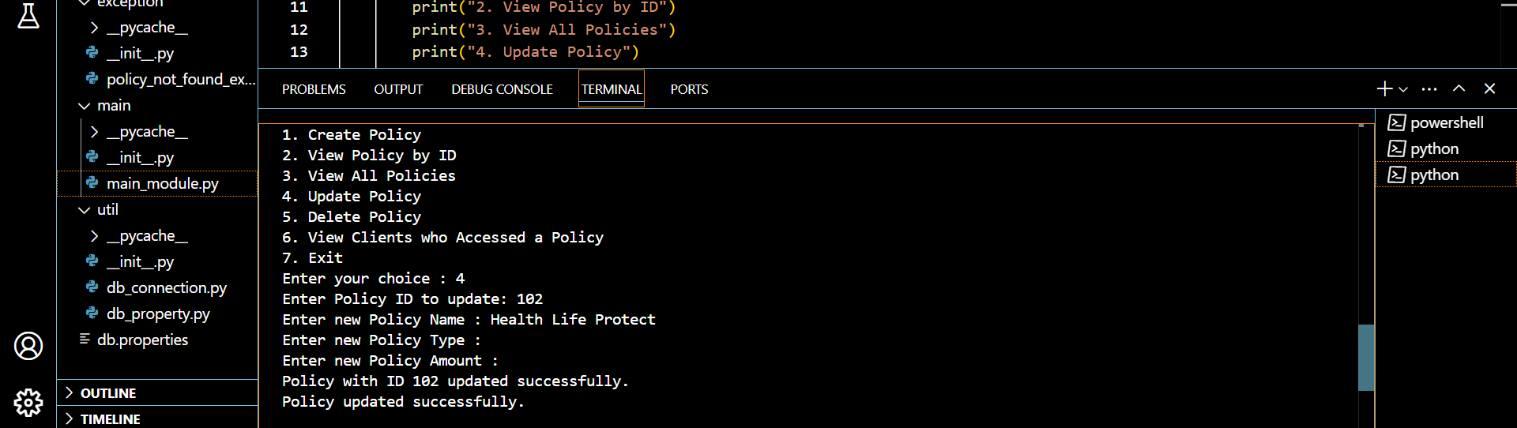

BEFORE UPDATING:



AFTER UPDATING POLICY NAME:

Changed from Life Insurance to Health Life Protect:

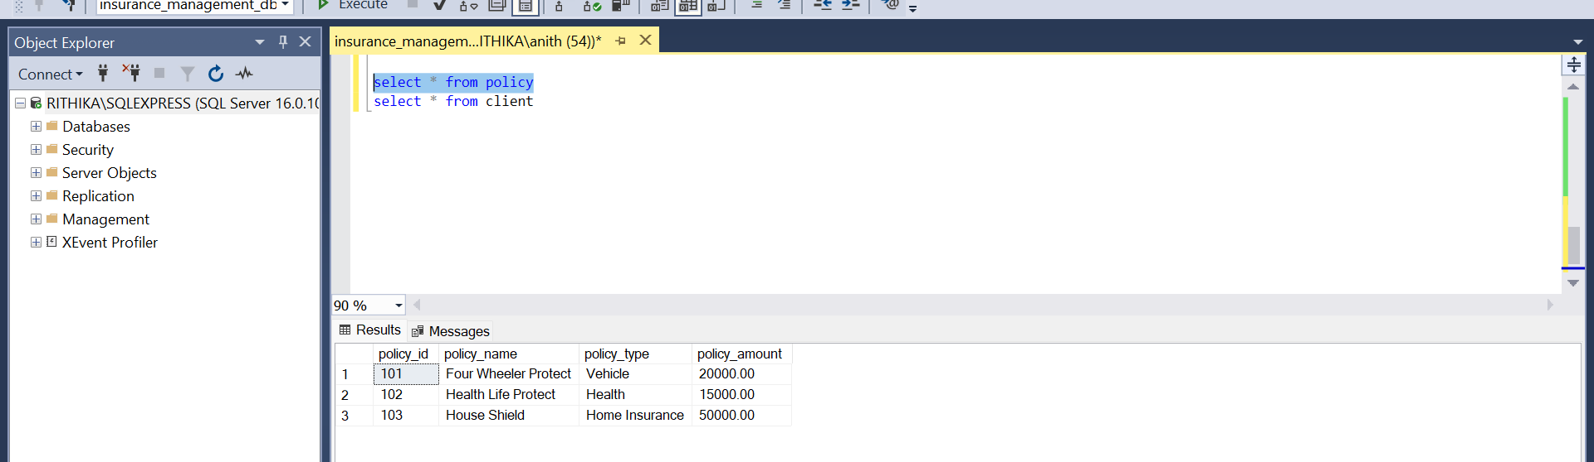

UPDATING POLICY AMOUNT OF ID 103 from Rs.50000 To Rs.5000

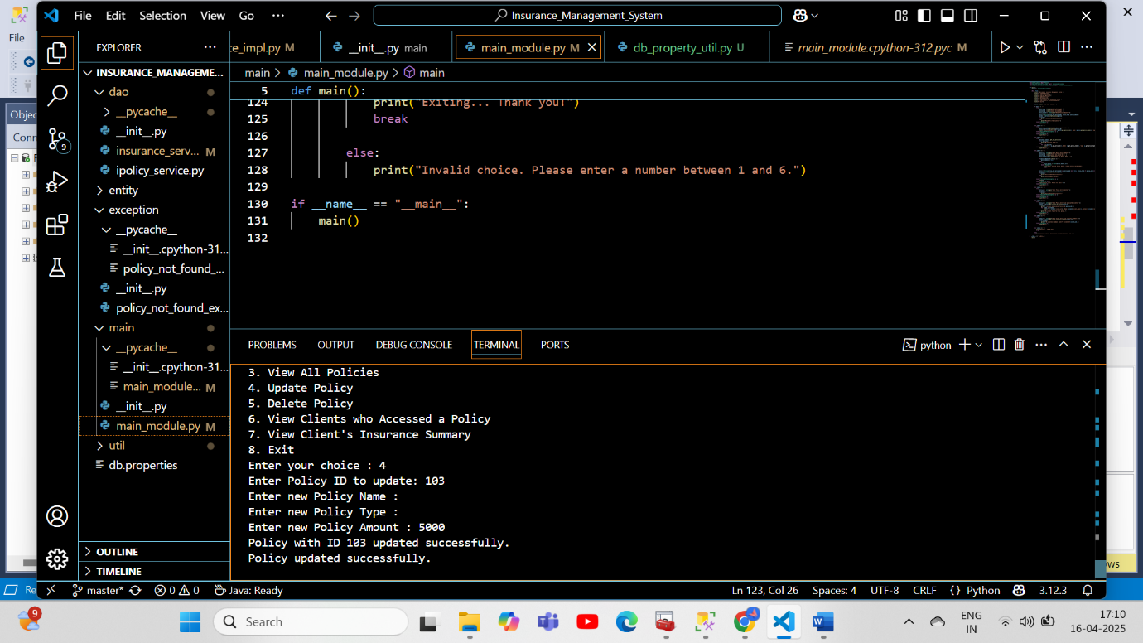

AFTER UPDATING:

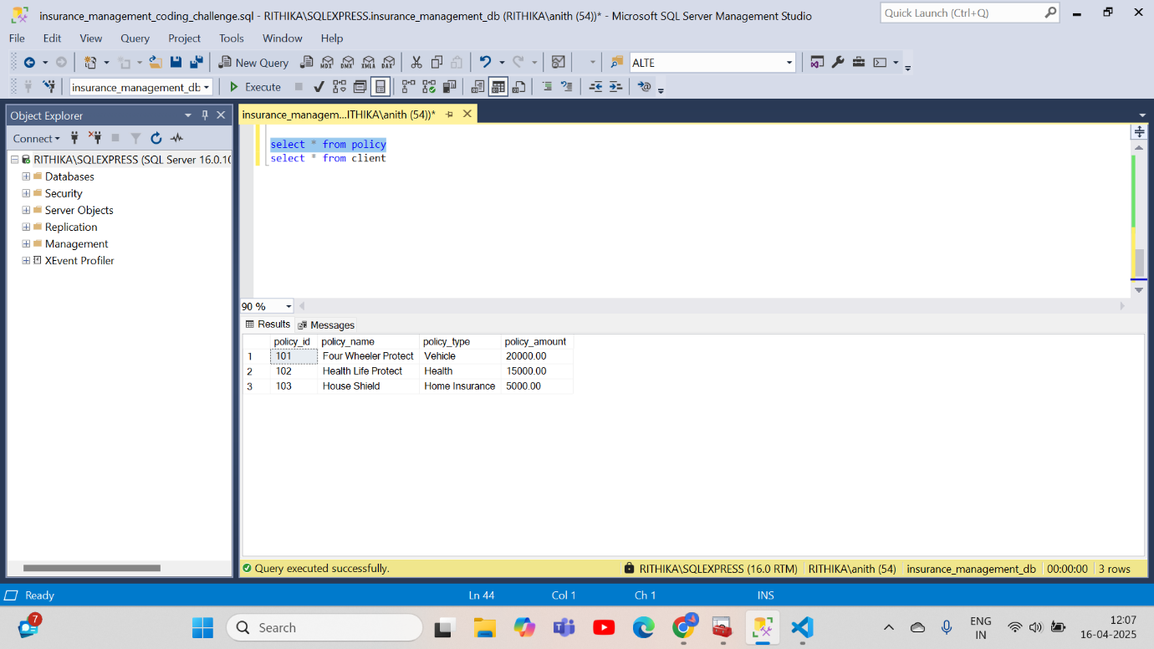

**5.DELETING POLICY:**

**Before Deleting Database:**

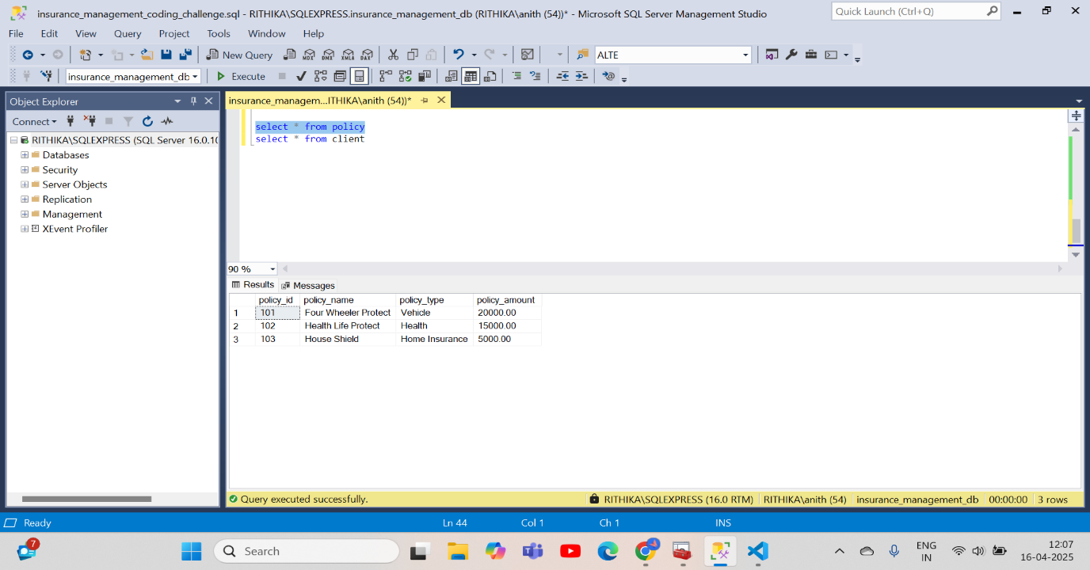

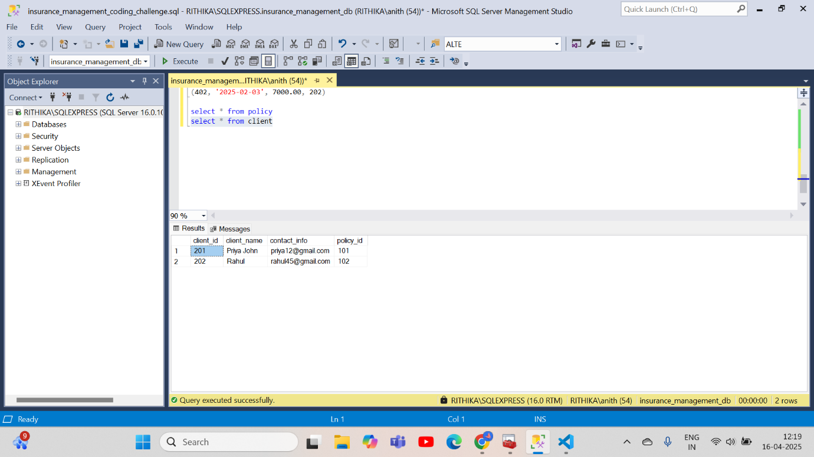

**AFTER DELETING POLICY:**

**Before deleting the system will ask whether to delete the policy and associated client details.**

**If NO then Deletion will be cancelled:**  
  
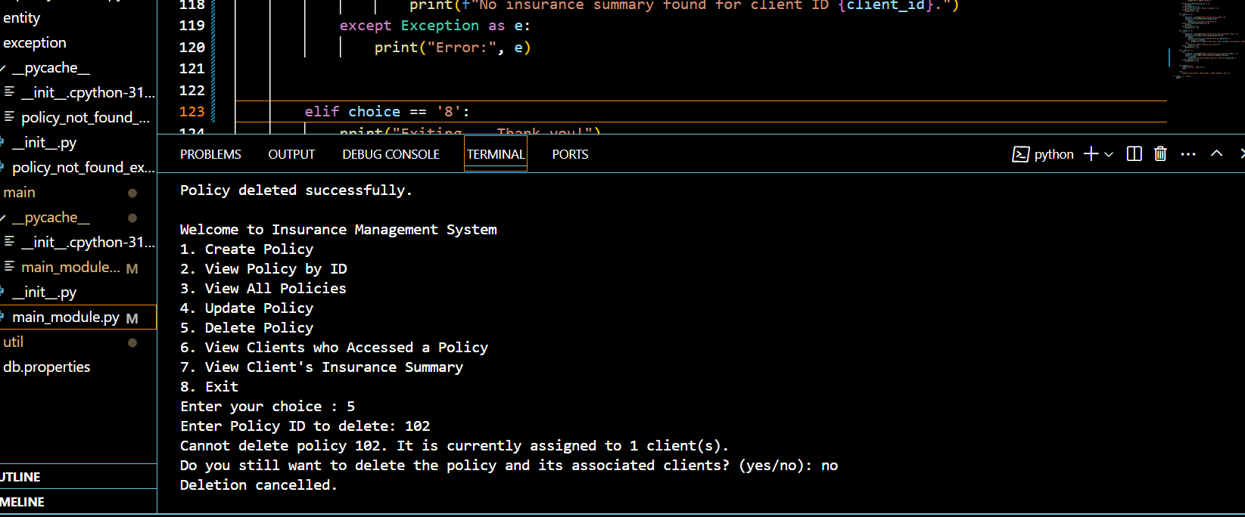

**If yes then related tables will be deleted:**

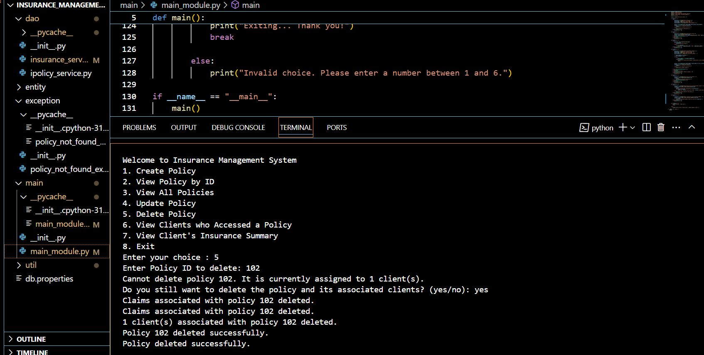

**In Database ID 102 associated field got Deleted**

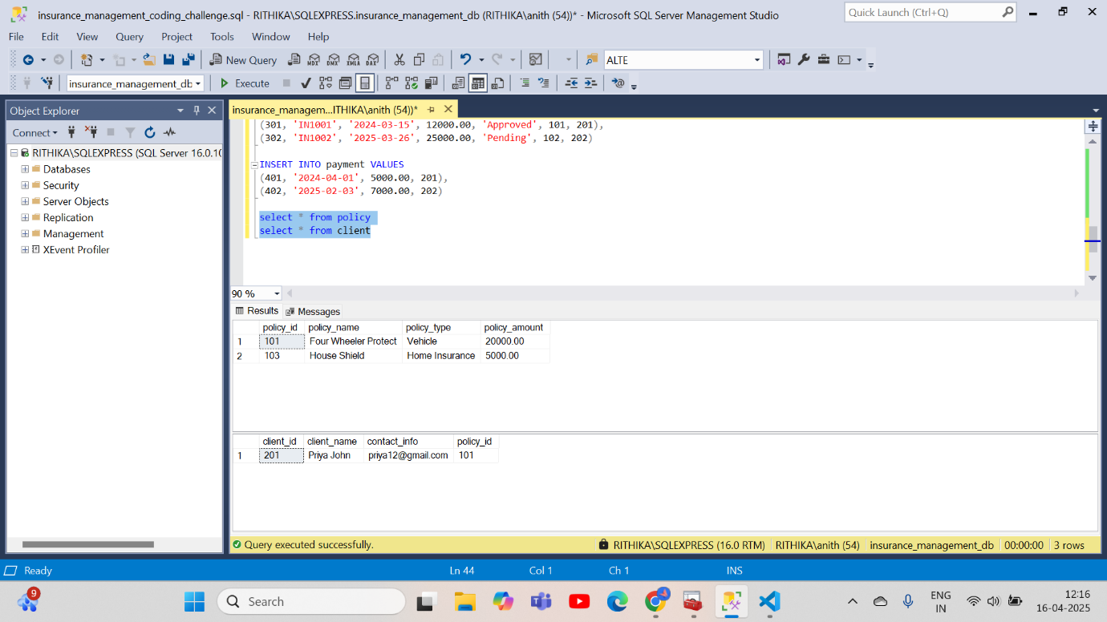

**6.VIEW THE CLIENT WHO TAKEN THE POLICY**

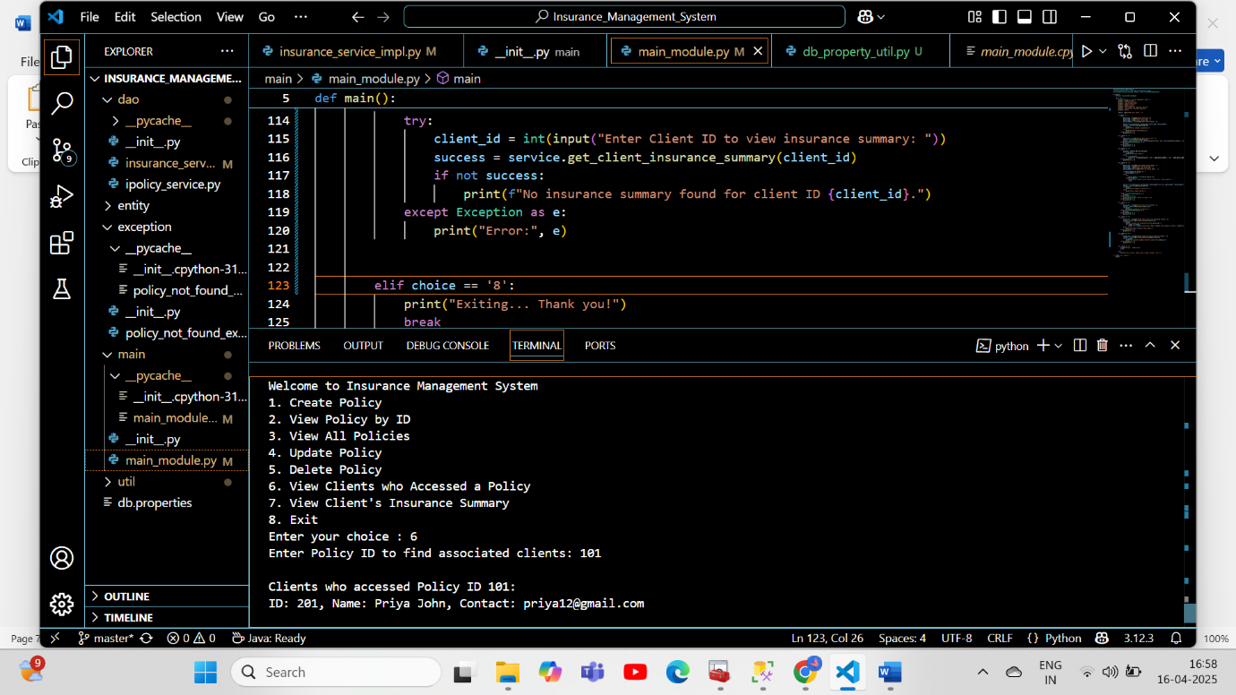

**7. TO VIEW CLIENT INSURANCE SUMMARY:**

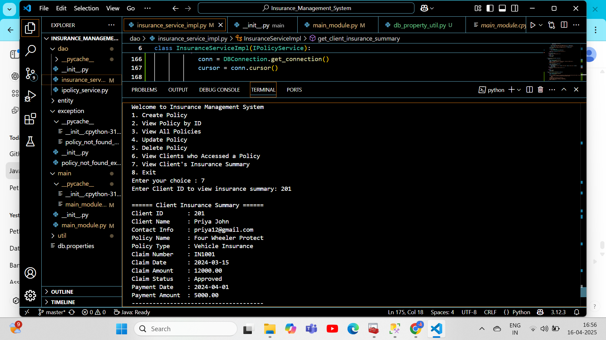

**8.EXIT:**

