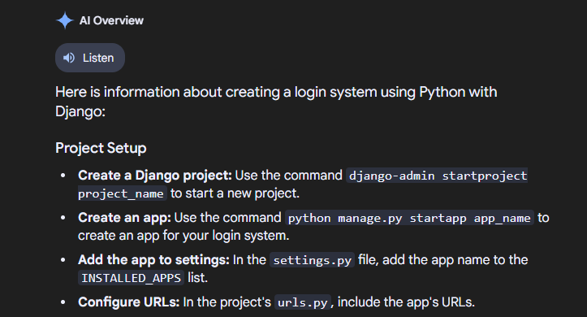

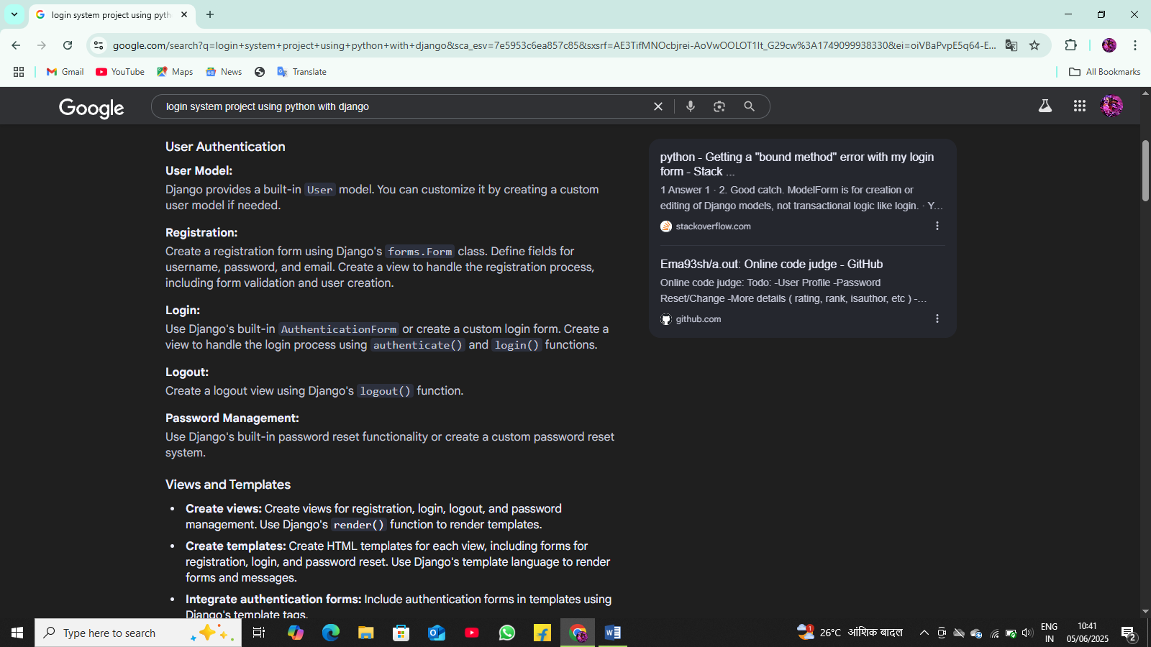

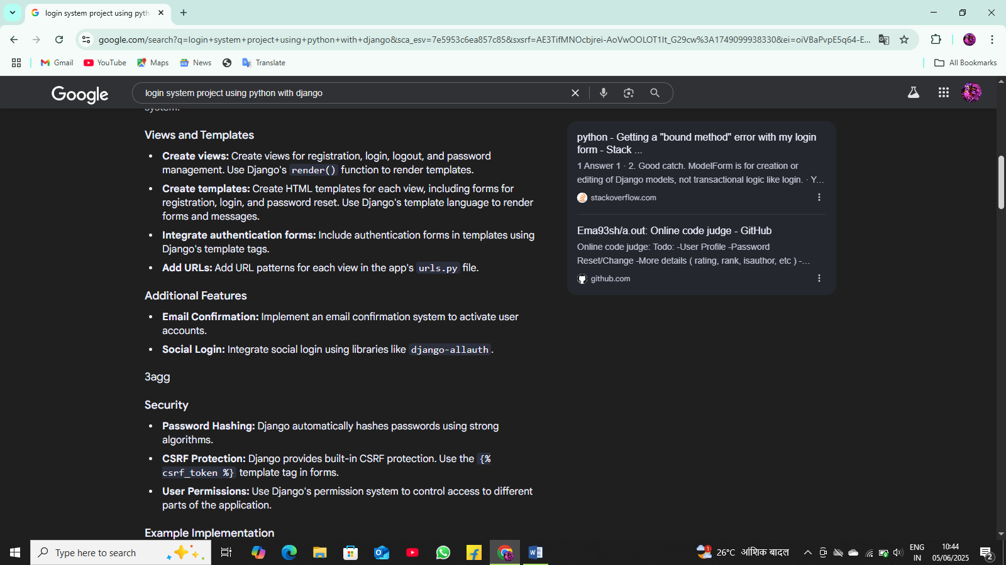

# forms.py
from django import forms

class RegistrationForm(forms.Form):
username = forms.CharField()
password = forms.CharField(widget=forms.PasswordInput)
email = forms.EmailField()

# views.py
from django.shortcuts import render, redirect
from django.contrib.auth.models import User
from django.contrib.auth import authenticate, login, logout
from .forms import RegistrationForm

def register(request):
if request.method == 'POST':
form = RegistrationForm(request.POST)
if form.is_valid():
username = form.cleaned_data['username']
password = form.cleaned_data['password']
email = form.cleaned_data['email']
user = User.objects.create_user(username=username, password=password, email=email)
login(request, user)
return redirect('home')
else:
form = RegistrationForm()
return render(request, 'registration.html', {'form': form})

def login_view(request):
# Implementation for login view
pass

