# **Ex No: 4B ANALYSE NETWORK TRAFFIC USING WIRESHARK TOOL**

**DATE:8/8/24**

# **AIM:**

To capture, save, filter and analyze network traffic on TCP / UDP / IP / HTTP / ARP /DHCP /ICMP /DNS using Wireshark Tool

**Exercises**

**1. Capture 100 packets from the Ethernet: IEEE 802.3 LAN Interface and save it.**

**Procedure**

* Select Local Area Connection in Wireshark.
* Go to capture 🡪 option
* Select stop capture automatically after 100 packets.
* Then click Start capture.
* Save the packets.

**Output**

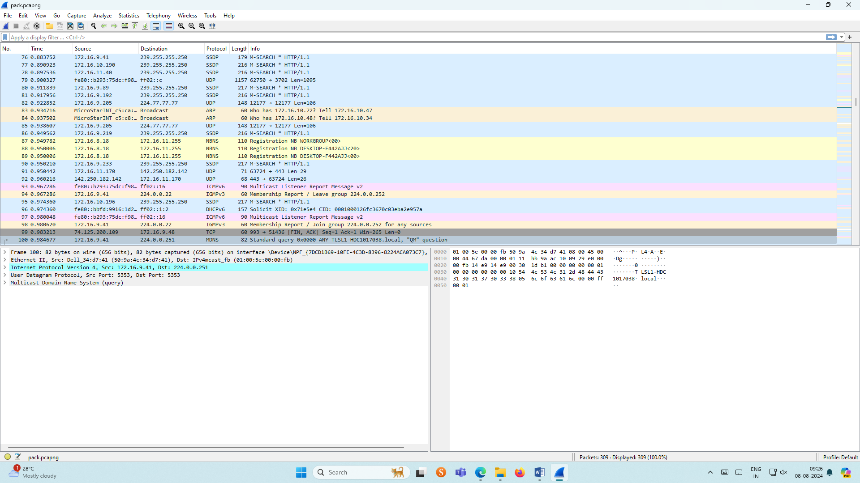

**2.Create a Filter to display only TCP/UDP packets, inspect the packets and provide the flow graph.**

**Procedure**

* Select Local Area Connection in Wireshark.
* Go to capture 🡪 option
* Select stop capture automatically after 100 packets.
* Then click Start capture.
* Search TCP packets in search bar.
* To see flow graph click Statistics🡪Flow graph.
* Save the packets.

**Output:**

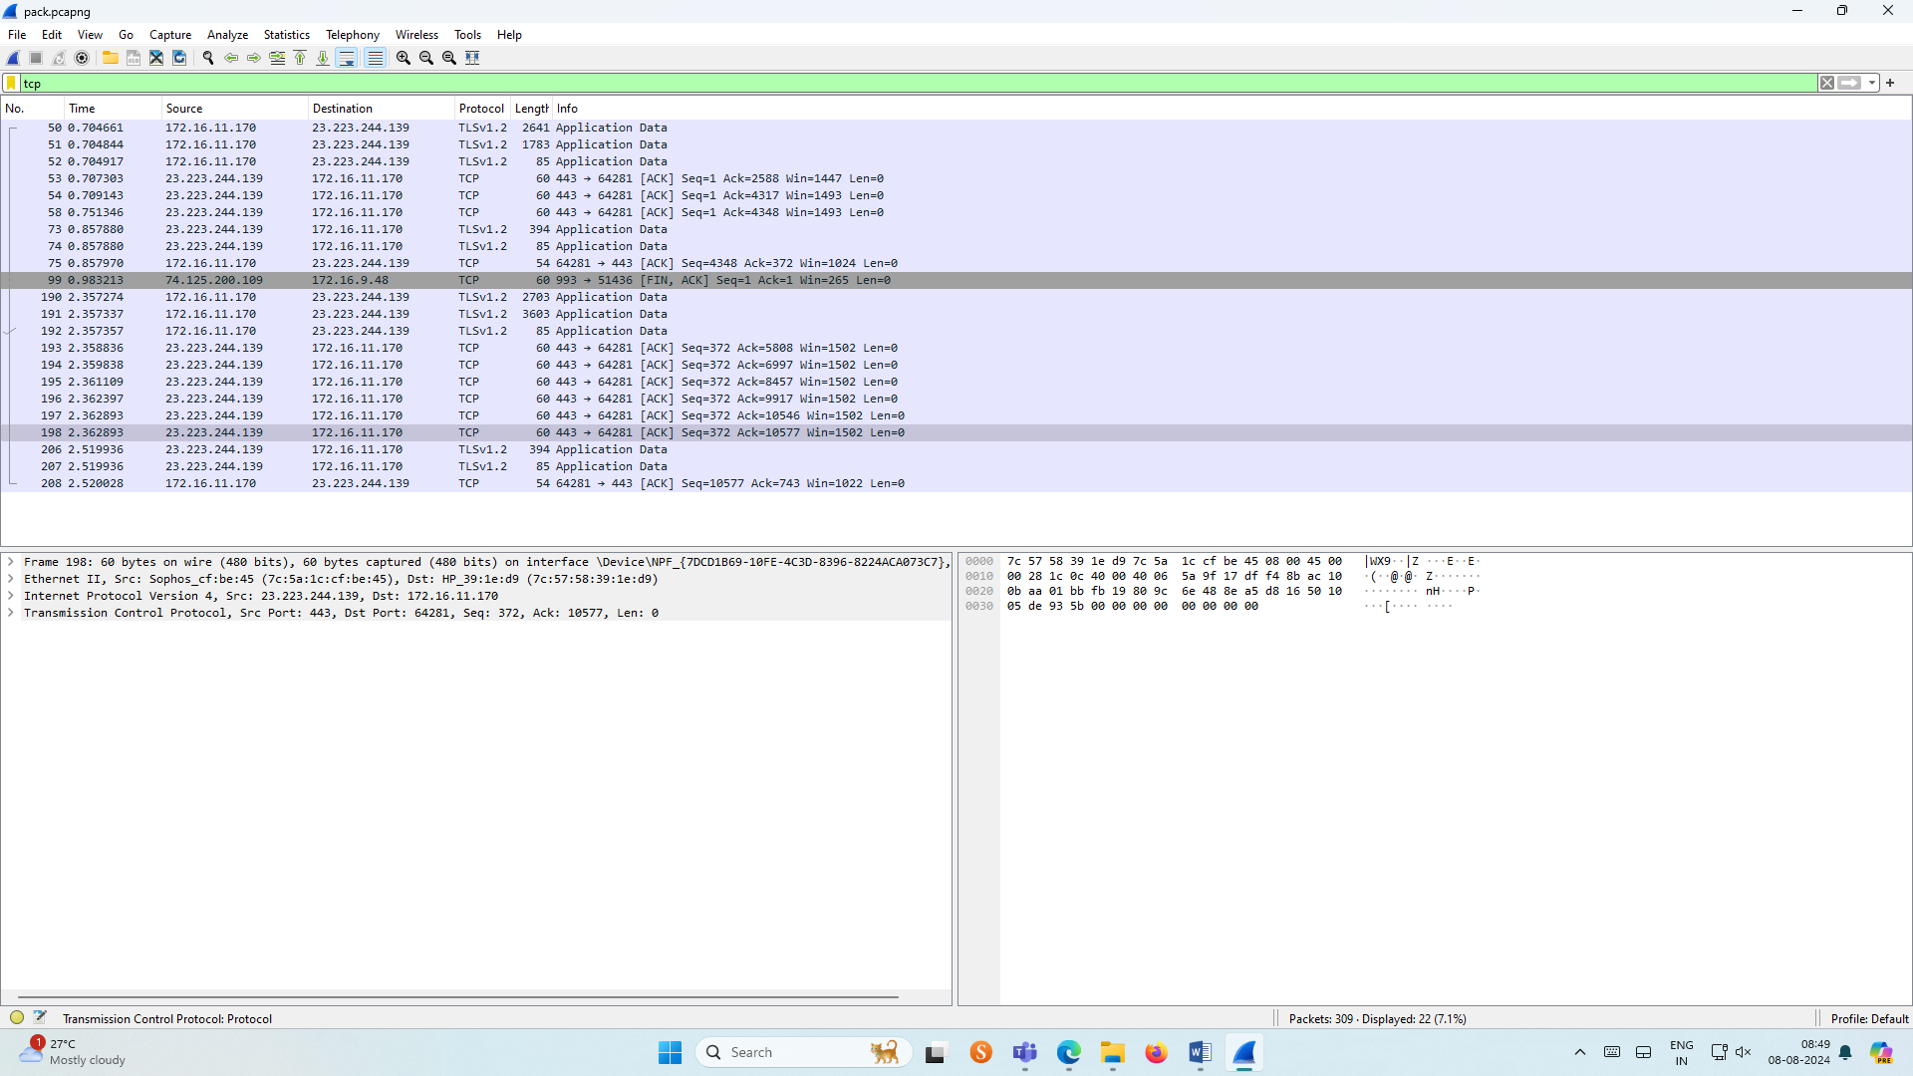

**Flow Graph output**

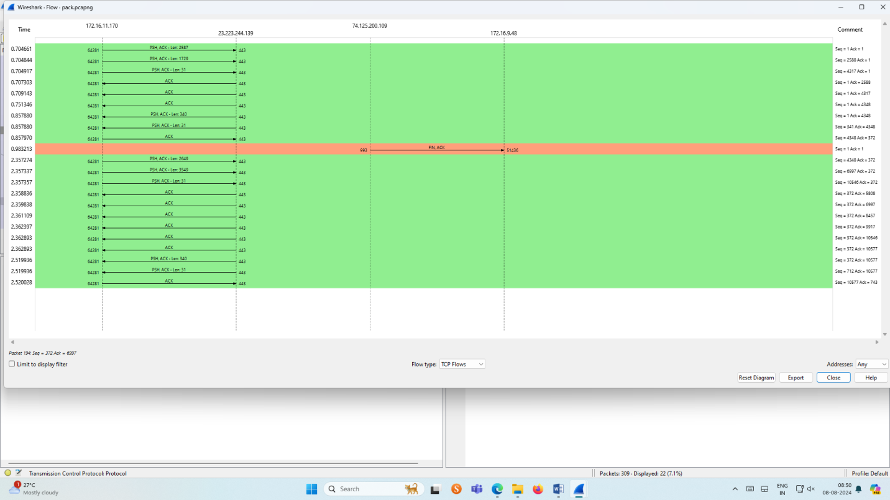

**3.Create a Filter to display only ARP packets and inspect the packets.**

**Procedure**

* Select Local Area Connection in Wireshark.
* Go to capture 🡪 option
* Select stop capture automatically after 100 packets.
* Then click Start capture.
* Search ARP packets in search bar.
* Save the packets.

**Output**

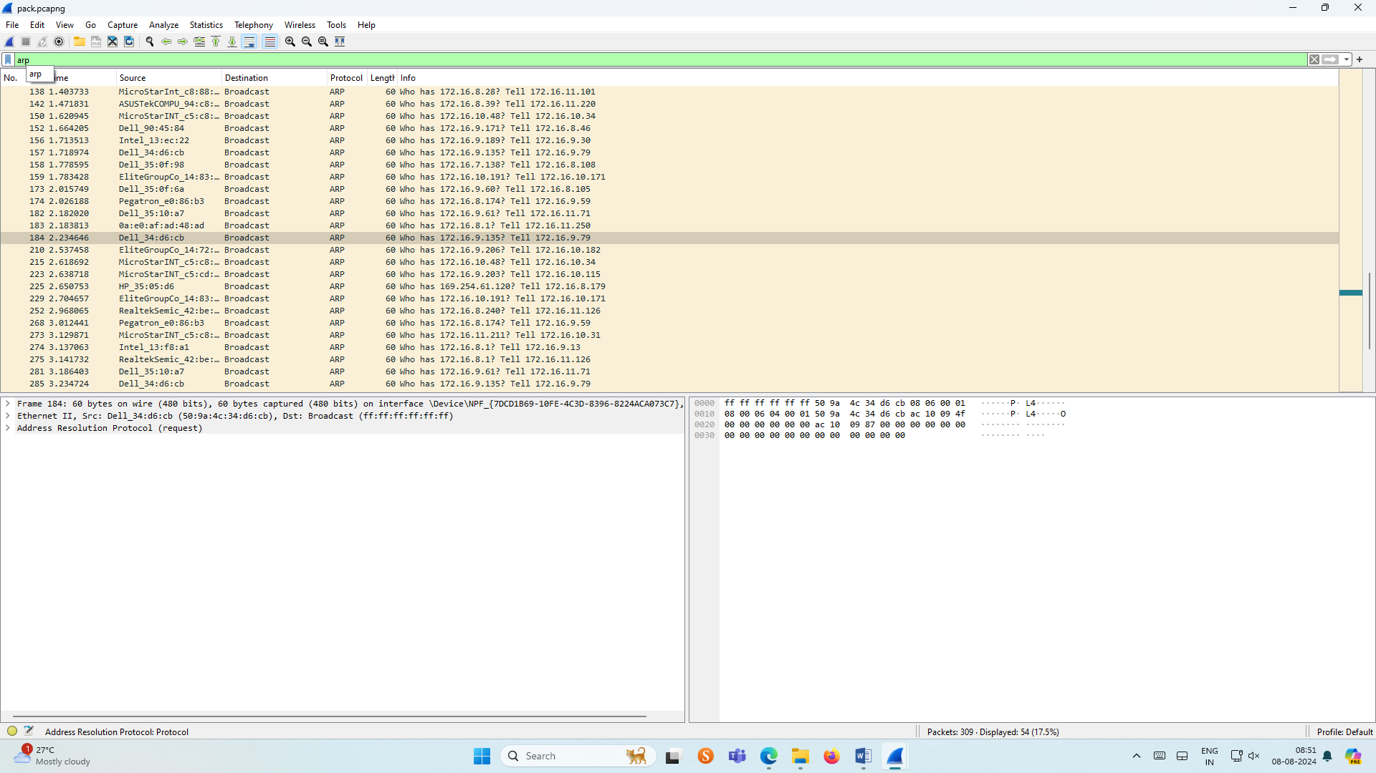

**4.Create a Filter to display only DNS packets and provide the flow graph.**

**Procedure**

* Select Local Area Connection in Wireshark.
* Go to capture 🡪 option
* Select stop capture automatically after 100 packets.
* Then click Start capture.
* Search DNS packets in search bar.
* To see flow graph click Statistics🡪Flow graph.
* Save the packets.

**Output**

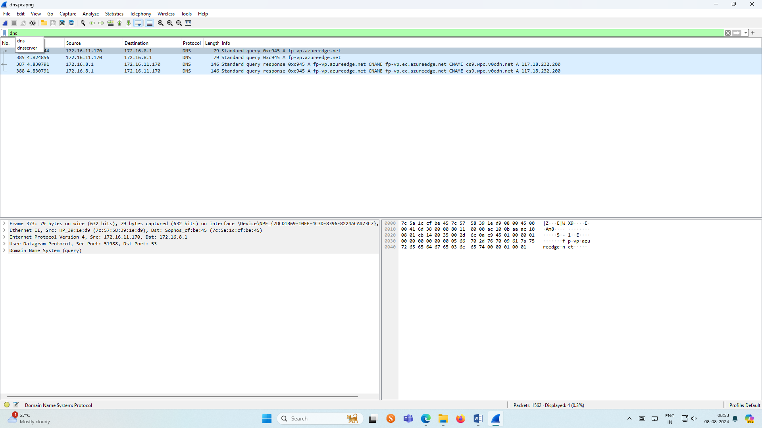

**Graph output**

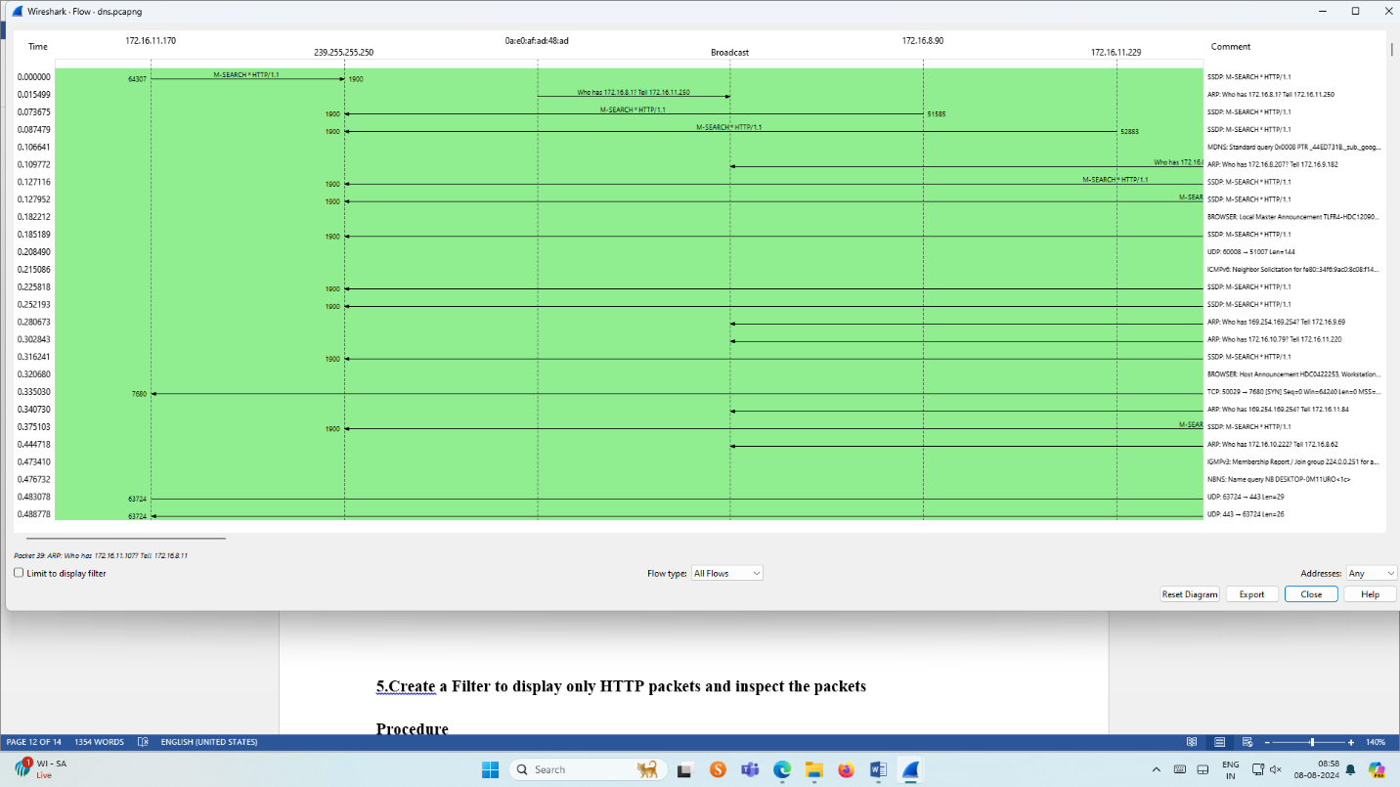

**5.Create a Filter to display only HTTP packets and inspect the packets**

**Procedure**

* Select Local Area Connection in Wireshark.
* Go to capture 🡪 option
* Select stop capture automatically after 100 packets.
* Then click Start capture.
* Search HTTP packets in the search bar.
* Save the packets.

**Output**

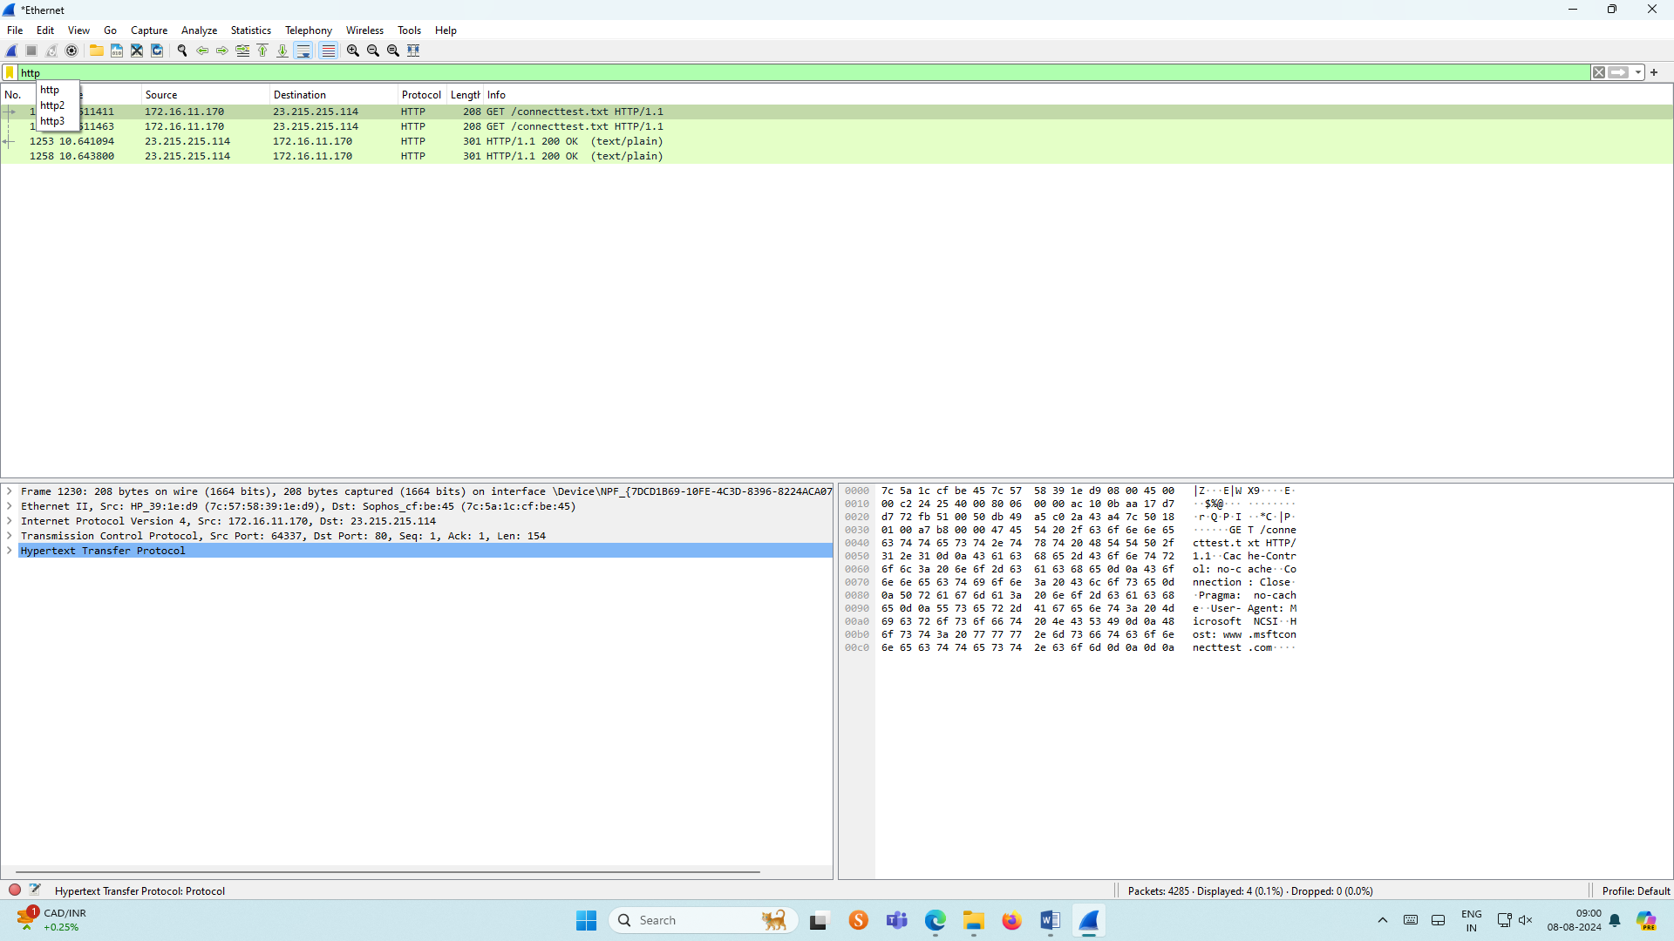

**Flow Graph output**

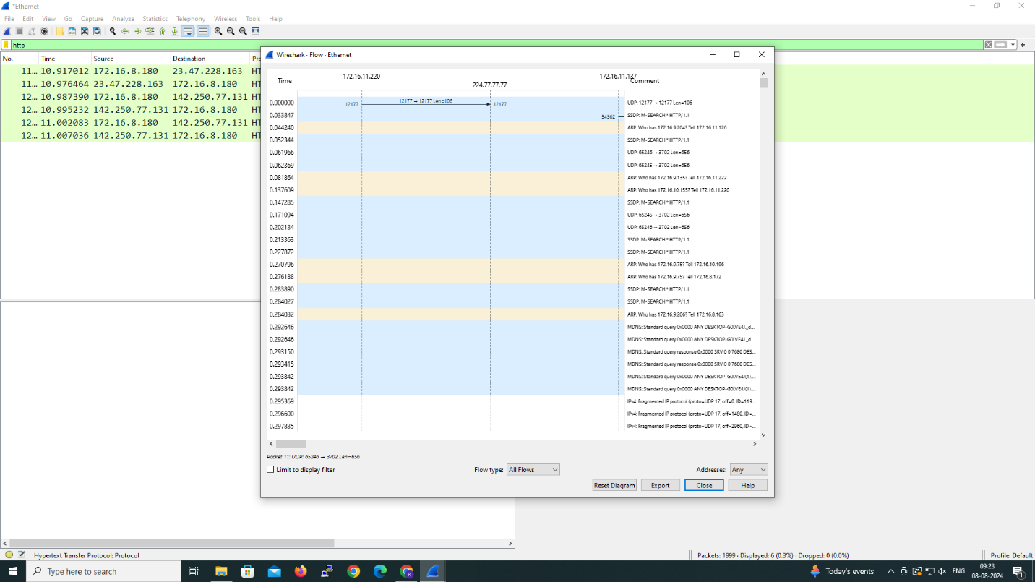

**6.Create a Filter to display only IP/ICMP packets and inspect the packets.**

**Procedure**

* Select Local Area Connection in Wireshark.
* Go to capture 🡪 option
* Select stop capture automatically after 100 packets.
* Then click Start capture.
* Search ICMP/IP packets in search bar.
* Save the packets

**Output**

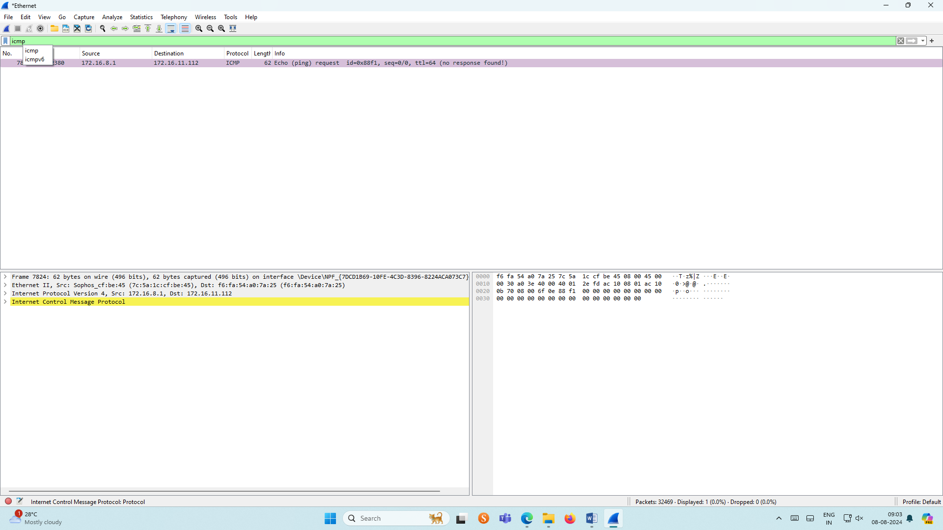

**Flow Graph output**

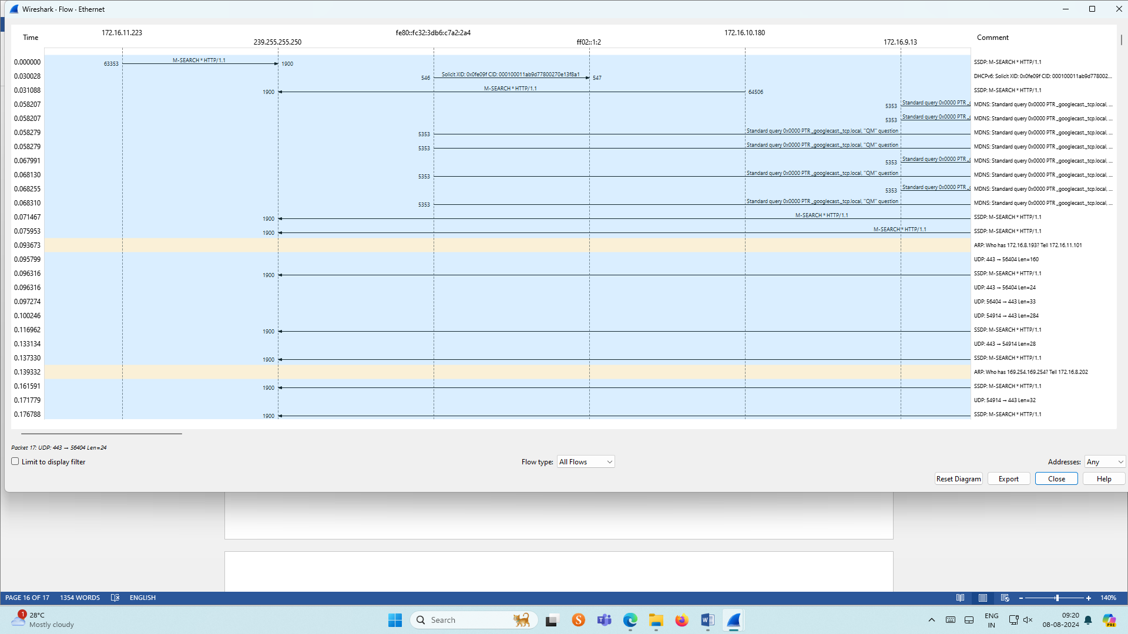

**7.Create a Filter to display only DHCP packets and inspect the packets.**

**Procedure**

* Select Local Area Connection in Wireshark.
* Go to capture 🡪 option
* Select stop capture automatically after 100 packets.
* Then click Start capture.
* Search DHCP packets in search bar.
* Save the packets

**Output**

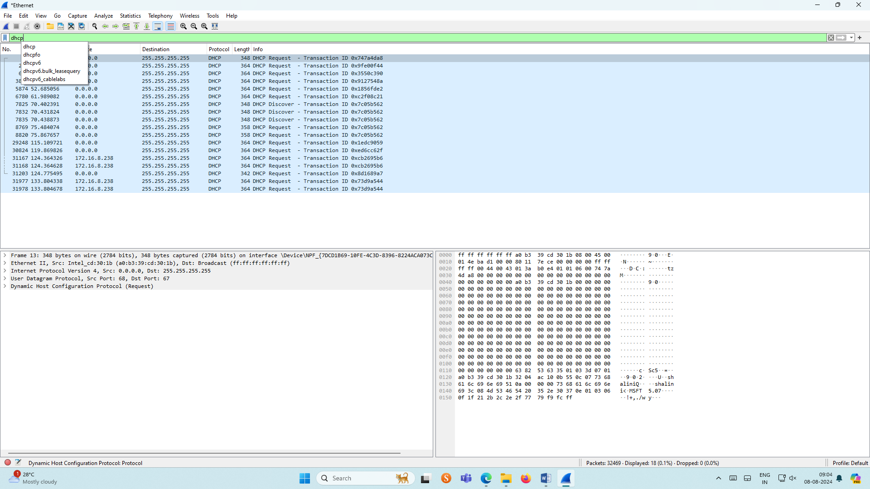

**RESULT:**

The analysing of network traffic using wireshark tool is studied and the output is verified.