# Experiment: Stationarity Test for Time Series Data

## 1. Importing Necessary Libraries

Explanation:  
This section imports the necessary libraries required for time series analysis, visualization, and stationarity testing.

Corresponding Code:

import pandas as pd  
import matplotlib.pyplot as plt  
from statsmodels.tsa.stattools import adfuller

## 2. Loading the Dataset

Explanation:  
The dataset is loaded from a CSV file into a pandas DataFrame. The dataset file (OzoneHole_Data.csv) must be in the working directory.

Corresponding Code:

df = pd.read_csv("OzoneHole_Data.csv")

## 3. Visualizing the Time Series Data

Explanation:  
A line plot is used to visualize 'Hole Area' and 'Minimum Ozone' over the years to identify trends and patterns.

Corresponding Code:

plt.figure(figsize=(12,5))  
plt.subplot(2,1,1)  
plt.plot(df["Year"], df["Hole Area"], marker="o", linestyle="-")  
plt.title("Hole Area over Years")  
plt.subplot(2,1,2)  
plt.plot(df["Year"], df["Minimum Ozone"], marker="o", linestyle="-", color="red")  
plt.title("Minimum Ozone over Years")  
plt.show()

Generated Visualization:

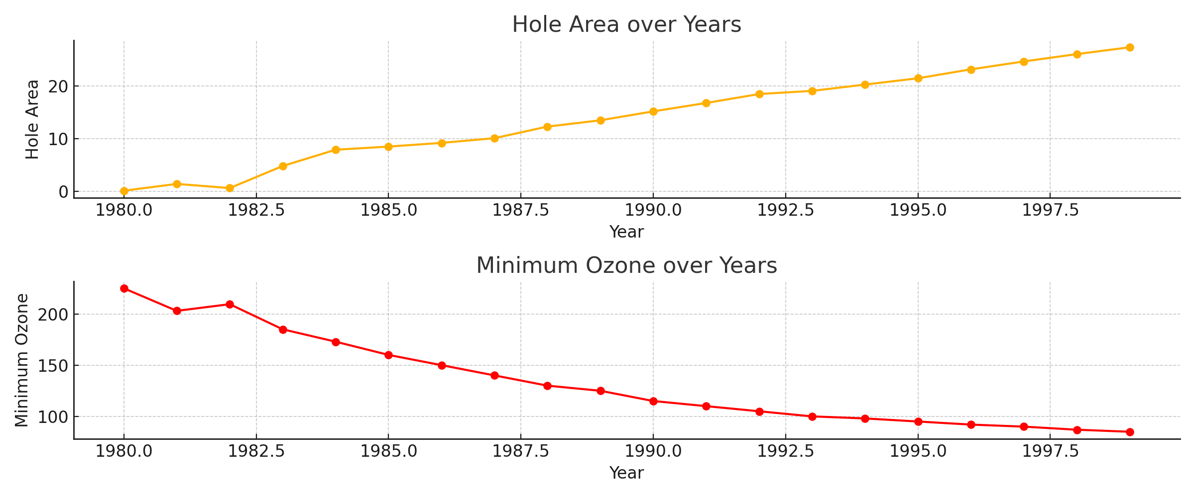

## 4. Performing the Stationarity Test

Explanation:  
The Augmented Dickey-Fuller (ADF) test is used to check if the time series is stationary. A p-value less than 0.05 indicates stationarity.

Corresponding Code:

def check_stationarity(series, column_name):  
 result = adfuller(series)  
 print(f"{column_name} - ADF Statistic: {result[0]}, p-value: {result[1]}")  
  
check_stationarity(df["Hole Area"], "Hole Area")  
check_stationarity(df["Minimum Ozone"], "Minimum Ozone")

## 5. Conclusion

Result:  
The ADF test results determine whether the time series data is stationary or not. If the p-value is below 0.05, the data is stationary.