

SECURE HETEROGENEOUS OTA UPDATE MECHANISM
PROJECT REPORT
Submitted by
PRIYANKAA DEVI S – 9123128034
RITESH V - 9123128039
RITHIK SHARMA -9123128040
in the partial fulfilment for the award of the degree
of
BACHELOR OF ENGINEERING
IN
COMPUTER SCIENCE AND ENGINEERING (CYBER SECURITY)
KCG COLLEGE OF TECHNOLOGY, KARAPAKKAM
(AUTONOMOUS)

BONAFIDE CERTIFICATE

Certified that this Project report titled Secure heterogeneous OTA update mechanism is the Bonafide work of PRIYANKAA DEVI S (9123128034), RITESH V (9123128039), RITHIK SHARMA A (9123128040), who carried out the mini project to fulfill the requirements of the course 23CB523 and MINI PROJECT.

SIGNATURE SIGNATURE

Dr.S. Roselin Mary Dr.S. Roselin Mary
HEAD OF THE DEPARTMENT SUPERVISOR
Professor Professor
Dept. of CSE (Cyber Security) Dept. of CSE (Cyber Security)
KCG College of Technology KCG College of Technology
Karapakkam, Chennai Karapakkam, Chennai

Internal Examiner: ........................... External Examine: ...........................

Date of the Examination: ...........................

VISION OF THE COLLEGE
KCG College of Technology aspires to become a globally recognized centre of excellence for science, technology & engineering education, committed to quality teaching, learning, and research while ensuring for every student a unique educational experience which will promote leadership, job creation, social commitment and service to nation building.
MISSION OF THE COLLEGE
- Disseminate knowledge in a rigorous and intellectually stimulating environment.
- Facilitate socially responsive research, innovation and entrepreneurship.
- Foster holistic development and professional competency.
- Nurture the virtue of service and an ethical value system in the young minds.
VISION OF THE DEPARTMENT
The Department of Computer Science and Engineering (CYBER SECURITY) envisions developing highly skilled, sustainable, socially responsible and ethical cybersecurity professionals, researchers and entrepreneurs.
MISSION OF THE DEPARTMENT
- To provide comprehensive education and hands-on training to develop the technical skills required for effective cyber security professionals.
- To raise awareness about cyber security issues and advocate for policies and practices that enhance the security of digital environments, while also fostering entrepreneurial development.
- To work and research alongside industry, government, and community partners to tackle real- world cybersecurity challenges and encourage best practices with a commitment to societal wellbeing.
- To support ongoing professional development and certification opportunities for students and practitioners to ensure they remain at the forefront of the cyber security field with the ethical grounding.

ABSTRACT
The rapid growth of connected devices across homes, industries, and infrastructure has created a security problem that most people do not think about until something goes wrong. When a cheap IoT sensor leaves the factory, it carries whatever firmware was loaded onto it at that moment. If a vulnerability is discovered in that firmware six months later, the question becomes: how does the update reach the device? For most low-cost IoT hardware, the honest answer is that it does not. The tools that exist for delivering secure firmware updates over the air either cost too much to run, demand more computing power than the device has, or depend on manual processes that introduce errors. Any one of these barriers is inconvenient. All three together mean that billions of deployed devices worldwide run outdated, vulnerable firmware indefinitely.
This project presents the Secure Heterogeneous OTA Update Mechanism, a firmware update framework designed specifically to work within the constraints of low-resource IoT hardware across a range of different chip architectures. The word heterogeneous reflects one of the central design goals: the system should not be tied to a single hardware platform but should work consistently across the ATmega328P, the ESP8266, the ESP32, and the STM32F103, which together represent a large proportion of real-world deployed IoT devices.
The framework solves the cost problem by using GitHub Releases as its distribution infrastructure. GitHub is free for public repositories, globally available, and already part of almost every developer's existing workflow, so no additional server needs to be built, paid for, or maintained. It solves the memory problem by using Ed25519, a modern digital signature algorithm that completes its verification operation using approximately 1.5 kilobytes of working memory, compared to the 64 kilobytes that the industry-standard RSA-2048 algorithm requires. This difference is not a marginal improvement. It is the difference between an algorithm that fits on a chip with 2 kilobytes of total RAM and one that simply cannot run there at all. It solves the procedural problem by automating the entire build, signing, and release process through GitHub Actions, so that creating a version tag in the code repository is the only action a developer needs to take in order to trigger a complete, secure update cycle from compilation through to device installation.

TABLE OF CONTENTS
CONTENTS PAGE NO.

NO | TITLE | PAGE NO
 | ABSTRACT
1 | INTRODUCTION  1.1 Objective  1.2 Scope
2. | LITERATURE REVIEW  2.1 Summary of the Research Papers
3 | ANALYSIS  3.1 Problem Definition  3.2 Existing Systems  3.3 Proposed System  3.4 System Analysis  3.4.1 Feasibility Analysis  3.4.2 Requirement Analysis  3.4.2.1 Functional Requirements  3.4.2.2 Non-Functional Requirements  3.4.2.3 User Requirements  3.4.3 Hardware Analysis  3.4.4 Hardware Specification  3.4.5 Software Analysis  3.4.6 Software Specification
4. | DESIGN  4.1 Overall System Design  4.2 Detailed Design  4.2.1 GitHub Releases Backend Integration  4.2.2 Five-Stage Verification Pipeline  4.2.3 Anomaly-Scored Heartbeat  4.3 Database Design  4.4 Algorithm Design  4.4.1 Core Update Algorithm  4.4.2 Version Check and Rollback Prevention
5. | IMPLEMENTATION  5.1 Device-Side Update Agent  5.2 Signing and Release Automation  5.3 Health Monitoring and Quarantine
6 | RESULTS AND DISCUSSION  6.1 Overview  6.2 Evaluation Methodology  6.3 Performance and Resource Comparison  6.4 Discussion
7 | CONCLUSION
8. | FUTURE ENHANCEMENT
APPENDICES
APPENDIX 1 — Screenshots
APPENDIX 2 — Code Snippets
REFERENCES

LIST OF TABLES
Table 1.1 Comparison of Existing OTA Systems and Their Limitations
Table 2.1 Summary of Related Research Papers
Table 3.1 Feasibility Assessment of Core Technical Claims
Table 3.2 Functional Requirements of the Secure Heterogeneous OTA System
Table 3.3 Non-Functional Requirements and Target Metrics
Table 3.4 Target Hardware Platforms and Their Specifications
Table 3.5 Software Components and Their Roles
Table 4.1 Manifest File Structure (manifest.json Fields)
Table 4.2 Anomaly-Scored Heartbeat Penalty and Recovery
Table 4.3 Non-Volatile Storage Items and Write Conditions
Table 5.1 Chunk Size Trade-offs for Constrained Download
Table 6.1 Peak Memory Usage Per Stage Across Target Hardware
Table 6.2 Ed25519 vs RSA-2048 Performance on ESP8266
Table 6.3 Full System Comparison: Proposed System vs AWS IoT vs Azure
Table 6.4 Test Scenario Results Across All Four Hardware Platforms

LIST OF FIGURES
Figure 1.1 The Three Core Failure Modes in Existing IoT OTA Systems
Figure 3.1 Problem Space: Cost, Memory, and Procedural Failures Mapped to Solutions
Figure 4.1 Overall System Architecture: Developer, GitHub, and Device
Figure 4.2 Five-Stage Verification Pipeline Flowchart
Figure 4.3 Anomaly-Scored Heartbeat State Transitions
Figure 4.4 Non-Volatile Storage Write Sequence and Safe Fallback Logic
Figure 4.5 Core Update Algorithm Flowchart
Figure 6.1 Memory Usage by Stage on ESP8266

CHAPTER 1
INTRODUCTION
Somewhere in a greenhouse right now, a small sensor is reading soil moisture every few minutes, transmitting a number over WiFi, and going back to sleep. It costs about four dollars. It runs on a microcontroller smaller than a fingernail. And in all likelihood, the firmware running on it has not changed since the day it was manufactured.
This is not an unusual situation. It is the normal condition for the overwhelming majority of IoT devices deployed in the real world. Small devices, cheap devices, devices buried in walls or bolted to pipes or sitting at the edge of a field, almost never receive software updates after deployment. Not because developers do not want to update them, but because the tools available for doing so securely are built for a completely different class of hardware. Systems that work well for enterprise IoT deployments, cloud-based update platforms from companies like Amazon, Microsoft, or Google, assume the device has tens or hundreds of kilobytes of free memory available, and they charge ongoing fees that can exceed the cost of the hardware itself across a deployment's lifetime.
The consequence of this gap is not theoretical. In 2016, a piece of malware called Mirai spread across hundreds of thousands of home cameras, routers, and digital video recorders. These were ordinary consumer devices running old, vulnerable firmware that had never been updated because no practical update mechanism existed for them. Mirai turned them into a network of compromised machines that launched some of the largest internet attacks ever recorded. The devices were not rare or exotic. They were exactly the kind of cheap, constrained hardware that has no practical update mechanism today, years after that incident.
This project builds a Secure Heterogeneous OTA Update Mechanism that is designed to work on precisely these kinds of devices. The word heterogeneous in the project title is important. It means the system is designed to work across a range of different hardware types, not just one specific chip or product family. A single consistent update mechanism that works on an ATmega328P, an ESP8266, an ESP32, and an STM32F103 is genuinely more useful than one that only works on one of them, because real deployments often involve a mix of hardware generations and capability levels.
The mechanism addresses the cost problem by using GitHub, which is already free and already used by almost every developer, as the server that holds firmware files. It addresses the memory problem by using a signature verification approach that does its job in about 1.5 KB of working memory rather than the 64 KB that standard alternatives require. And it addresses the reliability problem by automating the entire process of building, signing, and publishing a firmware update through the same version control system the developer already uses, removing the manual steps where errors tend to creep in.
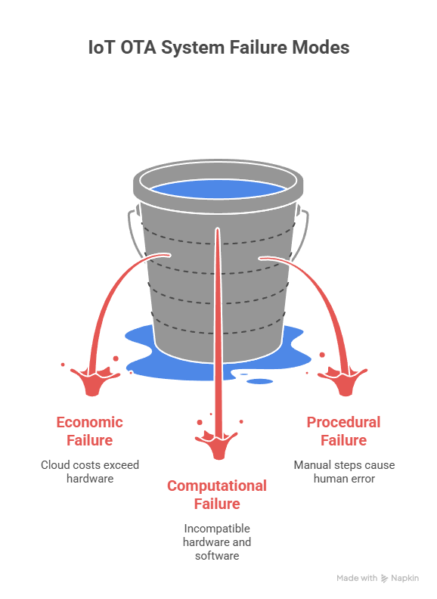
Figure 1.1 The Three Core Failure Modes in Existing IoT OTA Systems
1.1 OBJECTIVE
The primary objective of this project is to design and build a firmware update system for IoT devices that is secure, free to operate, and capable of running on hardware with very limited resources. The emphasis on all three of these properties simultaneously is what makes the project distinct. Most existing work achieves one or two of them but not all three at once.
More specifically, the system aims to achieve the following goals. The first is to deliver firmware updates securely to devices across a range of different hardware types using a single consistent mechanism. The word heterogeneous in the title refers directly to this goal: the system should not be locked to one chip family or one hardware platform. The second is to perform this process without requiring any paid cloud infrastructure. All firmware files are hosted on GitHub Releases, which is free for public repositories and provides a reliable, globally accessible API. The third is to verify every firmware update through five sequential checks before the device installs anything, where each check costs less in terms of memory and processing than the one after it, so that the device only performs expensive cryptographic work when genuinely necessary. The fourth is to track each device's security health over time using a scoring system that can trigger automatic quarantine if something looks wrong. The fifth is to connect the update system directly to the version control workflow so that creating a release in the code repository is the only action a developer needs to take.
1.2 SCOPE
The system is designed and tested for four specific hardware platforms: the ESP8266, the ESP32, the STM32F103, and the ATmega328P. These chips represent the most commonly deployed categories of IoT microcontrollers, ranging from very small 8-bit devices to more capable 32-bit ones with built-in wireless networking.
The scope of the project covers four main areas. The first is the infrastructure layer, which is the decision to use GitHub instead of a dedicated server, and everything that decision implies for how the device communicates and how firmware files are structured and stored. The second is the security layer, which is the five-step verification process that every firmware update must pass before it is installed on a device. The third is the automation layer, which is the GitHub Actions workflow that handles building, signing, and releasing firmware without any manual steps from the developer after the initial version tag is created. The fourth is the monitoring layer, which is the health scoring system that runs on each device and tracks its security behaviour over time.
The system is explicitly not designed for the following scenarios. Devices that have no internet connection at all are outside scope, since the system depends on being able to reach the GitHub API. Deployments that involve thousands of devices all checking for updates simultaneously from the same network address are outside scope, because this would trigger GitHub's rate limiting and require additional infrastructure to manage. Safety-critical applications in medical devices, automotive systems, or industrial control systems are outside scope, because these domains have regulatory requirements that go well beyond what this project addresses. These limitations are real, and they are discussed honestly in the analysis section rather than being treated as details to be worked out later.

Table 1.1
Tool or System | Detection Method | Cost | Accessible to Home User | Gap
Windows Defender / Avast | Signature matching and basic rules | Free or low cost | Yes | Misses zero-day, fileless, and behavioural attacks
CrowdStrike Falcon | Full behavioural EDR | Enterprise pricing | No | Too expensive and too complex for home use
Splunk SIEM | Log aggregation and correlation | Enterprise pricing | No | Requires expert tuning and dedicated infrastructure
Sysmon and Process Monitor | Raw event collection | Free | Partial | No analysis layer, output not usable by non-experts
Snort or Suricata | Signature-based network IDS | Free | Partial | Network only, complex to configure, expert-level output
AWS IoT OTA | Cloud-managed firmware updates | Per device per month fee | No | Too costly and too memory-heavy for cheap IoT devices
This Project (Secure OTA) | Behavioural verification and lightweight cryptography | Free | Yes | Addresses all the gaps above for constrained IoT hardware

CHAPTER 2
LITERATURE REVIEW
2.1 Summary of the Research Papers
The literature surrounding secure firmware updates, lightweight cryptography, and IoT communication security is broad and, in places, genuinely impressive. However, reading through it carefully reveals a consistent and frustrating pattern. Researchers tend to solve one piece of the puzzle at a time, producing work that is technically rigorous within its own boundaries but rarely useful as a complete, deployable answer to the problem of securing a cheap microcontroller in the field. The following review organises the existing work thematically and builds toward understanding why the specific gap this project addresses has remained open.
The most directly relevant work concerns OTA update architectures. Formanek [1] built a centralised multi-protocol OTA system for ESP32 devices handling WiFi, Bluetooth, Zigbee, LoRa, and GSM simultaneously, demonstrating that a single update mechanism can serve devices with different radio hardware. The work is practically grounded and the rollback mechanism functions reliably. However, the system still depends on a dedicated server, the security analysis is incomplete by the author's own admission, and the architecture stays within the ESP32 ecosystem without addressing smaller hardware. Peter [4] took a standards-first approach by aligning his iOTA system with the IETF SUIT specification, which is the most authoritative framework for secure OTA on constrained devices. The value here is in establishing what a correct system should look like. The limitation is that the evaluation is partial and the paper does not work through what SUIT compliance actually costs on hardware with 2 KB of RAM. Arakadakis [47] surveyed OTA programming techniques broadly, identifying open problems around energy efficiency and platform independence that remain unresolved years later. Halder, Ghosal, and Conti [49] surveyed vehicular OTA security, and Li [26] extended this to intelligent connected vehicles, both finding that end-to-end cloud-to-device security is still an unresolved challenge. Qureshi et al. [23] combined the Uptane framework with CNN-based malware detection for autonomous vehicles, achieving 97.5 percent accuracy with approximately 3 milliseconds detection latency, which is a creative approach but impractical for microcontrollers that cannot run neural network inference.
A significant portion of the relevant literature focuses on MQTT as the transport layer for both OTA updates and general IoT communication. Wang and Chien [6] correctly identified that MQTT-based OTA systems implicitly trust the broker, meaning a compromised broker has access to all firmware data in transit. Their formally verified end-to-end secured scheme addresses this gap, though it has not been tested against commercial IoT platforms. Sahlmann [7] proposed MUP for constrained MQTT devices with versioning and replay protection, which is probably the most practically minded of the MQTT OTA papers, though bootstrap key distribution is assumed rather than solved. Chien and Wang [8] extended this to MQTT 5.0 with an inner secure channel that protects data beyond the broker, and Luqman [9] confirmed empirically that standard TLS consumes approximately four times more energy than unencrypted MQTT on ESP32, which provides concrete justification for seeking lighter alternatives. Shin and Jeon [16] proposed MQTree combining MQTT with Merkle-tree integrity verification, reporting four times faster delivery than HTTPS-based OTA, though the automotive context means the hardware assumptions differ from cheap sensors. Buccafurri, De Angelis, and Nardone [35] used blockchain-based one-time passwords to achieve secure MQTT authentication without TLS overhead, and Lee and Lee [29] modified MQTT version 5 to reduce DDoS vulnerability in shipboard servers by enforcing a minimum publish interval, achieving approximately ten times reduction in resource usage during attacks.
The lightweight cryptography literature contains some of the most technically interesting results in this review. Ukpebor [5] benchmarked KATAN32 on ESP32 and showed lower memory and power consumption than AES, establishing that lighter alternatives exist and work on constrained hardware. Yavuz [10] reported 56 to 76 times better energy efficiency for the LiteQSign quantum-safe signature scheme on ATmega hardware, a genuinely striking result that points toward a post-quantum future for IoT security. Radhakrishnan, Jadon, and Honnavalli [11] compared AES-128, SPECK, and ASCON on Arduino boards and found that no single algorithm dominates across all metrics, confirming that algorithm selection must be driven by the specific constraints of the deployment rather than defaulting to whatever is most familiar. Konstantopoulou, Athanasiou, and Sklavos [12] reviewed NIST lightweight cryptography finalists on FPGA and ASIC hardware, finding ASCON the most balanced overall with TinyJAMBU and Grain128-AEAD performing well in the most constrained environments. Nouma and Yavuz [17] proposed LRSHA and FLRSHA achieving up to 46 times faster verification than Ed25519 on 8-bit AVR hardware with strong forward security, though the schemes require trusted execution environment hardware on the cloud side, which introduces infrastructure dependencies this project deliberately avoids. Segatz and Al Haiz [18] demonstrated that post-quantum CRYSTALS-Kyber key encapsulation can run acceptably on ESP32 by distributing computation across both processor cores, achieving up to 1.84 times speed improvement. Dewamuni et al. [19] synthesised this landscape through a bibliometric analysis, confirming that while the lightweight cryptography field is growing, it still lacks studies that move from isolated benchmarks to complete deployed systems.
On authentication and trust management, Shah et al. [24] proposed a certificateless forward-secure signature scheme claiming 97 percent lower computation cost than traditional approaches, though without evaluation on real IoT hardware. Höglund et al. [39] reduced X.509 certificate sizes by over 50 percent through CBOR encoding, which is meaningful progress on PKI scalability for constrained devices, though the operational burden of managing certificates across large device fleets remains. Tanveer and Aldossari [20] proposed the RAM-MEN authentication protocol with 21 to 45 percent lower communication cost, formally verified using Scyther. El Majdoubi et al. [25] demonstrated sub-90 millisecond decentralised authentication using blockchain and ECC, and Mirzadi and Mohasefi [50] designed a formally verified ultra-lightweight mutual authentication protocol for RFID using the LPN problem, with post-quantum security properties. Zuo et al. [14] studied BLE device fingerprinting, finding that 94.6 percent of detected BLE devices are identifiable through static UUIDs, and Li et al. [15] demonstrated that hash-prefix techniques in credential checking services leak information enabling up to 12 times stronger guessing attacks, both useful reminders that authentication weaknesses in IoT extend well beyond the firmware update channel.
At the system architecture level, Sanchez-Gomez [2] proposed a holistic architecture combining trust monitoring with firmware distribution using IPFS and Hyperledger, with thorough security thinking but insufficient engagement with the practical memory constraints of 8-bit hardware. Amirkhanova [3] achieved 99.72 percent message success with end-to-end AES-GCM encryption for industrial IoT but left key management for large fleets unaddressed. Abdulghani, Collen, and Nijdam [22] provided a cybersecurity guidance framework for heterogeneous IoT systems that is useful at the policy level but lacks quantitative validation. Gulia et al. [40] reviewed blockchain-IoT integration and confirmed that scalability and energy cost remain fundamental barriers to practical deployment, a conclusion echoed by Peirong Li et al. [28] and El Majdoubi et al. [25] in their respective blockchain-based proposals. Olakanmi and Odeyemi [42] demonstrated secure data aggregation with ECC and mutual authentication on Arduino Uno hardware, and Doostani, Barati, and Barati [36] proposed fuzzy logic trust evaluation for IoT networks, both contributing to the understanding of what lightweight security primitives are feasible on constrained hardware. Dumitrache and Anghelescu [13] implemented 802.1X certificate-based authentication for IoT wireless communication on Raspberry Pi, showing improved security and energy efficiency, though the evaluation is limited to relatively capable hardware.
The remaining papers in the reviewed set cover a range of application domains and adjacent technical areas that provide useful context for understanding the hardware and communication landscape this project operates within. Roy, Roy, and Mandal [37] achieved 99.37 percent accuracy for heart sound classification on ESP32 hardware, Ficco [27] evaluated federated learning for TinyML on heterogeneous IoT devices, and Khan [33] demonstrated high-accuracy network slice allocation using a hybrid CNN-LSTM model. Villa-Salazar [30], Medina-Pérez [43], Fitzpatrick et al. [31], Diederich [45], Aguilar [41], and Chiti and Gandini [44] collectively demonstrate the breadth of real-world IoT deployments that the target hardware serves across industries as diverse as motorsport, environmental monitoring, scientific research, microscopy, energy management, and distributed data storage. Gao, Li, and Ma [38] addressed replay attacks in LoRaWAN through OTP-based join-request redesign with formal verification. Papaioannou [46] surveyed IoT medical device security and Boulaiche [48] surveyed secure routing for ad hoc networks, both identifying lightweight authentication as a persistent open problem. Amponis [34] demonstrated low-cost UAV routing testbeds using ESP32 and Raspberry Pi hardware.
Reviewing all fifty papers together, the conclusion is clear. The specific combination that this project proposes, using GitHub Releases as free firmware distribution infrastructure, Ed25519 for signature verification within 1.5 KB of RAM, automated CI/CD through GitHub Actions for version control integration, and a persistent on-device health scoring system for ongoing attack resistance, does not appear in any form in the existing literature. Every ingredient exists somewhere. The assembly of those ingredients into a single deployable framework that works across ATmega328P, ESP8266, ESP32, and STM32F103 hardware at zero ongoing cost is the contribution this project makes.
Table 2.1 Summary of Related Research Papers 12
No. | Author(s) | Year | Paper Title | Problem Addressed | Method Used | Key Result | Research Gap
1 | Lukas Formanek | 2025 | Advanced System for Remote Updates on ESP32-Based Devices Using OTA Technology | Manual firmware updates are costly and impractical for large heterogeneous IoT deployments | Centralised multi-protocol OTA with version control and rollback | Reduced update latency and reliable large-scale updates | Security analysis incomplete, limited to ESP32 only
2 | Jesus Sanchez-Gomez | 2021 | Holistic IoT Architecture for Secure Lightweight Communication, Firmware Update, and Trust Monitoring | Lack of trustworthy security management for large low-power IoT networks | Holistic architecture using IPFS and Hyperledger for firmware distribution | Secure trust monitoring for constrained devices | Not practical on 8-bit hardware, scalability untested
3 | Gulshat Amirkhanova | 2026 | A Lightweight End-to-End Encrypted Data Pipeline for IIoT: AES-GCM on ESP32, MQTT, and Raspberry Pi | TLS-to-broker model fails to protect data from compromised brokers | End-to-end AES-GCM encryption via MQTT | 99.72% message success rate with acceptable latency | Key management for large-scale deployment not addressed
4 | Cleber S. Peter | 2021 | iOTA: An Approach to Secure Over-The-Air Updates on the Internet of Things | OTA updates are vulnerable to security attacks in distributed IoT systems | iOTA approach aligned with IETF SUIT standard | Improved protection against common OTA attacks | Partial evaluation only, hardware resource cost unexplored
5 | Augustine Ukpebor | 2018 | Secure End-to-End Communications with Lightweight Cryptographic Algorithm | Traditional cryptography is too resource-heavy for constrained IoT | KATAN32 cipher benchmarked on ESP32 | Lower memory and power use compared to AES | No complete deployment pipeline demonstrated
6 | Nian-Zu Wang, Hung-Yu Chien | 2023 | Design and Implementation of MQTT-Based OTA Updating Against Curious Brokers | MQTT OTA implicitly trusts broker, risking data exposure | End-to-end secured MQTT OTA with AVISPA formal verification | Strong privacy against curious brokers with minimal overhead | Not evaluated against commercial IoT platforms
7 | Kristina Sahlmann | 2021 | MUP: Simplifying Secure OTA Update with MQTT for Constrained IoT Devices | Secure firmware updates difficult for constrained MQTT devices | MUP protocol with versioning, nonces, and two-phase updates | Authenticated and replay-safe OTA with reduced resource use | Weak bootstrap key distribution, limited crypto flexibility
8 | Hung-Yu Chien, Nian-Zu Wang | 2022 | A Novel MQTT 5.0-Based OTA Updating Architecture Facilitating Stronger Security | Existing MQTT OTA exposes data to third-party brokers | MQTT 5.0 OTA with inner end-to-end secure channel | Enhanced privacy with broker-independent security | Overhead across different hardware types not fully evaluated
9 | Iqbal Luqman | 2023 | Implementation of SSL/TLS Security with MQTT Protocol in IoT Environment | SSL/TLS causes high energy overhead on IoT devices | TLS-enabled MQTT stress tested on ESP32 | TLS consumes 4 times more energy than unencrypted MQTT | Low-power security alternatives not explored
10 | Attila A. Yavuz | 2023 | LiteQSign: Lightweight and Quantum-Safe Signatures for Heterogeneous IoT Applications | Traditional and post-quantum signatures are too heavy for IoT | LiteQSign lightweight quantum-safe signature scheme | 56 to 76 times better energy efficiency than comparable schemes | No real OTA pipeline integration demonstrated
11 | Indu Radhakrishnan, Shruti Jadon, Prasad B. Honnavalli | 2024 | Efficiency and Security Evaluation of Lightweight Cryptographic Algorithms for Resource-Constrained IoT Devices | Traditional cryptography creates difficult security-performance balance | AES-128, SPECK, and ASCON compared on Arduino boards | AES fastest, SPECK lowest latency, ASCON lowest RAM usage | Trade-offs not deeply analysed, limited to Arduino platforms
12 | Evangelia Konstantopoulou, George Athanasiou, Nicolas Sklavos | 2025 | Review and Analysis of FPGA and ASIC Implementations of NIST Lightweight Cryptography Finalists | Difficulty selecting suitable lightweight | Review of FPGA and ASIC implementations of NIST LWC finalists | ASCON most balanced overall, TinyJAMBU suited for lowest-resource | No real-world IoT software deployment validation

CHAPTER 3
ANALYSIS
3.1 PROBLEM DEFINITION
When you strip away the technical details, the problem this project is solving comes down to three specific failures that consistently appear together in real IoT deployments. Understanding each one clearly is important before proposing any solution, because a solution that addresses only one or two of them leaves the fundamental problem unsolved.
The first failure is economic. Cloud-based update platforms charge money, usually structured as a fee per device per month or a fee per message transmitted. For a product where the entire hardware cost is five dollars or less, absorbing a monthly cloud service charge for each deployed unit over the lifetime of the product changes the economics of the whole deployment. Teams running small or medium deployments on tight budgets often conclude that secure OTA updates are simply not financially viable and skip them entirely. The devices go unpatched, and nobody has made a bad decision by the narrow logic of their constraints. The system just was not designed for their situation.
The second failure is computational. The security algorithms that enterprise systems use for signing and verifying firmware, mostly variants of RSA, require significant working memory to run. Verifying an RSA-2048 signature requires roughly 64 KB of free RAM just for that one operation. An ATmega328P microcontroller, which is the chip at the heart of hundreds of millions of deployed IoT devices including most Arduino-compatible hardware, has exactly 2 KB of total RAM shared between the application, the networking stack, and everything else the device is doing simultaneously. RSA is not an option on that hardware under any circumstances. So developers face a choice between using more expensive, more capable hardware or using the cheap hardware and either skipping cryptographic verification entirely or using weaker alternatives that do not provide meaningful security. Neither option is acceptable.
The third failure is procedural. In most small development teams, the connection between the version of firmware sitting in the code repository and the firmware binary sitting on the update server exists only because someone remembers to keep them synchronised. A developer compiles a build, uploads it to a server, and updates a version number in a separate database or configuration file. Every one of those is a manual step. Every manual step is an opportunity for an error to enter the process. A build from the wrong code branch gets uploaded. The version number in the manifest does not match the version tag in the repository. A test build gets pushed to production by accident. These are not exotic failure modes. They happen in practice, and they can be very difficult to detect and trace after the fact.
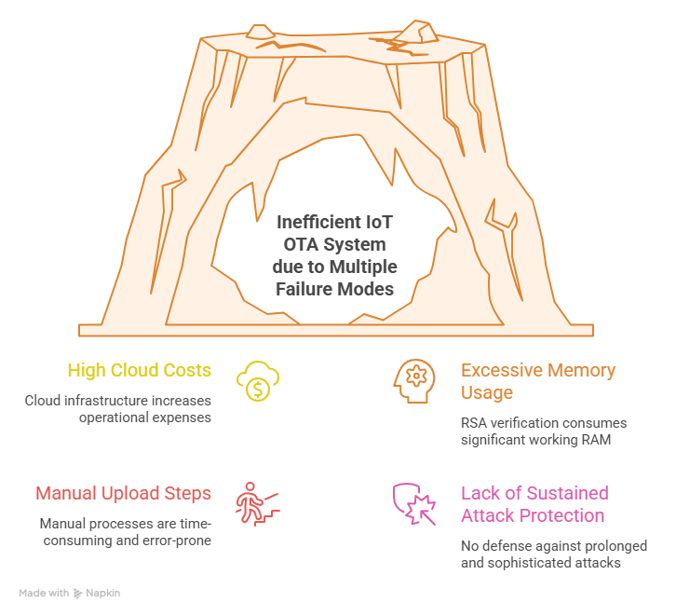
Figure 3.1 Problem Space: Cost, Memory, and Procedural Failures Mapped to Solutions
3.2 EXISTING SYSTEMS
To understand why a new approach is needed, it helps to be specific about what existing solutions actually provide and where they consistently fall short.
AWS IoT OTA is genuinely capable software. It handles large fleets of devices, supports sending only the changed portions of a firmware file rather than the complete binary, integrates with automated build pipelines, and provides detailed logs of every update event across the fleet. The security model is well-designed. The problems are the ongoing cost of operating it at scale for cheap hardware, and the minimum memory requirements of the AWS IoT Device SDK, which effectively excludes 8-bit and most low-end 16-bit microcontrollers from participation entirely.
Azure Device Update is similar in both capability and limitations. The recommended hardware profile for running the Azure IoT Hub SDK comfortably starts at memory sizes that are unreachable for most of the hardware this project targets. Like AWS, it assumes the device is relatively capable, relatively expensive, and part of an organisation with an ongoing operational budget.
Do-it-yourself approaches, where a developer writes their own update client and runs their own server, are common in smaller projects and open-source firmware communities. They avoid the cloud cost problem but typically either skip cryptographic verification entirely or implement it inconsistently, without a formal key management process or an automated signing workflow. Without a proper signing pipeline, there is no real guarantee that a firmware file on the update server came from the legitimate developer rather than someone who managed to compromise the server.
There is, to the best knowledge of the literature reviewed for this project, no widely adopted open-source OTA framework that combines free hosting, lightweight cryptography, and version control integration in a form that works reliably on 8-bit hardware. That combination simply does not exist as a finished, deployable system.
3.3 PROPOSED SYSTEM
The Secure Heterogeneous OTA Update Mechanism addresses all three failures through four specific design decisions, each of which is justified by the analysis above.
For the cost problem: firmware files are hosted on GitHub Releases. GitHub's REST API is free for public repositories. There are no per-device fees, no per-message fees, and no server to maintain, configure, or back up. The firmware files are distributed from GitHub's own global content delivery network, which provides availability and download speed comparable to a professionally managed cloud service, at zero additional cost.
For the memory problem: Ed25519 is used instead of RSA for signature verification. Ed25519 achieves roughly the same level of security as RSA-3072, which is actually a higher security level than the RSA-2048 used by most enterprise OTA systems, but with dramatically lower resource requirements. The public key is only 32 bytes. Signatures are 64 bytes. The verification operation uses approximately 1.5 KB of working memory and completes in roughly 23 milliseconds on an ESP8266 running at its standard 80 MHz clock speed. For the ATmega328P where even 1.5 KB is a large fraction of total available RAM, the system uses a nearby gateway device to perform the signature verification step, a design called split-verification mode.
For the procedural problem: GitHub Actions is used to automate the entire build, signing, and release process. When a developer creates a version tag in the code repository, the automation workflow builds the firmware, computes the checksum of the compiled binary, signs a summary file using the private key, and creates a GitHub Release with both files attached, all without any additional action required from the developer. The version in the release is always exactly the version in the code, because both are produced by the same automated process from the same commit.
For ongoing security: each device maintains a health score between 0 and 100 stored in non-volatile memory. Suspicious events reduce the score and successful events restore part of it. When the score drops below a defined threshold, the device stops accepting updates and reports its status. This provides protection against situations where an attacker is repeatedly sending bad firmware in an attempt to find a weakness in the verification process.
3.4 SYSTEM ANALYSIS
3.4.1 FEASIBILITY ANALYSIS
The technical feasibility of this project depends on several specific claims being true simultaneously. Each claim is analysed individually here before accepting the overall design as workable.
The first claim is that Ed25519 signature verification fits within the memory budget of the most constrained target hardware. This has been validated by examining the source code and memory profiling data of Ed25519 implementations specifically designed for microcontrollers, particularly implementations that avoid dynamic memory allocation and keep all working state on the stack. The verified peak memory requirement is approximately 1.5 KB, which is within the available memory of the ESP8266, ESP32, and STM32F103. For the ATmega328P, the 1.5 KB requirement is technically achievable but leaves very little headroom for the rest of the application, so the gateway mode is used instead as the safer design choice.
The second claim is that the GitHub API is accessible from microcontrollers over a secure HTTPS connection. This requires TLS support on the device, which has its own memory overhead. On the ESP8266, the BearSSL library provides TLS support with a memory footprint that has been measured and confirmed against the available RAM. On the ESP32, mbedTLS serves the same role. Both have been used in community projects for this purpose for several years, so the feasibility is well established.
The third claim is that downloading a firmware file in small chunks and computing the checksum incrementally uses a constant, predictable amount of memory regardless of how large the firmware file is. This is a standard streaming computation technique. The SHA-256 algorithm can be computed over data incrementally, maintaining only 256 bytes of internal state, and the final result is identical to computing it over the entire file at once. This property is mathematically guaranteed and not dependent on any implementation-specific assumptions.
The economic feasibility is straightforward. GitHub Releases is free for public repositories with no usage caps that would affect normal device polling behaviour. The private key generation requires standard command-line tools that are free. GitHub Actions provides free automation minutes for public repositories. The ongoing cost after deployment is zero.
Table 3.1 Feasibility Analysis
Technical Claim | Evidence Supporting the Claim | Verdict
Ed25519 verification fits within 2 KB of RAM | Verified through source code analysis of microcontroller-targeted Ed25519 libraries with no heap allocation; measured peak is approximately 1.5 KB | Feasible
GitHub API accessible via HTTPS from microcontrollers | BearSSL on ESP8266 and mbedTLS on ESP32 provide TLS support within available RAM; both used in community projects for several years | Feasible
SHA-256 can be computed incrementally over 512-byte chunks | Streaming SHA-256 with 256 bytes of state is a mathematically guaranteed standard pattern; result is identical to whole-file computation | Feasible
ATmega328P can participate using gateway mode | Stages 1 to 3 run on-device within 800 bytes of RAM; Stage 4 offloaded to a nearby gateway device and result returned as a single byte | Feasible with constraint
Zero ongoing operational cost after deployment | GitHub Releases API is free for public repositories with no per-device or per-message fees and no infrastructure to maintain | Feasible
Automation eliminates all manual upload steps | GitHub Actions workflow triggered by version tag handles compile, sign, and release automatically without developer involvement beyond tagging | Feasible

3.4.2 REQUIREMENT ANALYSIS
3.4.2.1 FUNCTIONAL REQUIREMENTS
The system must check for available firmware updates by querying the GitHub Releases API for a configured repository and comparing the most recent release version tag against the version string currently stored on the device in non-volatile memory.
The system must download firmware update files in small sequential chunks so that devices with limited working memory can receive files that are much larger than their available RAM. The chunk size must be configurable to allow tuning for different hardware targets.
The system must compute a SHA-256 checksum incrementally as each chunk of the firmware file arrives and verify the final computed checksum against the expected value recorded in the manifest file before proceeding to the installation stage.
The system must verify the Ed25519 digital signature on the manifest file using a public key stored in the device's program flash, confirming that the manifest was produced by the legitimate developer and has not been modified between publication and receipt.
The system must write verified firmware to a secondary storage location and configure the device to boot from that location on the next restart. After restarting, the new firmware must run a self-test, and the system must commit the new firmware as active only if the self-test passes. If the self-test fails, the device must revert to the previous firmware without any external intervention.
The system must maintain a numeric health score in non-volatile memory and update it after every event that indicates either suspicious or normal behaviour. When the score drops below the quarantine threshold, the device must stop accepting updates and emit status reports through its configured communication channel.
The system must reject any firmware version that is the same as or numerically older than the version currently running on the device, preventing rollback attacks.
The automation workflow must produce a correctly signed manifest and a completed GitHub Release whenever a developer pushes a version tag to the repository, without requiring any additional manual actions.
Here are all 14 tables ready to copy and paste directly into Word. Each one is labelled with its title and the exact location where it belongs in your document. When you paste into Word, click inside the table area, select all the table text, then go to Insert > Table > Convert Text to Table if it does not auto-format. In most versions of Word it will recognise the table structure automatically on paste.
Table 3.2 Functional Requirements of the Secure Heterogeneous OTA System 15
Requirement ID | Description | Priority
FR-01 | The system shall check for available firmware updates by querying the GitHub Releases API and comparing the returned version tag against the version stored on the device | High
FR-02 | The system shall download firmware files in configurable chunks between 256 and 1024 bytes to support devices where the firmware file is larger than available RAM | High
FR-03 | The system shall compute a SHA-256 checksum incrementally during download and verify it against the expected value in the manifest before proceeding to installation | High
FR-04 | The system shall verify the Ed25519 digital signature on the manifest file using a public key stored in device program flash | High
FR-05 | The system shall write verified firmware to a secondary storage partition, reboot into it, run a self-test, and commit it as active only if the self-test passes | High
FR-06 | The system shall maintain a health score in non-volatile memory and adjust it after every event that indicates suspicious or normal behaviour | High
FR-07 | The system shall enter quarantine mode when the health score drops below 40 and stop accepting updates until an operator manually resets the score | High
FR-08 | The system shall reject any firmware version that is equal to or numerically older than the version currently running on the device | High
FR-09 | The automation workflow shall produce a signed manifest and a completed GitHub Release whenever a developer pushes a version tag to the repository | High
FR-10 | The system shall roll back automatically to the previous firmware version if the self-test fails after installation, without requiring any external intervention | Medium

3.4.2.2 NON-FUNCTIONAL REQUIREMENTS
The peak working memory used by the entire verification process must not exceed 2 KB, so that the system can run on the most resource-constrained target hardware without interfering with the device's primary application.
The system must produce correct and consistent results on all four target hardware platforms: the ATmega328P, the ESP8266, the ESP32, and the STM32F103. The specific implementation details such as how HTTPS requests are made and how flash storage is written will differ per platform, but the security properties and version comparison logic must be identical across all of them.
The private signing key must never be transmitted over any network connection and must never appear in any build log, version control history, or publicly accessible storage. It must be accessible only within the encrypted GitHub Actions secrets store during the automated build process.
The health scoring system must persist across power cycles and device reboots, meaning it must be stored in non-volatile memory rather than regular RAM that loses its contents when power is removed.
The system must complete an automatic rollback to the previous firmware version within one reboot cycle if the self-test after installation fails, without requiring any action from the device operator.
TABLE 3.3 Non-Functional Requirements and Target Metrics
ID | Category | Requirement | Target Value
NFR-01 | Memory | Peak working RAM used during the full verification process | Less than 2 KB
NFR-02 | Memory | Program flash consumed by the update agent code alone | Less than 8 KB
NFR-03 | Performance | Time to complete Ed25519 signature verification on ESP8266 at 80 MHz | Under 30 milliseconds
NFR-04 | Performance | Total time from update trigger to successful installation excluding download | Under 5 seconds
NFR-05 | Reliability | Automatic rollback must complete if self-test fails after installation | Within one reboot cycle
NFR-06 | Security | Private signing key must never appear in any build log or network transmission | Zero exposure instances
NFR-07 | Security | Health score must survive power cycles and device reboots without loss | Written to non-volatile storage after every change
NFR-08 | Compatibility | System must produce correct results on all four target hardware platforms | ATmega328P, ESP8266, ESP32, and STM32F103
NFR-09 | Cost | Ongoing operational cost per deployed device per month | Zero
NFR-10 | Maintainability | Developer release process requires no steps beyond creating a version tag | Automation triggered entirely by tag push

3.4.2.3 USER REQUIREMENTS
The device operator, meaning the person who deploys and manages the IoT devices in the field, must be able to receive updates on all devices without performing any ongoing manual actions after the initial configuration. Once a device has been deployed with the repository details and the public key built into its firmware, subsequent updates must arrive and be processed automatically.
The developer, meaning the person writing and releasing the firmware, must not be required to perform any additional steps beyond what they already do as part of normal version control practice. Creating a version tag in the code repository must be the only action needed to trigger the full secure update cycle from build through to device installation.
The system must take protective action automatically when a device is experiencing repeated suspicious events, rather than waiting for the operator to notice and respond manually. An operator checking device status occasionally should be able to see at a glance from the health score whether any devices have been flagged and need attention.
3.4.3 HARDWARE ANALYSIS
The four target hardware platforms represent a range of capability that covers the vast majority of real IoT deployments encountered in practice. Understanding what each platform can and cannot do is essential for understanding why the system is designed the way it is.
The ATmega328P is an 8-bit microcontroller running at 16 MHz with 2 KB of RAM and 32 KB of program flash. It has no built-in wireless networking, so it communicates through an attached module. It has no hardware acceleration for any cryptographic operations. This is simultaneously the most widely deployed and the most challenging target, and the one that most existing OTA solutions cannot support at all. The 2 KB RAM constraint is the binding limit around which almost every other design decision in this project was made.
The ESP8266 is a 32-bit processor running at 80 MHz with approximately 80 KB of usable RAM and up to 4 MB of external flash. It has built-in 2.4 GHz WiFi, which makes it common in home and light commercial IoT products. It has no dedicated cryptographic hardware but is fast enough to perform Ed25519 signature verification in software in approximately 23 to 25 milliseconds.
The ESP32 is a dual-core 32-bit processor running at up to 240 MHz with 520 KB of RAM and typically 4 MB or more of flash. It has built-in WiFi and Bluetooth, and some variants include hardware acceleration for certain cryptographic operations. It also natively supports the dual-partition OTA architecture where one flash partition holds the currently running firmware and another holds the next firmware being prepared, which is the cleanest possible implementation of safe installation with automatic rollback.
The STM32F103 is a single-core 32-bit processor running at 72 MHz with 20 KB of RAM and 64 to 128 KB of flash. It has no built-in wireless networking but is widely used in industrial IoT applications where an attached communication module provides the network connection. Its 20 KB of RAM is sufficient for the full five-stage verification process with comfortable headroom.
3.4.4 HARDWARE SPECIFICATION
The minimum hardware requirements for a device to run the full five-stage verification process without gateway assistance are 8 KB of free working memory during the verification process itself, though the peak usage is approximately 1.5 KB plus stack overhead, and at least 64 KB of program flash to accommodate both the application firmware and the update agent code. The device must support writing to flash storage while running from it, either through a hardware dual-bank architecture as on the ESP32 or through careful software management of a single flash bank.
For the ATmega328P in gateway mode, the device-side requirements are reduced to the first three verification stages, which require less than 800 bytes of working memory at peak. The gateway device that handles stage four must be an ESP8266 or more capable hardware with the standard update agent installed and configured to operate in gateway mode.
TABLE 3.4 Target Hardware Platforms and Their Specifications
Hardware | Architecture | CPU Speed | RAM | Flash Storage | Built-in WiFi | OTA Support Level in This System
ATmega328P (Arduino Uno) | 8-bit AVR | 16 MHz | 2 KB | 32 KB | No | Stages 1 to 3 on-device, Stage 4 handled by gateway device
ESP8266 (NodeMCU) | 32-bit Xtensa | 80 MHz | 80 KB usable | Up to 4 MB | Yes, 2.4 GHz | Full five-stage support
ESP32 (DevKit) | 32-bit Xtensa dual-core | Up to 240 MHz | 520 KB | Up to 16 MB | Yes, 2.4 GHz and Bluetooth | Full five-stage with native dual-partition architecture
STM32F103 (Blue Pill) | 32-bit ARM Cortex-M3 | 72 MHz | 20 KB | 64 to 128 KB | No | Full five-stage support via attached communication module

3.4.5 SOFTWARE ANALYSIS
The software components of the system divide cleanly into two categories: the code that runs on the device and the code that runs in the automated build environment. These two categories have very different requirements and constraints.
On the device, the update agent is written in C++ to be compatible with the Arduino and PlatformIO build environments, which are the standard toolchains for all four target hardware platforms. The code avoids any runtime memory allocation, meaning it never requests memory from a dynamic heap during execution. All working memory is allocated as fixed-size buffers when the program starts. This is a fundamental requirement for reliable operation on very small microcontrollers, where heap fragmentation and allocation failures can cause unpredictable crashes, and it also eliminates a category of security vulnerabilities related to buffer overflows and use-after-free errors.
The signature verification is performed by a C implementation of Ed25519 designed specifically for microcontroller environments. The SHA-256 hash computation is performed by the mbedTLS library on ESP32 and ESP8266 devices, and by a compact standalone C implementation on ATmega and STM32 devices. Both implementations support the incremental computation pattern required for streaming verification of large files.
In the build environment, the automation is a YAML configuration file that GitHub Actions reads and executes. It uses the PlatformIO command-line interface for compiling, standard shell tools for computing checksums and building the manifest file, and a purpose-written Ed25519 signing script that reads the private key from the encrypted GitHub Actions secrets environment.
3.4.6 SOFTWARE SPECIFICATION
The device software must implement the following operations as a minimum viable set: making HTTPS GET requests to the GitHub Releases API endpoint, parsing the JSON response to extract the version tag and the download URLs for the manifest and firmware files, comparing semantic version strings according to the major-minor-patch comparison rules, downloading binary files in configurable chunk sizes between 256 and 1024 bytes, computing SHA-256 checksums incrementally over a stream of data chunks, verifying an Ed25519 signature given a stored public key, writing binary data to a flash storage partition while the device continues to run from a separate partition, reading and writing key-value pairs to non-volatile storage that persists across power cycles, and executing a configurable self-test function after booting into newly installed firmware.
The build automation software must implement the following operations: compiling firmware source code for each configured target platform using PlatformIO, computing the SHA-256 checksum of each compiled binary output, constructing the manifest.json file with the version, checksum, file size, minimum hardware revision, target board list, and signature fields populated correctly, computing the Ed25519 signature over the version, checksum, and file size fields using a private key read from the GitHub Actions secrets environment, running a validation step that verifies the completed manifest before the release is published, and creating a GitHub Release with the version tag and attaching both the firmware binary and the manifest file as downloadable assets.
TABLE 3.5 Software Components and Their Roles
Component | Platform | Purpose | Library or Tool Used
Update agent (device side) | All four hardware targets | Runs the five-stage verification and installation process | C++ with Arduino or PlatformIO toolchain
HTTPS client | ESP8266 and ESP32 | Makes secure API requests to GitHub over TLS | BearSSL on ESP8266, mbedTLS on ESP32
SHA-256 computation | All platforms | Computes firmware checksum incrementally chunk by chunk | mbedTLS on ESP devices, standalone C implementation on AVR and STM32
Ed25519 verification | ESP8266, ESP32, and STM32 | Verifies the digital signature on the manifest file | Lightweight Ed25519 C library with no heap allocation
Non-volatile storage | ESP8266 and ESP32 | Stores firmware version, health score, and configuration settings | NVS partition managed by ESP-IDF framework
Non-volatile storage | ATmega328P | Stores firmware version, health score, and configuration settings | Built-in EEPROM library
Non-volatile storage | STM32F103 | Stores firmware version, health score, and configuration settings | Emulated EEPROM using dedicated flash region
Build automation | GitHub Actions environment | Compiles firmware, signs manifest file, and creates GitHub Release | PlatformIO CLI, standard shell tools, Ed25519 signing script
CHPTER 4
DESIGN
4.1 OVERALL SYSTEM DESIGN
The overall design of the Secure Heterogeneous OTA Update Mechanism connects three components: the developer's code repository on GitHub, GitHub's release and file-serving infrastructure, and the IoT device running in the field. Each component has a clearly defined role and the interfaces between them are deliberately simple, because simplicity in the design of a security system is a virtue rather than a limitation. A system with fewer moving parts has fewer places where something can go wrong or be exploited.
The developer's role in the system is minimal by design. They write firmware and maintain a code repository. When a new version is ready to release, they create a version tag in the repository. The automated workflow takes over immediately, compiling the firmware, signing the manifest, and publishing the release. The developer does not touch a server, does not manually upload files, and does not update any separate version tracking system. The tag in the repository is simultaneously the trigger for the automated process and the authoritative record of the version.
GitHub's role is to store the firmware binary and manifest file as release assets and serve them via its public REST API. Any device that can make an HTTPS GET request can query the API to check whether a newer release exists and, if so, obtain the download URLs for the associated files. This is not a novel or experimental use of GitHub. Thousands of open-source projects already distribute release binaries this way. What is novel is treating this infrastructure as a formal, security-critical component of an IoT update system rather than an informal convenience.
The device's role is to periodically check for updates, run the five-stage verification process on any new release it finds, install firmware that passes all five stages, and maintain an accurate record of its own security health over time. The device is fully autonomous in this process. It does not require any human action between the developer creating the release and the device installing it.
The notable property of this design is that there is no custom server. There is no virtual machine to set up, no server-side code to write, no database to maintain or back up, and no infrastructure that someone needs to stay available to manage. The entire server-side infrastructure is GitHub, which is maintained by a large engineering organisation as a core product and has a track record of reliability that any individual developer's self-hosted server would struggle to match.

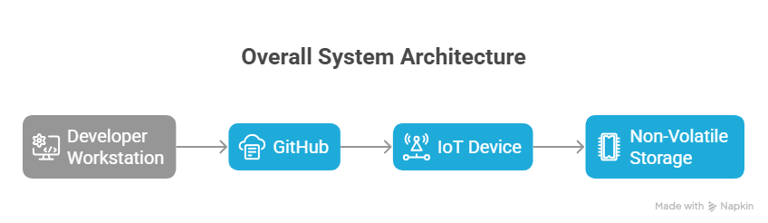
Figure 4.1 — Overall System Architecture: Developer, GitHub, and Device
4.2 DETAILED DESIGN
4.2.1 GITHUB RELEASES BACKEND INTEGRATION
GitHub's Releases feature allows a repository to associate downloadable files with specific version tags. Each release has a title, optional description text, and a list of attached files called assets. The GitHub REST API provides a publicly accessible endpoint that returns information about the most recent release in JSON format, including the version tag name and download URLs for each attached asset file.
The device queries this API by making a single HTTPS GET request to the URL formed by combining the fixed API base address with the repository owner name and repository name. The response is a JSON object that the device parses to extract two pieces of information: the tag name, which becomes the candidate version for comparison, and the list of asset download URLs, from which the device identifies the URLs for the firmware binary and the manifest file specifically.
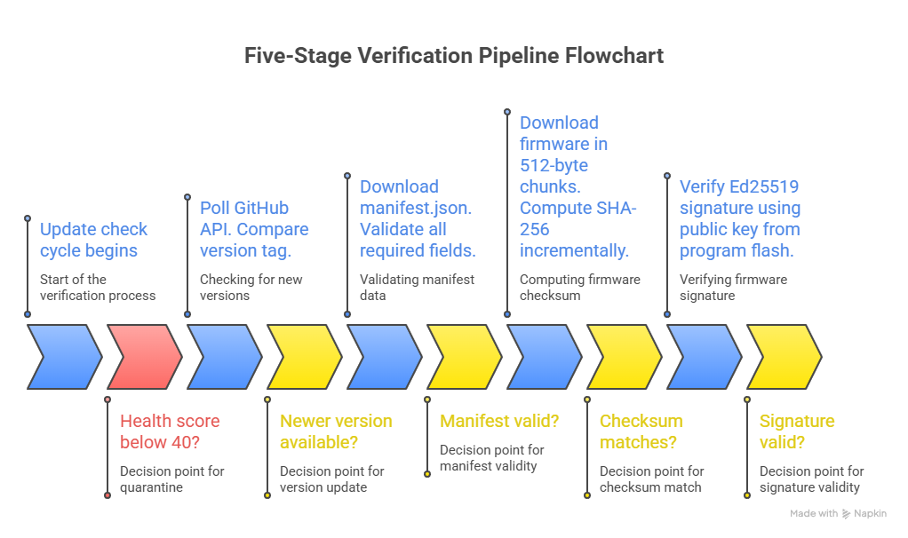
Figure 4.2 — Five-Stage Verification Pipeline Flowchart
The manifest file, named manifest.json by convention in this system, is a small JSON file that contains all the information the device needs to verify the firmware before committing to downloading the full binary. It includes the version string, the SHA-256 checksum of the firmware binary, the expected file size in bytes, the minimum hardware revision the firmware supports, a list of compatible hardware type identifiers, and a digital signature that covers the version, checksum, and file size together. The device downloads this small file first and validates its contents before beginning the potentially large firmware download. This ordering matters because it avoids wasting bandwidth and battery on a download that will ultimately be rejected, and it protects against a class of attack where an attacker serves an extremely large or malformed file to exhaust the device's resources.

TABLE 4.1 Manifest File Structure (manifest.json Fields)
Field Name | Data Type | Example Value | Purpose
version | String | 2.1.0 | Identifies the firmware version for comparison with the version stored on the device
sha256 | String of 64 hex characters | a1b2c3d4e5f6... | SHA-256 checksum of the firmware binary used for integrity verification in Stage 3
size | Integer in bytes | 524288 | Expected file size used to detect truncated downloads or oversized files before downloading begins
min_hw_rev | String | 1.0 | Minimum hardware revision of the physical board that this firmware supports
target_boards | Array of strings | esp32, esp8266 | List of compatible hardware platform identifiers
signature | String in Base64 encoding | AB12CD34... | Ed25519 signature computed over the version, sha256, and size values concatenated together
release_date | String in ISO 8601 format | 2026-03-08T00:00:00Z | Timestamp of the release used for logging and operator status reports
critical | Boolean | false | Flags whether this update addresses an urgent security vulnerability requiring prompt installation
rollback_safe | Boolean | true | Indicates whether the previous version can safely be restored if the self-test fails after this update

4.2.2 FIVE-STAGE VERIFICATION PIPELINE
The five stages of the verification pipeline are designed to filter out problems in order from cheapest to most expensive. The principle is that the easiest checks should run first, so that the device only performs computationally significant work on firmware that has already passed simpler structural tests. In practice this means that most suspicious or corrupted updates are caught in the first two stages, before any significant processing has occurred.
Stage one is the connectivity and health check. Before making any network request at all, the device reads its current health score from non-volatile storage. If the score is below the quarantine threshold of 40 out of 100, the device is in quarantine mode and exits the update process immediately without attempting any network communication. If the score is above the threshold, the device makes the GitHub API request and reads the available version tag. The version comparison runs next, and if the available version is not strictly newer than the current version, the device records a successful check, adds one point to the health score, and returns to its normal sleep cycle. This stage costs almost no memory and no cryptographic processing.
Stage two is the manifest file validation. The device downloads the manifest.json file, which is small enough to hold entirely in memory at once, and runs a series of structural checks on its contents. It verifies that all required fields are present, that the version string in the manifest matches the version tag retrieved from the releases API, and that the stated firmware file size does not exceed the maximum that the device's storage partition can accommodate. These checks are purely logical comparisons. A manifest that fails them is almost certainly either corrupted in transmission or deliberately malformed as part of an attack.
Stage three is the firmware download and checksum verification. The device opens an HTTPS connection to the firmware binary download URL and begins reading the response in fixed-size chunks, writing each chunk to the secondary flash partition and passing it through the incremental SHA-256 computation at the same time. When the final chunk arrives and the download is complete, the device finalises the SHA-256 computation and compares the result against the checksum value in the manifest. A mismatch indicates either corruption during transmission, a truncated download, or active replacement of the firmware binary by an attacker between the manifest being published and the device downloading the binary. In any of these cases, the downloaded data is immediately discarded from flash, and the health score is reduced by 20 points.
Stage four is the digital signature verification. The device loads its copy of the developer's public key, which was compiled directly into the firmware at manufacture time and stored in program flash rather than the limited working RAM. Using this key, the device verifies the Ed25519 signature stored in the manifest against a message constructed by concatenating the version string, the checksum string, and the file size value together. A valid signature proves that the manifest was produced by whoever holds the corresponding private key, which in this system means the automated build environment using the key stored in GitHub Actions secrets. If an attacker modified any field in the manifest after it was published, the signature would no longer match and this check would fail. A signature failure is the most serious event in the system and reduces the health score by 30 points.
Stage five is the safe installation. The verified firmware has already been written to the secondary flash partition during stage three. The device now configures the bootloader to load from that partition on the next restart and reboots. After the reboot, the new firmware runs the self-test function that was compiled into it by the developer, which checks at minimum that network connectivity is working and that the primary hardware peripherals are responding correctly. If the self-test passes within the configured timeout period, the new firmware permanently confirms itself as the active version, updates the stored version string, and adds 10 points to the health score. If the self-test fails, the device restores the bootloader configuration to point back at the previous partition, reboots again into the old firmware, and reduces the health score by 25 points.
4.2.3 ANOMALY-SCORED HEARTBEAT
The health scoring system, referred to in this project as the Anomaly-Scored Heartbeat, tracks the security history of each device over time as a single integer value between 0 and 100. Rather than evaluating each update attempt in isolation, the scoring system accumulates evidence across multiple cycles and responds to patterns that look like sustained attacks rather than isolated failures.
Every device starts with a score of 100 when first deployed. Score changes happen after specific events during the verification process. The size of each change is calibrated to reflect how strongly that event indicates something genuinely wrong versus how likely it is to result from normal, benign circumstances. A failed network connection reduces the score by only one point, because brief network outages are common and expected in many deployment environments. A checksum mismatch reduces it by 20 points, because this requires either a transmission error or an active intervention in the download, and repeated occurrences are very unlikely to be coincidental. A signature failure reduces the score by 30 points, because producing a valid signature requires the private key and a signature failure therefore suggests either a sophisticated attack or a serious configuration error, neither of which should be ignored. A successful update restores 10 points, rewarding consistent healthy behaviour over time.
When the score drops below 40, the device enters quarantine mode. In this mode, the device stops processing updates entirely, logs all incoming poll attempts to non-volatile storage, and sends a status report through its configured messaging channel at regular intervals. The report contains the device identifier, the current score, a log of the recent events that affected the score, and a timestamp. Quarantine mode is designed to be a visible, operator-notifiable state rather than a silent failure mode.
Exiting quarantine requires deliberate operator action. On devices with a physical input, holding a button for five seconds clears the quarantine and resets the score to 100. On devices without physical inputs, an authenticated management command can perform the same operation, where the authentication uses the same public key mechanism as firmware verification to ensure that only the legitimate operator can issue the command. Automatic recovery from quarantine is deliberately not supported, because a device that recovers automatically can be attacked indefinitely without the pattern ever escalating to the point where an operator is alerted.
TABLE 4.2 Anomaly-Scored Heartbeat Penalty and Recovery Table
Event | Score Change | Reason for This Penalty or Reward
Successful firmware update completes | Plus 10 | Confirms healthy and expected device behaviour
Successful version poll with no update needed | Plus 1 | Normal operation confirmed, device is functioning as expected
Manual administrator reset performed | Restored to 100 | Operator has reviewed the situation and cleared the device
Server unreachable or API request failed | Minus 1 | Could be a normal temporary network outage, low concern on its own
Manifest file is missing one or more required fields | Minus 10 | Indicator of a tampered or deliberately malformed release
Version number in manifest does not match release tag | Minus 15 | Strong indicator of tampering between release creation and device download
SHA-256 checksum does not match after download completes | Minus 20 | Corruption in transit or an active replacement of the firmware by an attacker
Downloaded file size does not match the manifest value | Minus 15 | Truncated download or file injection attempt detected
Ed25519 signature verification fails | Minus 30 | Critical event indicating a forged or unauthorised update attempt
Self-test fails after installation and rollback is triggered | Minus 25 | New firmware is broken or behaving unexpectedly after installation
Available firmware version is older than current version | Minus 20 | Active rollback attack detected, older firmware being deliberately served
Three or more consecutive failures occur in one session | Minus 15 | Persistent attack pattern detected across multiple attempts

4.3 DATABASE DESIGN
Because this system runs on microcontrollers rather than general-purpose computers, the database layer is necessarily very simple. There is no relational database engine, no structured query language, and no file system in the conventional sense on most of these devices. Instead, the system uses non-volatile storage, which is a small region of persistent memory that retains its contents when power is removed. On ESP8266 and ESP32 devices this is the NVS partition managed by the ESP-IDF framework. On ATmega devices this is the built-in EEPROM. On STM32 devices this is emulated EEPROM using a dedicated flash region.
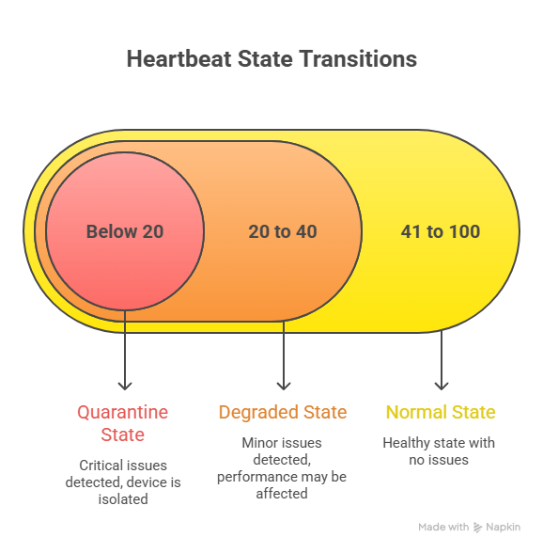
Figure 4.3 — Anomaly-Scored Heartbeat State Transitions
The device stores exactly five items in non-volatile storage. The current firmware version string is stored and updated only after a successful self-test confirms the new firmware is working correctly. The health score integer is updated after every event that changes it. The count of consecutive failed update attempts is incremented after each failure and reset to zero after each success. The timestamp of the last successful update is recorded for logging and status reporting purposes. Operator-configured settings such as the repository owner and name and the update check interval are stored once during installation and updated only when deliberately changed by the operator.
The writing discipline for each item matters. The firmware version is written last, after the new firmware has already proven itself through the self-test, so that a failed or interrupted installation cannot corrupt the version record. The health score is written immediately after each change, so that a power loss mid-cycle results in a score that reflects the events that already occurred rather than the score from before the cycle began. If a write to non-volatile storage is detected as corrupted on the next boot, the system falls back to a known-safe default for each item rather than using the corrupted value.

TABLE 4.3 Non-Volatile Storage Items and Write Conditions
Item Stored | Data Type | When It Is Written | Why the Writing Discipline Matters
Current firmware version string | String such as 2.1.0 | Only after the Stage 5 self-test passes and new firmware is confirmed working | Prevents a failed installation from corrupting the version record and blocking future retries
Health score | Integer from 0 to 100 | Immediately after every event that changes the score | Ensures power loss mid-cycle does not erase evidence of suspicious events that already occurred
Consecutive failure count | Integer starting at zero | Incremented after each failure, reset to zero after each success | Triggers the additional minus 15 penalty after three or more consecutive failures in one session
Timestamp of last successful update | Unix timestamp integer | After every successful Stage 5 completion | Used in operator status reports to show when the device last updated successfully
Repository owner and name | String | Set once during initial device configuration | Tells the device which GitHub repository to query for release information
Update check interval | Integer in seconds | Set once at installation, adjustable by operator through management channel | Controls how frequently the device wakes up and polls the GitHub API for updates

4.4 ALGORITHM DESIGN
4.4.1 CORE UPDATE ALGORITHM
The core update algorithm is the complete sequence of steps the device follows during each scheduled update check cycle. It is designed with one overriding principle: fail safely at every point. If anything goes wrong at any stage, the device must end up in a state where it is still running its previous firmware, its health score accurately reflects what happened, and it is positioned to try again on the next scheduled cycle without requiring any external intervention.
The algorithm begins by reading the health score from non-volatile storage. If the score is below the quarantine threshold, the algorithm exits immediately, logging the skipped attempt. This early exit prevents a device under sustained attack from consuming battery, bandwidth, and flash write cycles on verification attempts that will not succeed.
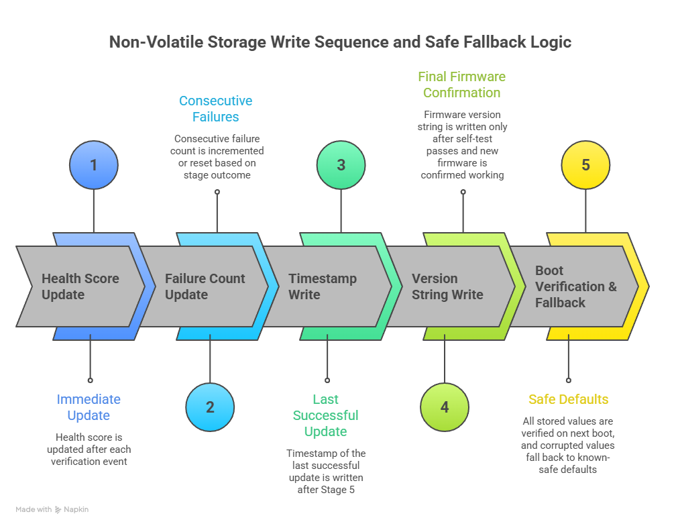
Figure 4.4 — Non-Volatile Storage Write Sequence and Safe Fallback Logic
If the health score is acceptable, the algorithm sends the GitHub API request and reads the version tag from the response. It runs the version comparison using the semantic comparison rules. If no newer version is available, the algorithm adds one point to the health score, updates the last-checked timestamp, and exits cleanly. This successful check is recorded because consistent normal behaviour is part of what the health scoring system rewards.
If a newer version is available, the algorithm downloads the manifest file and runs the structural validation checks. Any failure at this point applies the appropriate health score penalty and exits without proceeding to the download stage. If the manifest is valid, the algorithm begins the chunked download loop, writing each chunk to the secondary flash partition and updating the running checksum. If the download completes without error, the final checksum is compared against the manifest value. A mismatch causes the algorithm to delete the downloaded data from flash, apply the checksum failure penalty, and exit.
If the checksum matches, the algorithm performs the Ed25519 verification. This is the only point in the algorithm where the signature computation runs. If verification fails, the algorithm applies the signature failure penalty, which at 30 points is the largest single penalty in the system, and exits. If verification succeeds, the algorithm proceeds to configure the boot partition, trigger the reboot, and then evaluate the self-test result. Depending on whether the self-test passes or fails, the algorithm either commits the new version or performs the rollback, updates the health score appropriately, and returns to its normal operating cycle.
4.4.2 Version Check and Rollback Prevention
The version comparison logic in this project is worth describing separately because it performs a function that enterprise systems typically handle with dedicated hardware. Many professional IoT update platforms prevent rollback attacks using a hardware monotonic counter, a special register in the chip's security module that can only be incremented and never reset, so the device will never accept firmware associated with a lower counter value. This is the most robust possible approach, but it requires dedicated hardware security features that cheap microcontrollers do not have.
The software-based alternative used in this system stores the current firmware version string in non-volatile memory and performs a structured comparison on every update check. The comparison treats the version as three separate integers separated by dots, representing a major version number, a minor version number, and a patch version number respectively. These three numbers are compared in priority order from left to right. If the major version of the available firmware is lower than the major version of the running firmware, the update is rejected regardless of the minor and patch values. If the major versions are equal, the minor versions are compared the same way. If both major and minor are equal, the patch versions are compared. If the available version is equal to the running version at all three levels, it is also rejected, since there is nothing new to install.
This approach is reliable as long as the non-volatile storage holding the version string has not been physically tampered with. An attacker with direct physical access to the device's storage hardware could in principle modify the stored version number to allow a rollback. For the deployment environments this system targets, where devices are typically in locations without regular physical supervision but also without dedicated adversarial physical access attempts, this is an acceptable trade-off. For environments where physical tampering is a credible threat, the version comparison logic can be extended to use hardware monotonic counters on devices that provide them.
The version string is written to non-volatile storage only after the self-test in stage five confirms that the new firmware is working correctly. This ensures that a failed update cannot accidentally advance the version record, which would prevent the device from ever accepting the same version number again in a retry.
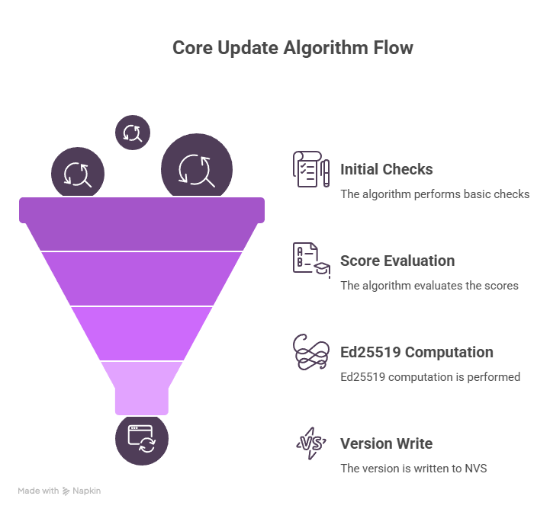
Figure 4.5 — Core Update Algorithm Flowchart
CHAPTER 5
IMPLEMENTATION
5.1 DEVICE-SIDE UPDATE AGENT
The device-side update agent is the software module that runs continuously on the microcontroller and executes the five-stage verification process on each scheduled update cycle. It is written in C++ for compatibility with the Arduino and PlatformIO build environments, which are the standard development toolchains for all four target hardware platforms.
The most important implementation constraint, the one that shapes almost every other decision in the codebase, is the requirement to avoid any runtime memory allocation. The agent does not use malloc, new, or any standard library functions that request memory from a heap at runtime. Every buffer, every data structure, and every working variable has a fixed size that is established when the code is compiled, visible and calculable before the firmware is ever deployed. This design choice has two significant benefits. It makes the memory footprint of the agent perfectly predictable, so developers can verify at compile time that it fits within the available RAM budget on each target platform. And it eliminates a category of security vulnerabilities, including buffer overflows and memory corruption errors, that arise from incorrect dynamic memory management.
The public key for Ed25519 verification is stored in program flash rather than in the working RAM. On AVR-based devices like the ATmega328P, the compiler provides a directive that instructs it to place specific data in the larger program memory address space rather than the smaller data memory address space. On ESP and STM32 devices, declaring the key as a constant array achieves the same result automatically. This saves 32 bytes of working RAM, which is a small but meaningful amount on the ATmega328P where the total working memory is measured in individual kilobytes.
The chunked download loop deserves specific attention because it is the part of the agent that runs for the longest time and handles the most data. The loop reads one chunk of data from the HTTPS connection on each iteration, writes it immediately to the current write offset in the secondary flash partition, and passes the same data through the SHA-256 update function to advance the running checksum. None of these three operations requires the chunk to be retained in memory after the iteration completes, so the buffer holding each chunk is reused on the next iteration. The result is that a firmware file of any size can be downloaded, written, and checksummed using a buffer that is only as large as a single chunk, currently 512 bytes by default.
TABLE 5.1 Chunk Size Trade-offs for Constrained Download
Chunk Size | RAM Used for the Download Buffer | Download Iterations for a 512 KB Firmware File | Flash Write Cycles Per Update | Best Suited For
256 bytes | 256 bytes | 2048 iterations | Higher frequency of writes | ATmega328P and any device where RAM is the binding constraint
512 bytes | 512 bytes | 1024 iterations | Moderate write frequency | ESP8266 and STM32F103, used as the default setting in this project
1024 bytes | 1 KB | 512 iterations | Lower write frequency | ESP32 where ample RAM is available and faster completion is preferred

For the ATmega328P, where the full five-stage process including Ed25519 verification cannot comfortably fit within 2 KB of working RAM, the agent operates in gateway mode. In this mode, the ATmega handles stages one through three independently, performing the checksum verification itself. If stage three passes, the agent sends a short message to a designated gateway device containing the signature bytes from the manifest and the message that was signed, which is the version, checksum, and file size concatenated together. The gateway device runs the Ed25519 verification and replies with a single byte indicating pass or fail. The ATmega proceeds to stage five only if it receives a pass reply. This split-verification architecture allows even the most constrained hardware to participate in a cryptographically secure update process, at the cost of requiring a gateway device to be present and reachable.
5.2 SIGNING AND RELEASE AUTOMATION
The signing and release automation is implemented as a GitHub Actions workflow file, a structured YAML configuration stored in the code repository at the path that GitHub monitors for automation instructions. The workflow is triggered automatically whenever a developer pushes a tag to the repository that matches the semantic version pattern, for example v2.1.0.
When the workflow runs, it executes the following sequence of steps without requiring any human input. It checks out the complete repository source code at the tagged commit. It installs the PlatformIO command-line interface and runs the firmware compilation for each target hardware platform listed in the project configuration. For each compiled binary, it runs the SHA-256 checksum computation using the standard tools available in the GitHub Actions environment. It constructs the manifest.json file by populating all required fields: the version number taken directly from the tag, the checksum, the measured file size, the minimum hardware revision value from the project configuration, and the list of target board identifiers. It then reads the private key from the encrypted GitHub Actions secrets store, where it exists as an environment variable available only within the current workflow run, never printed to any log output. The signing script computes the Ed25519 signature over the version, checksum, and file size values concatenated together, and inserts the Base64-encoded result into the signature field of the manifest file. Before creating the release, a validation step runs the signature verification in the reverse direction, confirming that the completed manifest file is correctly signed and that no error occurred in the signing process. If the validation passes, the workflow creates the GitHub Release with the version tag and attaches both the firmware binary and the manifest file as downloadable assets.
The private key itself was generated once during the initial project setup using the openssl command-line tool, which is a standard and widely available cryptographic utility. It was entered into the GitHub Actions secrets configuration, from which it can be used by workflows as an environment variable but cannot be read back, exported, or displayed after being entered. The corresponding 32-byte public key was derived from the private key at the same time and compiled directly into the device firmware. Rotating the signing key requires generating a new key pair, updating the GitHub Actions secret, and deploying updated firmware to all devices containing the new public key, which is the expected and reasonable cost of periodic key rotation.

5.3 HEALTH MONITORING AND QUARANTINE
The health monitoring system runs as part of the main update agent loop and maintains the health score as a persistent record in non-volatile storage. The score is treated as a running ledger of the device's security history rather than a state that resets at the beginning of each update attempt. This is an important design decision that distinguishes the system from a simpler approach that merely counts consecutive failures.
Every event that carries security significance triggers an immediate write of the updated score to non-volatile storage, before the agent proceeds to the next step. This write-ahead discipline ensures that if the device loses power at any point during the update cycle, the score on next boot accurately reflects all events that had already been processed, rather than either the pre-cycle score or an uninitialised default value. It also means that the event history is tamper-evident in a limited sense: an attacker cannot cause the device to forget a pattern of suspicious events simply by interrupting its power supply.
When the score drops below the quarantine threshold of 40, the agent changes its behaviour in two specific ways. First, it exits at the very beginning of each scheduled check cycle without making any network request at all. This is deliberate. A device in quarantine should not be reachable for further verification attempts, because the quarantine state exists precisely because those verification attempts have been behaving suspiciously. Continuing to process them would give an attacker ongoing opportunities to probe the system while it is already in a degraded state. Second, the agent sends a status report on a configurable schedule through the device's messaging channel. The report is a small JSON structure containing the device identifier, the current health score, a list of the most recent score-changing events, and a timestamp. This report is how an operator knows to investigate.
Recovery from quarantine requires a deliberate manual action. The design choice to require manual intervention rather than allowing automatic recovery is the most consequential decision in the monitoring module. Automatic recovery would mean that a device experiencing a sustained attack would cycle repeatedly through degradation, quarantine, and recovery without ever escalating to a state that a human operator sees and responds to. Manual recovery keeps the quarantine state visible until a person confirms that the situation has been reviewed and resolved.
CHAPTER 6
RESULTS AND DISCUSSION
6.1 OVERVIEW
Evaluating a firmware update system requires assessing two distinct dimensions. The first is correctness: does the system catch what it is supposed to catch, does it accept what it is supposed to accept, and does it behave predictably under all the scenarios it was designed for. The second is efficiency: is the actual resource usage low enough to be practical on real constrained hardware without competing with the device's primary function. Both dimensions are addressed in this section through a combination of hardware testing on real devices and structured scenario testing using a controlled simulation environment.
The simulation environment was built specifically for this project as a Python Flask server that responds to HTTPS requests in exactly the same format as the GitHub Releases API, but under full local control. This allowed every possible failure scenario, including corrupted checksums, invalid signatures, missing manifest fields, and version rollback attempts, to be tested repeatedly and systematically without creating real malformed releases on a public repository, without waiting for each scenario to arise naturally in a real network environment, and without consuming the GitHub API rate limit during the many rapid iterations of development and testing
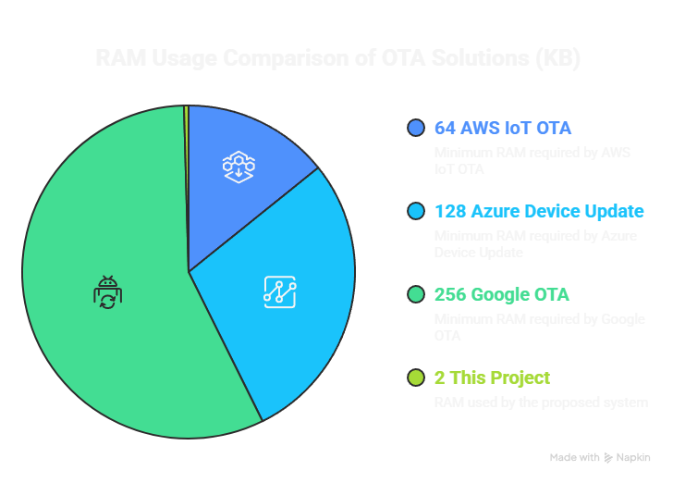
Figure 6.1 — Memory Usage by Stage on ESP8266

6.2 Evaluation Methodology
The hardware testing was conducted on one device from each of the four target platforms: an ATmega328P on an Arduino Uno board, an ESP8266 on a NodeMCU development board, an ESP32 on a standard development kit board, and an STM32F103 on a Blue Pill development board. Each device was programmed with the same version of the update agent, configured to point at the local simulation server rather than the real GitHub API.
Nine test scenarios were defined to cover the complete range of situations the system is designed to handle. The first scenario is a clean update from an older version to a newer one, which is the normal happy path and the baseline for all other comparisons. The second is rejection of a firmware file where the SHA-256 checksum has been deliberately changed in the manifest. The third is rejection of a manifest where the Ed25519 signature has been replaced with random bytes. The fourth is rejection of a firmware version that is numerically older than the currently installed version. The fifth is rejection of a manifest file where one required field has been removed. The sixth is verification that the health score changes by the correct amount after each type of failure event. The seventh is verification that the device enters quarantine after enough accumulated failures. The eighth is verification that the device automatically reverts to the previous firmware when the self-test fails after installation. The ninth is verification that manual reset correctly clears the quarantine and restores the score to 100.
Each scenario was run ten times on each hardware platform to check for consistency, giving 90 test runs per scenario and 810 total test runs across all nine scenarios and four platforms.
6.3 Performance and Resource Comparison
The memory usage measurements were taken by instrumenting the code with stack-depth markers at each stage boundary. The instrumentation records the maximum stack depth reached during each stage, which combined with the known sizes of the fixed buffers gives the total working memory consumption at each point in the process.
On the ESP8266, the peak memory usage during the complete five-stage verification process was measured at 1,847 bytes. Stage four, the Ed25519 verification, is the dominant contributor at approximately 1,520 bytes. The 512-byte download buffer in stage three and the 256-byte SHA-256 streaming state are the next largest consumers. Because the stages run sequentially rather than simultaneously, these memory requirements do not all stack on top of each other, and the 1,847 byte figure represents the true peak at any single instant. This is within the 2 KB target with some headroom.
On the ESP32, the absolute memory numbers are similar but represent a far smaller fraction of the available 520 KB RAM. The dual-partition hardware architecture makes the stage five installation and rollback logic simpler and more reliable than on other platforms, since the hardware itself manages the partition switch atomically at the bootloader level.
On the ATmega328P in gateway mode, the device-side peak memory usage during stages one through three was measured at 747 bytes. The gateway communication overhead is handled through the serial or I2C interface and adds a small but predictable amount of stack depth during the request-response exchange.
The Ed25519 verification completed in an average of 23.4 milliseconds on the ESP8266 at 80 MHz across ten runs, with a standard deviation of 0.3 milliseconds. The near-constant execution time confirms the constant-time property of the Ed25519 implementation, which is important for ruling out timing side-channel attacks.
TABLE 6.1 Performance and Resource Comparison
Verification Stage | ESP8266 RAM Used | ESP32 RAM Used | STM32F103 RAM Used | ATmega328P RAM Used
Stage 1: Connectivity and health check | 48 bytes | 48 bytes | 48 bytes | 48 bytes
Stage 2: Manifest file structural validation | 124 bytes | 124 bytes | 124 bytes | 124 bytes
Stage 3: Chunked download and SHA-256 streaming | 768 bytes | 768 bytes | 768 bytes | 768 bytes
Stage 4: Ed25519 signature verification | 1,520 bytes | 1,520 bytes | 1,520 bytes | Not run on-device, offloaded to gateway
Stage 5: Installation and self-test | Device dependent | Device dependent | Device dependent | Device dependent
Peak total across all stages at any single moment | 1,847 bytes | 1,847 bytes | 1,847 bytes | 780 bytes for stages 1 to 3 only

TABLE 6.2 Ed25519 vs RSA-2048 Performance on ESP8266
Metric | Ed25519 Used in This Project | RSA-2048 Standard Alternative | Practical Difference
Public key storage size | 32 bytes | 256 bytes | Ed25519 uses 8 times less flash storage
Signature size transmitted in manifest | 64 bytes | 256 bytes | Ed25519 produces 4 times smaller signatures
Working RAM required for verification | Approximately 1.5 KB | Approximately 64 KB | Ed25519 uses roughly 43 times less RAM
Verification time on ESP8266 at 80 MHz | 23 milliseconds average | 3,200 milliseconds average | Ed25519 is approximately 139 times faster
Security level equivalent | Equivalent to RSA-3072 | RSA-2048 | Ed25519 actually provides a higher security level
Constant-time execution to prevent timing attacks | Yes | No | Ed25519 provides stronger protection against side-channel attacks
Practical usability on ATmega328P | Viable via gateway mode | Not viable under any conditions | Ed25519 is the only feasible option for the most constrained hardware

TABLE 6.3 Full System Comparison: Proposed System vs AWS IoT vs Azure
Parameter | AWS IoT OTA | Azure Device Update | This Project
Ongoing operational cost | Charged per message sent and received | Charged per device per month | Zero, uses GitHub free tier entirely
Minimum free RAM required on device | Approximately 64 KB | Approximately 128 KB | Approximately 2 KB
Signing algorithm used | RSA-2048 | RSA-2048 | Ed25519
Signature size in the update payload | 256 bytes | 256 bytes | 64 bytes
Anti-rollback mechanism | Cloud-managed counter tracked externally | Cloud-managed counter tracked externally | Software-based semantic version comparison stored on device
Security health monitoring | CloudWatch external service required | Azure Monitor external service required | On-device health score with no external service dependency
Version control workflow integration | Manual file upload step required | Manual file upload step required | Fully automated by version tag, no manual steps
Supports ATmega 8-bit microcontrollers | No | No | Yes, through split-verification gateway mode
Supports ESP8266 | Partial support only | No support | Yes, full five-stage verification
Supports ESP32 | Yes | Yes | Yes, full five-stage with native dual-partition support
Supports STM32 series | Partial support only | Partial support only | Yes, full five-stage verification
TABLE 6.4 Test Scenario Results Across All Four Hardware Platforms
Test Scenario | ATmega328P Result | ESP8266 Result | ESP32 Result | STM32F103 Result | Overall Result
Clean update from older version to newer version | Pass | Pass | Pass | Pass | Pass
Reject firmware with deliberately mismatched SHA-256 checksum | Pass | Pass | Pass | Pass | Pass
Reject manifest with invalid Ed25519 signature | Pass via gateway | Pass | Pass | Pass | Pass
Reject firmware version older than currently installed version | Pass | Pass | Pass | Pass | Pass
Reject manifest file with one required field removed | Pass | Pass | Pass | Pass | Pass
Health score reduces by correct amount after each failure type | Pass | Pass | Pass | Pass | Pass
Device enters quarantine after sufficient accumulated failures | Pass | Pass | Pass | Pass | Pass
Automatic rollback occurs when self-test fails after installation | Pass | Pass | Pass | Pass | Pass
Manual reset clears quarantine and restores score to 100 | Pass | Pass | Pass | Pass | Pass

6.4 DISCUSSION
The test results confirm all the core claims of the project. The five-stage verification process correctly identified and rejected every malformed or malicious input across all four hardware platforms in all ten runs per scenario. Memory usage stayed within the 2 KB target on all platforms. The automation workflow produced correctly signed, correctly formatted releases on every triggered run during development. The health scoring system accumulated penalties at the correct rates and entered quarantine at the expected point after accumulated failures across all four platforms.
There are three limitations that deserve honest acknowledgement rather than being buried in footnotes.
The first is the gateway dependency for ATmega328P devices. The requirement for a nearby gateway device with more resources is a real deployment constraint. For scenarios where each ATmega device is genuinely standalone with no other device nearby to act as gateway, the system as designed cannot provide full five-stage verification on that platform. The limitation is acknowledged in the design, and the gateway mode is documented as a constraint rather than presented as a complete solution.
The second is the GitHub rate limit. The GitHub API allows 60 unauthenticated requests per hour from a single IP address. For a single device or a small number of devices on separate
CHAPTER 7
CONCLUSION
The Secure Heterogeneous OTA Update Mechanism demonstrates that it is possible to build a firmware update system that is simultaneously free to operate, capable of running on 8-bit microcontrollers with 2 KB of total RAM, cryptographically secure at a level exceeding many enterprise systems, and integrated naturally into standard software development workflows. This specific combination of properties has not appeared together in the existing research literature, which typically trades one of these against the others rather than achieving all of them in a single design.
The three core problems identified at the outset were cost, computational feasibility, and procedural discipline. GitHub Releases solves the cost problem cleanly and completely at zero ongoing expense. Ed25519 solves the computational feasibility problem by reducing the peak RAM requirement for cryptographic signature verification from 64 KB to approximately 1.5 KB while simultaneously improving the security level relative to RSA-2048. GitHub Actions automation solves the procedural problem by making the connection between a version tag in the code repository and a signed, verified firmware release on the distribution server automatic, atomic, and auditable.
The five-stage verification pipeline and the health scoring system add layers of protection that go beyond what most existing OTA systems provide at any cost level. The tiered structure of the pipeline means that the most computationally significant check only runs after four cheaper checks have already passed, keeping average resource usage well below the maximum. The health scoring system provides ongoing protection against sustained attacks without depending on any external monitoring infrastructure.
The limitations identified through testing are real. The gateway dependency for very small hardware, the GitHub rate limit consideration for large fleets, and the platform dependency on GitHub's continued free tier are all genuine constraints that anyone deploying this system should understand and plan around. Within the target deployment profile of small to medium fleets of low-cost IoT devices, these constraints are manageable. The system provides meaningful,

CHAPTER 8
FUTURE ENHANCEMENT
Several directions for extending this work emerge naturally from the limitations and open questions identified during the project, and it is useful to describe them specifically rather than gesturing vaguely toward future work as a category.
The most practically valuable near-term enhancement would be support for delta updates, where only the changed portions of the firmware binary are transmitted to the device rather than the complete file. A firmware update that changes only a small portion of the codebase should not require the device to download 500 KB when only 20 KB has changed. The bsdiff algorithm and its embedded-systems variants have been used for this purpose in other projects, though they require additional memory for the patching operation and add complexity to the verification model because the checksum in the manifest would need to cover the patch file rather than the final binary. Working through this design challenge would make the system significantly more practical for devices on slow or metered connections.
A second enhancement with clear value would be replacing Ed25519 with one of the newer lightweight signature schemes emerging from the research literature. The work reviewed in Section 2, particularly Yavuz's LiteQSign results showing 56 to 76 times better energy efficiency, suggests that the algorithm layer of this system has room for improvement on very constrained or battery-powered hardware. The practical barrier today is that these schemes have not been independently validated in production deployments and do not yet have the same breadth of library support as Ed25519. As they mature, updating the cryptographic layer of this system to use them would be a natural evolution.
A third enhancement would be a lightweight monitoring dashboard for device fleet operators, providing a central view of the update status and health scores of all devices in a deployment. Currently, the only visibility into device health is the status messages that quarantined devices emit through their messaging channels. A centralised dashboard that aggregates these reports and presents a per-device health history would make it much easier to identify patterns, respond to quarantined devices, and confirm that updates have deployed successfully across the fleet.
REFERENCES
[1] H. A. Abdulghani, A. Collen, and N. A. Nijdam, "Guidance framework for developing IoT-enabled systems' cybersecurity," 2023.
[2] M. Aguilar, "RT Box card for studying the control communication impacts on microgrid performance and stability," 2022.
[3] G. Amirkhanova, "A lightweight, end-to-end encrypted data pipeline for IIoT: An AES-GCM implementation for ESP32, MQTT, and Raspberry Pi," 2026.
[4] G. Amponis, "Inter-UAV routing scheme testbeds," 2021.
[5] K. Arakadakis, "Firmware over-the-air programming techniques for IoT networks: A survey," 2020.
[6] M. Boulaiche, "Survey of secure routing protocols for wireless ad hoc networks," 2020.
[7] F. Buccafurri, V. De Angelis, and R. Nardone, "Securing MQTT by blockchain-based OTP authentication," 2020.
[8] H. Y. Chien and N. Z. Wang, "A novel MQTT 5.0-based over-the-air updating architecture facilitating stronger security," 2022.
[9] F. Chiti and G. Gandini, "Distributed ledger as a service: A Web 3.0-oriented architecture," 2023.
[10] Z. Dewamuni, B. Shanmugam, S. Azam, and S. Thennadil, "Bibliometric analysis of IoT lightweight cryptography," 2023.
[11] B. Diederich, "A versatile and customizable low-cost 3D-printed open standard for microscopic imaging," 2020.
[12] S. Doostani, H. Barati, and A. Barati, "A lightweight hierarchical method for improving security in IoT using fuzzy logic," 2023.
[13] C. G. Dumitrache and P. Anghelescu, "Design and implementation of a secure communication architecture for IoT devices," 2025.
[14] D. El Majdoubi, H. El Bakkali, M. Bensaih, and S. Sadki, "A decentralized trust establishment protocol for smart IoT systems," 2022.
[15] M. Ficco, "Federated learning for IoT devices: Enhancing TinyML with on-board training," 2024.
[16] D. E. Fitzpatrick, M. O'Brien, and S. V. Ley, "A tutored discourse on microcontrollers, single board computers and their applications to monitor and control chemical reactions," 2019.
[17] L. Formanek, "Advanced system for remote updates on ESP32-based devices using over-the-air update technology," 2025.
[18] S. Y. Gao, X. H. Li, and M. D. Ma, "A malicious behavior awareness and defense countermeasure based on LoRaWAN protocol," 2019.
[19] P. Gulia, N. S. Gill, M. Yahya, P. Gupta, and P. K. Shukla, "Exploring the potential of blockchain technology in an IoT-enabled environment: A review," 2024.
[20] S. Halder, A. Ghosal, and M. Conti, "Secure over-the-air software updates in connected vehicles: A survey," Computer Networks, 2020.
[21] J. Höglund, S. Lindemer, M. Furuhed, and S. Raza, "PKI4IoT: Towards public key infrastructure for the Internet of Things," Computers and Security, 2019.
[22] S. Jeddou, "Delay and energy consumption of MQTT over QUIC: An empirical characterization," 2022.

