PRESENTER GUIDE

SecureOTA: A Secure Heterogeneous OTA Update Mechanism for Resource-Constrained IoT Devices
Model examination. Companion to SecureOTA_Model_Exam.pptx: what each slide means, what to say, the numbers to remember and the questions to expect.
Item | Detail
Team | Priyankaa Devi S (9123128034), Rithik Sharma A (9123128040), Ritesh V (9123128039)
Supervisor | [Supervisor name]
Project coordinator | [Project coordinator name]
Department | Cybersecurity Engineering, KCG College of Technology, Chennai
Deck | 18 slides, about 22 minutes without a live demo

Contents
1. How to use this guide
2. The project in plain words
3. Slide by slide
4. Numbers cheat sheet
5. Glossary
6. Check before the exam

1. How to use this guide
- Read section 2 first. It explains the whole project in plain words, so every slide makes sense.
- Section 3 has one block per slide: the one message, what to say, what to point at, numbers and likely questions.
- The speaker notes inside the .pptx hold a short version of the same talking points (Presenter View in PowerPoint shows them).
- The suggested split between presenters is only a suggestion; change it as you like.
- Before the exam, work through section 6. Some placeholders still need real names, and a few points in the paper need an agreed answer.

Suggested split and timing
Presenter | Slides | Topic | Time
Priyankaa Devi S | 1 to 5 | Title, abstract, problem, objectives, specification | about 6.5 min
Rithik Sharma A | 6 to 11 | Design diagrams and implementation (plus demo) | about 12 min
Ritesh V | 12 to 18 | Results, conclusion, future work, publications, references | about 8 min

2. The project in plain words
Small IoT devices (smart sensors, relays, controllers) run firmware: the program on their chip. Bugs and security holes are fixed by sending new firmware over the network, an over-the-air (OTA) update. If that path is not protected, an attacker can push fake or old firmware, or fake the status messages devices send, and nobody notices.
SecureOTA protects that path at three points:
- At build time. When a version is tagged, GitHub Actions builds the firmware, computes its SHA-256 fingerprint and signs it with an Ed25519 private key that never leaves the workflow. Devices hold only the public key, so they can check the signature but nobody can forge one.
- At download time. The device checks a new package in five steps (the gates). Cheap checks run first: wrong board or old version, wrong fingerprint, broken file header, wrong HMAC tag. The expensive signature check runs last, so most bad packages are thrown away almost for free.
- After installation. The device boots the new firmware, tests itself, and keeps it only if the test passes; otherwise it rolls back to the old version. A health score goes up on success and down on failure; a device whose score falls too low stops taking updates until a person looks at it.
Devices also report their status in sealed beacons: encrypted with AES-256-CBC, tagged with HMAC-SHA256, and numbered with a counter stored in non-volatile memory. A changed beacon fails the tag check; a recorded beacon sent again fails the counter check. Accepted beacons update the live dashboard in under 2 seconds.
The one-sentence summary to remember
SecureOTA makes firmware updates and device status trustworthy on cheap microcontrollers, and rejects 86.7% of bad updates before the expensive signature check, cutting the time spent on them by about 75%.

3. Slide by slide

Slide 1. Title
Time: 1 min Presenter: Priyankaa
The one message: SecureOTA keeps firmware updates and device status trustworthy on cheap microcontrollers, and rejects bad updates cheaply.

Say this
- Greet the panel, read the title, introduce the three team members, the supervisor and the coordinator.
- Explain OTA in one line: over-the-air updates let us patch devices remotely without visiting them.
- Point at the right panel: "This is the journey of one firmware update. The rest of the talk follows it."

Point at
- The four steps on the right: build and sign, publish and deliver, verify in five gates, boot, self-test and report.
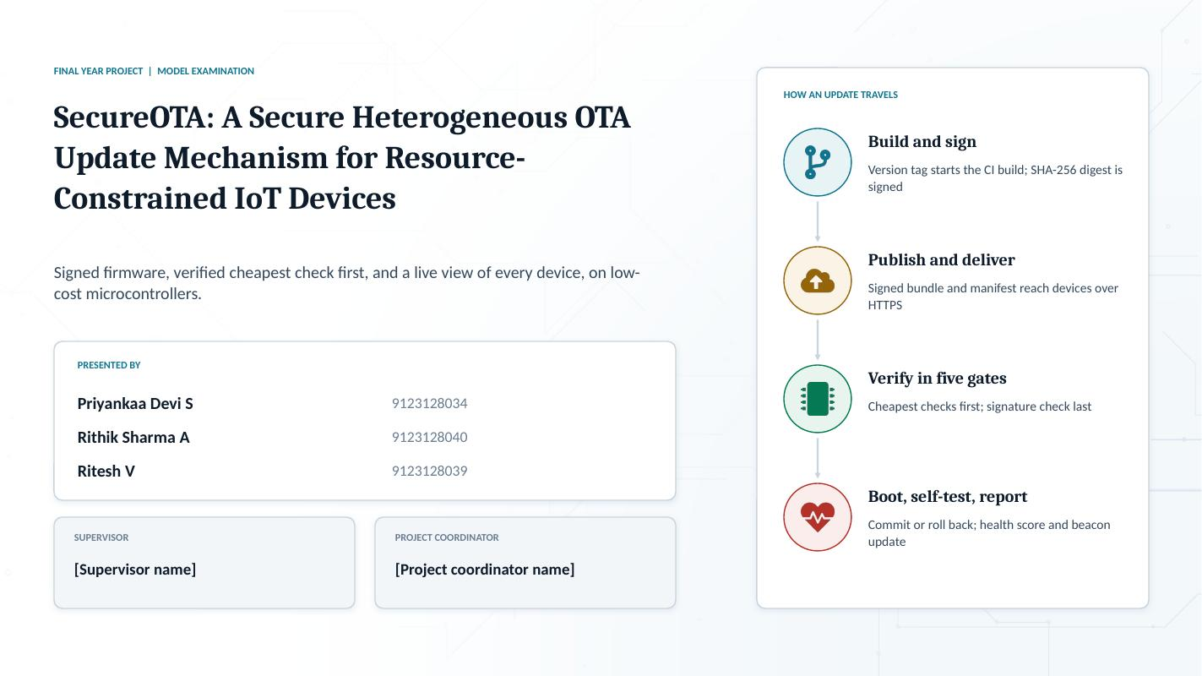

Slide 2. Abstract
Time: 1.5 min Presenter: Priyankaa
The one message: Three protections (signed firmware, sealed beacons, five ordered gates) and four headline results.

Say this
- Problem: IoT devices are out of sight after deployment, and many update paths never check a signature.
- Scope: ESP32, ESP8266, STM32F103 and ATmega328P.
- Protection 1: firmware is hashed with SHA-256 and signed with Ed25519 inside GitHub Actions.
- Protection 2: status beacons are encrypted (AES-256-CBC) and tagged (HMAC-SHA256) with a counter that only goes up, so they cannot be forged or replayed.
- Protection 3: five verification gates, cheapest first, plus a health score that quarantines failing devices.
- Read the four result cards out loud.

Numbers to know
- 86.7% of invalid packages rejected before the signature gate.
- Processing time for an invalid package down 74.8% (ESP32), 76.6% (ESP8266), 75.3% (ATmega328P).
- 720 test packages; every genuine one accepted.
- Dashboard updates in under 2 seconds.
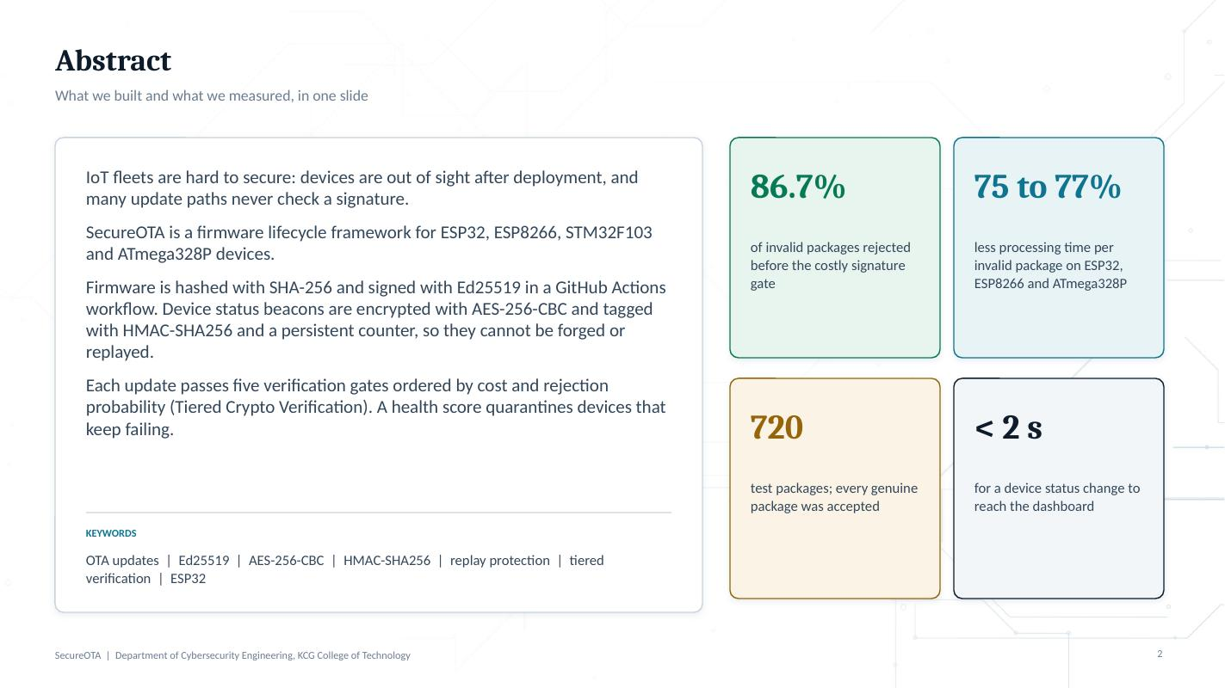

Slide 3. Problem Definition
Time: 1.5 min Presenter: Priyankaa
The one message: Updates and status can be faked, the expensive check runs on everything, and operators cannot see what devices run.

Say this
- Card 1: without signature checks and fresh status messages, an attacker can install old or altered firmware, or hide a failed device.
- Card 2, our key insight: Ed25519 verification is 75 to 78% of total verification time, yet a 1 ms check would already reject most invalid images.
- Card 3: no view after deployment, and manual release steps cause mismatched versions.
- Bottom row: the three closest recent works each miss part of this.

If the examiner asks
Q: What exactly is a replay attack here?
A: An attacker records a genuine status message or update and sends it again later. Our persistent counter rejects any message whose counter is not higher than the last accepted one, even after a reboot.
Q: Why not just use TLS?
A: TLS protects the channel, not the firmware or the message after it arrives. We still need a signature on the image and freshness on status. TLS is used for delivery as well.
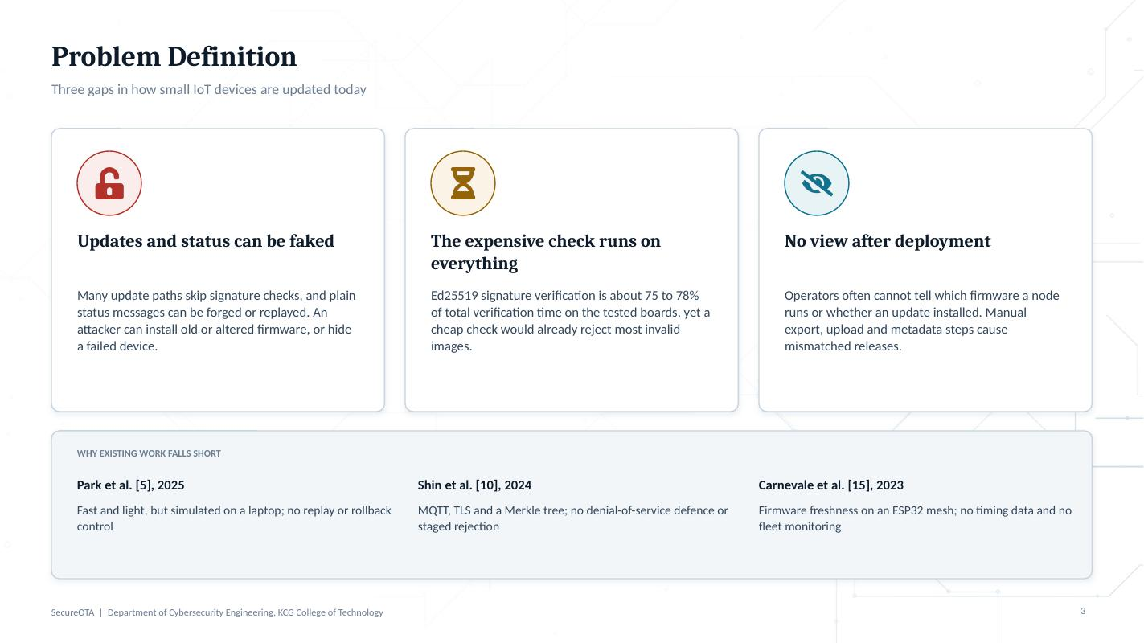

Slide 4. Objectives
Time: 1 min Presenter: Priyankaa
The one message: Five objectives, each answered by one mechanism.

Say this
- Read each objective and name its mechanism: sealed beacons, workflow-bound signing, Tiered Crypto Verification, compatibility check with self-test, rollback and quarantine, and the live dashboard.
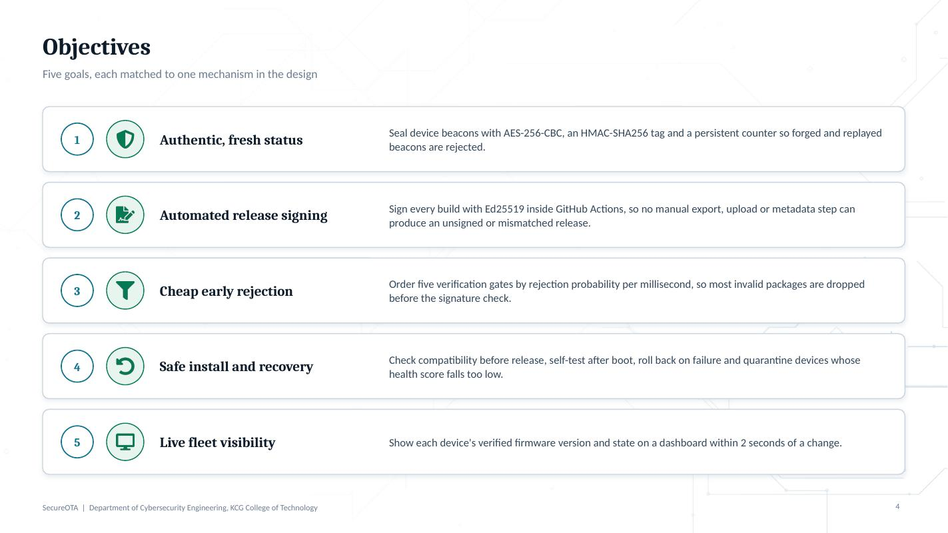

Slide 5. Hardware and Software Specification
Time: 1.5 min Presenter: Priyankaa
The one message: From 520 KB of RAM down to 2 KB, with one toolchain per layer.

Say this
- Left: the four board families. Stress the range: ESP32 has 520 KB of SRAM, the ATmega328P only 2 KB.
- ESP32 is the demo board. STM32F103 measurements are planned, not done; say so clearly.
- Right: firmware in Arduino-ESP32 C++, gateway in Python FastAPI, console in Next.js, data in SQLite and a JSON state store, flashing with esptool, releases on GitHub Actions, hosting with Docker and a Cloudflare tunnel.

If the examiner asks
Q: Why FastAPI for the gateway?
A: It is light, asynchronous, easy to test (the gateway has an automated test suite) and the cryptography library gives Ed25519, RSA and AES in Python.
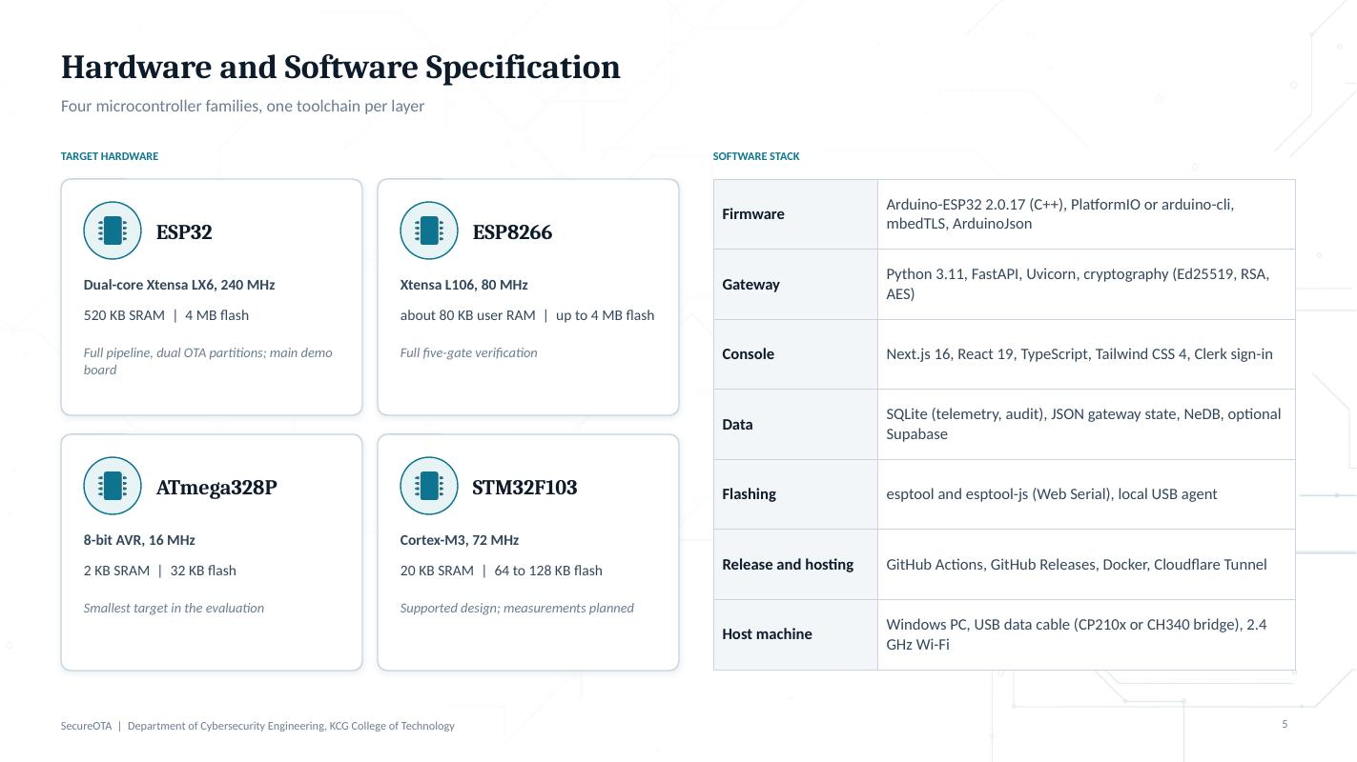

Slide 6. 6.1 Overall Design
Time: 2 min Presenter: Rithik
The one message: Release pipeline, gateway, devices and console, and what flows between them.

Say this
- Left to right: a version tag starts the build; the workflow hashes and signs the image and publishes a release bundle.
- The gateway serves signed manifests and packages to devices over HTTPS and receives their sealed beacons.
- Devices verify every package before installing it.
- The console reads everything from the gateway, and is used once per new board to flash and provision it over USB.

Point at
- The three arrows: publish, manifest plus package, sealed beacons.
- The dashed line: USB is only for the first install; every update after that is over the air.
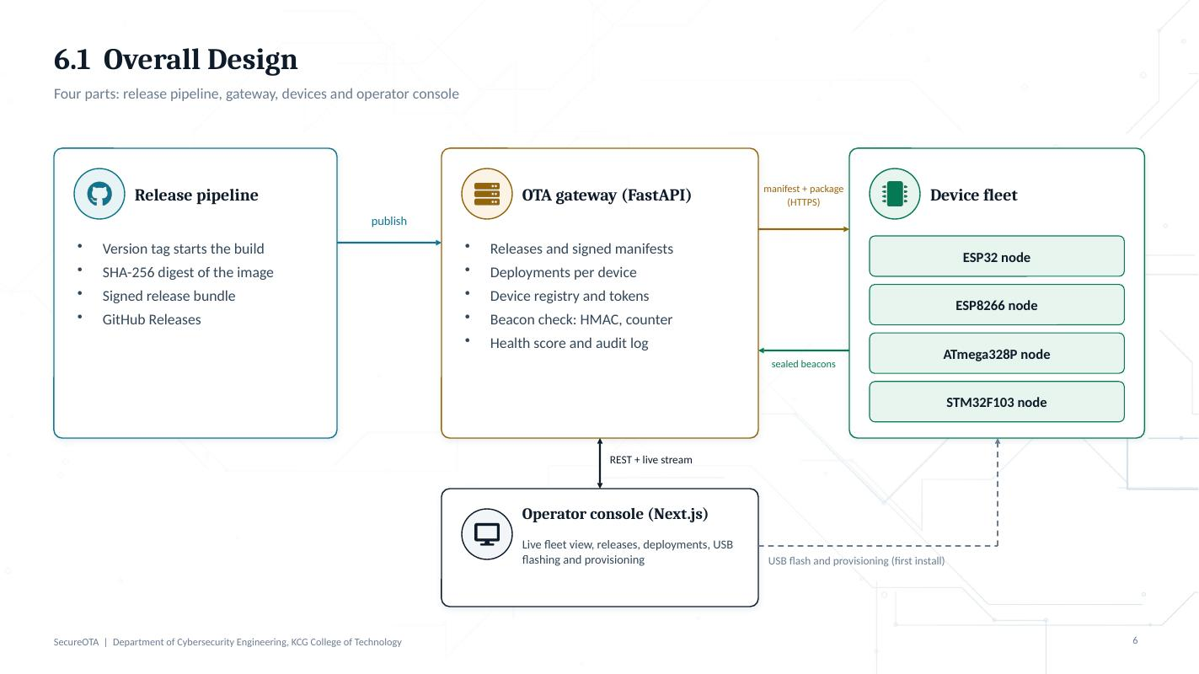

Slide 7. 6.2 Detailed Design
Time: 2 min Presenter: Rithik
The one message: The complete lifecycle of one firmware image, and the six mechanisms M1 to M6.

Say this
- This is Figure 1 of the paper. Two domains: developer and GitHub release domain on the left, the device agent on the right.
- Device steps: poll and validate manifest, download the signed bundle, run the TCV checks, boot the new partition, self-test.
- Pass: commit and raise the health score H. Fail: roll back and lower H.
- Name M1 to M6 from the right-hand list.
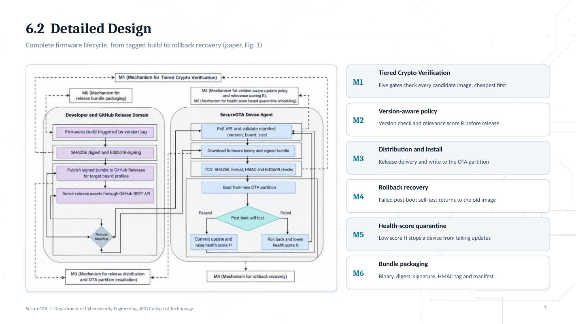

Slide 8. 6.3 Database Design
Time: 1.5 min Presenter: Rithik
The one message: Gateway state for devices, releases, deployments and commands; SQLite for telemetry and audit; console store for users and flash jobs.

Say this
- Top row: the operational state the gateway keeps for devices, releases, deployments and commands.
- Bottom left: SQLite tables for time series. Every beacon becomes a telemetry row; every write request becomes an audit row.
- Bottom right: the console's own store for user profiles with roles, and USB flash jobs. It can be mirrored to Supabase.
- Read the relationships line at the bottom.

If the examiner asks
Q: Why not one relational database for everything?
A: The gateway state is small and changes together, so it is saved as one document; telemetry and audit grow without limit, so they live in SQLite with indexes on device and time.
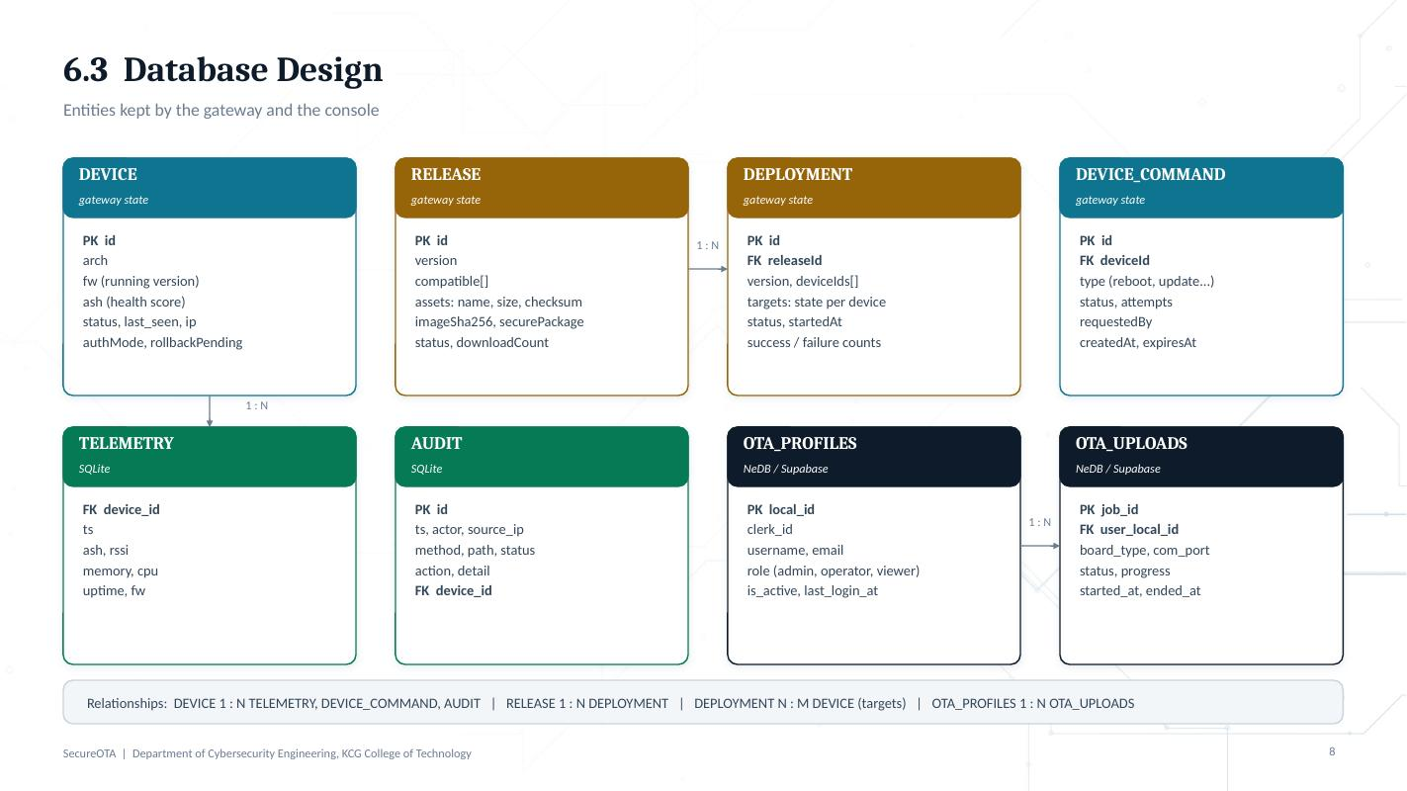

Slide 9. 6.4 Algorithm Design
Time: 2.5 min Presenter: Rithik
The one message: Five gates, cheapest and most likely to reject first, signature last; then self-test, rollback and quarantine.

Say this
- A package is installed only if all five gates pass: D equals the product of the gate results.
- Gate costs on the ESP32: manifest 1.2 ms, digest 11.8 ms, format 0.9 ms, HMAC 2.3 ms, Ed25519 47.5 ms.
- Priority of a gate = rejection probability divided by cost. The Ed25519 gate always goes last because it proves origin.
- Expected cost E[T]: a later gate only costs time for packages that got past the earlier ones. That is why ordering matters.
- Health score: up by alpha after a good update, down by beta after a failure, clamped between 0 and 1. Below the threshold the device stops polling.

Numbers to know
- Gate priorities from Table I: manifest 0.278, digest 0.042, format 0.556, HMAC 0.087, Ed25519 0.021 per ms.

If the examiner asks
Q: If gates are ordered by priority, why is image format (0.556) after manifest (0.278) and digest (0.042)?
A: See the note in the "Check before the exam" section. Agree an answer as a team before the exam.
Q: What are alpha, beta and the threshold?
A: Reward and penalty per update attempt, and the quarantine threshold theta. In the implementation the score runs from 0 to 100 and quarantine starts at 40, which is theta = 0.4.
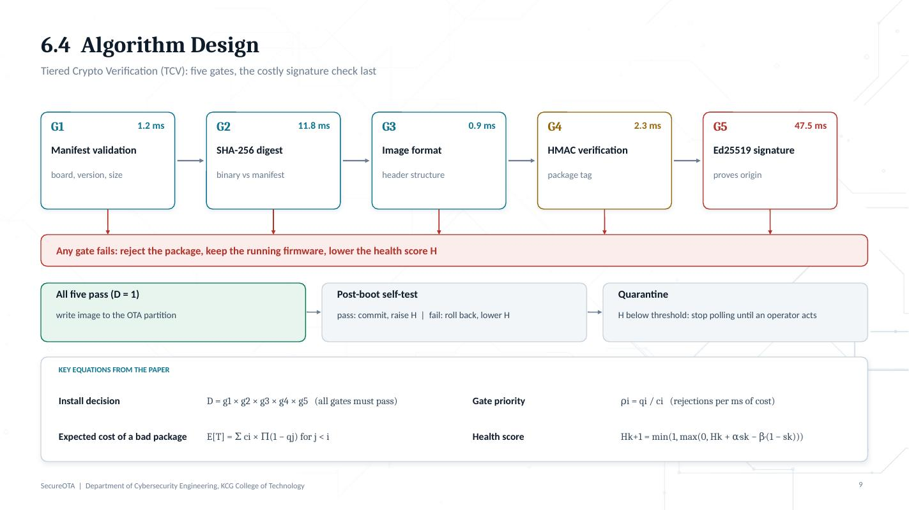

Slide 10. 7. Implementation: Modules
Time: 2 min Presenter: Rithik
The one message: Every mechanism from the design is a real part of the code.

Say this
- M6 packaging: release workflow and build script produce the signed release bundle.
- M1 verification: runs inside the device firmware before anything is written to the inactive partition.
- M2 policy: the gateway offers only the newest compatible release and refuses downgrades.
- M3 distribution: the gateway serves manifests and packages and tracks each deployment per device.
- M4 rollback: the new image boots in a pending state; a failed self-test returns to the old partition.
- M5 health quarantine: every outcome updates the score; at or below the threshold the device stops taking updates.

If the examiner asks
Q: How do you know an update actually worked?
A: A deployment is marked confirmed only when the device itself reports the new version in its beacon, not when the gateway has sent the file.
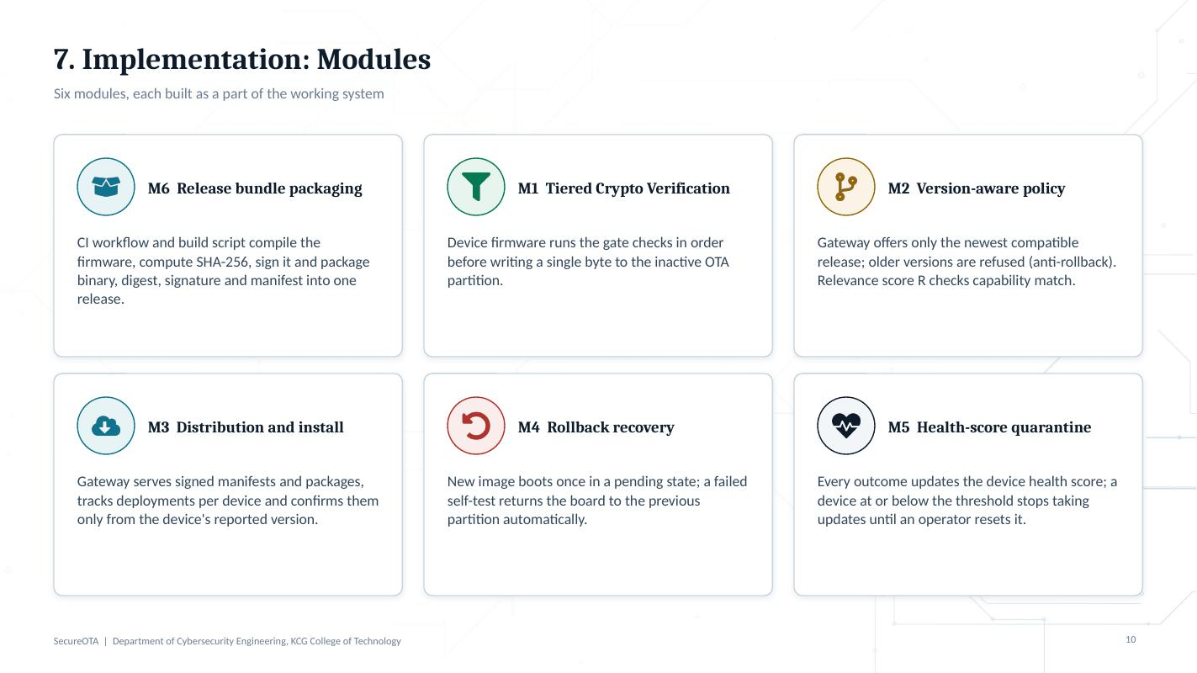

Slide 11. 7. Implementation: The Working Platform
Time: 2 min (longer with a live demo) Presenter: Rithik
The one message: The real console that builds, flashes, publishes, deploys and monitors.

Say this
- This screenshot is the Devices page of our console.
- Demo order: build the firmware, flash the first board over USB from the browser, publish the release, deploy, watch the board report the new version.
- Platform security: per-device tokens, admin, operator and viewer roles, an audit log of every write, and no private keys in the repository.

Point at
- Flash over USB card and the fleet summary tiles.
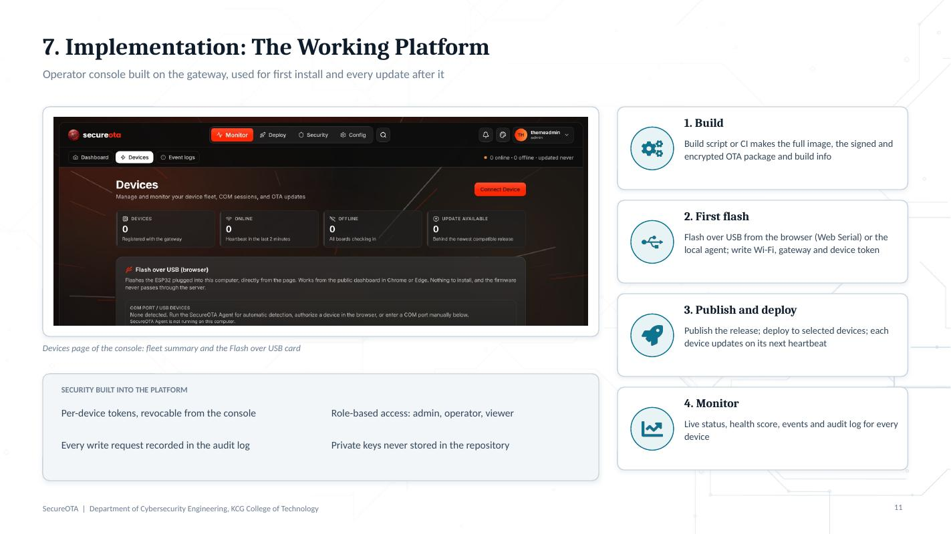

Slide 12. 8. Results: Gate Statistics
Time: 2 min Presenter: Ritesh
The one message: 312 of 360 invalid packages (86.7%) are rejected before the expensive signature gate, and no genuine package is lost.

Say this
- Test set: 720 packages, 360 invalid with six fault types, run on the ESP32.
- Walk the bars: 360 reach the manifest gate, 120 rejected; 240 reach the digest gate, 120 rejected; 120 reach format, 60 rejected; 60 reach HMAC, 12 rejected; 48 reach Ed25519, all 48 rejected.
- So only 48 packages ever pay for the 47.5 ms signature check.

Numbers to know
- Corpus: 2400 packages, 1200 genuine and 1200 invalid (200 of each of 6 fault types); 70/30 split, 1680 training and 720 testing.
- 12,000 simulated status beacons, 10% replayed or spoofed.
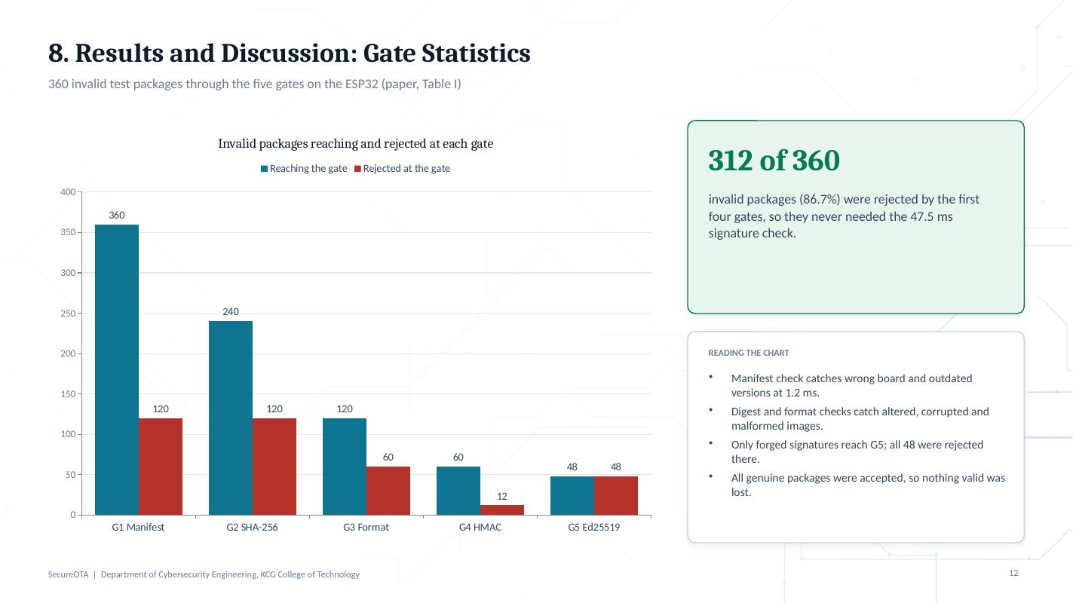

Slide 13. 8. Results: Verification Time
Time: 2 min Presenter: Ritesh
The one message: Time spent on an invalid package falls by about three quarters on every board.

Say this
- Grey bars: every gate always runs. Green bars: expected time with our ordering.
- ESP32 63.7 to 16.1 ms, ESP8266 119.2 to 27.9 ms, ATmega328P 429.0 to 106.1 ms.
- Why the saving is so similar on such different boards: the signature check is about three quarters of the pipeline on all of them, and most bad packages never reach it.
- Flash cost of the framework: 11 KB to 30 KB.
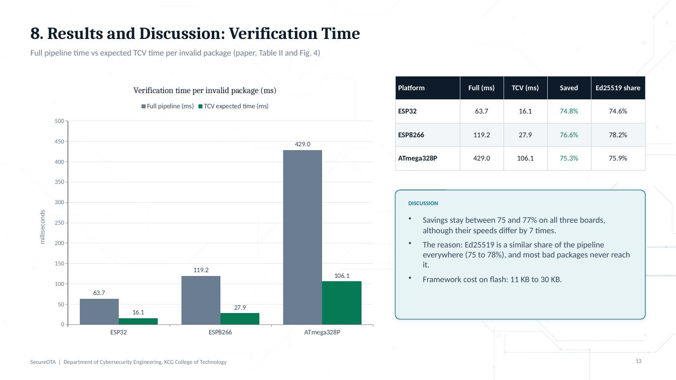

Slide 14. 8. Results: Comparison
Time: 1.5 min Presenter: Ritesh
The one message: No recent framework combines staged rejection, authenticated monitoring and automated signing; SecureOTA does.

Say this
- Read across the green column.
- Be fair: Park is fast but simulated on a laptop; Shin shows MQTT over TLS is about four times faster than HTTPS; Carnevale keeps firmware fresh on a mesh.

If the examiner asks
Q: Isn't MQTT faster than your HTTPS delivery?
A: Yes, Shin et al. report 0.116 s for MQTT over TLS against 0.467 s for HTTPS. Delivery speed is not our contribution; staged rejection, monitoring and automated signing are, and they work over either transport.
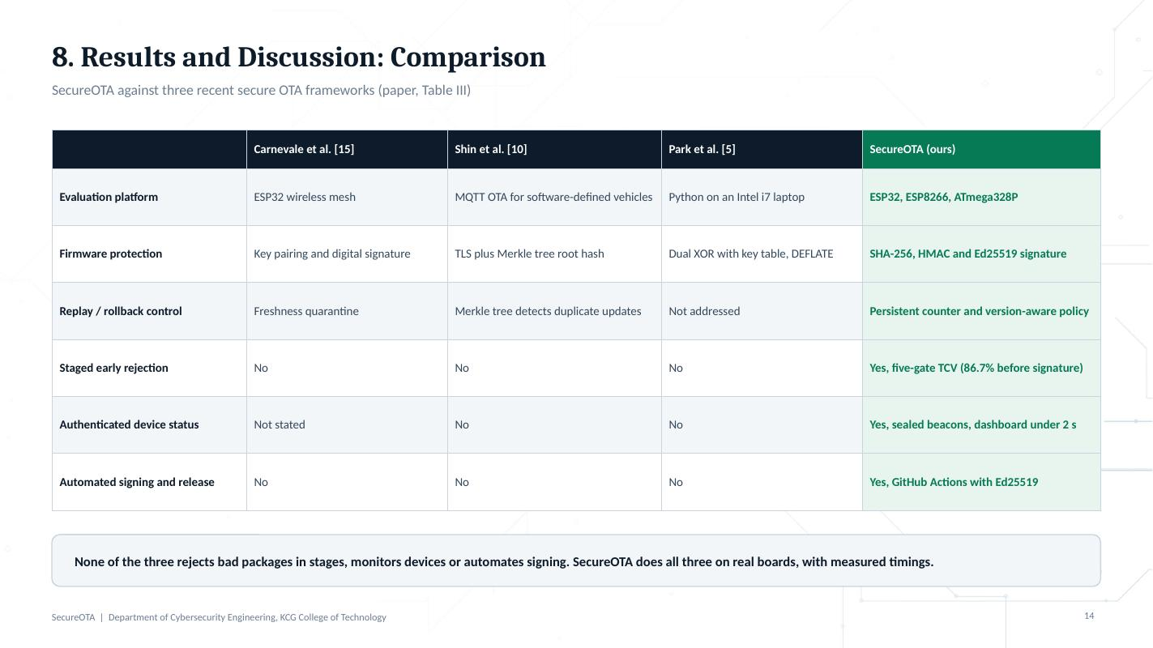

Slide 15. 9. Conclusion
Time: 1 min Presenter: Ritesh
The one message: Trusted updates and status, cheap rejection, and a self-healing fleet on low-cost hardware.

Say this
- One sentence per card, then read the dark bottom line.
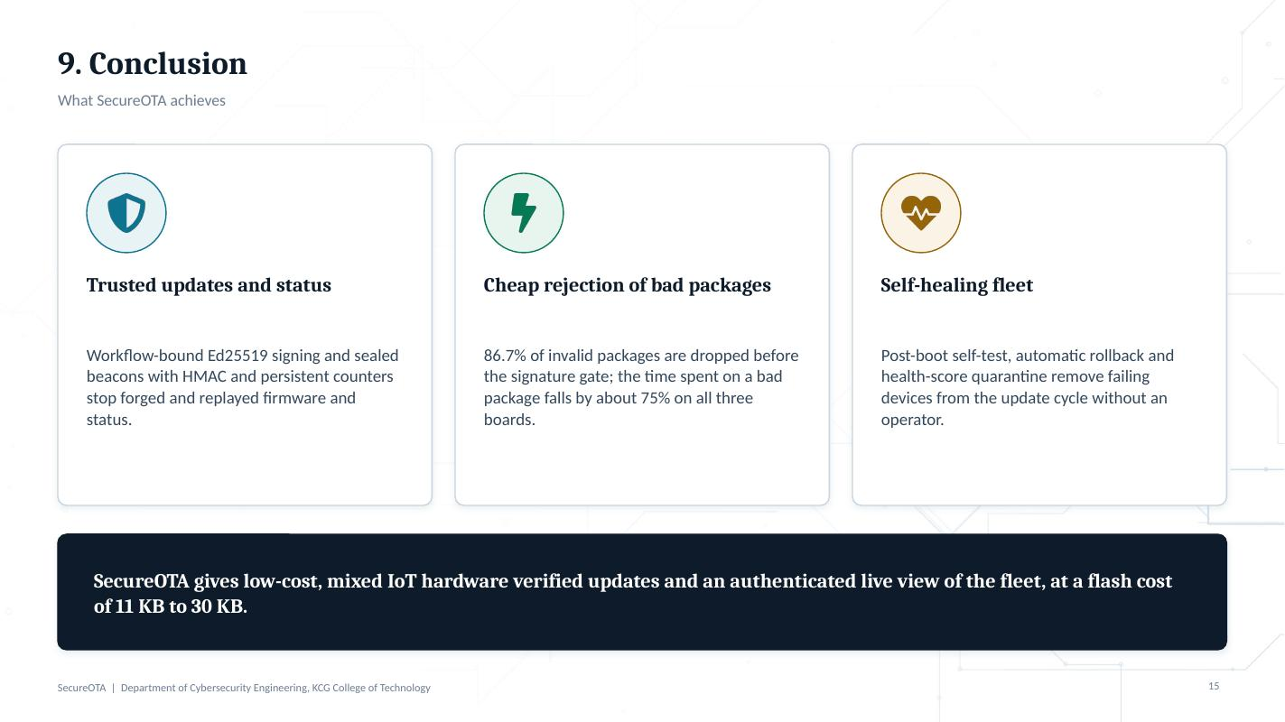

Slide 16. 10. Future Enhancements
Time: 1 min Presenter: Ritesh
The one message: Six next steps, starting with the honest gap: STM32F103 measurements.

Say this
- Read the six titles. Explain post-quantum briefly: Ed25519 can be broken by a large quantum computer, so we plan to support post-quantum signatures as well.
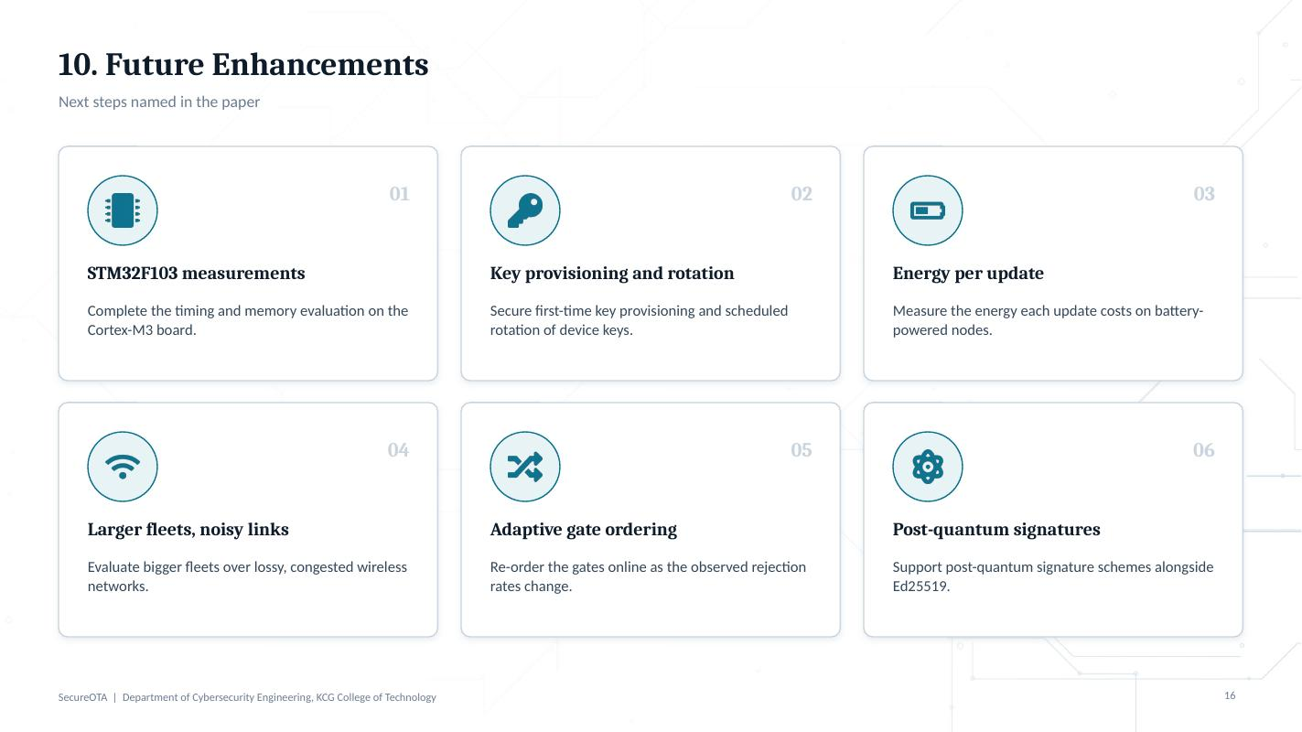

Slide 17. 11. Patent / Paper Publications
Time: 0.5 min Presenter: Ritesh
The one message: One IEEE conference paper prepared for submission; patent status to be confirmed.

Say this
- State the status exactly. Do not say accepted or published unless it is.
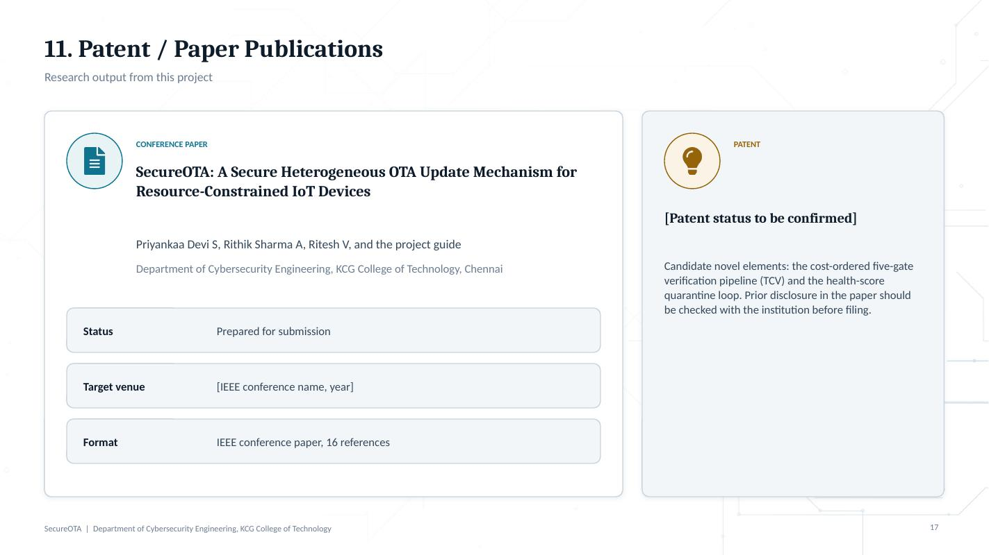

Slide 18. 12. References
Time: 0.25 min Presenter: Ritesh
The one message: Sixteen references, as in the paper.

Say this
- Do not read them. If asked, the three direct comparisons are [5] Park, [10] Shin and [15] Carnevale.
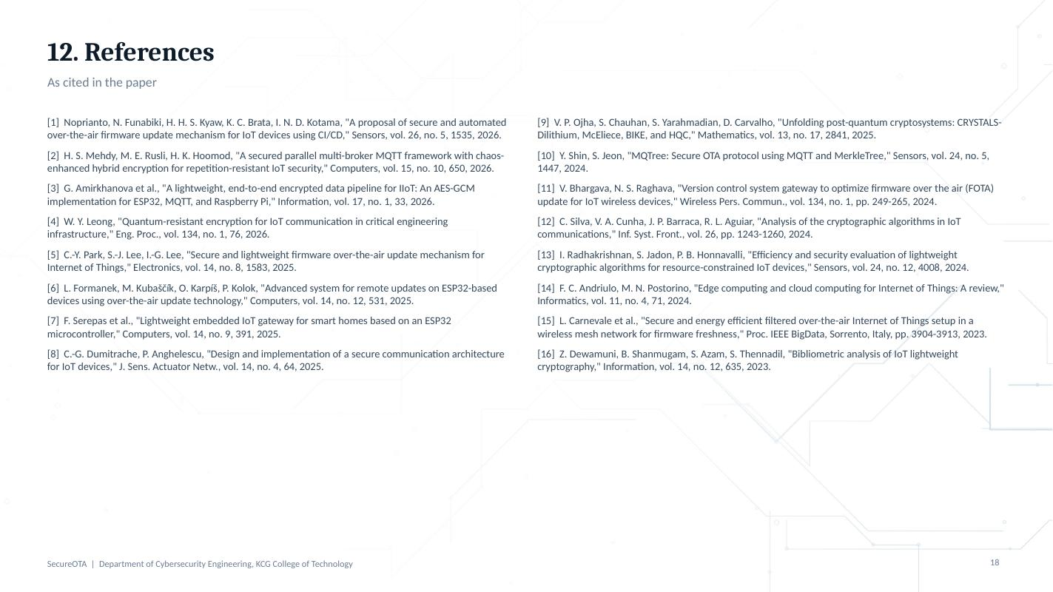

4. Numbers cheat sheet
What | Value | Where it comes from
Invalid packages rejected before the signature gate | 312 of 360 (86.7%) | Paper, Table I
Full pipeline vs TCV time, ESP32 | 63.7 ms vs 16.1 ms (74.8% saved) | Paper, Table II
Full pipeline vs TCV time, ESP8266 | 119.2 ms vs 27.9 ms (76.6% saved) | Paper, Table II
Full pipeline vs TCV time, ATmega328P | 429.0 ms vs 106.1 ms (75.3% saved) | Paper, Table II
Ed25519 share of the full pipeline | 74.6% (ESP32), 78.2% (ESP8266), 75.9% (ATmega328P) | Paper, Table II
Gate costs on ESP32 | 1.2, 11.8, 0.9, 2.3 and 47.5 ms | Paper, Table I
Test corpus (SFPC) | 2400 packages: 1200 genuine, 1200 invalid; 1680 train, 720 test | Paper, Section III-A
Fault types | 6, 200 each: wrong board, outdated version, altered binary, corrupted digest, malformed header, forged signature | Paper, Section III-A
Status beacons for freshness tests | 12,000, 10% replayed or spoofed | Paper, Section III-A
Dashboard update latency | under 2 s | Paper, abstract
Flash overhead of the framework | 11 KB to 30 KB | Paper, Section IV
Compatibility threshold | R of 0.30 or higher = compatible | Paper, Section III-E

5. Glossary
Term | Meaning in this project
OTA update | Sending new firmware to a device over the network instead of by cable.
Firmware image | The compiled program written to the microcontroller's flash.
SHA-256 | A hash function: a 256-bit fingerprint of the image. Any change to the image changes it.
Ed25519 | A fast digital signature scheme. Signed with a private key in CI, checked with a public key on the device.
HMAC-SHA256 | A tag computed with a shared secret key; proves a message was not changed and came from a key holder.
AES-256-CBC | Symmetric encryption used to hide beacon contents; a fresh IV is used each time.
Replay attack | Re-sending a recorded genuine message. Stopped by the persistent counter.
Rollback attack | Installing an older, vulnerable version. Stopped by the version check.
Manifest | Small metadata file: version, target board, size, digest and signature of a release.
OTA partition | A second flash area. The new image is written there, so the running image stays intact.
TCV | Tiered Crypto Verification: the five gates, ordered so cheap likely rejections happen first.
Relevance score R | Share of a device's capabilities the firmware supports; checked before release.
Health score H | Per-device score between 0 and 1, updated after every update attempt; low H means quarantine.
Gateway | The FastAPI server that stores releases, tracks devices and serves updates.
Web Serial | Browser API that lets the console flash a board over USB from Chrome or Edge.

6. Check before the exam

Placeholders to fill in the slides
- Slide 1: [Supervisor name] and [Project coordinator name]. (The paper lists Dr. G. G. Gokilam as guide; confirm before using it.)
- Slide 17: [IEEE conference name, year] and [Patent status to be confirmed].

Points examiners may notice, and agreed answers to prepare
1. Gate order versus gate priority
The paper says gates are sorted by priority (rejection probability per ms), but Table I lists them as manifest (0.278), digest (0.042), format (0.556), HMAC (0.087), Ed25519 (0.021). By priority alone, format would come first and HMAC before digest.
Prepare one answer, for example that some gates depend on earlier ones (the digest must match before the format of that exact image is trusted), or correct the order or wording in the paper before submission.

2. Paper design versus the current demo build
The paper describes Ed25519 firmware signing in GitHub Actions and UDP beacons sealed with AES-256-CBC and HMAC-SHA256 across four board families.
The firmware in the repository today targets the ESP32: releases are packaged as signed and encrypted OTA packages (RSA-2048 signature over version and image digest, AES-256-CBC), the gateway signs manifests with Ed25519, and devices report status in heartbeats over HTTP or HTTPS, authenticated with per-device tokens.
Decide how to present this, for example: the paper reports the full research design and evaluation corpus; the live demo shows the ESP32 implementation of the same lifecycle.

3. Units in the paper's conclusion
The conclusion says processing time fell "from 493 µs to 125 µs" on the ESP32 (and similar µs figures for other boards), while Tables I and II report 63.7 ms and 16.1 ms. Use the table values in the talk and fix the conclusion before submission.

4. STM32F103
It is named in the abstract and design, but its measurements are not ready. Always say "planned" for STM32F103 results.

Day-before checklist
- Open the deck in PowerPoint and check fonts (Cambria and Calibri) and that charts render.
- Run a full rehearsal with a timer; target 20 to 22 minutes plus questions.
- If doing a live demo: start the console and gateway, plug in the ESP32, and have a backup screen recording.
- Bring the paper PDF and be ready to show Tables I to III.

