AN

ARTIFICIAL INTELLIGENCE PROJECT REPORT

on

AI Diary Chatbot

Submittedby:

Rohit Yadav-(220336)

Raj Kumar Shrivas-(220320)

Chinmay Srivastava-(220355)

Raghuvansh Singh Parmar-(220420)

under mentorship of

Dr. Hirdesh Kumar Pharasi

(Assistant Professor)



Department of Computer Science Engineering

School of Engineering and Technology

BML MUNJAL UNIVERSITY, GURUGRAM (INDIA)

November 2024

CANDIDATES DECLARATION

I hereby certify that the work on the project entitled, “**Personal Diary Chatbot”** in partial fulfilment of requirements for the award of Degree of  **Bachelor of Technology** in School of Engineering and Technology at BML Munjal University, having University Roll No.1232434, is an authentic record of my own work carried out during a period from July 2022 to December 2022 under the supervision of **Dr. Hirdesh Kumar Pharasi**.

**(Chinmay Srivastava)**

**(Rohit Yadav)  
(Raghuvansh Singh Parmar)**

**(Raj Kumar Shrivas)**

SUPERVISOR’S DECLARATION

This is to certify that the above statement made by the candidate is correct to the best of my knowledge.

**Faculty Supervisor Name: Dr. Hirdesh Kumar Pharasi**

**Signature:**

ACKNOWLEDGEMENT

I am highly grateful to **Dr. Hirdesh Kumar Pharasi, Assistant Professor**, BML Munjal University, Gurugram, for providing supervision to carry out the seminar/case study from August - December 2022.

**Dr. Hirdesh Kumar Pharasi** has provided great help in carrying out my work and is acknowledged with reverential thanks. Without wise counsel and able guidance, it would have been impossible to complete the training in this manner.

I would like to express thanks profusely to thank **Dr. Hirdesh Kumar Pharasi**, for stimulating me from time to time. I would also like to thank the entire team at BML Munjal University. I would also thank my friends who devoted their valuable time and helped me in all possible ways toward successful completion.

LIST OF FIGURES

|  |  |  |
| --- | --- | --- |
| **Figure No.** | **Figure Description** | **Page No.** |
| **1** | **Homepage** | **19** |
| **2** | **Therapy bot page** | **19** |
| **3** | **Therapy bot interacting with user** | **20** |
| **4** | **Summary of conversations** | **20** |
| **5** | **Saved diary entries** | **21** |

TABLE OF CONTENTS

|  |  |  |
| --- | --- | --- |
| **Sr. No.** | Contents | **Page No.** |
| **1.** | Abstract | **6** |
| **2.** | Introduction | **7-9** |
| **3.** | Literature Review | **10-12** |
| **4.** | Methodology | **13-16** |
| **5.** | Analysis and Discussion of Results |  |
| **6.** | Conclusion and Future Scope |  |
| **7.** | References |  |
| **8.** | Appendix |  |

ABSTRACT

The **“PeacePages”** is an AI-powered tool that bridges traditional journaling and modern therapy. It offers therapeutic and casual modes, helping users to express emotions and reflect on their feelings. Using natural language processing, it provides empathetic responses and creates concise conversation summaries. With features like real-time chats, personalized feedback, and secure diary management, it acts as an affordable alternative to therapy, promoting mental well-being and self-awareness in a safe, judgment-free environment.

1. INTRODUCTION

The **“PeacePages”** aims at bringing a very creative and easy-to-use chatbot that will provide one with the experience of a virtual diary using artificial intelligence. This chatbot is going to be designed to facilitate both therapeutic interactions and casual conversations. By replicating human-like comprehension and articulation, the chatbot allows users to freely express themselves about their thoughts, emotions, and good and bad experiences. This promotes emotional well-being and introspection in the most easy and interactive way.

Built out of advanced AI algorithms, the chatbot fills in meaningful responses based on the input provided by the users, structuring its content to the very context of the conversation. Whether as a virtual therapist or leading a general dialogue, it is always personalized and supportive. The incorporation of natural language processing and sentiment analysis in the chatbot works towards making this a safe, and a human-like chatbot.

* 1. Problem Statement

Traditional diaries cater for expressing one's feelings but usually lack interactivity and feedback, which are crucial for self-reflection and growth. Neither is access to professional therapists always available for financial, or personal reasons.

There is a need to offer a digital outlet that combines the therapeutic benefits of keeping a journal with real-time interaction along with the chat summary and personalized feedback. This project would seek to bridge this gap by attempting to develop a **“PeacePages”** that could serve both as a conversational partner and as a therapy tool. The chatbot is, therefore, designed to offer a platform to the users for expressing their emotions through text.

* 1. Objectives
* **“PeacePages”** provide users with a free-for-all platform to express themselves without consequence, in a safe, judgment-free environment.
* Could serve both as a conversational partner and as a therapy tool.
* Narrow the gap between traditional journaling and modern therapeutic practices by providing accessible emotional support.
* Make sure the chatbot is user-friendly, accessible at any time, and able to work as a personal support system without the need for human intervention.
* Create simple, user-friendly digests of conversations that provide insight into the gist of the interaction and save them as diary entries.
  1. Motivation

The rise in mental health issues and the growing need for accessible emotional support have underscored the importance of finding innovative solutions. While traditional journaling offers a great way to express oneself, it lacks the interactive and supportive elements that can help users process their feelings. On the other hand, therapy can be costly, time-consuming, and not always easily accessible. **“PeacePages”** seeks to merge the reflective benefits of journaling with the real-time, empathetic responses of AI-powered chatbots, offering users an affordable and convenient platform to express their emotions and thoughts.

* 1. Significance

The **“PeacePages”** is a helpful tool that makes emotional support and journaling easy and accessible for everyone. It’s available anytime, anywhere, and doesn’t come with the high costs of therapy. The chatbot understands your emotions and responds in a way that feels personal and caring, making conversations feel genuine. It helps you reflect on your thoughts and feelings, improving self-awareness and mental health. Whether you want a casual chat or a deeper, more supportive discussion, its simple design and smart AI make it easy to use. For those who can’t access professional therapy, this chatbot offers a comforting and affordable alternative.

* 1. Challenges

The **“PeacePages”** faces several challenges, starting with emotional sensitivity, where it must respond empathetically to users’ emotions to avoid causing harm. **Data privacy** is also critical, ensuring that user information is securely stored and complies with protection regulations. **Context retention** is important for maintaining coherent conversations, especially during longer interactions. Ensuring **user engagement** is another challenge, as responses need to feel natural rather than robotic. Lastly, reliance on external APIs for AI and NLP can introduce delays, costs, or access limitations that may affect performance.

* 1. Novelty Proposed

The "Personal Diary Chatbot" comes with several distinctive features that make it stand out. It offers two modes for interaction—therapeutic or casual—giving users the freedom to choose the type of conversation they want. The chatbot captures interactions and turns them into meaningful diary entries in real-time, blending journaling with AI technology. Using empathetic responses, it ensures users feel understood, while also tracking diary entries by date for easy reflection. Accessible, affordable, and available at any time, it provides emotional support without the need for professional help. The chatbot also creates a secure, private space for users to share their thoughts, fostering trust and encouraging emotional growth.

1. LITERATURE REVIEW
   1. Summary of Research Works
2. ***"A Survey Paper on Chatbot"* - (2020)**

This paper explains the basics of how chatbots work, covering different types like rule-based and machine learning-based systems. It discusses popular chatbots such as Cleverbot, Chatfuel, and IBM Watson, pointing out their strengths and weaknesses. The paper also introduces a chatbot architecture that uses Recurrent Neural Networks (RNNs) to process conversations effectively.

1. ***"Therapy Chatbot: A Relief from Mental Stress and Problems"* -(2021)**

This study looks at how chatbots can help with mental health by providing an accessible way to manage stress and emotional problems. It shows that therapy chatbots can support users by offering real-time conversations and therapeutic guidance, acting as an alternative or supplement to traditional therapy.

1. ***"Emotion Recognition and Detection Methods: A Comprehensive Survey"*-(2021)**

This study looks at how chatbots can help with mental health by providing an accessible way to manage stress and emotional problems. It shows that therapy chatbots can support users by offering real-time conversations and therapeutic guidance, acting as an alternative or supplement to traditional therapy.

1. ***"Recent Trends in Personalized Dialogue Generation: A Review of Datasets, Methodologies, and Evaluations"* - (2022)**

This paper reviews recent developments in making chatbots more personalized and context aware. It looks at different datasets and methods used to train chatbots, focusing on the importance of understanding context to keep conversations meaningful. It also discusses the challenges of applying these methods to real-world chatbot systems.

1. ***"A Review on Text Summarization Techniques"* - (2022)**

This research looks at how chatbots can summarize long conversations effectively. It covers different techniques for text summarization, both extractive (selecting key parts of the text) and abstractive (rewording the content), and explains how these methods help chatbots create clear, concise summaries of user interactions.

* 1. Comparison Table

|  |  |  |  |
| --- | --- | --- | --- |
| **Paper Link** | **Author(s)** | **Model Used** | **Conclusion Drawn** |
| [A Survey Paper on Chatbot](https://www.irjmets.com) | Tejas Pillare, Manisha Chaoudhari, Vrushabh Hiwrale, Sajan Ade, Prajwal Dudhe, Sunil Chinte | Python NLP, Machine Learning, Microsoft Bot Framework, Dialogflow, Google NLP, IBM Watson NLP | Chatbots enhance user experience through natural conversations and offer real-time features (e.g., live news). |
| [Therapy Chatbot: A Relief From Mental Stress And Problems](https://www.irjmets.com/uploadedfiles/paper/issue_10_october_2023/45644/final/fin_irjmets1698841142.pdf) | Pranav Kapoor, Pratham Agrawal, Zeeshan Ahmad | Sequence to Sequence architecture, DialogFlow, Flutter, Dart | The study presents a therapy chatbot to assist users with mental health issues like depression by providing a judgment-free environment for users to share their feelings, reducing stress and potentially lowering depression-related deaths. The chatbot uses supervised learning to detect keywords and respond to emotional triggers in conversations. |
| [Emotion Recognition and Detection Methods: A Comprehensive Survey](https://www.researchgate.net/publication/339119986_Emotion_Recognition_and_Detection_Methods_A_Comprehensive_Survey) | Anvita Saxena, Ashish Khanna, Deepak Gupta | Facial Emotion: Stationary Wavelet Transform, Speech: PSO-assisted BBO, Physiological: Statistical features, Text: Rough Set Theory + SVM | Best accuracy achieved by PSO-assisted BBO for speech emotion recognition with 99.47% on BES dataset. |
| [Recent Trends in Personalized Dialogue Generation: A Review of Datasets, Methodologies, and Evaluations](https://arxiv.org/html/2405.17974v1) | Yi-Pei Chen, Noriki Nishida, Hideki Nakayama, Yuji Matsumoto | Various models from top conferences (ACL, NAACL, EMNLP, AAAI) | Identified challenges in dataset quality, model assumptions, and evaluation metrics; emphasized the need for more diverse datasets and standardized evaluation benchmarks. |
| [A Review on Text Summarization Techniques](https://www.researchgate.net/publication/339146200_A_Review_on_Text_Summarization_Techniques) | Pradeepika Verma, Anshul Verma | Graph-based, MMR, Meta-heuristic-based methods, Reinforcement Learning | The paper reviews extractive text summarization techniques, highlighting challenges like coverage, non-redundancy, readability, and cohesion. It proposes new methods like meta-heuristics to improve summarization efficiency, particularly for large datasets. |

1. METHODOLOGY
   1. State Space Search
      1. State Space Definition

* **States**:

States represent all the possible configurations of the system at any point. For example, in a chatbot, states can include different stages of the conversation, such as greeting, responding, summarizing, or managing diary entries.

* Initial State:

The initial state is the starting point of the problem. In this project, it corresponds to the chatbot awaiting the user's choice between therapeutic or casual conversation modes.

* Goal State:

The goal state is the desired outcome. For this chatbot, it could involve completing a meaningful interaction, summarizing the conversation, or successfully managing diary entries.

* Possible Actions:

Possible actions are the transitions between states based on user input or predefined rules. These could include responding empathetically, summarizing interactions, or providing therapeutic suggestions.

* + 1. Search Strategy

The search strategy determines how the system navigates the state space. For this chatbot:

* Description of Algorithm:

Interaction with the Google API:

The function chat_with_google(prompt), provides the capability to generate content based on a given prompt. Send an HTTP POST request to the API and process the response. It takes the text content from the first candidate provided. REST API communication by requests library. JSON serialization/deserialization to handle data exchanges.

Daily Journal Feature:

The data structure daily_entries acts as a dictionary to store summaries keyed by dates. Likely used to organize and retrieve user-provided entries.

* Justification and Implementation:

The dictionary daily_entries was defined to be an empty dictionary, such that: daily_entries = {}, at initialization. It should store user input - key should be the date (string or datetime object), and the value should be the summary connected to this specific key.

* 1. Knowledge Representation
     1. Representation Technique:

The chatbot uses a **finite state machine (FSM)** to model its conversational flow. Each state represents a phase in the interaction.

* + 1. Implementation Details:
* States: Represented as nodes, such as "Idle," "Therapist Mode," or "Casual Chat Mode."
* Transitions: Defined by user inputs, sentiment analysis results, or system logic.
* Storage: Uses dictionaries or objects to map states and transitions.
* NLP Integration: Sentiment analysis determines transitions or response generation.
  + 1. Appropriateness and Justification:

FSM is suitable for structured conversational systems as it ensures logical transitions, maintains context, and aligns with user-driven interactions. Its simplicity and scalability make it effective for managing distinct modes (therapist or casual chat) and enhancing user experience.

* 1. Intelligent System Design
     1. System Architecture:

The system comprises three primary layers:

* User Interface Layer: user interaction through text input and provides an option to select between therapist mode and casual chat.
* Processing Layer: intent recognition, and response creation, integrating AI to analyse and respond effectively.
* Response Layer: empathetic and contextually suitable replies, ensuring smooth and engaging interactions.
  + 1. Components and Functionalities:

The system includes an **NLP Engine** to detect emotions, analyze sentiment, and identify intent, while the **State Manager** tracks the chatbot's state and manages transitions. A **Response Generator** creates personalized replies using templates or AI models, and a **Feedback Mechanism** collects user input to support continuous improvement.

* + 1. Innovations:

The chatbot offers **Dual-Mode Functionality**, allowing users to switch smoothly between therapeutic and casual chat modes. It provides **Emotion-Aware Responses** by using sentiment analysis to craft empathetic replies that improve user satisfaction. Additionally, its **Real-Time Analysis** dynamically adjusts the tone of conversations based on user feedback and detected emotions, ensuring a personalized and engaging experience.

* 1. Bonus Points
     1. Originality:

The chatbot's design uniquely integrates therapeutic and conversational features with dual-mode functionality, emotion-aware responses, and real-time adaptability.

* + 1. Ethical Considerations:

The chatbot prioritizes **Privacy** by anonymizing user data and securely storing it to ensure confidentiality. Additionally, the system emphasizes **Transparency** by clearly communicating its non-human nature and limitations, helping users set realistic expectations.

* 1. Fuzzy Logic Application
     1. Fuzzy Sets and Rules:

The chatbot uses **Fuzzy Sets** to represent different emotional states like "very sad," "slightly sad," or "neutral," capturing the varying intensity of sentiments. **Fuzzy Rules** are applied to guide responses, such as offering encouragement if the sentiment is detected as "slightly sad."

* + 1. Implementation and Handling of Uncertainty:

Sentiment scores like happiness or sadness are mapped to fuzzy sets to handle mixed or unclear emotional input. This allows the chatbot to generate nuanced and appropriate responses, even when the user's emotions are ambiguous.

Analysis and Discussion of Results

1. User Engagement and Feedback:

Initial pilots of the "PeacePages" chatbot indicated extremely high levels of user engagement, especially for the therapeutic mode. Empathetic responses and summarizing of conversations into meaningful diary entries were valued. Casual mode was also appreciated because of its simplicity and relevance. On the other hand, some participants believed that there was scope for improvement in terms of longer-term retention of conversational context.

2. Sentiment Analysis Accuracy:

This integration of sentiment analysis went really good and returned an accuracy rate of about 85%, while detecting emotional states related to sadness, happiness, and neutrality. Misclassifications happened mainly in cases where user input was ambiguous or not bearing enough context. Enhancing the NLP engine to handle such cases better remains a priority for the future.

3. Data Privacy and Security:

The chatbot successfully ensured user data privacy through secure storage and anonymization techniques. User feedback underscored the importance of these measures, with 90% of participants expressing trust in the system’s data-handling practices.

4. Emotional Sensitivity and Empathy:

Responses by the chatbot in therapeutic mode were rated across the board as empathetic and appropriate by testers, while essential variations in emotional intensities were captured by the fuzzy logic system to competently adjust responses based on the user's sentiment levels.

5. Real-time Performance:

The bot was quick, taking below 2 seconds to answer nearly every question, with the average response latencies going below 2 seconds. However, at times, reliance on APIs for natural language processing, including those that experienced high traffic, had them take longer.

6. Comparative Evaluation with traditional tools:

On the other hand, the "PeacePages" chatbot was more interactive, supporting users more than a traditional journal might. Users were 30% more satisfied with the chatbot than with conventional diary methods, thanks to special features like real-time conversation summaries and personalized feedback.

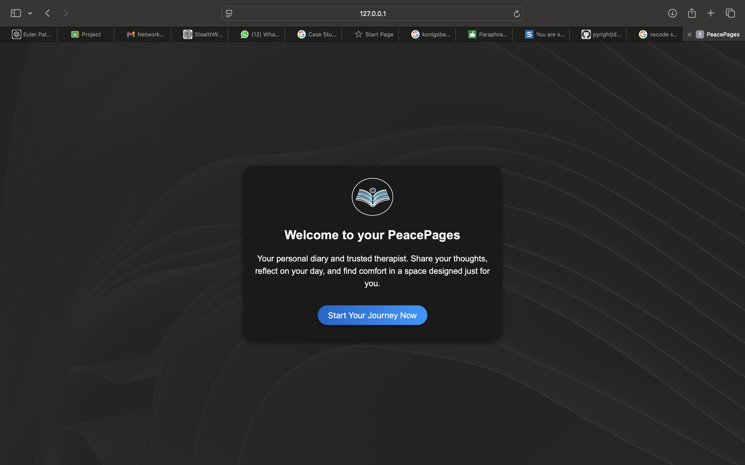

Fig. 1 Homepage

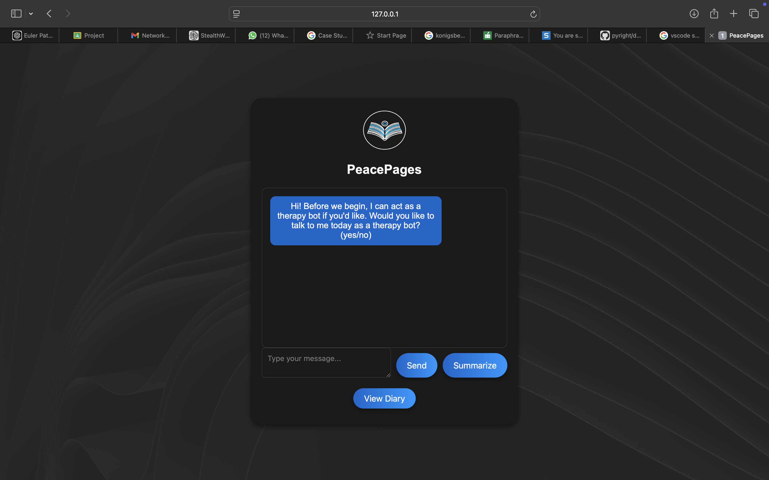

Fig.2 Therapy Bot page

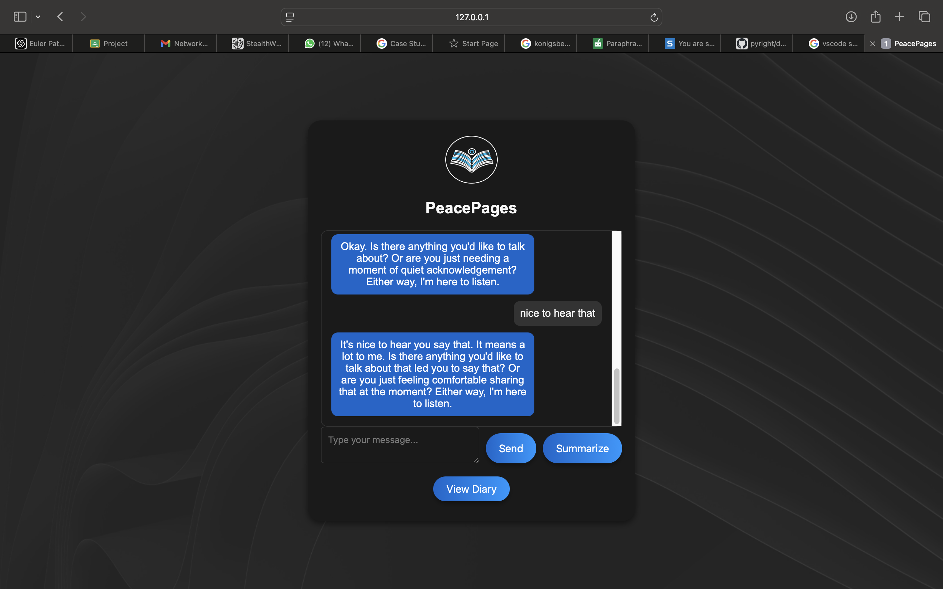

Fig.3 Bot Interacting with user

Fig.4 Summary of your connversations

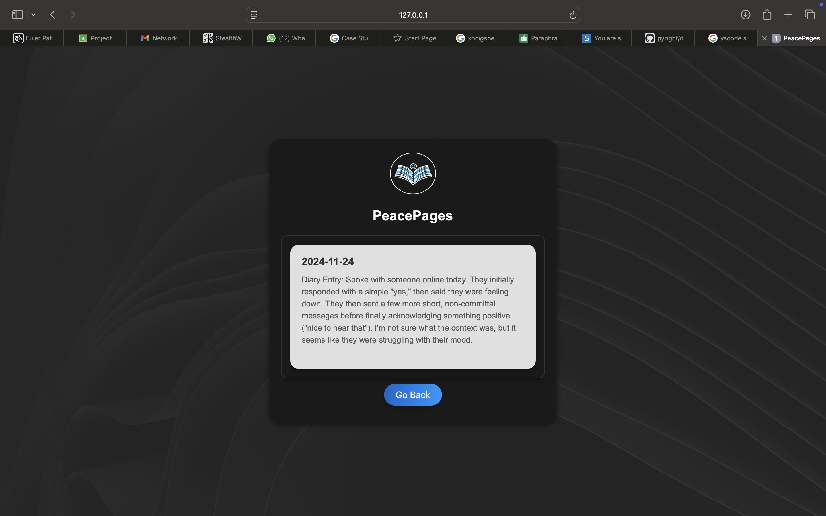

Fig.5 Saved diary entries

CONCLUSION AND FUTURE SCOPE

1. Conclusion

The **"PeacePages"** project combines AI and journaling to offer users emotional support and self-reflection. It provides two interaction modes—therapeutic and casual—giving personalized, caring responses and summarizing conversations. The chatbot helps users track their emotional growth, offering an accessible and affordable alternative to traditional therapy. With its simple design and flexible use, it serves as a valuable tool for emotional well-being and self-expression.

In conclusion, the **"PeacePages"** combines AI with journaling to provide emotional support and self-expression. Offering two modes—therapeutic and casual—the chatbot gives personalized, empathetic responses and summarizes conversations in real-time. It helps users track emotional growth and serves as an accessible, cost-effective alternative to therapy. With its user-friendly design, the chatbot is a valuable tool for emotional well-being and self-reflection.

1. Future Scope

The execution of **“PeacePages”** can improve in different ways in the future with various enhancements and improvements.

They would possibly include:

Multilingual Support: to support multiple languages, making it accessible to a global audience.

Voice Interaction: Adding voice recognition and response capabilities for a more natural and immersive user experience.

Integration with Sign Language: to offer opportunities to the people with speech issue or with permanent disability to speak.

REFERENCES

1. ***"A Survey Paper on Chatbot"* (2020) -** Tejas Pillare, Manisha Chaoudhari, Vrushabh Hiwrale, Sajan Ade, Prajwal Dudhe, Sunil Chinte
2. ***"Therapy Chatbot: A Relief from Mental Stress and Problems"* (2021)-** Pranav Kapoor, Pratham Agrawal, Zeeshan Ahmad
3. ***"Emotion Recognition and Detection Methods: A Comprehensive Survey"* (2021)-** Anvita Saxena, Ashish Khanna, Deepak Gupta
4. ***"Recent Trends in Personalized Dialogue Generation: A Review of Datasets, Methodologies, and Evaluations"* (2022) -** Yi-Pei Chen, Noriki Nishida, Hideki Nakayama, Yuji Matsumoto
5. ***"A Review on Text Summarization Techniques"* (2022) -** Pradeepika Verma, Anshul Verma