 

**Placement Empowerment Program**

***Cloud Computing and DevOps Centre***

Set Up a Cloud-Based Monitoring Service Enable basic cloud monitoring (e.g., CloudWatch on AWS) View metrics like CPU usage and disk I/O for your cloud VM.

Name: Rithik.G.V Department: ECE



**Introduction and Overview**

Cloud-based monitoring is a critical component of modern infrastructure management, enabling real-time insights into the performance and health of cloud resources. In this PoC, we will set up AWS CloudWatch to monitor key metrics for an EC2 instance, such as CPU utilization, disk I/O, and network traffic. This task demonstrates how to track system performance, identify bottlenecks, and set up alerts for proactive issue resolution.

**Objective**

The goal of this project is to:

1. Understanding the basics of AWS CloudWatch and its monitoring capabilities.
2. Configuring CloudWatch to monitor essential EC2 metrics.
3. Gaining hands-on experience in proactive cloud resource management

**Importance of Cloud-Based Monitoring**

**Hands-On Learning:**  Provides practical exposure to cloud-based monitoring tools like AWS CloudWatch, helping you gain essential skills for real-world cloud infrastructure management.

**Proactive Resource Management**: Enables you to monitor system performance in real-time, identify performance issues, and take corrective actions before they impact end users.

**Foundation for Automation:** Lays the groundwork for automating monitoring processes, such as setting up alerts and scaling actions, which are critical for efficient cloud operations and DevOps practices.

**Step-by-Step Overview**

Step1:

Open the AWS Management Console. Navigate to the EC2 Dashboard.

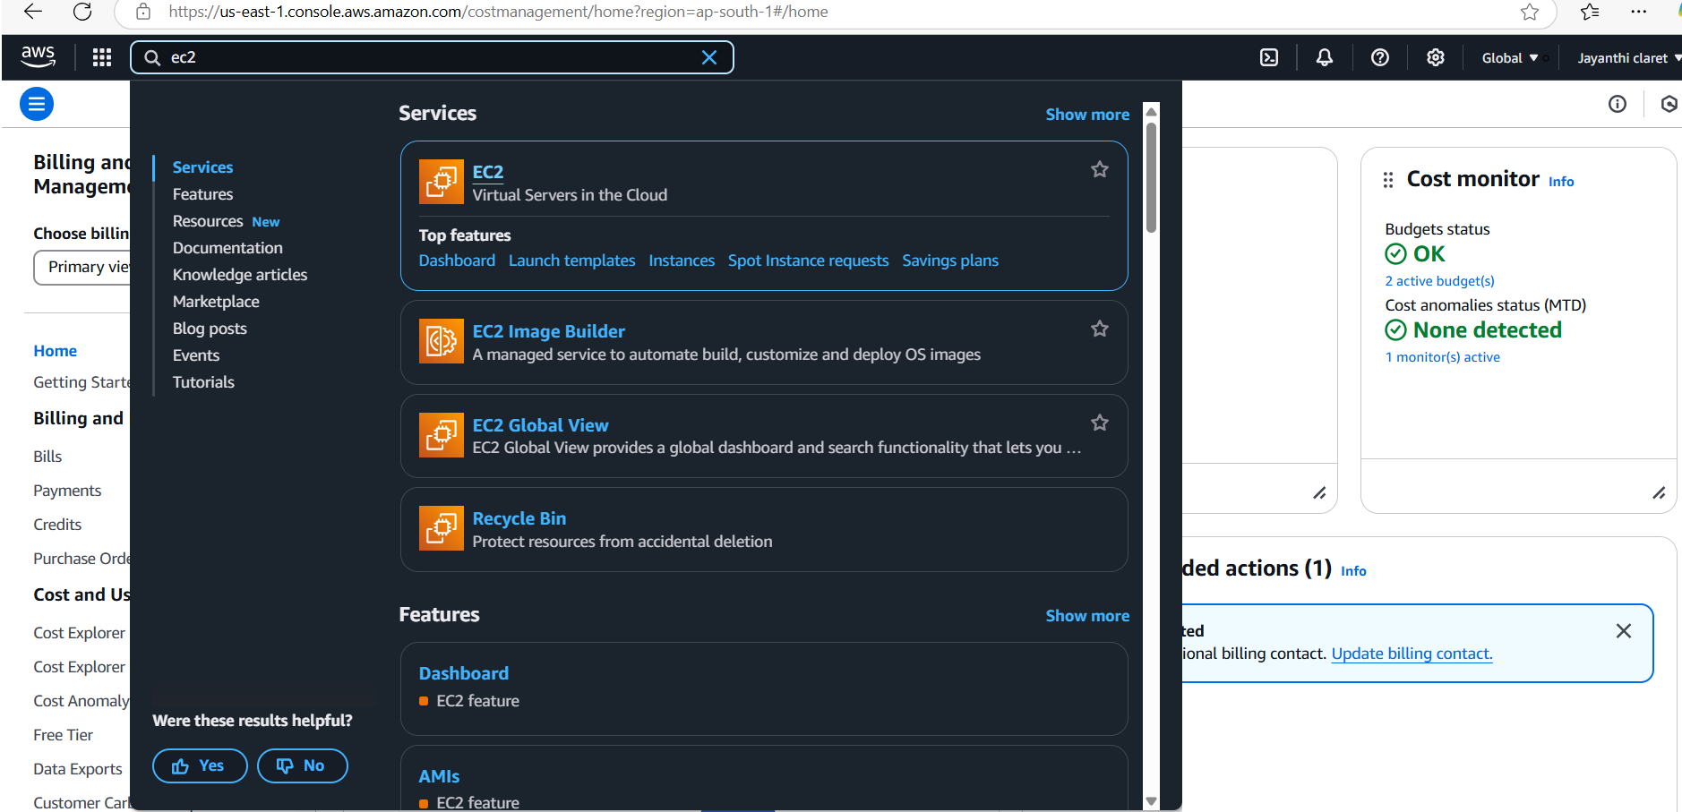

Step 2 :

Click Launch Instance, Configure the instance as needed:

Select an Amazon Machine Image (e.g., Amazon Linux or Ubuntu).

Choose an instance type (e.g., t2.Micro for free-tier eligibility)

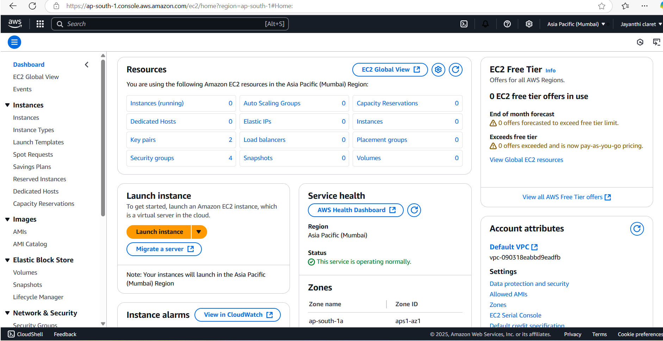

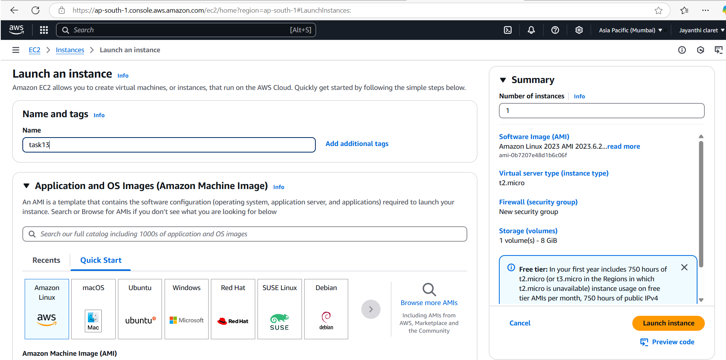

Step 3:

Configure the security group to allow necessary ports (e.g., SSH, HTTP, etc.).

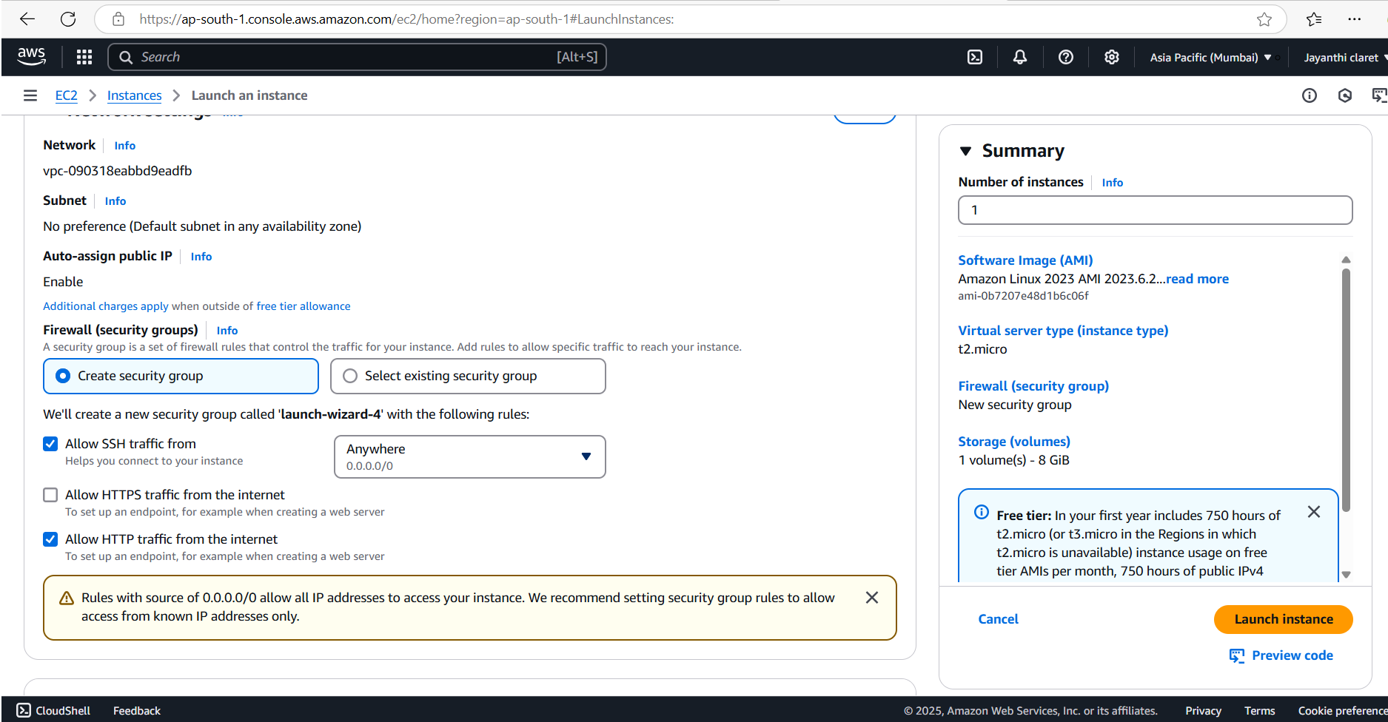

Step 4:

Launch the instance, While launching the EC2 instance:

Under the "Advanced Details" section, ensure that the CloudWatch monitoring option is enabled.

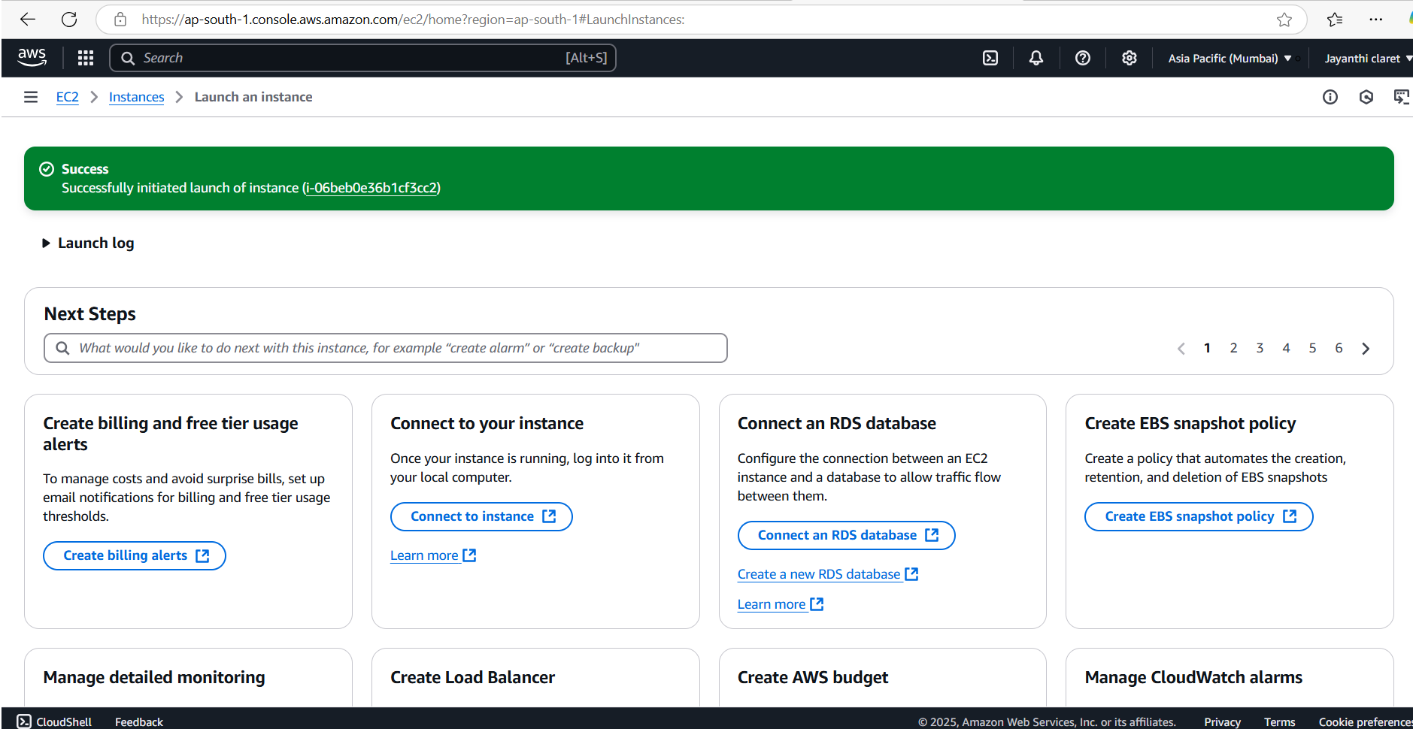

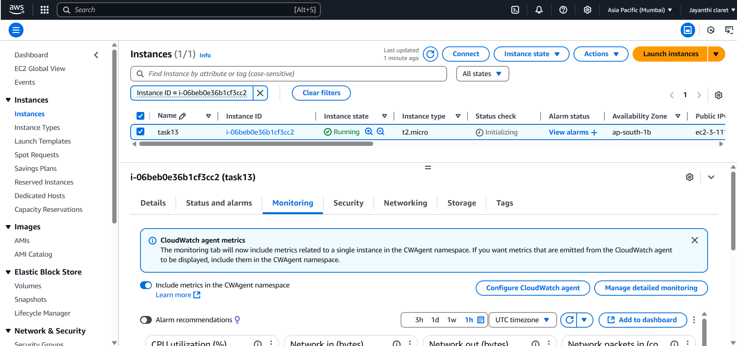

Step 5:

Open the CloudWatch Dashboard, On the CloudWatch Dashboard, navigate to Metrics on the left-hand menu.

Click All Metrics and choose the EC2 namespace.

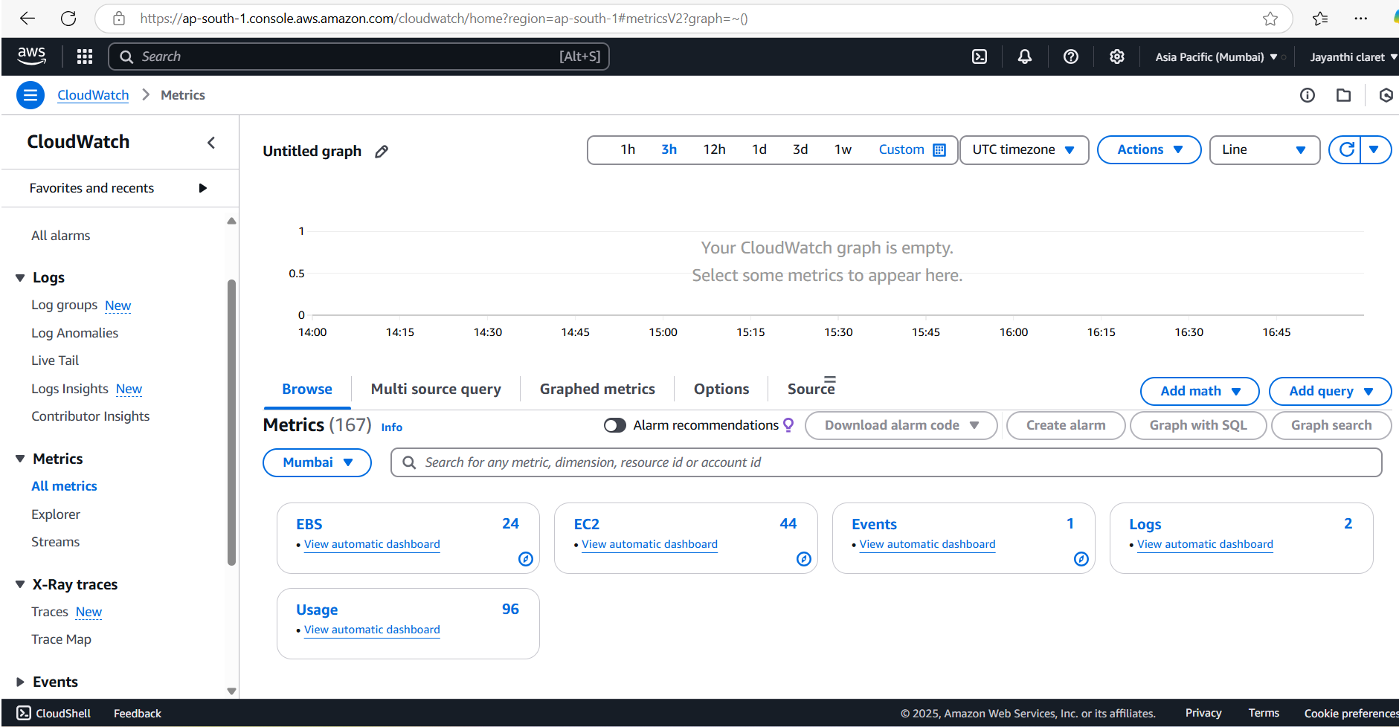

Step 6:

Select metrics like:

CPUUtilization (CPU usage in percentage).

DiskReadBytes and DiskWriteBytes (disk I/O activity).

Network In and Network Out (network data transfer).

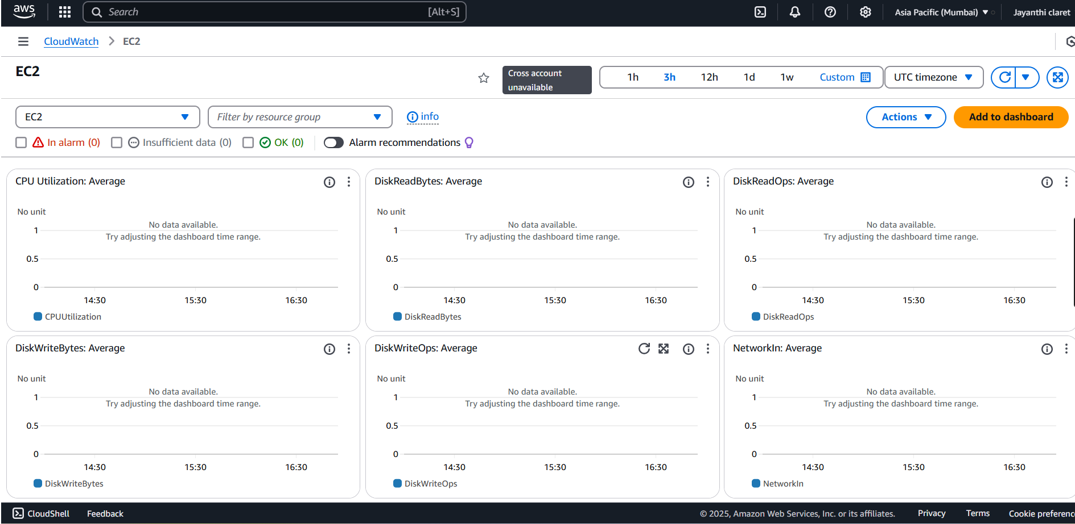

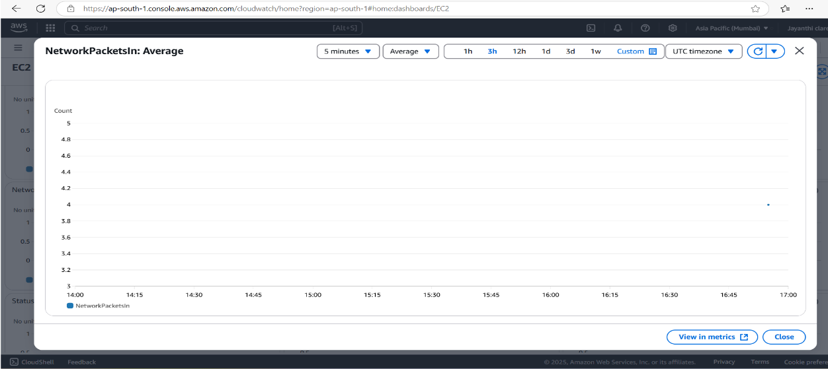

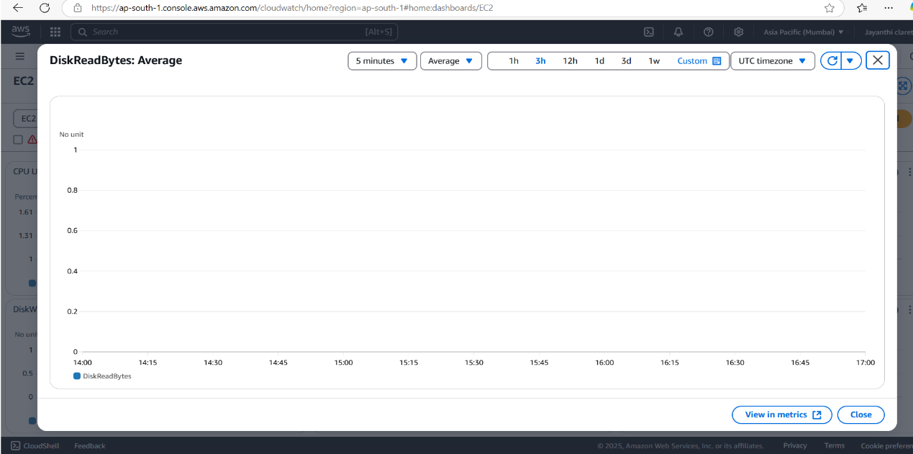

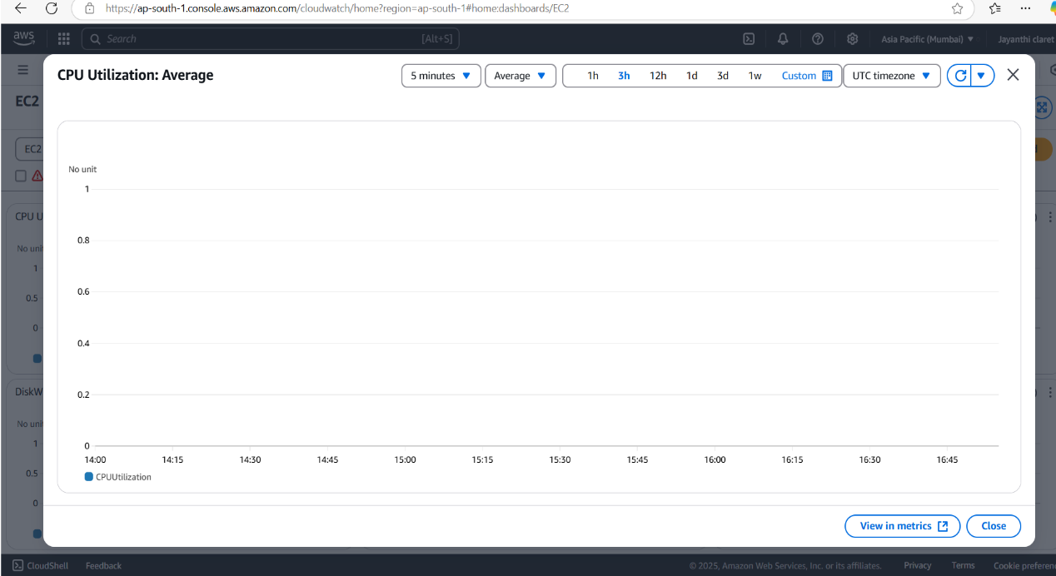

**Expected Outcome**

By completing this POC, you will:

1. Successful setup of AWS CloudWatch to monitor key metrics like CPU usage, disk I/O, and network traffic for an EC2 instance.
2. Creation of a custom CloudWatch dashboard for real-time performance tracking.
3. Improved understanding of cloud monitoring and proactive resource management.