 

Placement Empowerment Program

***Cloud Computing and DevOps Centre***

*Installing Docker and Running Your First Container on Windows*

Name:Rithik.G.V Department: ECE



# Introduction and Overview

Docker is a powerful tool that allows developers to create, deploy, and run applications in isolated environments called containers. These containers ensure that applications run consistently across different systems, eliminating compatibility issues.

In this guide, we will go through the step-by-step process of installing Docker on Windows, setting up a basic Nginx web server inside a container, and accessing it through a browser.

# Objective

* To install Docker on Windows and verify its functionality.
* To learn how to pull and run a basic Nginx container.
* To understand how to access a containerized web application using a browser.
* To gain hands-on experience with containerization and Docker commands.

# Importance

* Simplifies Deployment – Containers eliminate compatibility issues by packaging applications with all their dependencies.
* Improves Efficiency – Docker containers are lightweight and use system resources more effectively than virtual machines.
* Enhances Portability – Applications run consistently across different environments (local, cloud, or server).
* Boosts Scalability – Docker makes it easier to scale applications up or down based on demand.
* Speeds Up Development – Developers can quickly create isolated environments for testing and debugging**.**

# Step-by-Step Overview

**Step 1: Install Docker Desktop**.

1. Download **Docker Desktop for Windows** from the official website: http[s://www.docker.com/products/docker-desktop/](http://www.docker.com/products/docker-desktop/)
2. Run the installer and follow the on-screen instructions.
3. Ensure **WSL 2** is enabled (Docker requires this for Windows).
4. Restart your PC and launch **Docker Desktop**.

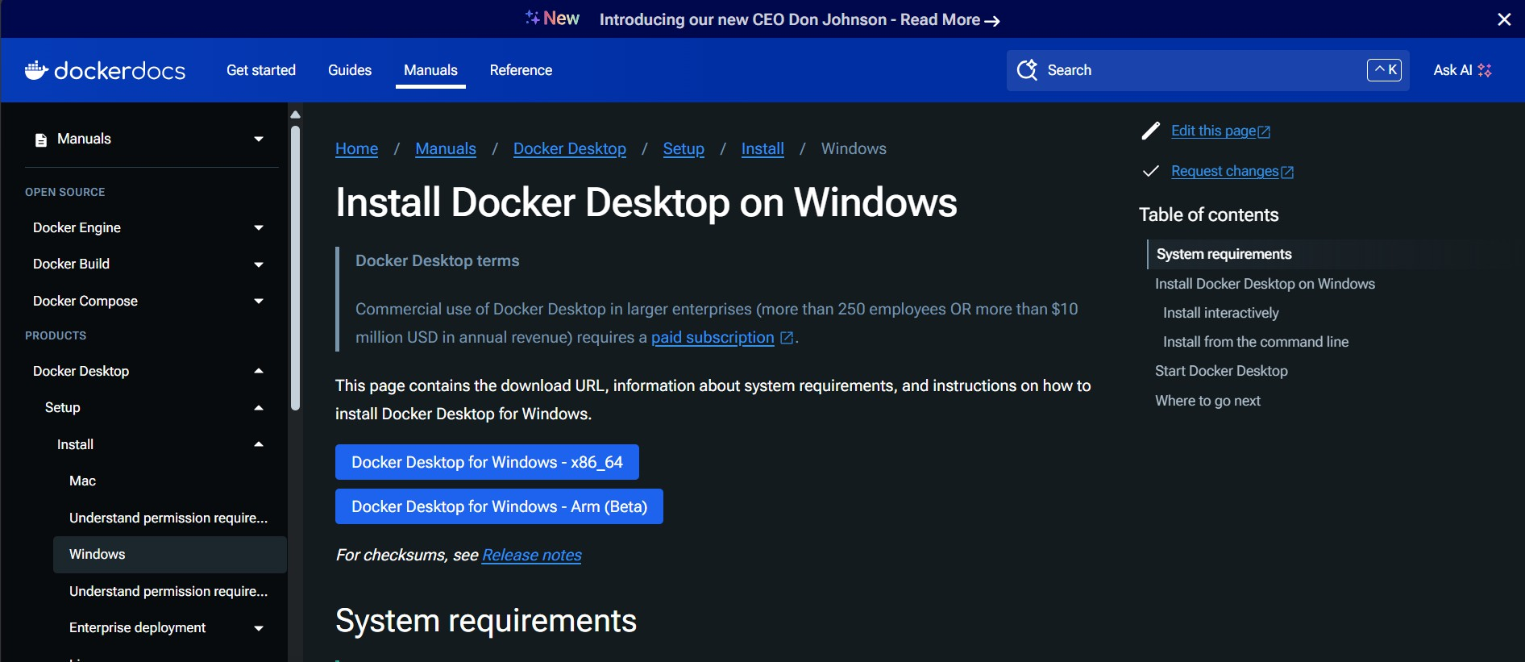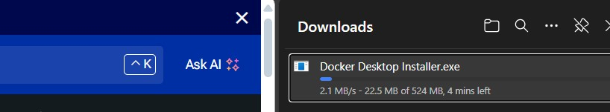

# Step 2: Verify Docker Installation

* + Open PowerShell and check if Docker is installed by running the version command.
  + Verify that Docker is running properly by checking its system information.
  + If there are any errors, ensure Docker Desktop is open and running in the background

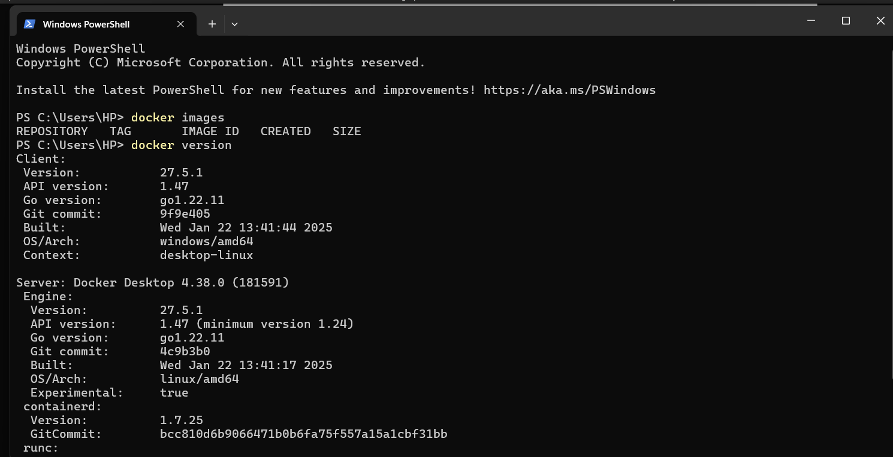

# Step 3: Pull the Nginx Docker Image

* + Use the Docker pull command to download the latest Nginx image from Docker Hub.
  + Once the image is downloaded, verify it by listing all available images in Docker.

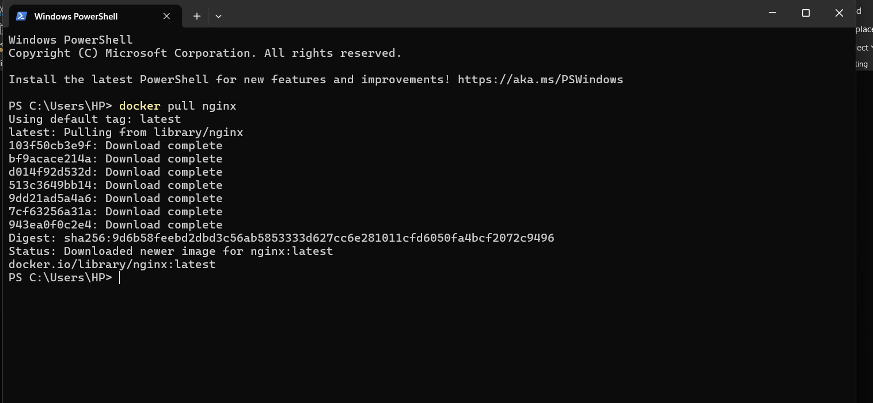

# Step 4: Run the Nginx Container

* + Start an Nginx container by running it in detached mode and mapping it to port 8080.
  + Verify that the container is running by listing all active containers.

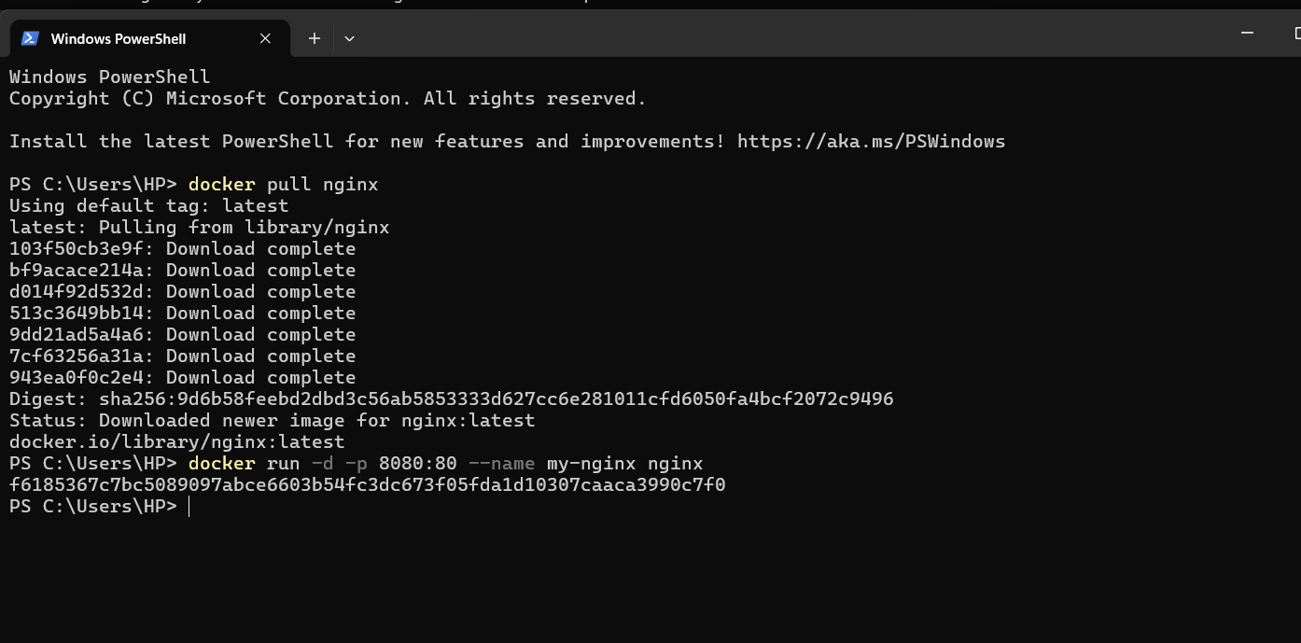

# Step 5: Access the Nginx Web Page

* + Open a web browser and go to [http://localhost:8080.](http://localhost:8080/)
  + If everything is set up correctly, the default Nginx welcome page should appear.



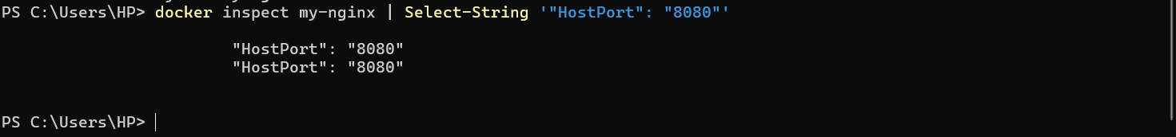

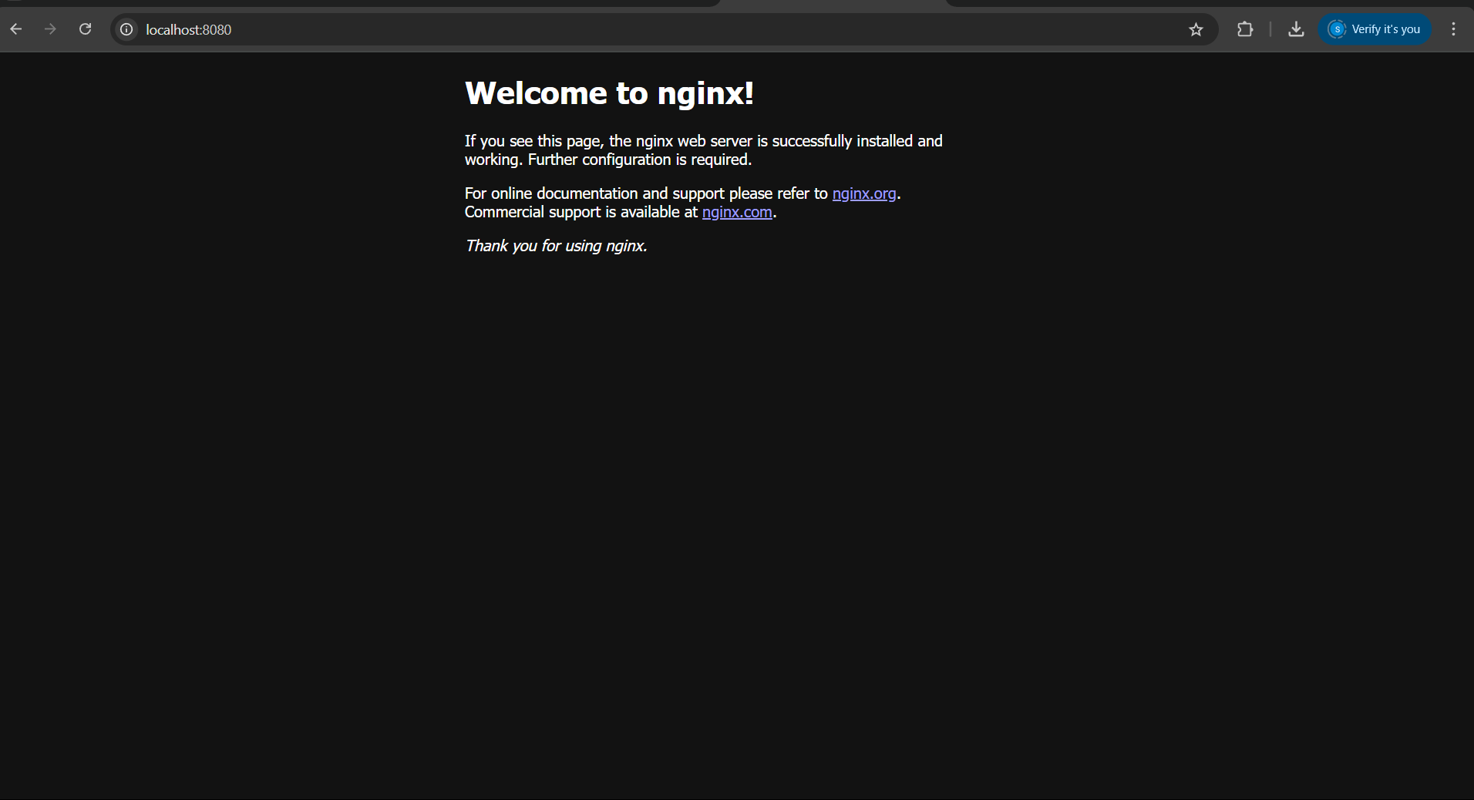

# Step 6: Stop and Remove the Container

* + If you no longer need the container, stop it using the stop command.
  + Remove the stopped container from Docker.
  + Optionally, remove the Nginx image if you want to free up space.

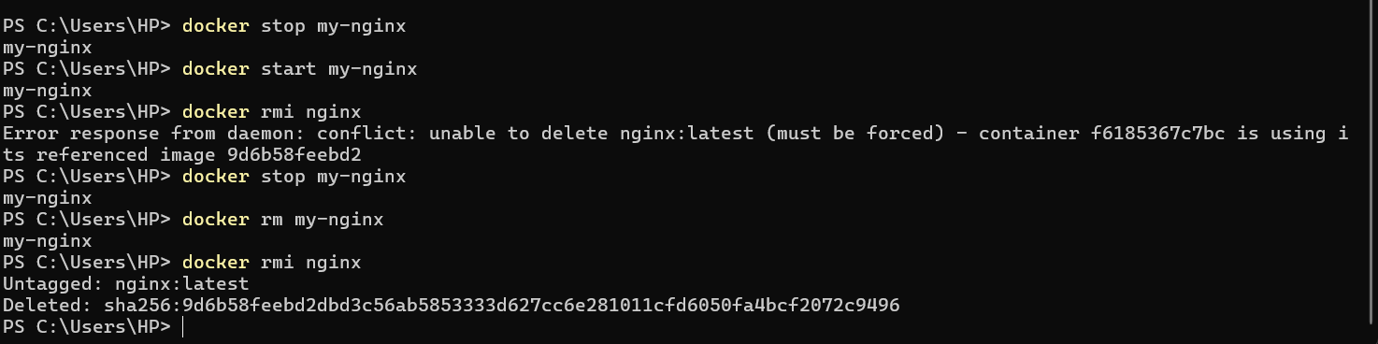

# Expected Outcome

* + Successful installation of **Docker Desktop** on Windows.
  + Verification that Docker is running correctly through **PowerShell commands**.
  + Pulling and running an **Nginx container** without errors.
  + Accessing the **Nginx default welcome page** in a web browser at [http://localhost:8080.](http://localhost:8080/)
  + Understanding basic **Docker commands** like pull, run, stop, and remove.