AIIA
AIIA Annual Report 2029-2030
Annual · 2029-2030
TABLE OF CONTENTS
1 PREFACE 3
2 BACKGROUND 5
3 MANAGEMENT 7
4 IMPORTANT MILESTONES 2024-25 13
5 HOSPITAL AND PATIENT CARE 16
6 OTHER IMPORTANT INITIATIVES 19

1. PREFACE
All India Institute of Ayurveda (AIIA), New Delhi
>The All India Institute of Ayurveda (AIIA), New Delhi, established by the Ministry of Ayush, Government of India, stands as the first-of-its-kind Apex Institute for Ayurveda in the country, envisioned on the lines of AIIMS.
Dedicated to the Nation by the Hon’ble Prime Minister of India on the 2nd Ayurveda Day, 17th October 2017, AIIA has been committed to setting the highest benchmarks in patient care, academics, and research through Ayurveda for the welfare of humanity.
In a short span since its inception, AIIA has emerged as a Centre of Excellence for Ayurveda with NABH accreditation, ISO 9001:2015 certification, and A++ grade from NAAC. With a blend of traditional wisdom and modern technology, the Institute has provided holistic healthcare to more than 27 lakh patients and has gained global recognition for its integrative approach, research rigor, and academic excellence.
The Institute today runs 44 specialty OPD clinics, nine interdisciplinary research laboratories, a 200-bed referral hospital, and offers postgraduate (MD/MS) and doctoral (PhD) programmes across 12 disciplines of Ayurveda.The Institute has also expanded its footprint through the establishment of its Satellite Centre in Goa, extension centres at Kevadia, IIT Delhi, the Supreme Court of India, and other institutions of national importance, thereby bringing quality Ayurveda care closer to the people.
Academic collaborations with over 50 national and 17 international institutions, including Harvard Medical School, Western Sydney University, and London School of Hygiene & Tropical Medicine, reinforce AIIA’s vision of creating global scientific acceptance of Ayurveda.
The establishment of an Incubation Centre and recognition as a Host Institute by the Ministry of MSME further highlights AIIA’s role in innovation, entrepreneurship, and translational research in the Ayush sector.The Institute has also hosted several significant national and international events, including the World Health Organisation’s first-ever Global Summit on Traditional Medicine, the launch of AROHA-2024 – AIIA’s International Conference on Ayurveda, and the commemoration of Ayurveda Day and International Day of Yoga with wide participation and impact.
It is a matter of pride that the Institute continues to receive the guidance and support of the Ministry of Ayush, enabling it to achieve its mandate of making Ayurveda healthcare, education, and research of the highest standards accessible at both national and international levels.As AIIA progresses into its next phase of growth, the Institute remains committed to its mission of blending the timeless wisdom of Ayurveda with modern scientific validation, ensuring its relevance and utility for future generations, and contributing to the vision of a healthier, empowered, and sustainable world.
Advancing Holistic Healthcare
>At the heart of AIIA’s mission is patient care. During 2024–25, the Institute achieved remarkable growth in its clinical services:
• >Outpatient Services: A total of 4,38,757 OPD registrations were recorded, averaging nearly 2,000 daily footfalls. Patients were treated across 46 specialty clinics, including Panchakarma, Kay achikitsa, Kaumarbhritya, Shalakya, Shalya Tantra, Stri Roga and Prasuti Tantra, Swasthavritta, and integrated AYUSH clinics.
• >Inpatient Services: The 200-bed IPD facility served 5,074 admissions, supported by ICU, NICU, modular OTs, labour rooms, and advanced diagnostic facilities.
• >Specialized Procedures: The year saw 63,069 Panchakarma procedures, 8,154 Kriya Kalpa therapies, and 2,512 dental procedures successfully performed.
• >Diagnostics: State-of-the-art diagnostic services provided over 2.17 lakh laboratory investigations, 12,704 ultrasound scans, 10,159 X-rays, and 5,711 ECGs, ensuring accurate clinical decision-making.
• >Extension Centres: AIIA expanded access through extension centres at the Supreme Court of India, Kevdia Arogya Van, LBSNAA Mussoorie, and AIIMS-NCI Jhajjar, benefitting 28,474 patients and performing 20,611 procedures.
>The Institute continued to serve diverse populations, including women, children, senior citizens, and Delhi Police personnel, while also providing dignitary care and outreach services.
Preventive and promotive health initiatives in mental health, geriatric care, maternal health, pain management, oral health, and latent tuberculsis further reinforced AIIA’s public health role.
Academic Leadership and Research Excellence
>Education and research remain at the core of AIIA’s identity. In 2024–25:
• >Postgraduate Education: 92 MD/MS (Ayu) students joined across 12 specialty departments, making AIIA one of the largest postgraduate Ayurveda training centres in India.
• >Doctoral Research: The PhD entrance exam attracted 380 candidates, of whom 323 appeared, reflecting the growing global interest in Ayurvedic research.
• >Research Projects: The Institute advanced 24 extra-mural and 28 intra-mural projects, covering areas such as integrative oncology, metabolic disorders, mental health, and pharmacological validation of Ayurvedic formulations.
• >Publications: Faculty and scholars contributed to reputed peer-reviewed journals including AyuCaRe and IJAR, strengthening scientific validation of Ayurveda.
• >Collaborations: AIIA sustained partnerships with 50 national institutes and 17 international organisations, including Harvard Medical School, Western Sydney University, and the London School of Hygiene & Tropical Medicine.
• >Skill Development: Certificate courses in Hospital Management and Nursing Skill Upgradation, as well as Panchakarma Technician training, empowered healthcare workers with new-age skills.
>AIIA’s NAAC A++ accreditation with CGPA 3.55 in its very first cycle reaffirmed the Institute’s academic rigour and excellence.
Global Recognition and Strategic Expansion
>The year also witnessed important milestones in institutional growth and international recognition:
• >Infrastructure Development: The Phase-II expansion at the New Delhi campus, spread over 15 acres at an outlay of ₹289 crores, neared completion, promising enhanced facilities for patients and researchers. An additional 12 acres of land at Sarita Vihar was secured for future expansion.
• >Goa Campus: The 50-acre satellite campus at North Goa, inaugurated in 2022 by the Hon’ble Prime Minister, expanded academic and healthcare services with 14 undergraduate disciplines and growing research facilities. Its first Annual Day was celebrated in December 2023 with international participation.
• >Extension Centres: New centres were established at Kevadia (Ekta Nagar), Supreme Court of India, and IIT Delhi, reflecting AIIA’s national footprint.
• >International Conferences & Events:
• >Hosted AROHA-2024, the first international Ayurveda research conference, inaugurated by the Hon’ble Chief Justice of India.
• >Celebrated International Day of Yoga 2024 with the theme Yoga for Women Empowerment.
• >Represented Ayurveda at the WHO Traditional Medicine Global Summit (2023, Gandhinagar) and the World Heritage Committee Session (2024, Bharat Mandapam, New Delhi).
• >Signed MoUs with BITS Goa, National Institute of Oceanography, and private innovators under iCAINE (Incubation
>Prof. (Dr.) Sujata Kadam
Director (I/c), All India Institute of Ayurveda

2. BACKGROUND
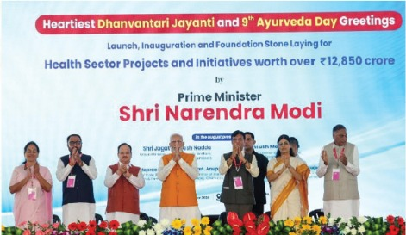
On the occasion of Dhanvantari Jayanti and the 9th Ayurveda Day, Prime Minister Shri Narendra Modi inaugurated Phase-II of All India Institute of Ayurveda
All India Institute of Ayurveda (AIIA)
>All India Institute of Ayurveda (AIIA) was inaugurated and dedicated to the nation by Hon’ble Prime Minister of India Shri Narendra Modi on 17th October, 2017.AIIA is a holistic tertiary care Ayurveda treatment center and hospital supported by the latest medical tools for diagnosis. The Institute has been conceived as an Apex Institute for Ayurveda with the aim of bringing synergy between traditional Ayurveda wisdom and modern tools and technology through scientific validation of fundamental principles and human resource development programs.The Institute is working under the guidance of the Ministry of Ayush, Government of India, to achieve the following objectives of its establishment by the Government of India.
Objectives of the Institute
• To provide postgraduate, doctoral, and post-doctoral teaching, research facilities, and quality patient care services under the Ayurveda system of medicine.
• To act as a referral hospital and a “Centre of Excellence” to set the highest standards of education, research, and patient care, and also function as a model center for international collaboration.
• To act as a model institution to show the strength, efficacy, and popularity of Ayurveda. The institute will be used for promoting Ayurveda in India and abroad.
• To provide services in specialties like Panchkarma, Kayachikitsa, Vata-Vyadhi, Rasayna, Kayakalpa, Twacha Roga (Skin Disorders), Vajikaran, Shalya Tantra, Kshar evam Anushastra Karma (Jalauka and Rakta Mokshan), Marma Chiktisa, Vrikka Roga (Nephrology), Mutra Roga (Urology), Shalakya (Eye, ENT and Dental Disorders), Stri Roga and Prasuti Tantra, Bal Roga, Rog Nidan, Lifestyle and Metabolic Disorders, Yoga and Swastha Vritta, Ahara Bidhi Vigyan (Dietetics), Ayurvedic Pharmacy, Fundamental Principles of Ayurveda and their application in a set up that combines the ancient tradition of Ayurveda along with the Advantages of biomedicine, current management and information technology tools.
• To impart interdisciplinary postgraduate, doctoral, and post-doctoral teaching, training, and research in all Ayurvedic specialties and also health and hospital management programmes. It will have all necessary infrastructure to cater to secondary and tertiary level health care facilities for diagnosis and treatment in collaboration with national and international institutions.
• To give highest priority to explore and explain the scientific basis of various aspects of Ayurveda through collaborative, inter-disciplinary research. In this direction, the required infrastructure would be developed with the help of various R&D institutions including Central Council for Research in Ayurveda and Siddha (CCRAS), Indian Council of Medical Research (ICMR), Council for Scientific and Industrial Research (CSIR), National Institute for Pharmaceutical Education and Research (NIPER), and other national level institutes. Human resources and infrastructure of participating institutions will be utilized in conducting project-based research programmes on need specific clinical and drug studies.
• To develop model teaching tools and demonstration modules of teaching in postgraduate, doctoral, and post-doctoral Ayurveda medical education in all branches so as to demonstrate high standards of education for use in Ayurvedic institutions.
Institutional Facilities and Academic Programmes
>The Institute has 12 Specialty Departments and 44 clinics with 9 inter-disciplinary research laboratories.The Institute offers postgraduate and doctoral courses in 12 disciplines of Ayurveda.The institute has a 200-bed referral hospital for facilitating clinical research along with comprehensive care against COVID-19 functional in preventive, promotive, palliative, and post COVID scenario.The Institute is a perfect blend of ancient wisdom and modern technology, attracting global attention and expected to boost medical tourism in India with a focus on fundamental research on Ayurveda, drug development, standardization, quality control, safety evaluation, and scientific validation of Ayurvedic medicines.

3. MANAGEMENT
The All-India Institute of Ayurveda is governed by the following statutory bodies: General Body (GB), Executive Council (EC), Standing Finance Committee (SFC).

Governing Body:
S.No | Members | Position
1 | Shri Prataprao Jadhav, Hon'ble MoS (Independent Charge), Ministry of Ayush, Government of India | President
2 | Vacant | Vice President
3 | Vaidya Rajesh Kotecha, Hon'ble Secretary, Ministry of Ayush, Government of India | Member
4 | Padmabhushan Vaidya Devinder Triguna, Nominated Member by Ministry of Ayush | Member
5 | Dr. Rajiv Behal, Director General, Indian Council of Medical Research (ICMR) | Member
6 | Shri. Hoveyda Abbas, AS & FA, Ministry of Health & Family Welfare | Member
7 | Prof. Rabi Narayan Acharya, Director General, Central Council for Research in Ayurvedic Sciences (CCRAS) | Member
8 | Vacant | Member
9 | Vd. Shivaratna Sadashiv Shete, All India Institute of Medical Sciences, New Delhi (Ayurved Consultant, Solapur, M.S.) | Member
10 | Dr. Vijay Vishwanath Doiphode, Director, Ayurveda Rashashala Foundation | Member
11 | Prof. Yogesh Singh, Vice Chancellor, Delhi University | Member
12 | Dr. N.K. Manjunath, Vice Chancellor, S-VYASA Yoga University | Member
13 | Dr. Sanjay Jachak, Professor and In-charge HoD, Dept. of Natural Products, National Institute of Pharmaceutical Education and Research (NIPER) | Member
14 | Sh. K. Raja Bhanu, Director General, PHARMEXCIL | Member
15 | Sh. K. Raja Bhanu, Director General, PHARMEXCIL | Member
16 | Representative of Department of Biotechnology | Member
17 | Mr. Chakravarthy T. Kannan, Secretary General, Quality Council of India (QCI) | Member
18 | Prof. (Dr.) Manjusha Rajagopala, Director (I/C), All India Institute of Ayurveda | Secretary

Executive Council:
S.No | Members | Position
1 | Vaidya Rajesh Kotecha, Ministry of Ayush, Government of India | Chairperson
2 | Shri Jaideep Kumar Mishra, AS & FA, Ministry of Health & Family Welfare | Member
3 | Shri Rajiv Behal, Secretary, Department of Health Research & Director General, ICMR, New Delhi | Member
4 | Padmabhushan Vaidya Davendra Triguna, President, Ayurved Mahasammelan, New Delhi | Member
5 | Dr. Vijay Vishwanath Doiphode, Director, Ayurveda Rasashala, Pune | Member
6 | Shri B.K Singh, Joint Secretary, Ministry of Ayush, Govt. of India | Member
7 | Dr. Manasi Nesari, Advisor (Ayurveda), Ministry of Ayush | Member
8 | Dr. M Srinivas, Director, All India Institute of Medical Sciences, New Delhi | Member
9 | Prof. Rabi Narayan Acharya, Director General, Central Council for Research in Ayurvedic Sciences (CCRAS) | Member
10 | Prof. Dulal Panda, Professor, National Institute for Pharmaceutical Education and Research (NIPER) | Member
11 | Prof. (Dr.) Tanuja Manasi Nesari, Director, All India Institute of Ayurveda | Member Secretary

Standing Finance Committee:
S.No | Members | Position
1 | Shri B.K Singh, Joint Secretary, Ministry of Ayush, GoI | Chairperson
2 | Shri Jaideep Kumar Mishra, AS & FA or his representative, Ministry of Health & Family Welfare | Member
3 | Dr. Manasi Nesari, Advisor (Ayurveda), Ministry of Ayush, GoI | Member
4 | Smt. Jaspal Kaur Pradyut, The Chief Controller of Accounts, Ministry of Health & Family Welfare | Member
5 | Director General, Central Council for Research in Ayurvedic Sciences (CCRAS), Delhi | Member
6 | Dr. Padma Srivastava, AIIMS, New Delhi | Member
7 | Prof. (Dr.) Tanuja Manasi Nesari, Director, All India Institute of Ayurveda | Member Secretary

List of Faculty Positions as on 31st March 2025 at AIIA, New Delhi
Name | Designation
Dr. Tanuja Manoj Nesari | Professor / Director (Till 31.10.2024)
Sujata Dhanajirao Kadam | Professor / Director (From 01.11.2024)
Pradeep Kumar Prajapati | Professor
Manjusha Rajagopala Bhat | Professor
Maheshkumar Shivnarayan Vyas | Professor
Jonah Sandrepogu | Professor
Anandaraman P V | Professor
Yogesh Rajendra Badwe | Professor
Sarita Vilas Ohol | Professor
Meda Mruthyumjaya Rao | Professor
Vittal Govindappa Huddar | Additional Professor
Rama Kant Yadava | Additional Professor
Kamini Dhiman | Additional Professor
Santoshkumar Bankatlalji Bhatted | Additional Professor
Vyasadeva Mahanta | Additional Professor
Rajgopala Shrikrishna Bhat | Additional Professor
Galib | Additional Professor
Meera Keshavlal Bhojani | Additional Professor
Shivakumar Shankar Harti | Additional Professor
Narayan Giriyappa Bavalatti | Additional Professor
Meena Shamrao Deogade | Additional Professor
Vivek Agarwal | Additional Professor
Arun Kumar Mahapatra | Associate Professor
Rajaram Jagat Mahto | Associate Professor
Prasanth Dharmarajan | Associate Professor
Meenakshi Pandey | Associate Professor
Pramod Ratiram Yadav | Associate Professor
Divya Kajaria | Associate Professor
Pankaj Kundal | Associate Professor
Shivani Ghildiyal | Associate Professor
Shalini Rai | Associate Professor
Swati Vinayak Gaikwad | Associate Professor
Ramesh Kumar Kl | Associate Professor
Rinky Thakur | Associate Professor
Ramavtar Sharma | Associate Professor
Awadhesh Kumar Pandey | Associate Professor
Shekhar Gopalrao Uike | Assistant Professor
Kamal Kumar | Assistant Professor
Garima Srivastava | Assistant Professor
Nidhi Sharma | Assistant Professor
Ankur Tripathi | Assistant Professor
Rashmi R Bhise | Assistant Professor
P Neelayathatchi | Assistant Professor
Prashant Kumar Gupta | Assistant Professor
Laxmi Maharana | Assistant Professor
Sushma Kumari | Assistant Professor
Praveen Kumar K S | Assistant Professor
Rupashri Nath | Assistant Professor
Meeta Jhala | Assistant Professor
Amrish Prakash Dedge | Assistant Professor
Swapnil Yashwant Chaudhari | Assistant Professor
Bidhan Mahajon | Assistant Professor

4. IMPORTANT MILESTONES 2024-25
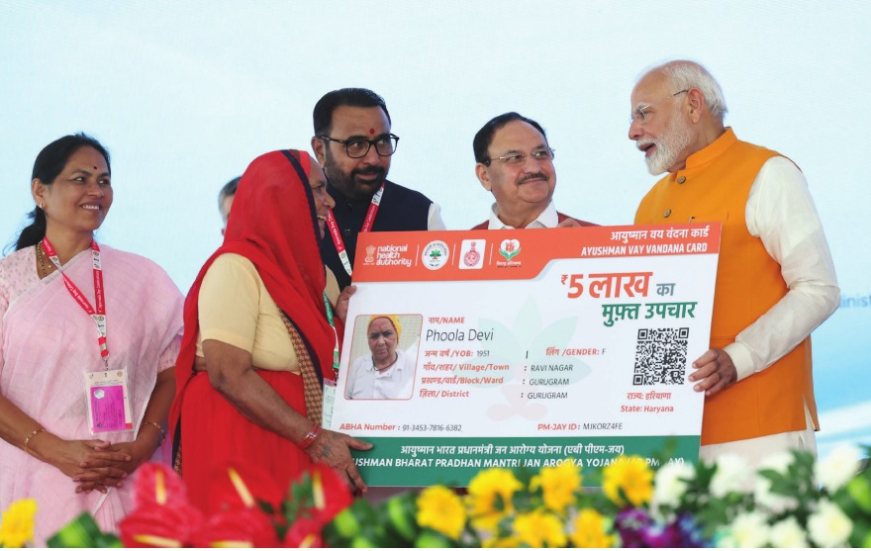
Prime Minister Narendra Modi’s visit to the All India Institute of Ayurveda (AIIA) during the 9th Ayurveda Day on Dhanvantari Jayanti (October 29, 2024).
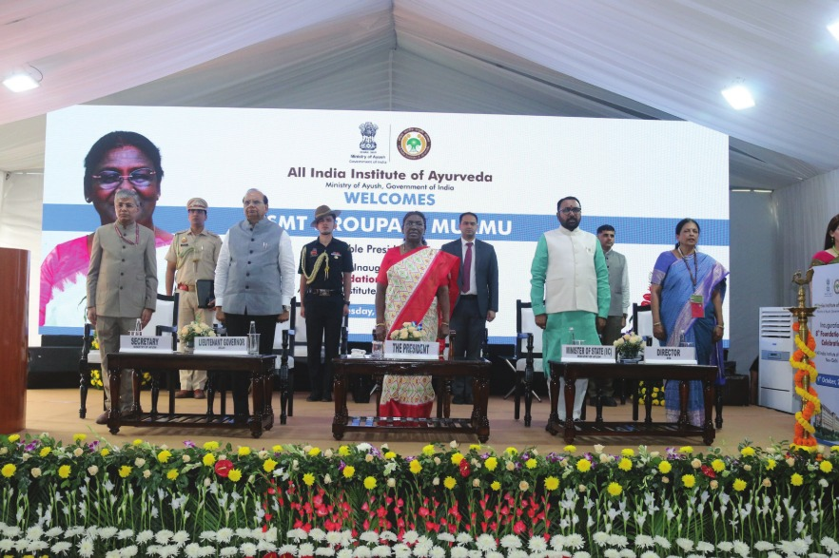
The President of India, Smt Droupadi Murmu graced the 7th foundation day of All India Institute of Ayurveda (AIIA) in New Delhi today (October 9, 2024).
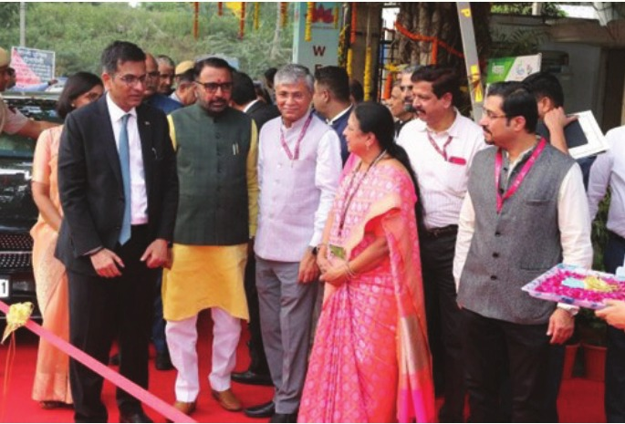
The Chief Justice of India (CJI), Dr. Justice Dhananjaya Yeshwant Chandrachud, visited the All India Institute of Ayurveda (AIIA) in October 2024 to inaugurate the first internatioal conference, AROHA-2024
The All-India Institute of Ayurveda (AIIA), New Delhi, organised a grand event to commemorate the 10th edition of International Day of Yoga, 2024. The theme of the event on this occasion was “Yoga for Women Empowerment”. Sister BK Shivani, a well-known motivational speaker, was the Chief Guest of this eventAIIA, New Delhi, and Nadipulse Prognostics Pvt. Ltd. signed a Memorandum of Understanding (MoU) under iCAINE, the Incubation Centre for Ayurveda Innovation and Entrepreneurship, for the clinical validation of the Nadi Parikshan equipment, nPulse, developed by Nadi Pulse Prognostics Pvt. Ltd. The MoU was signed by AIIA Director, Prof. (Dr.) Tanuja Nesari.
Under the Ministry of Ayush, AIIA hosted the Global Technical Consultation Group meeting on “Artificial Intelligence (AI) for Global Health: Advancing Traditional Medicine” in collaboration with the WHO Global Traditional Medicine Centre (GTMC) and the Department of Digital Health and Innovation (DHI-WHO-HQ) on 11–12 September 2024.
AIIA successfully showcased Ayurveda at the Ayush Pavilion during the 46th Session of the World Heritage Committee held at Bharat Mandapam, New Delhi. The event was inaugurated by Hon’ble Prime Minister Shri Narendra Modi on 22 July 2024.

5. HOSPITAL AND PATIENT CARE
All India Institute of Ayurveda (AIIA)
>All India Institute of Ayurveda (AIIA) is an Apex Ayurveda Institute functioning under the aegis of the Ministry of Ayush, with a vision to be a Centre of Excellence for Ayurveda Education, Research, and Healthcare.The Institute is a perfect blend of Ancient Wisdom and Modern Technology, attracting global attention and expected to boost medical tourism in India by showcasing the strengths of Ayurveda.AIIA is providing NABH-accredited tertiary quality healthcare services to patients through holistic treatment. The Ayurveda Healthcare Model at AIIA Hospital provides services segregated under the following categories:
• Out Patient Department (OPD)
• In Patient Department (IPD)
• Centre for Integrated Medicine
• Covid Health Centre
(a) Out Patient Department (OPD)
The Institute has a fully centralized AC hospital and well-equipped OPDs running under highly qualified and experienced Consultants in seven different departments, namely:
• Kaumarbhritya (Paediatrics)
• Kayachikitsa (General Medicine)
• Panchakarma
• Shalakya Tantra (Ophthalmology, Ear, Nose & Throat)
• Shalya Tantra (Surgery)
• Striroga and Prasuti Tantra (Obstetrics & Gynaecology)
• Swasthavritta (Diet, Lifestyle and Yoga Clinic)
• Integrated AYUSH Clinic (Unani, Siddha and Homeopathy)
Specialty Clinical Services
The Institute houses 12 specialty departments and 46 clinics, along with 8 interdisciplinary research laboratories. It offers postgraduate and doctoral programs across various branches of Ayurveda.The 200-bed referral hospital facilitates clinical research and provides comprehensive healthcare services, including preventive, promotive, palliative, and post- COVID-19 care.
I. Specialty OPD's at AIIA:
Specialized Health Care Clinics:
A- | Kayachikitsa
1 | Cardiorespiratory care & General Kayachikitsa OPD
2 | Neurological & Degenerative Disease Care Unit
3 | Rheumatology & Musculoskeletal Care Unit
4 | Gastrointestinal & Liver Disorders Care Unit
5 | Diabetes & Metabolic/ Disorders Care Unit
6 | General OPD/Rasayan/Vajeekaran/ Manas Roga
7 | Skin Care/General OPD
8 | Post Covid OPD/General OPD
9 | Post Covid OPD/General OPD
10 | Manasroga OPD
11 | Ay. Nephrology Unit (Every Thursday)

B- | Swasthavritta
11 | Swasthavritta (Lifestyle, Dietetics & Yoga)
12 | Yoga (09AM to 10AM) & 3:30PM to 4:30PM)

C- | Shalakya
14 | EYE-Shalakya Netra Roga
15 | ENT care Unit- Shalakya
16 | Kriyakalpa Unit Shalakya

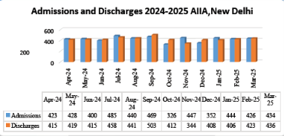
Admission and discharge 2024-2025

6. OTHER IMPORTANT INITIATIVES
AYURVEDA INNOVATION AND ENTREPRENEURSHIP (AIIA-iCAINE)
1. Introduction & Mission
iCAINE, launched on 29 October 2021 by the Ministry of Ayush at AIIA, New Delhi, is India’s premier public-sector Ayurveda startup incubator. It fosters entrepreneurship and innovation by supporting concept-to-market initiatives in Ayurveda.
Designated as a Host Institute under the Ministry of MSME, iCAINE offers incubation infrastructure, mentoring, and networking for Ayurveda-based startups.
2. Vision & Objectives
Vision
To evolve into a Centre of Excellence promoting invention, innovation, and entrepreneurship in Ayurveda.
Mission
• Train and mentor innovators in translational research and enterprise setup.
• Facilitate academia–industry synergy through infrastructure and technology.
• Support incubatees with mentoring, networking, and market-readiness tools.
3. Key Functions
Incubation & Mentorship
iCAINE provides space, laboratories, business guidance, and regulatory guidance to Ayurveda startups. It is recognized by MSME for supporting innovation.
Workshops & Sensitization
The centre hosts events on startup ecosystems, intellectual property, and business planning.
Community & Ecosystem
iCAINE partners with Ayush, NCISM, MSME, and the Ministry of Education to build a robust innovation landscape.
4. Training & Capacity-Building Activities
MSME Idea Hackathon 4.0
During the MSME Idea Hackathon 4.0, held from 11 September to 10 October 2024, iCAINE served as MSME's Host Institute. The programme invited innovators aged 18–35 and supported incubation along with potential funding of ₹15 lakh per idea.
Regular Seminars
Regular seminars were conducted on intellectual property, methods, and industry–academia collaboration for entrepreneurship development.
5. Incubation Activities
Knowledge Partner
iCAINE entered into a Knowledge Partner agreement with C-CAMP Bangalore, a leader in bioscience incubators. Through this partnership, a CEO, Program Manager, and Finance Portfolio Personnel were appointed.
Startups Incubated: FY 2024–25
During FY 2024–25, iCAINE incubated 5 teams of founders, with 1 startup MVP study in progress.
Facilities Provided
Facilities provided to incubatees included mentoring in business and clinical validation through clinical trials.
Fund Raising
A proposal for iTBI Nidhi DST was successfully submitted on 14 February 2025.
Milestones
Key milestones included successful prototype development, incubation of SIH Hackathon winners, and participation in national exhibitions.
Incubation Policy
The working draft of the Incubation Policy Manual is ready.
6. Lectures, Conferences & Events by Staff
Staff members led sessions at “AYUR-UDYAMAH” and the MSME Idea Hackathon.
They were also active contributors and panellists at the World Ayurveda Congress 2024.
7. Startups’ Achievements & Awards
iCAINE initiated the Navapravarthan Idea Hackathon.
SIH Hackathon participants became eligible for funding, with evaluation and incubation underway.
Multiple startups were shortlisted nationally, securing grant and incubation support.
Events Organized
Date | Event | Highlights
11–12  September  2024 | MSME Idea Hackathon 4.0 – Kickoff | National-level competition hosted  by AIIA-iCAINE; ideas evaluated  by expert panels.
14 December  2024 | iStartup SaturdayWebinar Series – The  Biological Diversity Act and its Relevance in  Utilisation of Biological Resources for  Research and Commercial Use | Speaker: Mr. Shivakumar, Founder  and Managing Attorney, IPMentor  for Startups, Advisor for BDA&  Technology Transfer.
28 December  2024 | iStartup SaturdayWebinar Series –  Exploring Ayurveda-Based  Entrepreneurship: Insights, Opportunities  and Challenges | Speaker: Dr. Nimin Sreedhar,  Entrepreneur and Founder, The  Dravya App.
11 January  2025 | iStartup SaturdayWebinar Series – From  Idea to Execution: A Beginner’s Guide to  Start-ups | Speaker: Manager, Startup &  MSME Development, T-Works,  Hyderabad.
16 January  2025 | National Startup Day 2025 – Entrepreneurial  Talk Celebration under iCAINE;  SensitizationWorkshops & Mentorship for  Navapravarthan Idea Hackathon | Speakers: Mr. Ujjwal Bhardwaj,  Founder & CEO, Electrifuel, and  Mr. Sujith Eranezhath, CEO,  iCAINE-AIIA.
22 February  2025 | Legal & Regulatory Aspects of Start-ups and  their Impact on Ayurveda Enterprises | Speaker: Mr. Abhishek Giya,  Practising Company Secretary,  Zolvit (Vakilsearch).
22 March  2025 | iStartup SaturdayWebinar Series –  Introduction to Funding: Bootstrapping vs  External Investment | Speaker: Dr. Rijesh Krishna, CEO,  Dr. Moopen’s Medical College,  Wayanad.

9. Summary & SWOT Outlook Summary
>During FY 2024–25, iCAINE strengthened its position as an important bridge between Ayurveda knowledge and entrepreneurship. With MSME recognition and multiple startup showcase opportunities, the incubator charted a path toward scaling innovations and building an empowered AYUSH startup ecosystem. The centre continued to support innovators by providing an ecosystem for concept development, mentorship, networking, business guidance, clinical validation, and opportunities for incubation support.
The strengths of iCAINE lie in its unique position as a public-sector Ayurveda incubator, its recognition as an MSME Host Institute, and its strong institutional network. These factors provide iCAINE with a significant advantage in supporting Ayurveda-based innovators and startups. Its association with AIIA, the Ministry of Ayush, MSME, academic institutions, research organisations, and industry partners enables it to create a strong platform for innovation, entrepreneurship, translational research, and commercialization in the AYUSH sector.
At the same time, iCAINE requires more detailed reporting on incubated startups, their progress, commercialization milestones, and long-term outcomes. Strengthening documentation, monitoring mechanisms, startup performance tracking, and impact assessment will help the incubator demonstrate the effectiveness of its support systems and identify areas for further improvement.
The incubator has significant opportunities to launch focused innovation challenges, expand digital and artificial intelligence projects, and initiate global collaborations. By encouraging innovators to develop solutions in areas such as digital health, artificial intelligence, Ayurveda diagnostics, personalized healthcare, drug development, wellness technologies, and sustainable healthcare products, iCAINE can expand its contribution to the AYUSH innovation ecosystem. International partnerships and collaborations can further support knowledge exchange, technology transfer, market access, and global visibility for Ayurveda-based startups.
The key challenges and threats include retaining startups within the incubation ecosystem, securing seed funding, and sustaining momentum after award cycles. Continued efforts are needed to ensure that promising startups receive adequate financial support, mentorship, market access, regulatory guidance, and business development opportunities. Maintaining long-term engagement with incubated startups and creating a sustainable funding ecosystem will be important for ensuring the success of Ayurveda-based innovations.
10. Future Roadmap
>The future roadmap of iCAINE includes the continued implementation of the Navapravarthan Idea Hackathon to identify and support innovative ideas in the AYUSH sector. The incubator also plans to initiate a Seed Funding Scheme to provide early-stage financial support to promising startups and innovators. This initiative is expected to help entrepreneurs move from the idea stage to prototype development, clinical validation, product development, and commercialization.
iCAINE will focus on scaling laboratory and digital infrastructure to strengthen research, development, testing, validation, and prototyping activities. Enhanced laboratory facilities, technology platforms, digital tools, and research support systems will help startups develop high-quality Ayurveda-based products, diagnostics, healthcare services, and technology solutions.
The incubator will also reinforce funding channels through MSME, venture capital, corporate social responsibility initiatives, and Ayush grants. Strengthening these funding mechanisms will help startups access the capital required for research, product development, clinical trials, regulatory approvals, market entry, and business expansion.
In addition, iCAINE aims to institutionalize annual innovation challenges targeting diverse AYUSH sectors. These challenges will encourage innovators, students, researchers, healthcare professionals, entrepreneurs, and industry partners to develop solutions for key healthcare needs. Through these initiatives, iCAINE aims to build a stronger, more sustainable, and globally competitive AYUSH startup ecosystem.

