AIIA
AIIA annual report 2028-2029
Annual · 2028-2029
TABLE OF CONTENTS
1 Preface 3
2 Management 5
3 Important Milestones 8
4 In Patient Department 11
5 Department of Kayachikitsa 14

1. Preface

The All India Institute of
Ayurveda (AIIA), New Delhi, established by the Ministry of Ayush, Government of
India, stands as the first-of-its-kind Apex Institute for Ayurveda in the
country, envisioned on the lines of AIIMS. Dedicated to the Nation by the
Hon’ble Prime Minister of India on the 2nd Ayurveda Day, 17th October 2017,
AIIA has been committed to setting the highest benchmarks in patient care,
academics, and research through Ayurveda for the welfare of humanity.
In a short span since its
inception, AIIA has emerged as a Centre of Excellence for Ayurveda with NABH
accreditation, ISO 9001:2015 certification, and A++ grade from NAAC. With a
blend of traditional wisdom and modern technology, the Institute has provided
holistic healthcare to more than 27 lakh patients and has gained global
recognition for its integrative approach, research rigor, and academic
excellence.

The Institute today runs 44
specialty OPD clinics, nine interdisciplinary research laboratories, a 200- bed
referral hospital, and offers postgraduate (MD/MS) and doctoral (PhD)
programmes across 12 disciplines of Ayurveda. The Institute has also expanded
its footprint through the establishment of its Satellite Centre in Goa,
extension centres at Kevadia, IIT Delhi, the Supreme Court of India, and other
institutions of national importance, thereby bringing quality Ayurveda care
closer to the people.
Academic collaborations with
over 50 national and 17 international institutions, including Harvard Medical
School, Western Sydney University, and London School of Hygiene & Tropical
Medicine, reinforce AIIA’s vision of creating global scientific acceptance of
Ayurveda. The establishment of an Incubation Centre and recognition as a Host
Institute by the Ministry of MSME further highlights AIIA’s role in innovation,
entrepreneurship, and translational research in the Ayush sector.
The Institute has also hosted
several significant national and international events, including the World
Health Organisation’s first-ever Global Summit on Traditional Medicine, the
launch of AROHA-2024 – AIIA’s International Conference on Ayurveda, and the
commemoration of Ayurveda Day and International Day of Yoga with wide
participation and impact.
It is a matter of pride that the
Institute continues to receive the guidance and support of the Ministry of
Ayush, enabling it to achieve its mandate of making Ayurveda healthcare,
education, and research of the highest standards accessible at both national
and international levels.

As AIIA progresses into its next
phase of growth, the Institute remains committed to its mission of blending the
timeless wisdom of Ayurveda with modern scientific validation, ensuring its
relevance and utility for future generations, and contributing to the vision of
a healthier, empowered, and sustainable world.

Advancing Holistic Healthcare
At the heart of AIIA’s mission is patient care. During 2024–25, the Institute achieved remarkable growth in its clinical services:
• Outpatient Services: A total of 4,38,757 OPD registrations were recorded, averaging nearly 2,000 daily footfalls. Patients were treated across 46 specialty clinics, including Panchakarma, Kayachikitsa, Kaumarbhritya, Shalakya, Shalya Tantra, Stri Roga and Prasuti Tantra, Swasthavritta, and integrated AYUSH clinics.
• Inpatient Services: The 200-bed IPD facility served 5,074 admissions, supported by ICU, NICU, modular OTs, labour rooms, and advanced diagnostic facilities.
• Specialized Procedures: The year saw 63,069 Panchakarma procedures, 8,154 Kriya Kalpa therapies, and 2,512 dental procedures successfully performed.
• Diagnostics: State-of-the-art diagnostic services provided over 2.17 lakh laboratory investigations, 12,704 ultrasound scans, 10,159 X-rays, and 5,711 ECGs, ensuring accurate clinical decision-making.
• Extension Centres: AIIA expanded access through extension centres at the Supreme Court of India, Kevadia Arogya Van, LBSNAA Mussoorie, and AIIMS-NCI Jhajjar, benefitting 28,474 patients and performing 20,611 procedures.
The Institute continued to serve diverse populations, including women, children, senior citizens, and Delhi Police personnel, while also providing dignitary care and outreach services. Preventive and promotive health initiatives in mental health, geriatric care, maternal health, pain management, oral health, and latent tuberculosis further reinforced AIIA’s public health role.
Academic Leadership and Research Excellence
Education and research remain at the core of AIIA’s identity. In 2024–25:
• Postgraduate Education: 92 MD/MS (Ayu) students joined across 12 specialty departments, making AIIA one of the largest postgraduate Ayurveda training centres in India.
• Doctoral Research: The PhD entrance exam attracted 380 candidates, of whom 323 appeared, reflecting the growing global interest in Ayurvedic research.
• Research Projects: The Institute advanced 24 extra-mural and 28 intra-mural projects, covering areas such as integrative oncology, metabolic disorders, mental health, and pharmacological validation of Ayurvedic formulations.
• Publications: Faculty and scholars contributed to reputed peer-reviewed journals including AyuCaRe and IJAR, strengthening scientific validation of Ayurveda.
• Collaborations: AIIA sustained partnerships with 50 national institutes and 17 international organisations, including Harvard Medical School, Western Sydney University, and the London School of Hygiene & Tropical Medicine.
• Skill Development: Certificate courses in Hospital Management and Nursing Skill Upgradation, as well as Panchakarma Technician training, empowered healthcare workers with new-age skills.
AIIA’s NAAC A++ accreditation with CGPA 3.55 in its very first cycle reaffirmed the Institute’s academic rigour and excellence.

2. Management
The All-India Institute of Ayurveda is governed by a General Body (GB), Executive Council (EC), and Standing Finance Committee (SFC). Governing Body:
sno | members | position
1 | Shri Prataprao Jadhav, Hon'ble MoS (Independent Charge), Ministry of Ayush, Government of India | President
2 | Vacant | Vice President
3 | Vaidya Rajesh Kotecha, Hon'ble Secretary, Ministry of Ayush, Government of India | Member
4 | Padmabhushan Vaidya Devinder Triguna, Nominated Member by Ministry of Ayush | Member
5 | Dr. Rajiv Behal, Director General, Indian Council of Medical Research (ICMR) | Member
6 | Shri Hoveyda Abbas, AS & FA, Ministry of Health & Family Welfare | Member
7 | Prof. Rabi Narayan Acharya, Director General, Central Council for Research in Ayurvedic Sciences (CCRAS) | Member
8 | Vacant | Member
9 | Vd. Shivaratna Sadashiv Shete, All India Institute of Medical Sciences, New Delhi (Ayurved Consultant, Solapur, M.S.) | Member
10 | Dr. Vijay Vishwanath Doiphode, Director, Ayurveda Rashashala Foundation | Member
11 | Prof. Yogesh Singh, Vice Chancellor, Delhi University | Member
12 | Dr. N.K. Manjunath, Vice Chancellor, S-VYASA Yoga University | Member
13 | Dr. Sanjay Jachak, Professor and In-charge HoD, Dept. of Natural Products, National Institute of Pharmaceutical Education and Research (NIPER) | Member
14 | Sh. K. Raja Bhanu, Director General, PHARMEXCIL | Member
15 | Sh. K. Raja Bhanu, Director General, PHARMEXCIL | Member
16 | Representative of Department of Biotechnology | Member
17 | Mr. Chakravarthy T. Kannan, Secretary General, Quality Council of India (QCI) | Member
18 | Prof. (Dr.) Manjusha Rajagopala, Director (I/C), All India Institute of Ayurveda | Member Secretary

List of Faculty
name | designation
Joshi Mohan Ramchandra | Professor
Ashutosh Kumar Yadav | Associate Professor
Sumeet Goel | Associate Professor
C Ashwin Chandra | Associate Professor
Sarita M. Kapgate | Associate Professor
Praveen B S | Associate Professor
Sanjay Bhausaheb Khedekar | Associate Professor
Rashmi Pujar | Associate Professor
Pravin Madhukar Bhat | Associate Professor
Nitin Ujjaliya | Associate Professor
Bhargav Vijay Bhide | Associate Professor
Tejaswini Dhiraj Buchade | Assistant Professor
Shivanand Patil | Assistant Professor
Yogesh Bhagwanrao Shinde | Assistant Professor
Foram P Joshi | Assistant Professor
Resmi B G | Assistant Professor
Prashant Uttam Sasane | Assistant Professor
Swapnil Shivaji Auti | Assistant Professor
Rahul Dhanraj Ghuse | Assistant Professor
Rajesh Uikey | Assistant Professor
Akhilesh Shukla | Assistant Professor
Thrijil Krishnan E M | Assistant Professor
Bharat Krushna Khuntia | Assistant Professor
Neethu Kesavan | Assistant Professor
Akhila M | Assistant Professor
Shilpa Govind Patil | Assistant Professor
Vinayak Somnath Chakor | Deputy Medical Superintendent
Shubham Rameshwar Bhongle | Yoga Instructor

3. Important Milestones
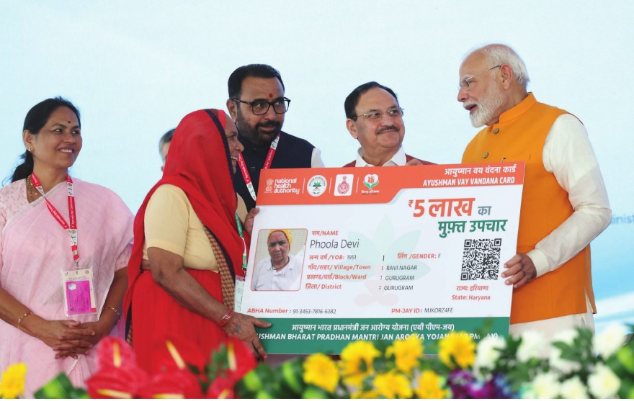
Prime Minister Narendra Modi’s visit to the All India Institute of Ayurveda (AIIA) during the 9th Ayurveda Day on Dhanvantari Jayanti (October 29, 2024).
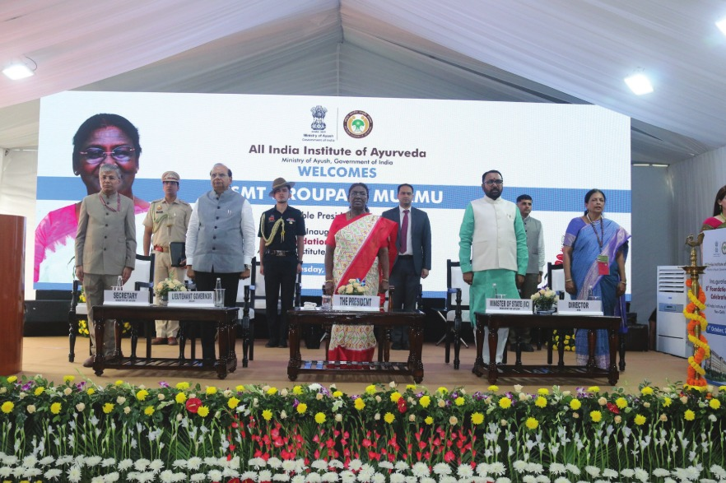
The President of India, Smt Droupadi Murmu graced the 7th foundation day of All India Institute of Ayurveda (AIIA) in New Delhi today (October 9, 2024)
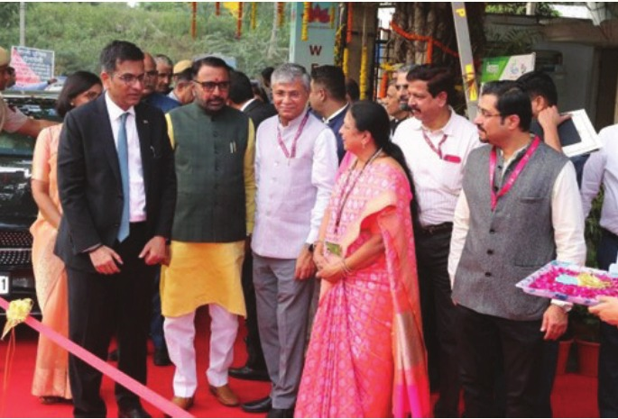
The Chief Justice of India (CJI), Dr. Justice Dhananjaya Yeshwant Chandrachud, visited the All India Institute of Ayurveda (AIIA) in October 2024 to inaugurate the first internatioal conference, AROHA-2024
Key Events / Institutional Achievements (2024)
• The All India Institute of Ayurveda (AIIA), New Delhi organized a grand event to commemorate the 10th International Day of Yoga (IDY) 2024. The theme of the event was “Yoga for Women Empowerment”. The Chief Guest of the event was Sister BK Shivani, a well-known motivational speaker.
• AIIA, New Delhi and Nadipulse Prognostics Pvt. Ltd. signed a Memorandum of Understanding (MoU) under the iCAINE (Incubation Centre for Ayurveda Innovation and Entrepreneurship) for clinical validation of the Nadi Parikshan equipment (nPulse) developed by Nadipulse Prognostics Pvt. Ltd. The MoU was signed by the Director of AIIA, Prof. (Dr.) Tanuja Nesari.
• Under the Ministry of AYUSH, AIIA hosted a Global Technical Consultation Group Meeting on “Artificial Intelligence (AI) for Global Health: Advancing Traditional Medicine” in collaboration with the WHO Global Traditional Medicine Centre (GTMC) and the Department of Digital Health and Innovation (DHI-WHO-HQ) on 11–12 September 2024.
• AIIA successfully showcased Ayurveda at the Ayush Pavilion during the 46th Session of the World Heritage Committee held at Bharat Mandapam, New Delhi. The event was inaugurated by the Hon’ble Prime Minister Shri Narendra Modi on 22 July 2024.

4. In Patient Department
The In-Patient Department (IPD) comprises 200 fully oxygen-supported beds with roundthe-clock care by trained medical and paramedical staff. Services are offered across key specialties including Kayachikitsa, Panchakarma, Shalakya, Shalya, Stri Roga & Prasuti Tantra, and Kaumarbhritya. The IPD is equipped with dedicated ICU and NICU facilities (for in-house patients only), along with a well- functioning Operation Theatre (OT) and Labor Room, ensuring comprehensive and integrative patient care.
Therapeutic Procedures
S.No | Procedure
1 | Panchakarma
2 | Kriyakalpa
3 | Major and Minor Surgical Procedures
4 | Dental Procedures

Diagnostic Services
The institute provides the following diagnostic services:
1. Clinical Diagnostic Procedures
• Colposcopy
• Colonoscopy
• Nadi Clinic
• Prakriti Clinic
2. Laboratory and Imaging Services
Laboratory Services
• Haematology
• Biochemistry
• Microbiology
• Pathology
Imaging & Functional Diagnostics
• Electrocardiography (ECG)
• Radiology

Admissions and Discharges
period | admissions | discharges | alos
24-Apr | 423 | 415 | 10
24-May | 428 | 419 | 9
24-Jun | 400 | 415 | 10
24-Jul | 485 | 458 | 10
24-Aug | 440 | 441 | 9
24-Sep | 469 | 503 | 9
24-Oct | 326 | 412 | 9
24-Nov | 447 | 344 | 8
24-Dec | 352 | 408 | 10
25-Jan | 444 | 406 | 7
25-Feb | 426 | 423 | 8
25-Mar | 434 | 436 | 9

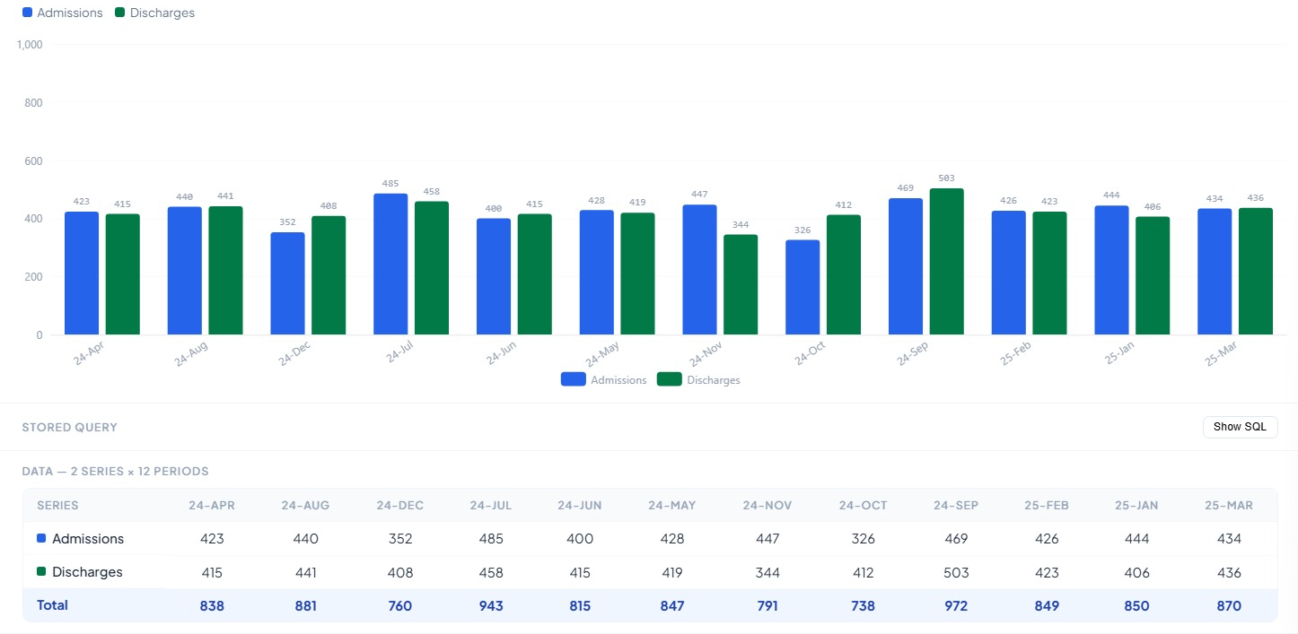
KPI

5. Department of Kayachikitsa
Name of Department
Ayurveda Samhita and Siddhanta Department
Introduction
The Samhita Siddhanta Department is one of the academic departments at the All India Institute of Ayurveda (AIIA). The postgraduate department is primarily concerned with the study of the fundamentals of Ayurveda, known as Samhitas (classical compendiums), and the exploration of their direct and indirect clinical applications.
The department imparts multi-dimensional fundamental education to postgraduate and PhD scholars in a pragmatic manner, enabling scholars to understand the core essence of the subject and develop the ability to explore new research and practical applications.
Vision
To establish excellence in the understanding and interpretation of fundamental concepts explained in the Samhitas and relevant literature, and to conduct outstanding research work in various fields.
Mission
• Empower students with the basic tools for approaching the science of Ayurveda in a structured manner
• Enable understanding of Ayurvedic literature and its application in clinical practice
• Serve society through effective integration of Ayurvedic knowledge in healthcare
Objectives
• To educate students in understanding the fundamental concepts of Ayurveda
• To develop a Language Lab for exploring Sanskrit and other regional and international languages for scientific research purposes
• To develop a manuscript unit for studying and researching original, unexplored manuscripts
Functions
• AIIA conducted Ganesh Aarti, Poojana, 24-hour Samhita Pathana, and Ganapati Atharvasheersha Pathana during Gunadhish 2024 – Ganeshotsava Celebration (07/09/2024 to 11/09/2024)
• Conducted Pathan session during Charak Jayanti Celebration on 09/08/2024
• Conducted Samhita Pathan session focusing on Charak Sutrasthan during Vasant Panchami Celebration on 03/02/2025
• Conducted Samhita Pathan and Dhanvantari Vandana during Janmashtami Celebration on 28/08/2024

Research Activities during the year:
name_of_the_project | pi_copi
Development of E-Charak Module Sutrasthana 30 Chapters for Academic Purpose | PI: Prof. Dr. Mahesh VyasCo-PI: Dr. Kamal Kumar
Efficacy and safety of Punarnavadi Mandura alone and in combination with Drakshavaleha compared to iron folic acid in the treatment of moderate iron deficiency anaemia among non-pregnant women of reproductive age group: a community-based three-arm multicentre randomized controlled trial | Coordinator: Dr. Rinky Thakur (PI and CTRI number not stated in report)

Publications:
sno | title_of_paper | journal | name_of_faculty_or_scholar
1 | A review on textual criticism in Ayurveda | International Ayurvedic Medical Journal (IAMJ), 12(3), 2024. DOI: 10.46607/iamj1612032024 | Vyas M., Kumar K., Baghel A. S., P. A.
2 | Application of Rasnadi Churnam on Shiras (Mid-scalp) as a daily regimen | International Journal of Ayurveda and Pharma Research, 12(2), 2024. DOI: 10.47070/ijapr.v12i2.3035 | Vyas M., Kumar K., Baghel A. S., P. A.
3 | Broncho-protective effect of Tulsi using total lung capacity analysis on Pranavaha Srotas – A case series | Annals of Ayurvedic Medicine, 13(2), 2024. DOI: 10.5455/AAM.92550 | Burolia R. K., Vyas M.
4 | Promising role of traditional (Ayurvedic) medicine in COVID-19 management | Journal of Herbal Medicines, 2024. DOI: 10.1016/j.hermed.2024.100868 | Nesari T., Prajapati P. K., Vyas M., et al.
5 | Guest editorial | Journal of Vishwa Ayurveda Parishada, 2024 | Vyas M.
6 | Psychological dimensions of Prakriti | Deep Science Publishing Book, 2025. DOI: 10.70593/978-93-49307-81-0_4 | Nikita Sharma, Rinky Thakur
7 | Prakriti: A trans-disciplinary approach | Deep Science Publishing Book, 2025. DOI: 10.70593/978-93-49307-81-0_1 | Rinky Thakur, Nikita Sharma
8 | Effect of Samskara initiative on PG scholars | International Journal of Ayurveda Research, 6(1), 67–69, 2024. DOI: 10.4103/ijar.ijar_24_25 | Rinky Thakur
9 | Breastfeeding trends and implications | Journal of Research in Ayurvedic Sciences, 8(6), 276–285, 2024. DOI: 10.4103/jras.jras_236_23 | Mishra A., Halder S., Vyas M. K., Kumar K., Sharma N.
10 | Ayurvedic health-care in cancer management | International Journal of Ayurveda Research, 5(3), 163–171, 2024. DOI: 10.4103/ijar.ijar_138_23 | Jain S., Tiwari R., Singh V., Vyas M., Kumar K., Sharma N.
11 | P5 approach for geriatric health care | Annals of Ayurvedic Medicine, 14(2), 139–151, 2025. DOI: 10.5455/AAM.233388 | Tiwari R., Vyas M., Kumar K., Sharma N.
12 | Loka–Purusha Samya principle | International Journal of Ayurveda Research, 2024. DOI: 10.4103/ijar.ijar_104_23 | Aishwarya A. Joglekar, Meera K. Bhojani, Nikhil Mehere, etc.
13 | Bindu Matra of Shatavari Ghrita | International Journal of Ayurveda Research, 5(4), 2024. DOI: 10.4103/ijar.ijar_166_24 | Aishwarya A. Joglekar, Mahesh Kumar Vyas
14 | Opinion piece on Ayurveda in COVID-19 diabetes care | Advances in Integrative Medicine, 4(1), 2025. DOI: 10.1016/j.aimed.2025.01.004 | Aishwarya A. Joglekar, Mahesh Kumar Vyas

Special Achievements / Awards / Honors
• Dr. Aishwarya Joglekar participated and won 1st prize in the event Panak Pratiyogita, organized by All India Institute of Ayurveda, New Delhi, held on 18 March 2023.
• Dr. Aishwarya Joglekar won a prize in the Best Thesis Competition organized by AIMIL Pharmaceuticals in October 2024.
• Dr. Aishwarya Joglekar (PhD Ayu, II year) secured First Prize in Quiz Competition during “SMRITI – Memory Assessment and Awareness Programme”, organized by the Department of Kriya Sharira, AIIA, on 22 November 2024.
• Dr. Anita Chaudhary (PhD Ayu, III year) won the Consolation Prize in the National E-Slogan Competition – IDY 2024 on 15 September 2024.
• Dr. Avishek Mishra (MD Ayu, II year) won Third Prize in Quiz Competition during “SMRITI – Memory Assessment and Awareness Programme”, organized by the Department of Kriya Sharira, AIIA, on 22 November 2024.
• Dr. Komal Sharma (MD Ayu, II year) won Third Prize in Quiz Competition during “Yoga Competition Programme”, organized by the Department of Swasthavritta and Yoga, AIIA, on 10 June 2024.
• Dr. Pallavi Wankhede (MD Ayu, II year) won Third Prize in Quiz Competition during “Yoga Competition Programme”, organized by the Department of Swasthavritta and Yoga, AIIA, on 10 June 2024.
• Dr. Vinaya Kamble (MD Ayu, I year) won Second Prize in Quiz Competition during “Yoga Competition Programme”, organized by the Department of Swasthavritta and Yoga, AIIA, on 10 June 2024.
• Dr. Parul Gupta (MD Ayu, III year) secured First Prize in Quiz Competition during “SMRITI – Memory Assessment and Awareness Programme”, organized by the Department of Kriya Sharira, AIIA, on 22 November 2024.
• Dr. Pallavi Wankhede (MD Ayu, II year) secured Second Prize in Quiz Competition during “SMRITI – Memory Assessment and Awareness Programme”, organized by the Department of Kriya Sharira, AIIA, on 22 November 2024.
• Dr. Vinaya Kamble (MD Ayu, I year) secured Second Prize in Quiz Competition during “SMRITI – Memory Assessment and Awareness Programme”, organized by the Department of Kriya Sharira, AIIA, on 22 November 2024.

