AIIA
Annual Report Demo
Annual · 2029-2030
TABLE OF CONTENTS
1 Introduction 3

1. Introduction
Lorem ipsum dolor sit amet, consectetur adipiscing elit, sed do eiusmod tempor incididunt ut labore et dolore magna aliqua. Ut enim ad minim veniam, quis nostrud exercitation ullamco laboris nisi ut aliquip ex ea commodo consequat.
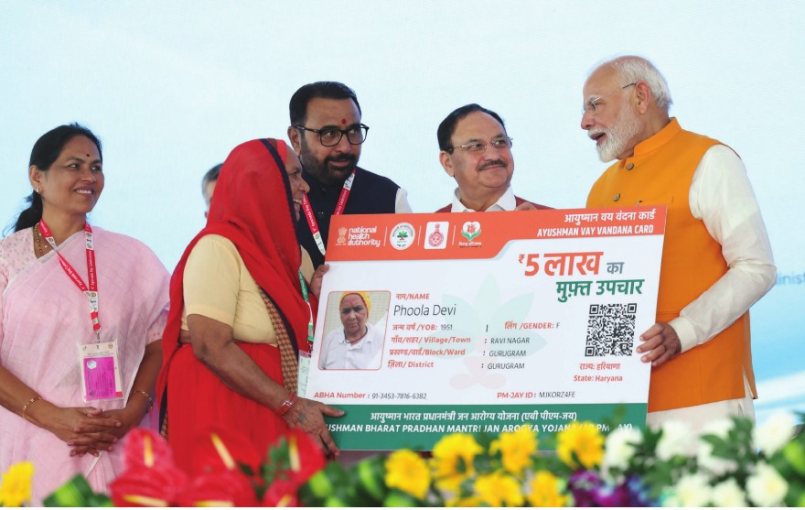
Fig.
period | admissions | discharges | alos
46136 | 423 | 415 | 10
46166 | 428 | 419 | 9
46197 | 400 | 415 | 10
46227 | 485 | 458 | 10
46258 | 440 | 441 | 9
46289 | 469 | 503 | 9
46319 | 326 | 412 | 9
46350 | 447 | 344 | 8
46380 | 352 | 408 | 10
46047 | 444 | 406 | 7
46078 | 426 | 423 | 8
46106 | 434 | 436 | 9

