AIIA
Annual Report Test
Annual · 2029-2030
TABLE OF CONTENTS
1 Introduction 3

1. Introduction
summa
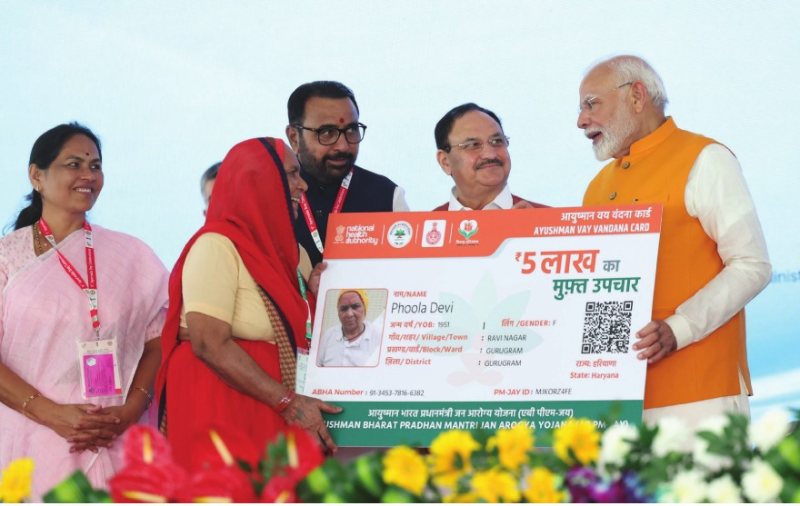  Fig. Caption | 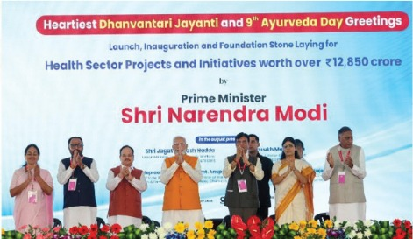  Fig. Caption

