AIIA
New report
Annual · 2026-27
TABLE OF CONTENTS
1 Introduction 3
1.1 subsection 3
2 Conclusion 6

1. Introduction

Fig 1 | Fig 2 | Fig 3

Test | Name
No 1 | Rithik
No 2 | Rohit
No 3 | Likesh
No 4 | Divakar
No 5 | Kanagavel


Fig 4 Illumunati

1.1. subsection

  Fig 1 Illumunati 1 |   Fig 2 Illumunati 2

2. Conclusion

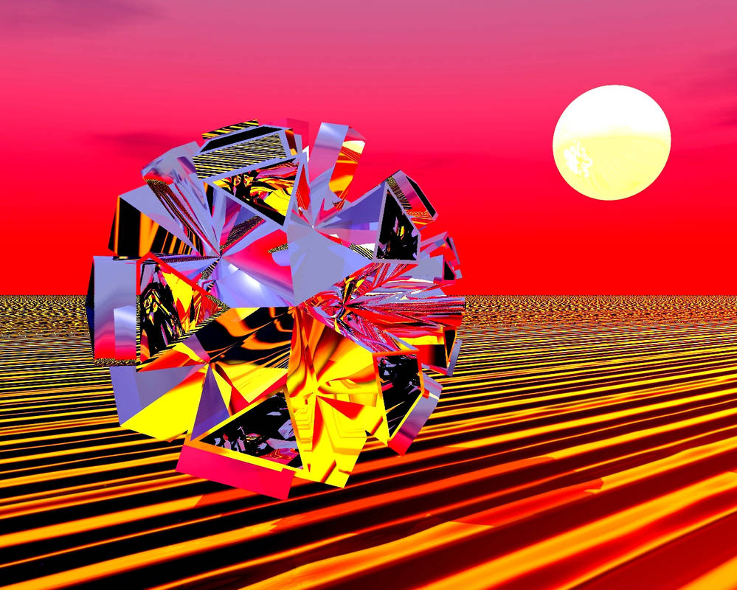 | 

