Add employee:

Api Link : <https://employee-management-422016.el.r.appspot.com/add>

Json Object:

{

    "employeeName":"Mahendra Singh Dhoni ",

    "phoneNumber":"5464564554",

    "email":"dhoni@gmail.com",

    "reportsTo":"fe89e266-25a1-4e2b-830b-212f4964e269",

    "profileImage":"https://img1.hscicdn.com/image/upload/f_auto,t_ds_square_w_320,q_50/lsci/db/PICTURES/CMS/319900/319953.png"

}

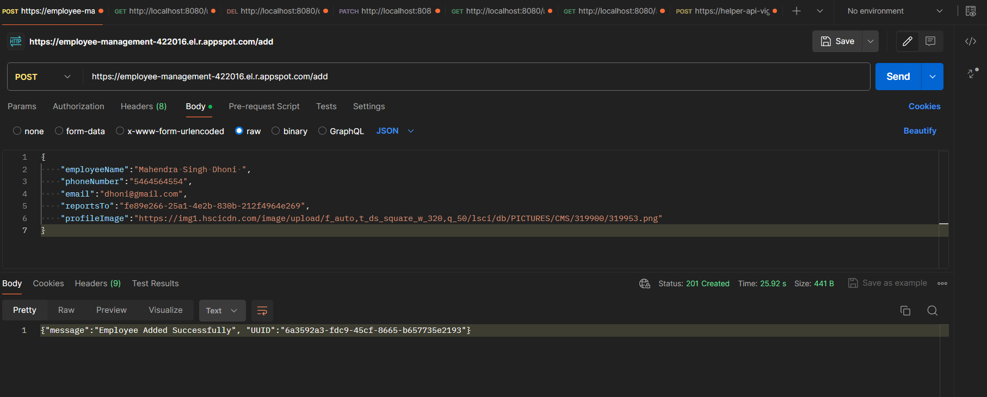

In DataBase:

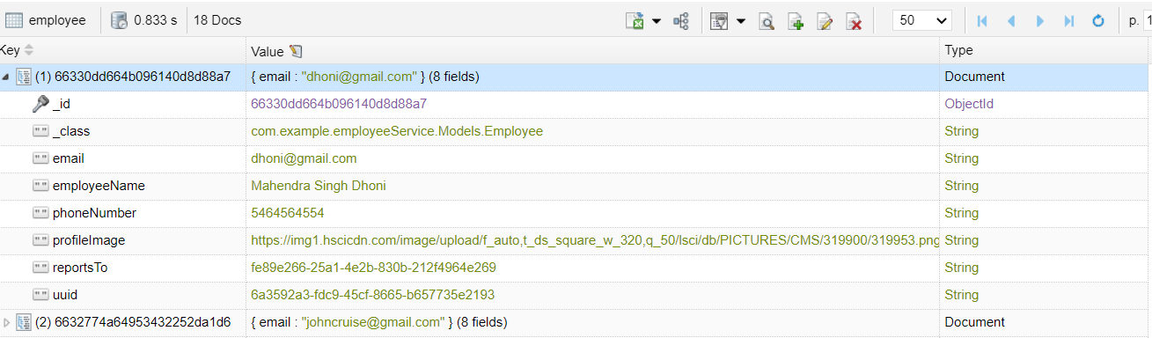

Email will be received for the manager :

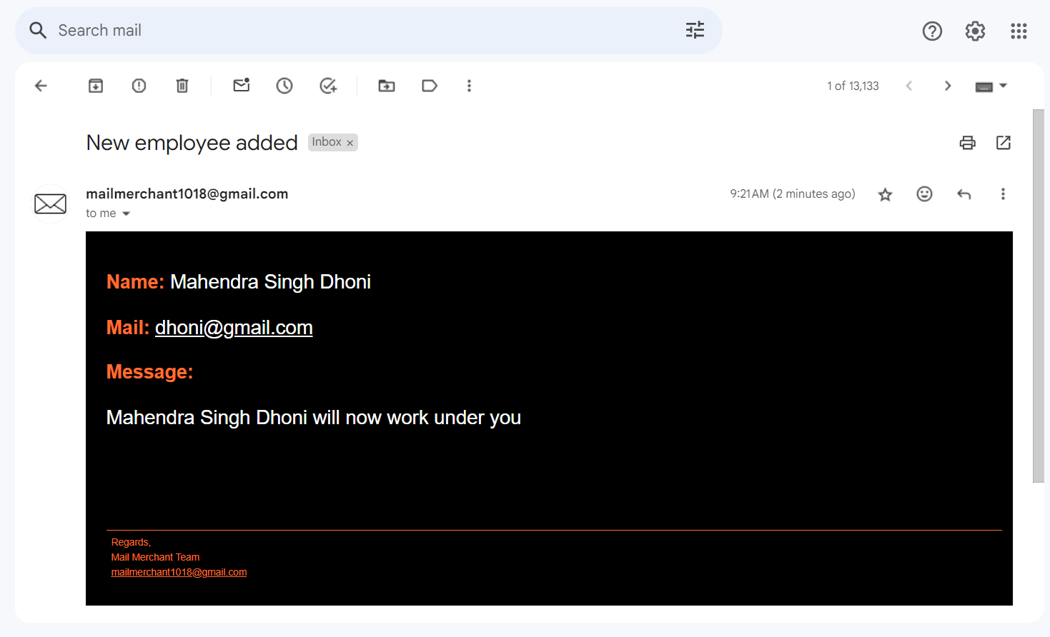

When you click the mail link received in email then we can compose new email

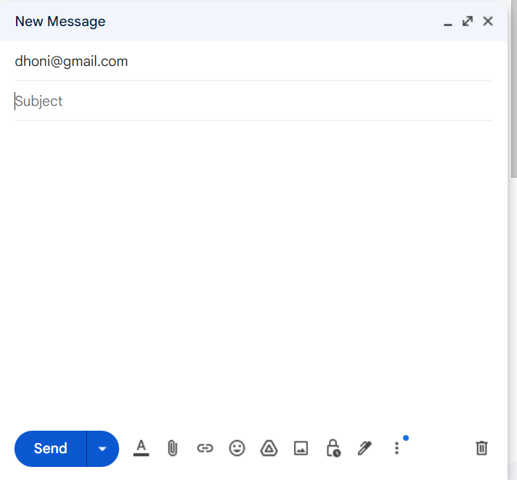

Display Employees:

User need to send page number, page index and sorting must be done by (Employee name or email):

Api link: <https://employee-management-422016.el.r.appspot.com/users>

Example:

Api link : https://employee-management-422016.el.r.appspot.com/users?pageNumber=1&pageSize=2&sort=employeeName

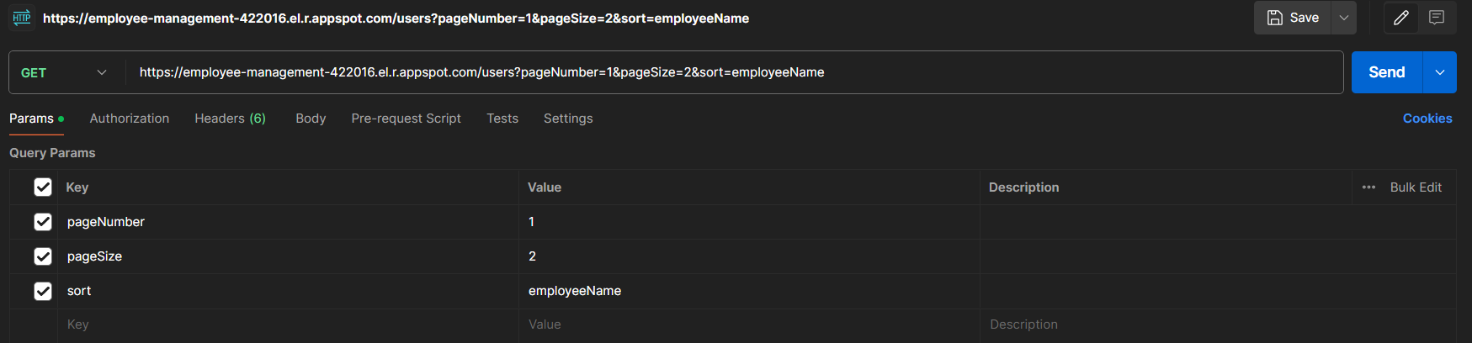

Output:

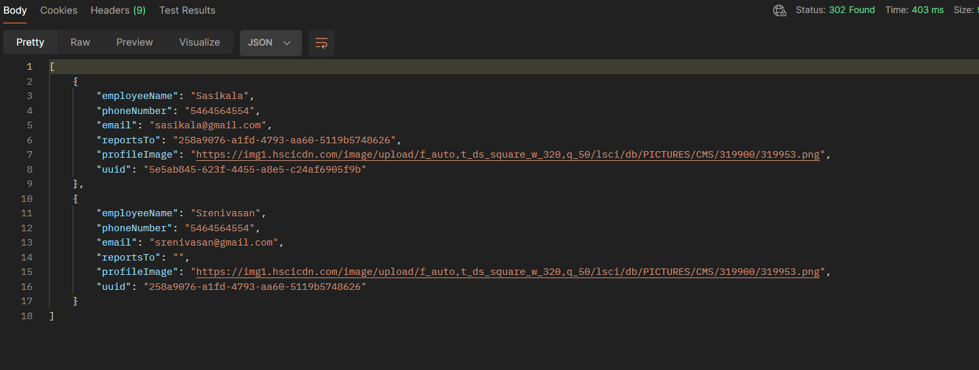

Delete Employee :

Api Link : <https://employee-management-422016.el.r.appspot.com/delete>

When user with uuid is not found then it response will be user not found .

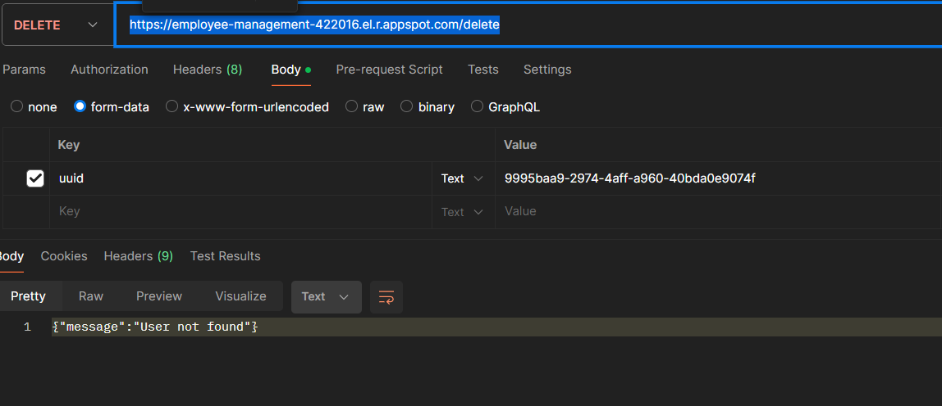

When user with uuid is found then the user will be deleted .

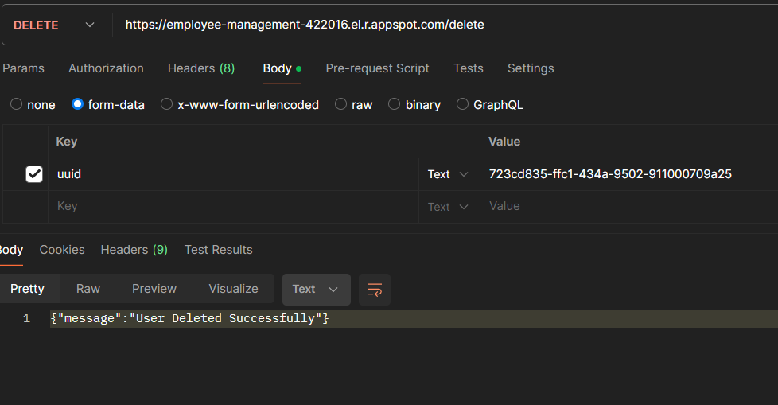

Update Employee:

User can change the employee name, email ,phone number ,reports to and profile image

By giving required fields in json object.

Validation is done for handling the employees who doesn’t exist.

Api Link : <https://employee-management-422016.el.r.appspot.com/update>

Note :: uuid cannot be changed.

Json Object:

{

    "uuid":"6a3592a3-fdc9-45cf-8665-b657735e2193",

    "email":"indiancricketerdhoni@gmail.com",

    "phoneNumber":"12345698786"

}

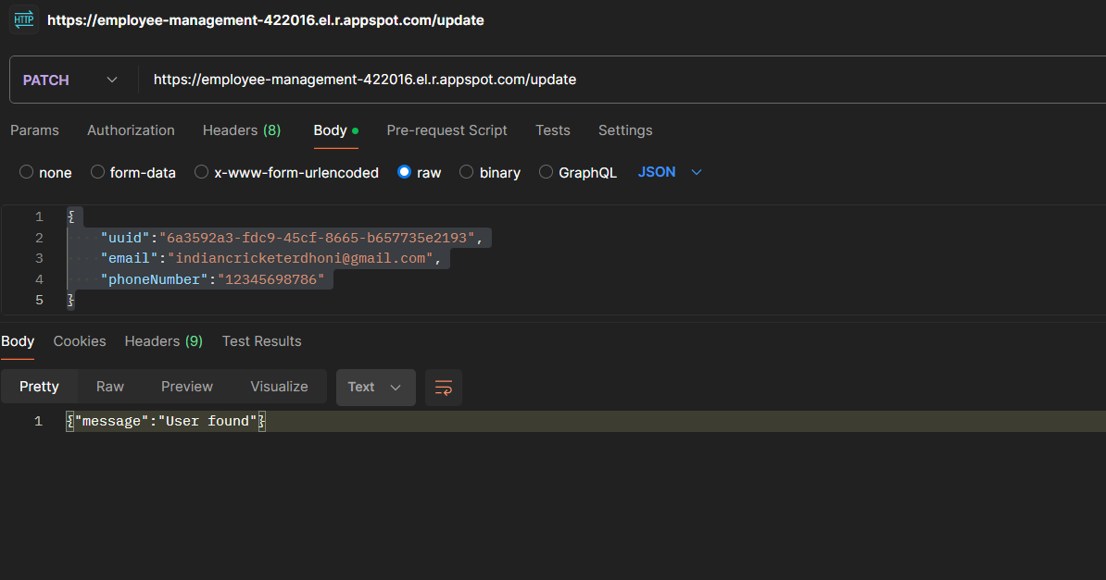

Before Updating :

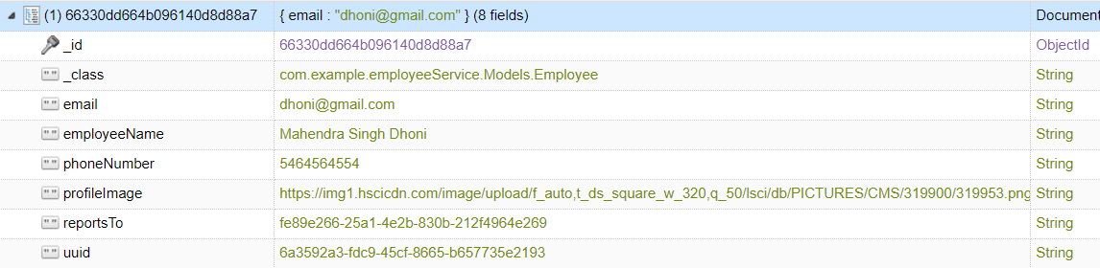

After updating:

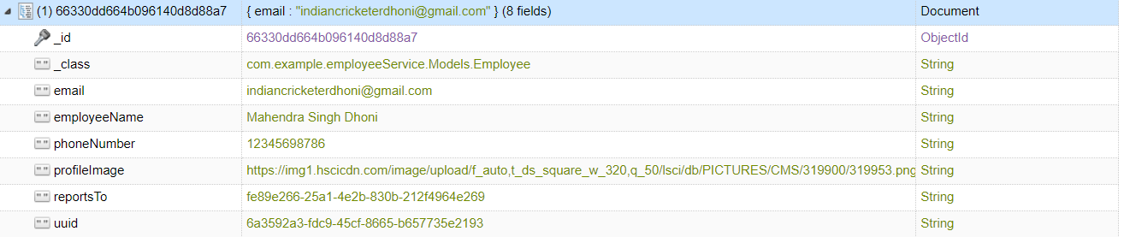

Reporting n’th level of the manager:

Employee must pass the level then the corresponding level of the manger details will be printed.

