EXPERIMENT NO. 2
SETTING UP A ZOHO CREATOR ACCOUNT AND EXPLORING THE PLATFORM ARCHITECTURE AND INTERFACE
NAME: RITHIKA L
ROLL No: 240701430
1. AIM
To set up a Zoho Creator account, create a sample Student Internship Management System using low-code development, and explore the platform architecture and interface for developing, deploying, and managing applications.

2. SETTING UP ZOHO CREATOR
2.1 Introduction to Zoho Creator
Zoho Creator is a low-code application development platform that allows users to create customized business applications with minimal programming. It provides a visual development environment for creating forms, reports, dashboards, workflows, and automated processes.
For this experiment, a Student Internship Management System is created to maintain and monitor students' internship details.

2.2 Creating the Sample Application
A sample application named Student Internship Management System is created using Zoho Creator.
The application is designed to store student internship information such as student name, register number, department, company, internship role, duration, mode, and status.
Application Name:
Student Internship Management System
Main Components:
- Internship Details Form
- Internship Report
- Internship Dashboard

3. CREATING THE FORM
A form is used to collect and store information in a Zoho Creator application.
A form named Internship Details is created with the following fields:
S.No | Field Name | Field Type
1 | Student Name | Single Line
2 | Register Number | Single Line
3 | Department | Dropdown
4 | Company Name | Single Line
5 | Internship Role | Single Line
6 | Start Date | Date
7 | End Date | Date
8 | Internship Mode | Dropdown
9 | Status | Dropdown
Dropdown Values
Department:
- CSE
- ECE
- IT
- EEE
- Mechanical
Internship Mode:
- Online
- Offline
- Hybrid
Status:
- Applied
- Ongoing
- Completed
The form is used to enter and store internship details of students.

Figure 1: Internship Details Form
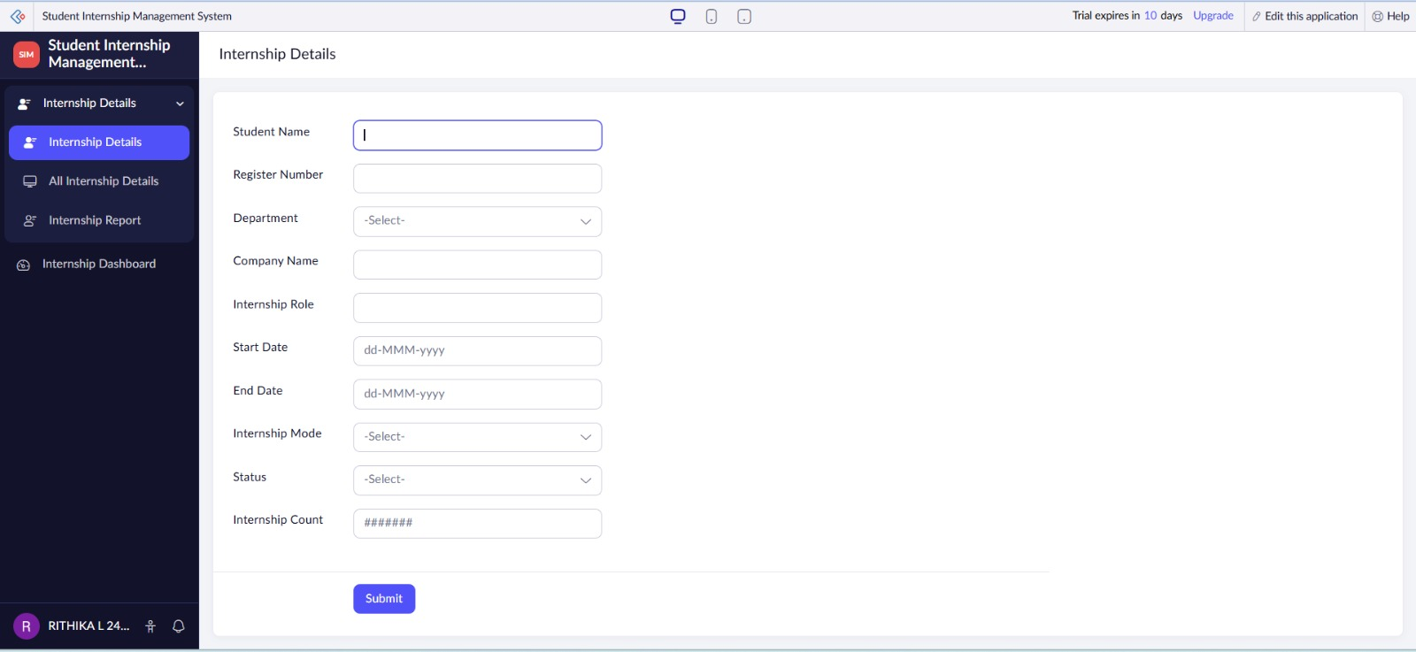

Explanation
The Internship Details Form is used to collect student internship information. It contains fields for student details, company details, internship duration, mode, and status. The information entered through the form is automatically stored in the application's database.

4. CREATING THE REPORT
A report is used to display the data collected through a form in an organized manner.
A report named Internship Report is created using the Internship Details form as the data source.
The report displays information such as:
- Student Name
- Register Number
- Department
- Company Name
- Internship Role
- Start Date
- End Date
- Internship Mode
- Status
The report allows users to view and organize the internship records.
Figure 2: Internship Report
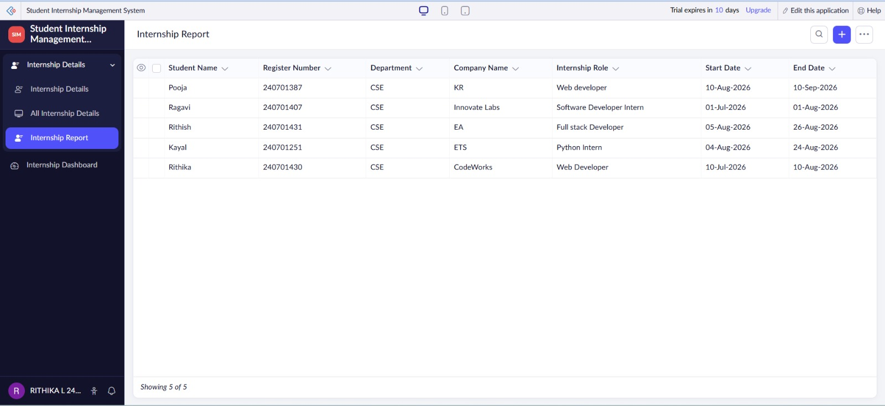
Explanation
The Internship Report displays the records entered through the Internship Details Form. It provides an organized view of the stored information and helps users search, sort, filter, and manage internship records efficiently.

5. CREATING THE DASHBOARD
A dashboard provides a visual representation of important application data.
A page named Internship Dashboard is created in the application. The dashboard can contain reports, charts, and summary information.
The dashboard displays internship information such as:
- Total Internships
- Applied Internships
- Ongoing Internships
- Completed Internships
A chart can also be added to display the number of students based on internship status.

Figure 3: Internship Dashboard
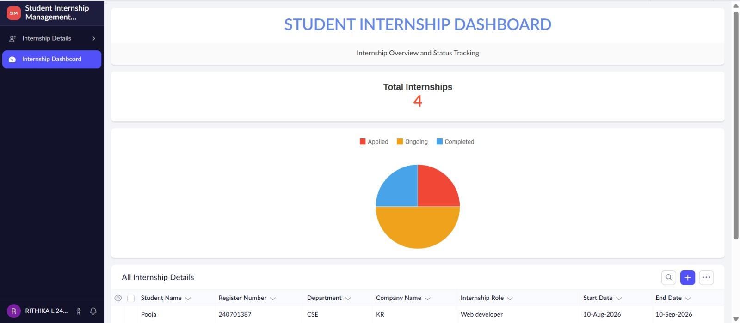
Explanation
The Internship Dashboard provides a visual summary of internship data. It helps users quickly understand the current status of internships using reports and charts. It makes the application more informative and user-friendly.

6. EXPLORING THE PLATFORM ARCHITECTURE AND INTERFACE
6.1 Develop
Zoho Creator provides a low-code development environment for creating applications with minimal programming.
Users can create forms, reports, pages, dashboards, and workflows using a visual interface.
The platform helps developers build applications quickly using drag-and-drop components and built-in features.
6.2 Deploy
Zoho Creator allows completed applications to be published and accessed by authorized users through web and mobile interfaces.
Applications can be deployed without building the complete application infrastructure manually.
Users can access the forms, reports, and dashboards according to the permissions provided to them.
6.3 Manage
Zoho Creator provides features for managing application data, users, permissions, workflows, and application settings.
Administrators can monitor and maintain the application after deployment.
Applications can be modified and updated whenever new requirements arise.

7. ZOHO CREATOR INTERFACE
The main areas of the Zoho Creator interface include:
Application Builder
The Application Builder is used to design and customize the application using low-code components.
Forms
Forms are used to collect and store data from users.
Reports
Reports are used to display, filter, sort, and analyze the stored data.
Pages
Pages are used to create customized interfaces and dashboards for presenting application information.
Workflows
Workflows are used to automate actions and business processes based on specified conditions.
Settings
Settings are used to configure application properties, users, permissions, and other application-related options.

8. ADVANTAGES OF ZOHO CREATOR
- Reduces the amount of manual coding required.
- Provides a visual and user-friendly development environment.
- Allows applications to be developed quickly.
- Supports forms, reports, dashboards, and workflows.
- Provides centralized data management.
- Makes application maintenance and modification easier.
- Supports web and mobile application access.

9. RESULT
Thus, a Zoho Creator account was successfully set up and a Student Internship Management System was created using the low-code development approach. The Internship Details Form, Internship Report, and Internship Dashboard were created successfully. The Develop, Deploy, and Manage features of the Zoho Creator platform were also explored.

