Game Design Document

Fill up the following document

1. Write the title of your project.

Pokemon Run

1. What is the goal of the game?

To collect 10 poke balls

1. Write a brief story of your game.

The main sprite is pikachu. He needs to collect 10 poke balls to finish the game. He has to overcome obstacles such as fire, ice and water. If pikachu hits a heart then his speed will increase.

1. Which are the playing characters of this game?

* Playing characters are the ones who respond to the user based on the input from the user.
* Cars, monkeys, dinos, wizards, etc., are the playing characters in the game.

|  |  |  |
| --- | --- | --- |
| Number | Character Name | What can this character do? |
| 1 | Pikachu | He can move with the help of arrow keys. |
| 2 | Start Button | To start the game |
| 3 | Restart Button | To restart the game |
| 4 |  |  |
| 5 |  |  |
| 6 |  |  |
| 7 |  |  |
| 8 |  |  |

1. Which are the Non-Playing Characters of this game?

* Non-Playing characters are the ones that don't have an action or behavior when the user interacts with the game.
* Hurdles, stones, bananas, coins, etc., are non-playing characters in the game.

|  |  |  |
| --- | --- | --- |
| Number | Character Name | What can this character do? |
| 1 | Fire | obstacle |
| 2 | Water | obstacle |
| 3 | Ice | obstacle |
| 4 | Heart | Increases speed |
| 5 | Poke Ball | Needs to be collected in order to win the game |
| 6 |  |  |
| 7 |  |  |
| 8 |  |  |

Draw your imagination of this game. What does this game look like?

* Draw the game either on your computer or on paper.
* Add images of the game scenes to show each of the playing and non-playing characters at least once.

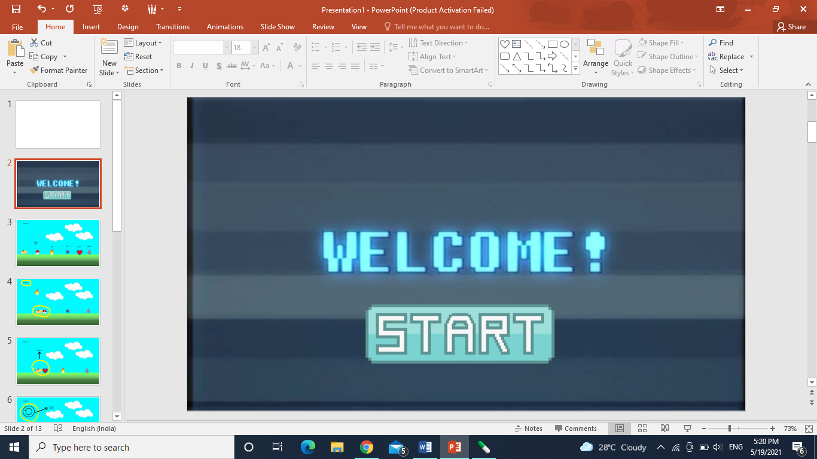

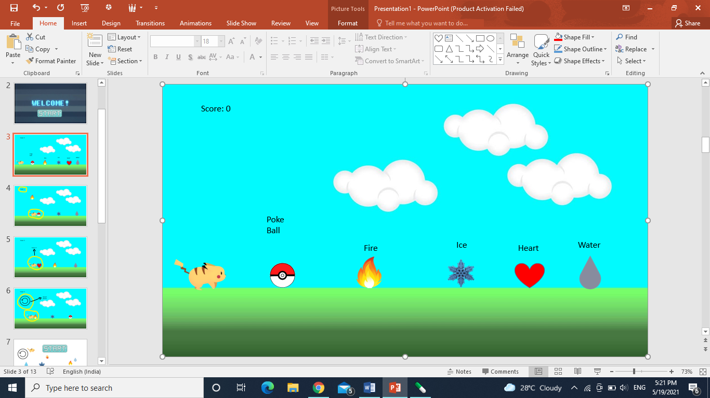

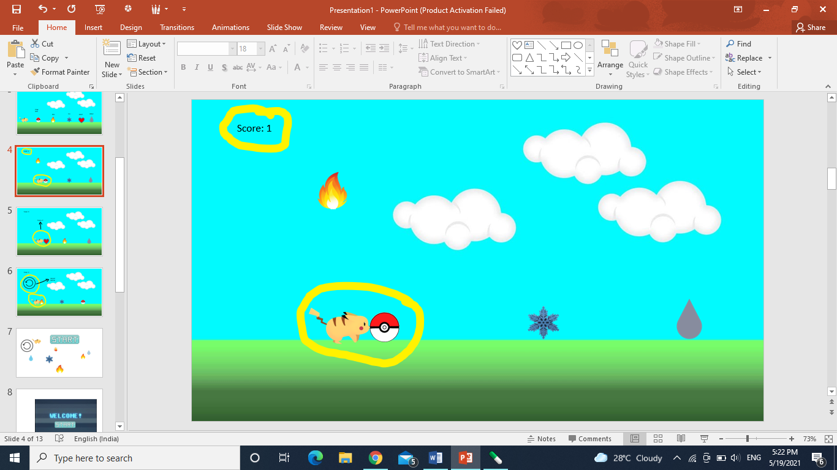

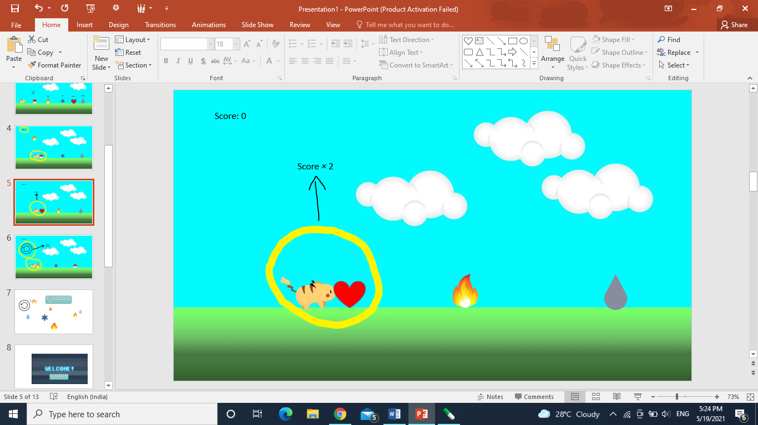

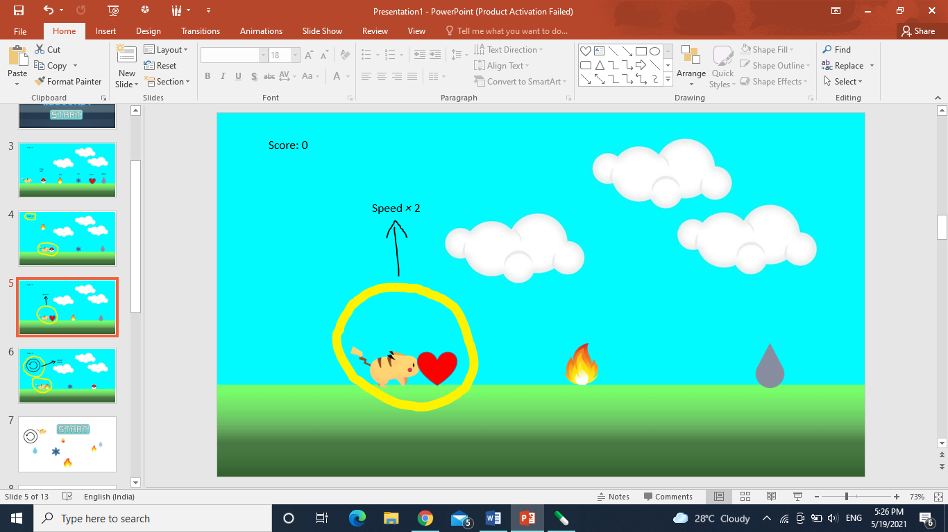

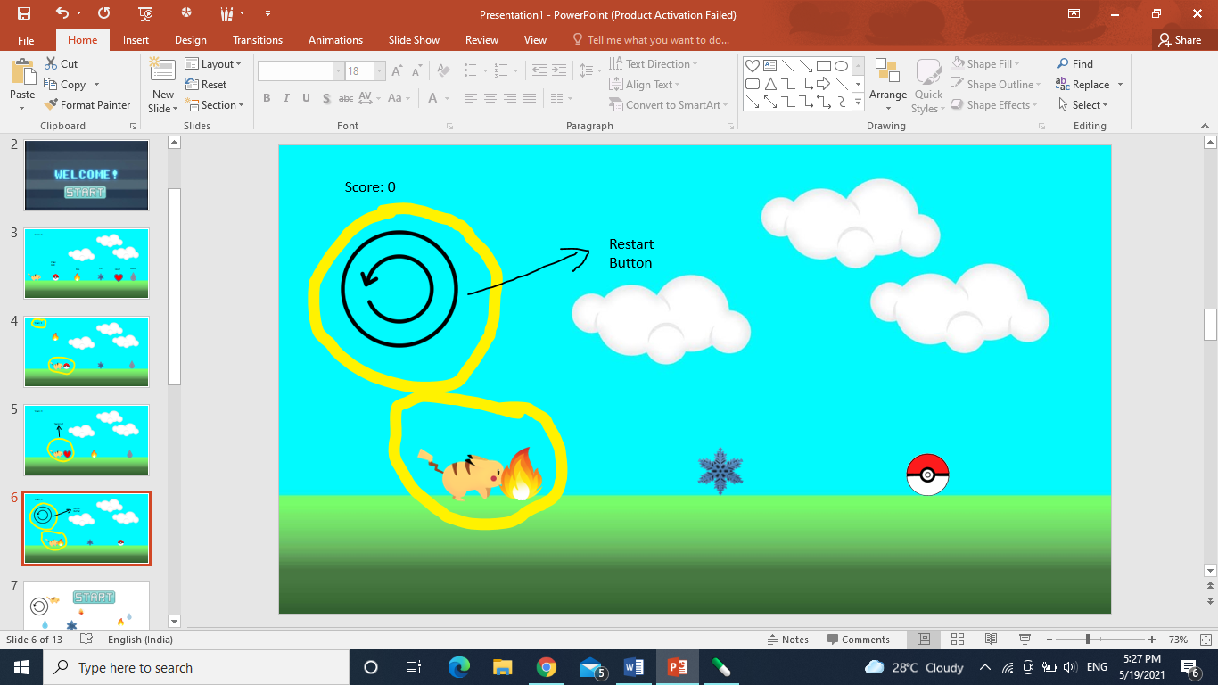

How do you plan to make your game engaging?

This game will be engaging as it is fun, colourful and easy to play.