**BUSINESS INTLEGENCE ASSIGNMENT**

1. **With Jio coming in, we have seen an influx of internet users from Tier 2 and Tier 3. Video/Content apps like Youtube and Tiktok have seen a huge growth while Amazon/Flipkart haven’t seen similar.**

* As we all know that, Jio has made our life addictive to social media. Jio is available for a wide range of people across the globe, as it’s affordable and a plethora of people have access to it.
* Now a days, peopleare looking for ways to entertain themselves in every way possible. We’ve a plethora of ways to entertain oneself. For example:
* I’m bored, let’s watch something on YouTube.
* I want to change my attire for my first day in office, let’s check what bloggers got to say about the latest trend.
* The above examples, states that people are so reliable on what the new trend is, so that they don’t miss out (there’s a popular slang called as, FOMO which states as Fear of Missing Out). The youngsters have this anxious feeling when you feel others are having a good time without you. It’s so common these days.

**Let’s talk about Amazon and Flipkart:**

* Amazon was first launched on 5th July 1994, Bellevue, US.
* Amazon started as an online bookstore and soon varied by selling DVDs, Video Games, Furniture, Groceries, Fire TV Stick, Electronics, Kindle and etc.
* Flipkart was first launched on October 2007, Bengaluru.
* Flipkart started by selling only books, their main focus was to supply unlimited books.
* As soon as it expanded, they started to offer many other products like Electronics, Air Conditioners, Stationery, Life-style and e-books.
* We can see that, Amazon and Flipkart were trying to make lives easy. So, people only brows only to fulfil their needs.

The main question was “Why does YouTube/TikTok have influx of users compared to Amazon/Flipkart?”

* It has become really easy to earn money, just by making a video and uploading it on YouTube. YouTube is not only used for entertainment but it also used to learn new things like lecture on a certain topic, amazing facts and etc.
* In 2020, we saw a lot of people started to make TikTok videos and posting them on various Social-media accounts. By doing this everyone got to chance to insult each other’s rather than supporting one another.
* A bunch of people find it amusing to watch troll people, and that goes on for days.
* And by chance you miss out on any of the troll, you’ll be like “Oh! No, what’ve I missed.” And you start surfing on the internet to check, what it is about.
* By doing this we are motivating them to do it more often.
* For Example: There was phase where CarryMinati aka Ajey Nagar trolled Amir Siddique in such a hysterical way. The topic was about “YouTube VS TikTok”.
* People insanely surfed the internet to know what the issue was about. They are many more incidents like this.

**Conclusion:**

I want to conclude by saying that, they are more number of user on YouTube/TikTok because people are more interested in other’s lives rather than themselves. Amazon/Flipkart have less users because once their needs are fulfilled, what’s the need to look back.

1. **New Onboarding Design at Nymtra:**

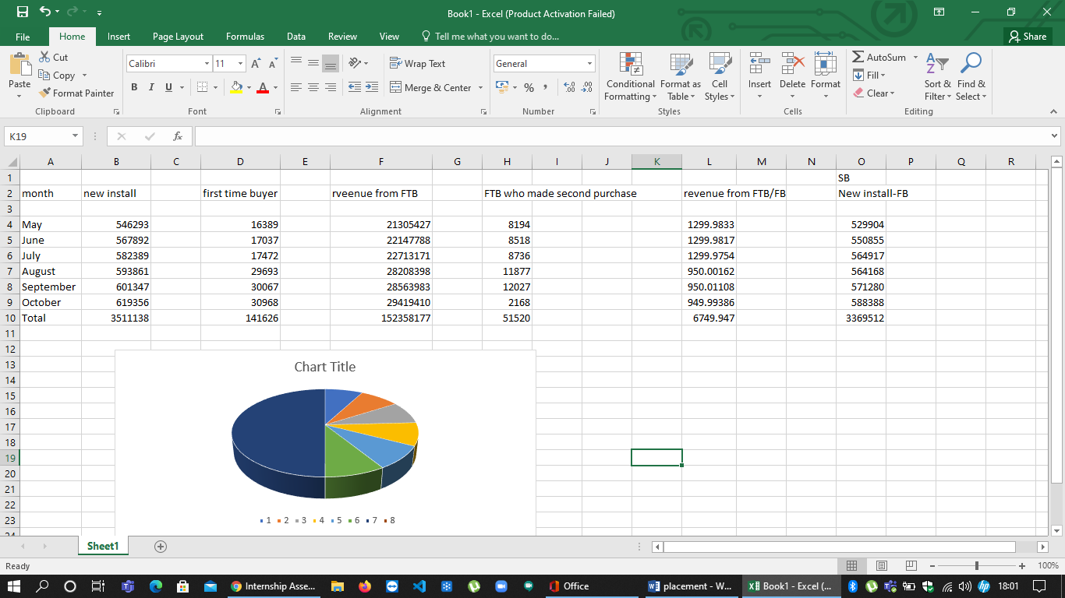



* Nymtra Product Team’s initiative to revamp app’s onboarding group was an advantage to achieve its target.
* The numbers shows that the new install are increasing right but the numbers of First Time Buyers (FTB) have increased with a huge margin.
* Which has resulted by assembling better revenues from First Time Buyers (FTB).
* We can discus on why the numbers of Second Purchase had decreased rapidly in the month of October. The result may be because many internal and external issues.
* The aim was to achieve buyers and in FTB it was successful.

**Conclusion:**

* They have successfully eased their shopping experience by adding ‘Skip Login’ option and also by highlighting their selling points on walkthrough.

1. **Personalised Recommendations at FilmiStar:**
2. **What will be the change in user behaviour once this feature is introduced?**

* User’s behaviour is generally based on what they like or dislike.
* If we’re are using an app and we want something to be according to our need/requirement. It can be anything like “I wish, the movie I was wanting to watch suddenly pops-up out of nowhere” you feel really happy about it.
* FilmiStar has designed a new carousel of movies based on your movie genre. You’d love that!
* Personally, if I see this feature I would be amazed that they are a set of movies related to what I’ve watched recently and I’ll definitely be addicted to it.
* When it comes to all the users then I can say the same thing because everyone wants thing to be done instantly. When you search for a movie in the catalogue, they are a lot of options and by seeing a wide range of option you’d be confused and skip watching.
* So, they will be a lot more dependent on the app rather than their own interest.

1. **What should be the goals and metrics for this feature?**

* The goal should be based on what range of movies does the user prefer and what relevant options can be suggested.
* The metrics should be a balance of what the user prefer and the related movies we can suggest.
* For example: If the user prefer Rom-Com movies then we can give a list of Rom-Com with few more option of only Comedy.

1. **How should this feature be launched and evaluated?**

* The feature should be launched with a slogan “Can’t decide what to watch next? Don’t worry we got the best solution for you. TA-TADA! Stop scrolling and swish to the home screen, we know exactly what you’re looking for”.
* We can check the usability of the users and evaluate and by observing the usability we can see if it’s going good or not. If it’s not we can study the problem and can come with the best solution possible.