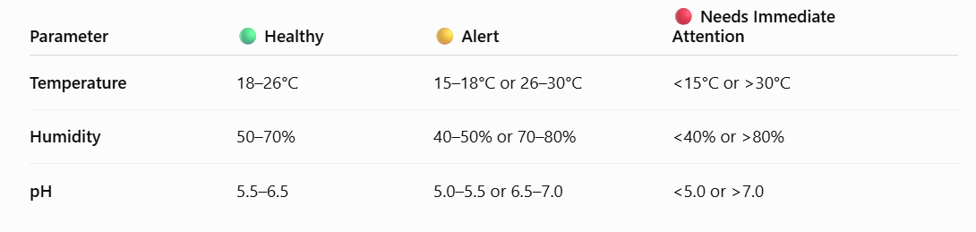
- The about shows the Healthy, alert and immediate attention ranges for Temperature, Humidity, PH
- Even if any one of the parameters is other than healthy (ie even if temperature is alert/need attention range) , then the overall health status becomes “Not healthy”
- If all the parameters are in healthy range, then the overall health status becomes “healthy”
- Create another column Reason...where in case the of health status is “Not healthy” then give the reason in the Reason column (ie temperature in alert state / humidity in Need attention state)

