SQL Queries including join

Name: Rithika Sreya

Class: II MA Applied Economics

Register.no: 2382468

1. Display all the attributes of the data.

select * from weathersource-com.pub_weather_data_samples.sample_weather_forecast_great_britain_postalcode_daily;

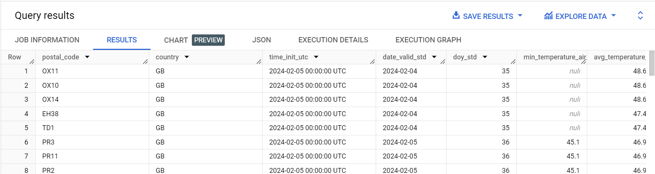

1. Get max, min and average air temperature for GB country.

select country,avg(max_temperature_air_2m_f) as avg_max_temp,avg(min_temperature_air_2m_f) as avg_min_temp,avg(avg_temperature_air_2m_f) as avg_temp from weathersource-com.pub_weather_data_samples.sample_weather_forecast_great_britain_postalcode_daily where country='GB' group by 1;

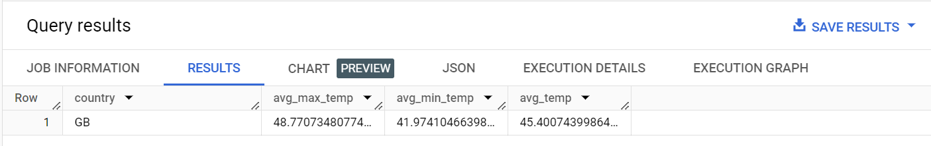

1. What all unique postal codes are included in data?

select distinct postal_code from weathersource-com.pub_weather_data_samples.sample_weather_forecast_great_britain_postalcode_daily;

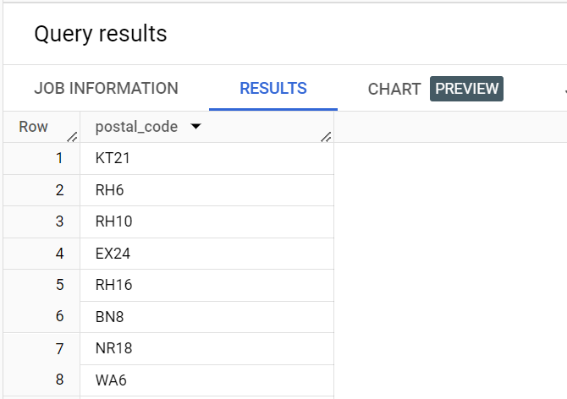

1. Find top 8 max pressure postal codes with max pressure, min pressure, avg_pressure.

select  postal_code, avg(max_pressure_2m_mb) as avg_max_pressure,avg(min_pressure_2m_mb)as avg_min_pressure,avg(avg_pressure_2m_mb) as avg_pressure from weathersource-com.pub_weather_data_samples.sample_weather_forecast_great_britain_postalcode_daily group by postal_code order by avg_max_pressure desc limit 8;

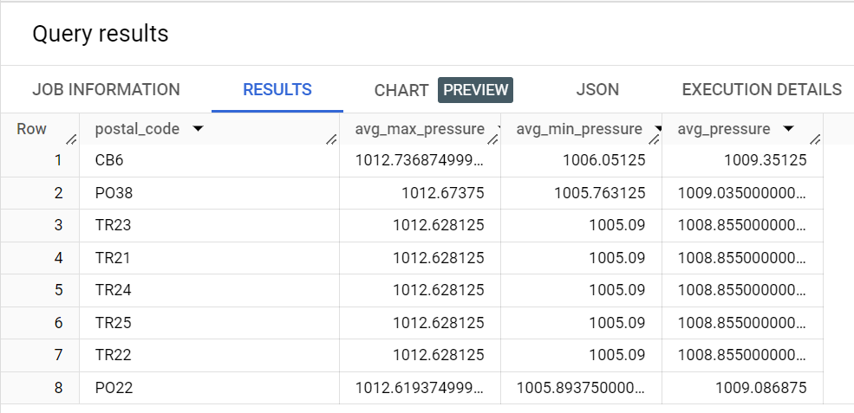

1. What are the total crimes in US.

select country, sum(num_crimes) as crimes from weathersource-com.pub_weather_data_samples.sample_weather_and_crime_comparison_chicago_daily_2016 where country = 'US' group by 1;

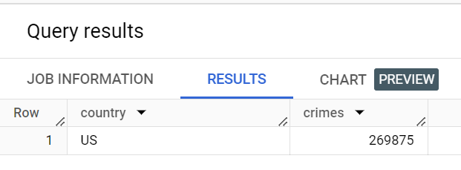

1. Get the crimes of first week of June in US.

select country,cast(date_valid_std as date) as crimedate, sum(num_crimes) as crimes from weathersource-com.pub_weather_data_samples.sample_weather_and_crime_comparison_chicago_daily_2016 where date_valid_std BETWEEN '2016-06-01' and '2016-06-07' group by 1,2 order by crimedate asc;

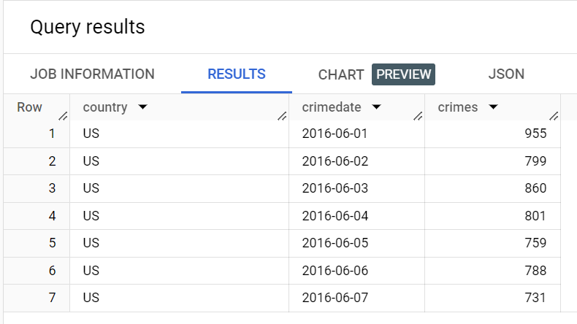

1. Which month has highest crimes in US.

select EXTRACT(month FROM date_valid_std ) AS month,country, sum(num_crimes) as crimes from weathersource-com.pub_weather_data_samples.sample_weather_and_crime_comparison_chicago_daily_2016 group by 1,2 order by crimes desc limit 1;

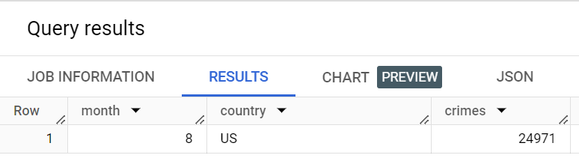

1. Which month has minimum crimes in US.

select EXTRACT(month FROM date_valid_std ) AS month,country, sum(num_crimes) as crimes from weathersource-com.pub_weather_data_samples.sample_weather_and_crime_comparison_chicago_daily_2016 group by 1,2 order by crimes asc limit 1;

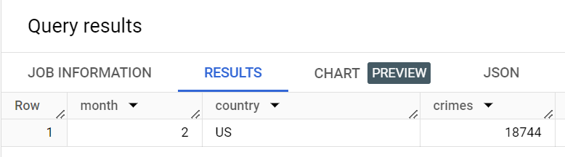

1. Use inner join to get all the common columns of both the dataset.

select * from

weathersource-com.pub_weather_data_samples.sample_weather_forecast_us_zipcode_daily a

inner join

weathersource-com.pub_weather_data_samples.sample_weather_forecast_anomaly_us_zipcode_daily b

on a.postal_code=b.postal_code and a.date_valid_std=b.date_valid_std

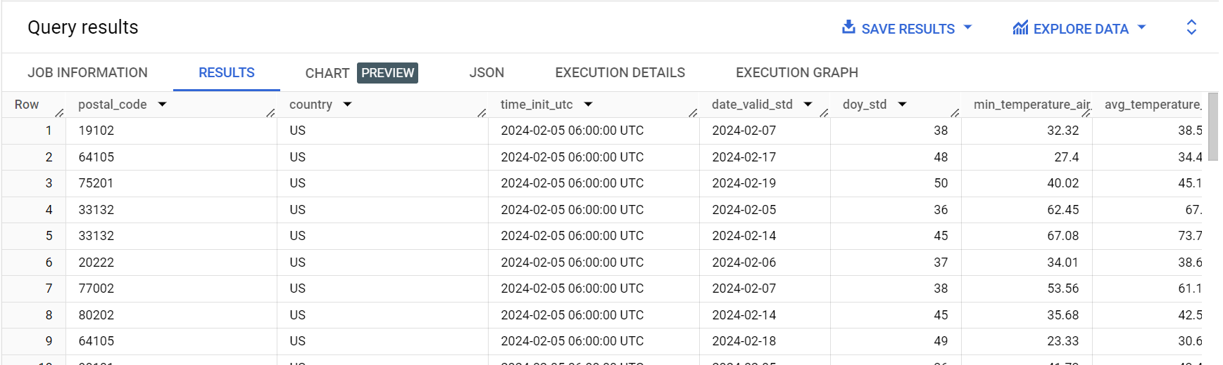

1. What is the average wind direction degree as per anomaly wind.

select a.postal_code,a.date_valid_std as date,avg(avg_wind_direction_10m_deg) as wind_direc, avg(avg_wind_speed_10m_anomaly_mph) as anomaly_windspeed from

weathersource-com.pub_weather_data_samples.sample_weather_forecast_us_zipcode_daily a

inner join

weathersource-com.pub_weather_data_samples.sample_weather_forecast_anomaly_us_zipcode_daily b

on a.postal_code=b.postal_code and a.date_valid_std=b.date_valid_std

group by 1,2

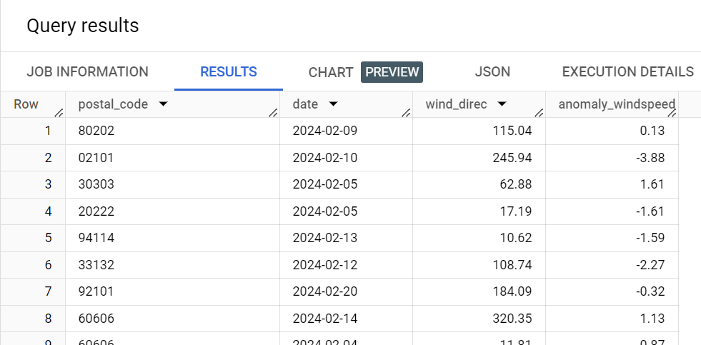

1. What are the min and max pressure for anomaly temperature?

select a.postal_code,a.date_valid_std as date,avg(min_pressure_2m_mb) as min_pressure,avg(max_pressure_2m_mb) as max_pressure, avg(avg_temperature_anomaly_air_2m_f) as anomaly_temperature from

weathersource-com.pub_weather_data_samples.sample_weather_forecast_us_zipcode_daily a

inner join

weathersource-com.pub_weather_data_samples.sample_weather_forecast_anomaly_us_zipcode_daily b

on a.postal_code=b.postal_code and a.date_valid_std=b.date_valid_std

group by 1,2

