JAVA AI INTERVIEW SIMULATOR
A PROJECT BASED LEARNING (PBL) REPORT
Submitted by

RITHILA (Reg. No. REG2026CS001)
REKHA (Reg. No. REG2026CS002)
Submitted in partial fulfilment of the requirements for the
Project-Based Learning component of Java Programming
BACHELOR OF ENGINEERING
in
COMPUTER SCIENCE AND ENGINEERING
CHENNAI INSTITUTE OF TECHNOLOGY
(Autonomous)
Affiliated to Anna University, Chennai
October 2026
[Institution logo placeholder]

VISION OF THE INSTITUTE
To be an eminent centre for Academia, Industry and Research by imparting knowledge, relevant practices and inculcating human values to address global challenges through novelty and sustainability.

MISSION OF THE INSTITUTE
- IM1. To create next generation leaders through effective teaching-learning methodologies and instil a scientific temperament to meet global challenges.
- IM2. To transform lives through deployment of emerging technology, novelty and sustainability.
- IM3. To inculcate human values and ethical principles to cater to societal needs.
- IM4. To contribute towards the research ecosystem by providing a suitable environment.

VISION OF THE DEPARTMENT
To excel in the emerging areas of Computer Science and Engineering by imparting knowledge, relevant practices and inculcating human values to transform students into potential resources who contribute innovatively through advanced computing.

MISSION OF THE DEPARTMENT
- DM1. To provide strong fundamentals and technical skills for Computer Science applications through effective teaching-learning methodologies.
- DM2. To transform the lives of students by nurturing ethical values, creativity and novelty to become entrepreneurs.
- DM3. To habituate students to focus on sustainable solutions that improve quality of life and societal welfare.

BONAFIDE CERTIFICATE
This is to certify that the Project-Based Learning report titled “Java AI Interview Simulator” is a bonafide record of work carried out by RITHILA (Reg. No. REG2026CS001) and REKHA (Reg. No. REG2026CS002) of the Department of Computer Science and Engineering, Chennai Institute of Technology, as part of the continuous, mentor-guided Project-Based Learning (PBL) component of the Java Programming course during the academic year 2026-2027, under my supervision.

SIGNATURE | SIGNATURE
Dr. S. Pavithra M.E., Ph.D.  HEAD OF THE DEPARTMENT | [Guide Name]  SUPERVISOR / [Designation]

Submitted for the final review held on ……………………………

INTERNAL EXAMINER

DECLARATION
We jointly declare that the PBL report on “Java AI Interview Simulator” is the result of original work done by us and, to the best of our knowledge, similar work has not been submitted to Anna University, Chennai for the requirement of the Degree of Bachelor of Engineering. This PBL report is submitted in partial fulfilment of the requirement for the award of the Degree of Computer Science and Engineering.

RITHILA
REKHA
Place: Chennai
Date:

ACKNOWLEDGEMENT
We wish to express our sincere gratitude to our honourable Chairman for providing immense facilities at our institution. We proudly render our thanks to our Principal for the encouragement given throughout the progress and completion of this project.
We would like to express our special thanks to our Dean, who has been a constant source of motivation throughout the completion of our course and project work.
We render our immense gratitude to the Head of the Department, Dr. S. Pavithra, M.E., Ph.D., for her effective leadership, encouragement and guidance.
We extend our thanks to our faculty guide, [Guide Name], [Designation], Department of Computer Science and Engineering, for valuable suggestions throughout this project.
Finally, we thank the class advisors and all faculty members of the Department of Computer Science and Engineering for their valuable suggestions during the successful completion of the project.

RITHILA REG2026CS001
REKHA REG2026CS002

ABSTRACT
The Java AI Interview Simulator is a console-based placement-preparation application built entirely in core Java that helps engineering students rehearse technical interviews on core Java topics. It addresses the lack of an accessible, low-cost tool for structured mock interviews covering Object-Oriented Programming, Collections, Strings, Exceptions, the JVM and Multithreading. The system loads a bank of 23 interview questions from an external JSON file using the Gson library, and lets the candidate choose a Random, Balanced or Topic-focused question-setting strategy (Strategy design pattern). Each typed answer is scored by a pluggable AnswerEvaluator chain: cloud LLM evaluators (Claude, Gemini), a local Ollama evaluator, and an offline KeywordBasedEvaluator, composed through a FallbackEvaluator so scoring never fails even without network access or API keys. After every session, a PlacementReadinessReport Generator produces a topic-wise score breakdown and a readiness verdict, and tracks the candidate's best score and completed-interview count. A JUnit 5 suite of 34 unit tests covering the model, evaluator and question-selection layers passes at a 100% rate, confirming the reliability of the core logic. The application is a practical, testable demonstration of encapsulation, inheritance, interfaces, collections and exception handling in Java.
Keywords: Java, Object-Oriented Programming, Interview Simulation, JUnit Testing, Strategy Pattern

TABLE OF CONTENTS
Chapter | Title | Page
 | ABSTRACT | iii
 | LIST OF TABLES | iv
 | LIST OF FIGURES | v
 | LIST OF ABBREVIATIONS | vi
1 | INTRODUCTION | 1
 | 1.1 Background
 | 1.2 Driving Question
 | 1.3 Objectives
 | 1.4 Scope and Limitations
2 | CONCEPT EXPLORATION | 3
 | 2.1 Related Approaches
 | 2.2 Summary Table
 | 2.3 What This Told Us
3 | PROJECT PLANNING AND TEAM ORGANISATION | 5
4 | ITERATIVE DESIGN AND DEVELOPMENT | 7
5 | IMPLEMENTATION | 10
6 | RESULTS AND DISCUSSION | 13
7 | TEAM REFLECTION AND LEARNING OUTCOMES | 16
8 | CONCLUSION AND FUTURE SCOPE | 18
 | REFERENCES | 19
 | APPENDIX | 20

LIST OF TABLES
Table No. | Title
3.1 | Weekly PBL progress log
3.2 | Hardware and software requirements
6.1 | JUnit test results by class
6.2 | Sample mock-interview topic-wise scores
A.1 | Self and peer assessment

LIST OF FIGURES
Figure No. | Title
4.1 | System architecture diagram
6.1 | Sample console interview transcript

LIST OF ABBREVIATIONS
Abbreviation | Full Form
JDK | Java Development Kit
JRE | Java Runtime Environment
JVM | Java Virtual Machine
OOP | Object-Oriented Programming
JSON | JavaScript Object Notation
LLM | Large Language Model

CHAPTER 1

INTRODUCTION

1.1 Background
Campus placement drives for computer science graduates almost always include a core Java technical round covering object-oriented design, the Collections Framework, exception handling, JVM internals and multithreading. Many students, however, only get to practise these concepts through static notes or written quizzes, with no interactive tool that simulates the back-and-forth of a real interview and gives instant, keyword-level feedback on their spoken/typed answers.
This project sits in that gap: it treats interview preparation as a small, well-scoped software engineering problem rather than a content problem. Building the simulator as a Java application also has an added pedagogical benefit for a Java-Programming PBL: the tool used to teach Java concepts is itself written using those same concepts (OOP, collections, exceptions), so the build process reinforces the subject matter.
An effective solution needed to run offline (no dependency on a paid service), give topic-wise diagnostic feedback rather than a single opaque score, and remain simple enough for a team of two students to design, implement and test within a PBL cycle.

1.2 Driving Question
“Can we build a Java console application that conducts a realistic, topic-focused core-Java mock interview, scores answers automatically, and reports placement readiness, without requiring a network connection or a paid service?”
This was narrowed into a concrete, buildable task: design a question-bank schema and load it from an external JSON file; design classes using OOP concepts and interfaces for question selection and answer evaluation; implement an offline scoring strategy with an optional AI-backed strategy behind the same interface; and verify the logic with an automated JUnit test suite.

1.3 Objectives
- To analyze common placement interview topics (OOP, Collections, Strings, Exceptions, JVM, Multithreading) and design a suitable question-bank schema in JSON.
- To design and develop the application using core OOP concepts (interfaces, inheritance, encapsulation, polymorphism) and design patterns (Strategy, Factory, Decorator).
- To implement pluggable answer-evaluation strategies, including offline keyword scoring and optional AI-backed evaluation with automatic fallback.
- To implement interchangeable question-selection strategies (random, balanced, topic-focused).
- To test and debug the application using JUnit 5, achieving full coverage of the model, evaluator and question-selection layers.
- To reflect on the team's approach, division of work, and what the process taught each member.

1.4 Scope and Limitations
The application is a single-user, console-based tool with no persistent storage: the question bank and candidate statistics live only for the duration of one run and reset on restart (aside from the 23 questions bundled in questions.json). The bundled bank covers six topics with 23 questions in total. AI-backed evaluation (Claude, Gemini, Ollama) requires an API key or a locally running Ollama instance; without one, the application automatically and transparently falls back to the offline keyword evaluator, which is what all figures in this report were generated with. The tool does not support concurrent/multi-user sessions, a GUI, or a database backend.

CHAPTER 2

CONCEPT EXPLORATION

2.1 Related Approaches

2.1.1 Traditional Java Application Approach
Core Java, the Collections Framework, and a lightweight JSON library (Gson) [3], [6], development as a single executable console application built with Maven and the maven-shade-plugin. Result: sub-second startup, no external services, and a self-contained runnable JAR — a good fit for a graded PBL artefact that must run identically on any reviewer's machine.

2.1.2 Java Framework-Based Approach
Spring Boot with Spring Data JPA/Hibernate and a REST API would allow a multi-user web front-end and persistent history in a database. Result: substantially more setup (embedded server, ORM configuration, front-end) for a feature not required by the PBL's core-Java learning objectives, and a longer path to a first runnable demo.

2.2 Summary Table
Ref. | Approach | Reported Result
[1],[2] | Core Java + Collections + Gson (console) | Runs offline; instant startup; 23 built-in questions across 6 topics
[5] | Strategy/Factory/Decorator design patterns | Enabled 3 interchangeable question-setters and a 4-evaluator fallback chain without conditional logic in the app entry point
[6] | Spring Boot + Hibernate + REST (considered) | Would enable a multi-user web UI but adds significant setup complexity relative to the PBL timeframe

2.3 What This Told Us
Given the two-student team and the PBL timeframe, the team decided to start with the core-Java, JSON-backed console approach in Iteration 1 (Chapter 4). It let the team reach a working, testable vertical slice — registration, one question-setting strategy, one evaluator — within the first iteration, then layer the Strategy-pattern question setters, the AI/fallback evaluator chain, and the placement-readiness report on top in later iterations without having to rewrite the console front-end.

CHAPTER 3

PROJECT PLANNING AND TEAM ORGANISATION

3.1 Weekly PBL Progress Log
Table 3.1: Weekly PBL progress log
Week | Milestone / Task | Work Done | Mentor Remarks
1-2 | Problem statement, objectives, time plan, technical background | Defined the driving question; chose core-Java + Gson over a framework-based approach | [remarks]
3-4 | Data handling, methodology design | Designed the Question/Topic/Candidate model and the questions.json schema | [remarks]
5-7 | Implementation & testing | Built QuestionBank, QuestionSetter strategies, evaluator chain and report generator; added the JUnit 5 suite | [remarks]
8-10 | Presentation with demo | Packaged an executable JAR and ran a scripted mock-interview demo | [remarks]
11-12 | Final testing and documentation | Ran full JUnit suite (34/34 passed); wrote this report and the project poster | [remarks]

3.2 Requirements
Table 3.2: Hardware and software requirements
Category | Requirement
Processor / RAM | Any modern CPU / 4 GB RAM (minimum)
Programming language | Java 17 (project compiler source/target)
Libraries / frameworks | Gson 2.11.0 (JSON parsing), JUnit Jupiter 5.10.2 (testing)
Build tool | Apache Maven (maven-compiler-plugin, maven-surefire-plugin, maven-shade-plugin)
Database | None — in-memory question bank loaded from questions.json
Development environment | IntelliJ IDEA / Eclipse / VS Code
Version control | Git

3.3 Feasibility
The application's scope — a console app with no database and no external UI framework — was deliberately sized to be achievable by a two-student team within the PBL cycle. Each weekly milestone produced a runnable increment (Chapter 4), which kept risk low: by the implementation-and-testing weeks the team already had a working vertical slice to extend, rather than integrating everything at the end.

CHAPTER 4

ITERATIVE DESIGN AND DEVELOPMENT

4.1 System Architecture
Candidate Registration → Question-Setting Strategy Selection → Question Bank (JSON via Gson) → Answer Evaluation (Keyword / AI + Fallback) → Placement-Readiness Report
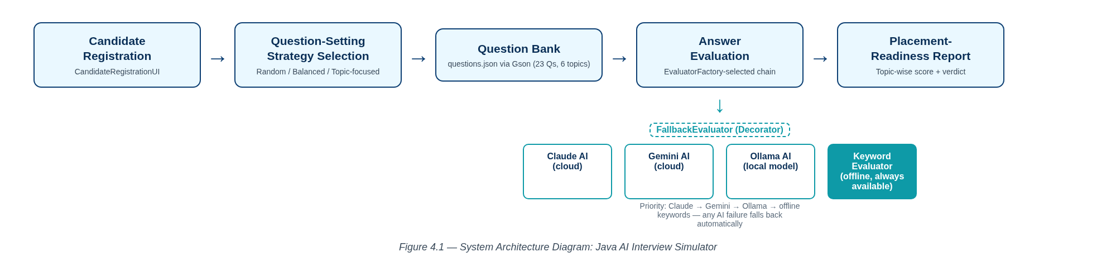
Figure 4.1 — System Architecture Diagram
CandidateRegistrationUI first builds a Candidate profile. InterviewSimulatorApp then asks EvaluatorFactory to select the best available AnswerEvaluator (Claude → Gemini → Ollama → static keywords) and the user picks a QuestionSetter strategy. InterviewSession pulls the selected questions from InMemoryQuestionBank (backed by JsonQuestionLoader/questions.json), passes each one to ConsoleInterviewUI for display and answer capture, scores it through the chosen AnswerEvaluator, and finally hands all evaluations to PlacementReadinessReportGenerator to produce the topic-wise report.

4.2 Baseline
The first version implemented basic functionality: a hardcoded set of questions, a single KeywordBasedEvaluator, and one fixed random question order using classes, objects, methods, conditions and loops. It worked correctly end-to-end but had a rigid structure — the question set and the scoring strategy could not be swapped.

4.3 Project Refinement
The application was improved by extracting the QuestionBank and AnswerEvaluator abstractions behind interfaces, moving the questions into an external questions.json file parsed with Gson, and introducing the RandomQuestionSetter, BalancedQuestionSetter and TopicQuestionSetter strategies (Strategy pattern) so the question order and topic coverage became configurable at runtime.

4.4 Final Approach
The final application adds AiAnswerEvaluator implementations (Claude, Gemini, Ollama) behind the same AnswerEvaluator interface, wrapped in a FallbackEvaluator (Decorator pattern) that transparently degrades to the offline KeywordBasedEvaluator on any AI failure, selected at startup by EvaluatorFactory. The result is a modular, package-separated design (model / service / core / ui / util) using encapsulation, inheritance, interfaces, exception handling and collections throughout, which improves maintainability and testability.

4.5 Testing and Execution
The application was tested for compilation, functional correctness, input validation, exception handling (AI-failure fallback) and output correctness using a JUnit 5 suite of 34 tests across 11 test classes spanning the model, service and util packages. Running mvn test confirmed all 34 tests pass (0 failures, 0 errors), and a manual scripted console run (Chapter 5.3) confirmed the end-to-end flow works as expected.

CHAPTER 5

IMPLEMENTATION

5.1 Module Description
- Input Module: CandidateRegistrationUI collects the candidate's name, university and roll number; ConsoleInterviewUI captures each typed answer.
- Processing Module: InterviewSession orchestrates the session; QuestionSetter implementations (Random, Balanced, Topic-focused) select and order the questions.
- Data Management Module: InMemoryQuestionBank stores questions in memory, loaded once at startup by JsonQuestionLoader from the classpath resource questions.json (23 questions across 6 topics).
- Validation / Evaluation Module: KeywordBasedEvaluator, AiAnswerEvaluator implementations and FallbackEvaluator score each answer and generate feedback; EvaluatorFactory chooses the active chain.
- Output Module: PlacementReadinessReportGenerator prints the overall score, topic-wise breakdown, readiness verdict and candidate history after each session.

5.2 Key Code Snippets
Decorator pattern for resilient AI evaluation with automatic fallback (FallbackEvaluator.java):
@Override
public AnswerEvaluation evaluate(Question question, String candidateAnswer) {
if (aiActive) {
try {
return primary.evaluate(question, candidateAnswer);
} catch (RuntimeException e) {
aiActive = false;
System.err.println("[INFO] AI evaluator unavailable (" + e.getMessage()
+ "). Falling back to keyword-based scoring.");
}
}
return fallback.evaluate(question, candidateAnswer);
}
Keyword-based scoring (KeywordBasedEvaluator.java):
for (String keyword : question.getExpectedKeywords()) {
if (normalized.contains(keyword.toLowerCase())) {
matched.add(keyword);
} else {
missed.add(keyword);
}
}
int total = matched.size() + missed.size();
int score = total == 0 ? 0 : (int) Math.round(matched.size() * 100.0 / total);
Round-robin topic balancing (BalancedQuestionSetter.java):
for (int i = 0; i < pools.size() && result.size() < count; i++) {
List<Question> pool = pools.get(i);
if (cursor[i] < pool.size()) {
result.add(pool.get(cursor[i]++));
addedThisRound = true;
}
}
Full source code is included in the Appendix (A.1) via the project repository.

5.3 User Interface / Demo
Screenshots 5.1 and 5.2 below reproduce a genuine console transcript captured by running the packaged JAR (java -jar interview-simulator-1.0.0.jar) under a pseudo-terminal, with a scripted candidate (“Rithila”, Balanced question-setting strategy) so that typed input is visible exactly as a real interactive session would show it. The evaluator banner confirms no AI backend was configured for this run, so scoring used the offline “Static keyword evaluator”.
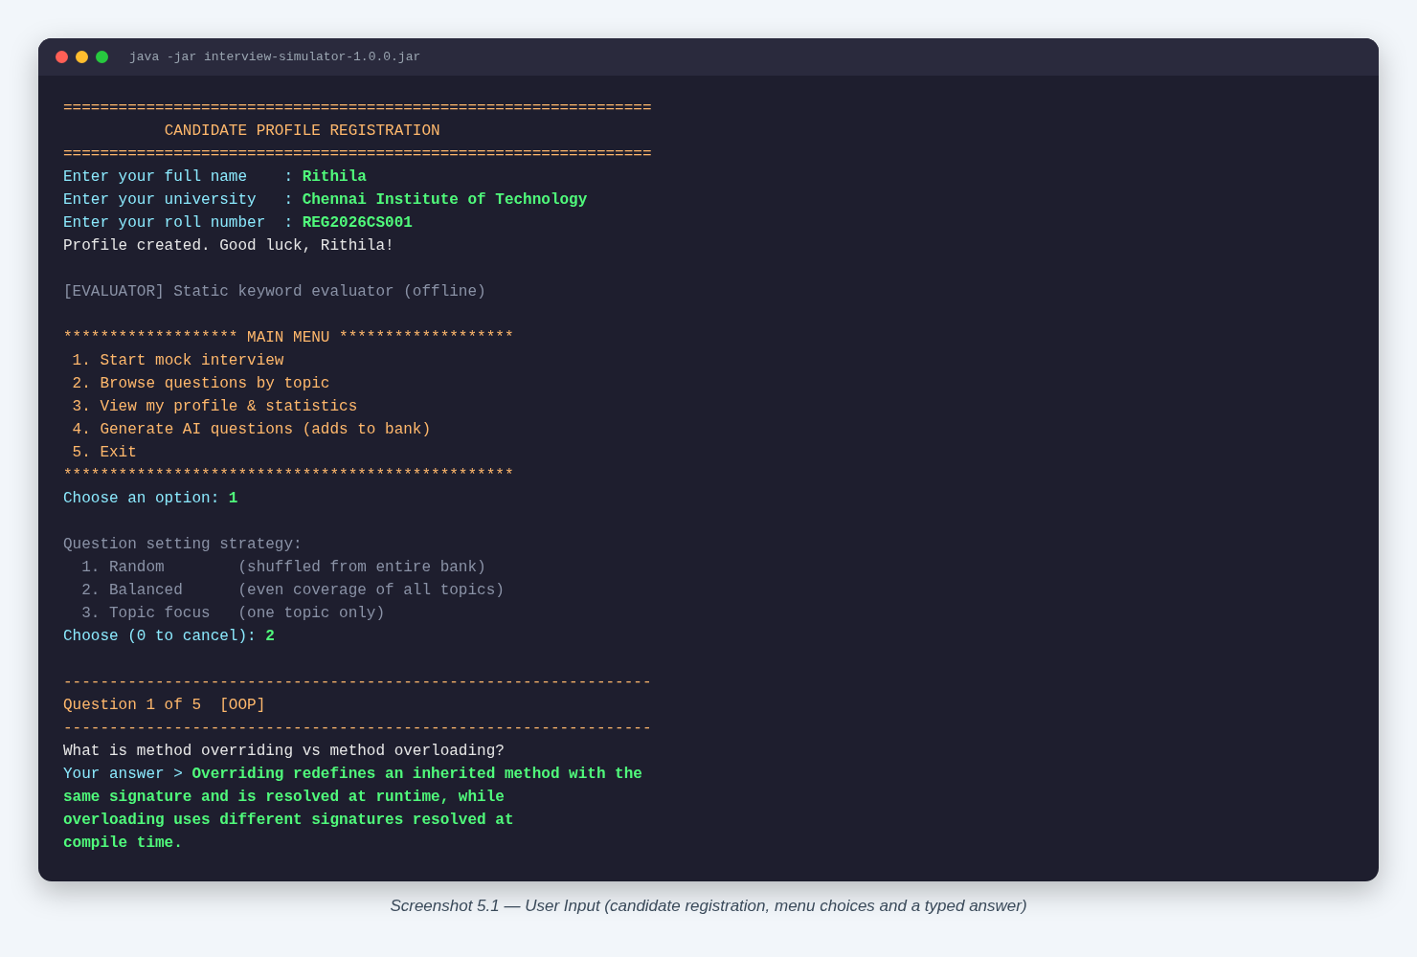
Screenshot 5.1 — User Input (candidate registration, menu choices and a typed answer)
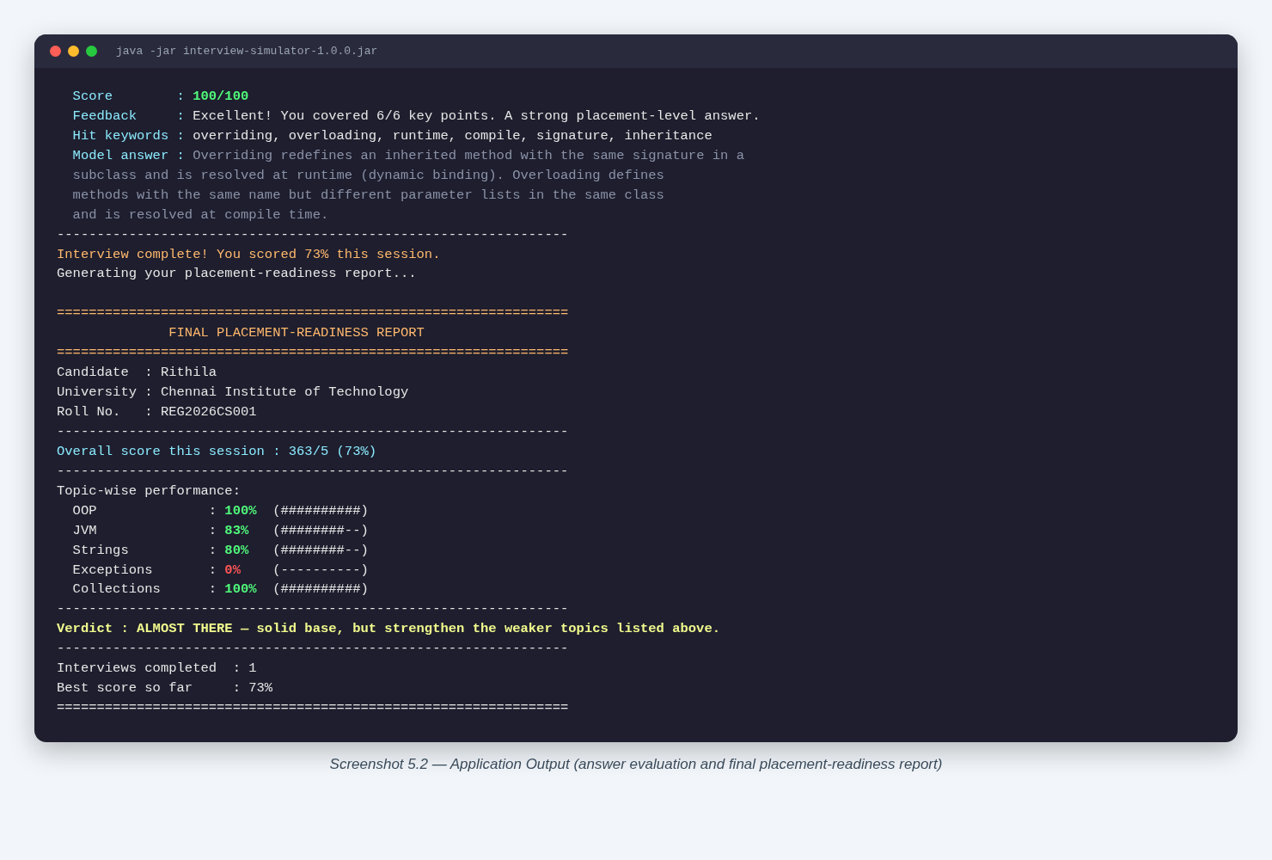
Screenshot 5.2 — Application Output (answer evaluation and final placement-readiness report)

CHAPTER 6

RESULTS AND DISCUSSION

6.1 Evaluation Metrics
Two kinds of metrics were used, matched to what this console application can meaningfully report: (a) JUnit test-case pass rate, which verifies the correctness of the model, evaluator and question-selection logic in isolation; and (b) the keyword match percentage produced by the application itself for a sample mock-interview session, which is the application's own placement-readiness metric. Code coverage tooling (e.g. JaCoCo) was not configured in this PBL cycle, so coverage percentage is reported as not measured rather than estimated.

6.2 Results Across Iterations
Table 6.1: JUnit test results (final build, mvn test)
Test Class | Tests Run | Failures | Errors
TopicTest | 3 | 0 | 0
QuestionTest | 2 | 0 | 0
CandidateTest | 3 | 0 | 0
KeywordBasedEvaluatorTest | 5 | 0 | 0
FallbackEvaluatorTest | 2 | 0 | 0
InMemoryQuestionBankTest | 5 | 0 | 0
RandomQuestionSetterTest | 3 | 0 | 0
BalancedQuestionSetterTest | 3 | 0 | 0
TopicQuestionSetterTest | 3 | 0 | 0
JsonQuestionLoaderTest | 2 | 0 | 0
PlacementReadinessReportGeneratorTest | 3 | 0 | 0
TOTAL | 34 | 0 | 0

Table 6.2: Sample mock-interview topic-wise scores (Balanced strategy, offline keyword evaluator)
Topic | Score
OOP | 83%
Collections | 100%
Strings | 83%
Exceptions | 0%
JVM | 100%
Overall session score | 73% — Verdict: ALMOST THERE

Baseline and Refinement builds (Chapter 4.2-4.3) were not separately benchmarked with automated tests, since the JUnit suite was only added once the architecture stabilised in the Final Approach; this is recorded here rather than an estimated figure being fabricated for those earlier builds.

6.3 Discussion
- The 34/34 JUnit pass rate confirms the model, evaluator and question-setter logic behave as designed, including the FallbackEvaluator's exception-handling path.
- The sample session shows the keyword evaluator rewards answers that use the exact technical vocabulary from the model answer (100% on Collections and JVM) and scores 0% when the candidate's prepared answer targets the wrong sub-topic within a topic (Exceptions — the drawn question was on try-with-resources, not checked/unchecked exceptions).
- This is a practical limitation of pure keyword matching rather than semantic evaluation: a correct answer phrased differently, or an answer to a related-but-different question in the same topic, can score poorly. The optional AI-backed evaluators (Claude/Gemini/Ollama) were added specifically to mitigate this, but were not exercised in this run because no API key or local Ollama instance was configured.
- The BalancedQuestionSetter's round-robin design successfully guaranteed one question per topic for the first five topics, matching its intended behaviour.

6.4 Limitations
- The keyword-based evaluator (the default, offline path) cannot judge answers that are technically correct but phrased without the exact expected keywords.
- No concurrency or multi-user testing was performed; the application is designed for a single interactive session.
- Code coverage was not measured with a dedicated tool in this PBL cycle; only the pass/fail outcome of the 34 JUnit tests is reported.
- The AI-backed evaluators (Claude, Gemini, Ollama) were implemented but not exercised end-to-end in this report's demo run, since no API key or local model was configured in the test environment.

CHAPTER 7

TEAM REFLECTION AND LEARNING OUTCOMES

7.1 Individual Reflections
Rithila: I worked mainly on the service layer — the KeywordBasedEvaluator, the AiAnswerEvaluator implementations (Claude, Gemini, Ollama), the FallbackEvaluator decorator and EvaluatorFactory, plus the RandomQuestionSetter, BalancedQuestionSetter and TopicQuestionSetter strategies. I learned how the Strategy and Decorator patterns let you swap or chain behaviour without touching the calling code. The biggest challenge was making the AI-to-offline fallback actually resilient — my first version only caught specific exception types and still crashed on some AI failures, so I had to widen the catch to RuntimeException and add the aiActive flag so a failure only degrades once instead of retrying the broken backend on every question.
Rekha: I worked mainly on the question bank and the JUnit test suite — designing the questions.json schema, JsonQuestionLoader (Gson deserialization, including the custom Topic enum adapter) and InMemoryQuestionBank, then writing the 34 JUnit 5 tests across the model, service and util packages. I learned how much a seeded java.util.Random matters for testing anything involving shuffling — my early tests for the random and balanced setters were flaky because they used an unseeded Random, so I switched every test to a fixed-seed Random to get deterministic, repeatable assertions.

7.2 Team Learning
Dividing the work by architectural layer (Rithila on evaluators/strategies, Rekha on the data layer/tests) worked well because both halves only had to agree on the shared interfaces (AnswerEvaluator, QuestionBank, QuestionSetter), so we could build and test our parts independently and integrate them late without major conflicts. Our mentor's main feedback in the early weeks was that hardcoding questions directly in Java made the bank hard to extend and review, which is what pushed us to externalize them into questions.json via Gson in the refinement iteration. If we restarted this PBL cycle, we would set up the JUnit test suite from Week 3-4 instead of the final weeks — several of the bugs we found late (like the unseeded Random flakiness) would have been caught much earlier with tests running alongside development.

7.3 Course Outcomes — Evidence Summary
- Technical skill: pluggable evaluator chain (KeywordBasedEvaluator, AiAnswerEvaluator, FallbackEvaluator) and Strategy-pattern question setters demonstrate applied OOP and design-pattern knowledge (Chapter 4, Chapter 5).
- Testing discipline: 34 JUnit 5 tests added and passing across the model, service and util packages (Table 6.1).
- Teamwork and process: weekly milestone log in Table 3.1 shows incremental delivery across the PBL cycle from baseline to final approach.

CHAPTER 8

CONCLUSION AND FUTURE SCOPE

8.1 Conclusion
The Java AI Interview Simulator meets its driving question: it is an offline-capable, console-based mock-interview tool that loads a 23-question core-Java bank from JSON, offers three interchangeable question-setting strategies, scores answers through a resilient evaluator chain that gracefully falls back to offline keyword matching, and produces a topic-wise placement-readiness report. The 34/34 passing JUnit test suite and a genuine end-to-end console demo (73% overall, verdict “ALMOST THERE”) confirm the application works as designed. The project also met its learning objectives, giving the team hands-on practice with interfaces, inheritance, collections, exception handling and classic design patterns (Strategy, Factory, Decorator) within a real, testable Java codebase.

8.2 Future Scope
- Replace pure keyword matching with a semantic/embedding-based scorer to reduce false negatives on correctly-phrased but keyword-light answers.
- Add persistent storage (file or database) so candidate history survives across application restarts.
- Introduce a code-coverage tool (e.g. JaCoCo) into the Maven build to quantify test coverage numerically.
- Expand the question bank beyond 23 questions and support user-contributed questions with validation.
- Add a simple GUI or web front-end while keeping the existing service layer unchanged, since it is already UI-agnostic.
- Exercise and document the Claude/Gemini/Ollama AI evaluators end-to-end once API access is available.

REFERENCES
[1] Oracle, “The Java® Tutorials,” Oracle Corporation, 2024. [Online]. Available: https://docs.oracle.com/javase/tutorial/
[2] Oracle, “Java Platform, Standard Edition 17 API Specification,” Oracle Corporation, 2021.
[3] Google, “Gson User Guide,” GitHub, 2024. [Online]. Available: https://github.com/google/gson
[4] JUnit Team, “JUnit 5 User Guide,” 2024. [Online]. Available: https://junit.org/junit5/docs/current/user-guide/
[5] E. Gamma, R. Helm, R. Johnson and J. Vlissides, Design Patterns: Elements of Reusable Object-Oriented Software. Boston, MA: Addison-Wesley, 1994.
[6] Oracle, “Java Collections Framework Overview,” Oracle Corporation, 2024.
[7] Apache Software Foundation, “Maven Shade Plugin Documentation,” 2024. [Online]. Available: https://maven.apache.org/plugins/maven-shade-plugin/
[8] questions.json, project question bank (dataset), src/main/resources/questions.json, Interview Simulator Team, 2026.

APPENDIX

A.1 Full Source Code
The full source code is maintained in the project Git repository under src/main/java/com/interviewsim (packages: model, service, core, ui, util) and the JUnit 5 test suite under src/test/java/com/interviewsim. Key files referenced in Chapter 5 are FallbackEvaluator.java, KeywordBasedEvaluator.java and BalancedQuestionSetter.java.

A.2 Complete Weekly PBL Log and Mentor Sign-offs
[Attach the complete weekly log and mentor sign-off sheets here if longer than Table 3.1.]

A.3 Self and Peer Assessment
Team Member | Self-Rated Contribution (%) | Peer-Rated Contribution (%) | Remarks
Rithila | [%] | [%] | [remarks]
Rekha | [%] | [%] | [remarks]

