Exercise 1: Implementing the Singleton Pattern
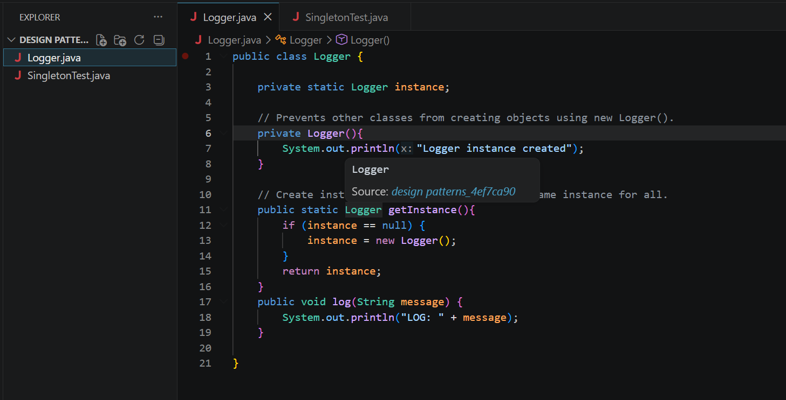
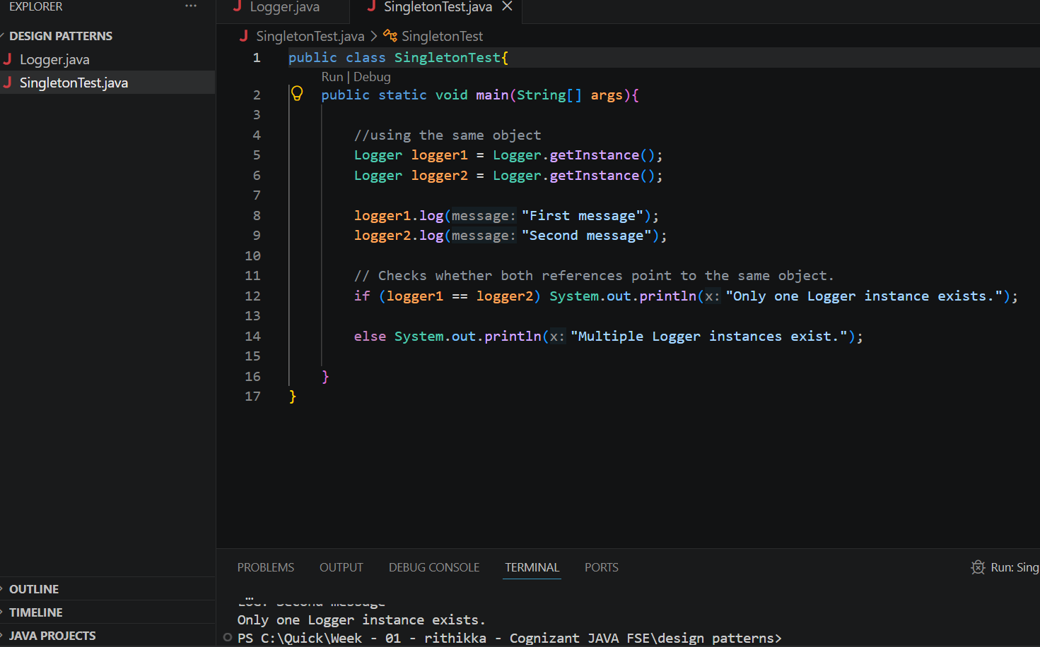
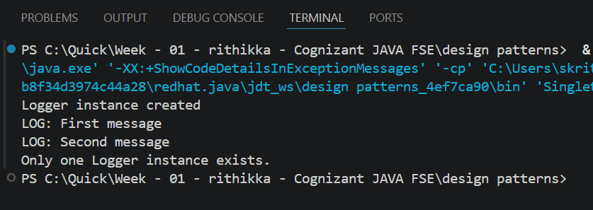
CODE:

public class SingletonTest{
public static void main(String[] args){

//using the same object
Logger logger1 = Logger.getInstance();
Logger logger2 = Logger.getInstance();

logger1.log("First message");
logger2.log("Second message");

// Checks whether both references point to the same object.
if (logger1 == logger2) System.out.println("Only one Logger instance exists.");
else System.out.println("Multiple Logger instances exist.");
}
}
public class Logger {
private static Logger instance;
// Prevents other classes from creating objects using new Logger().
private Logger(){
System.out.println("Logger instance created");
}
// Create instance only once and return the same instance for all.
public static Logger getInstance(){
if (instance == null) {
instance = new Logger();
}
return instance;
}
public void log(String message) {
System.out.println("LOG: " + message);
}
}

Exercise 2: Implementing the Factory Method Pattern
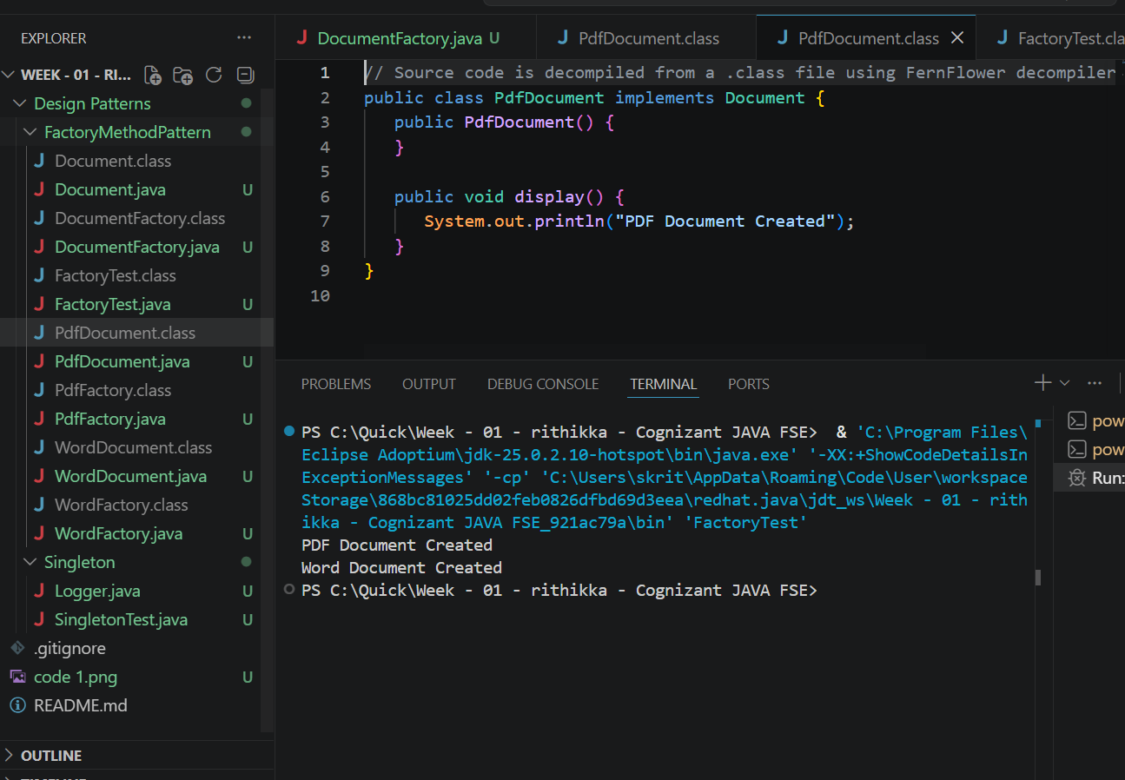
CODE:
// Source code is decompiled from a .class file using FernFlower decompiler (from Intellij IDEA).
public class FactoryTest {
public FactoryTest() {
}

public static void main(String[] var0) {
PdfFactory var1 = new PdfFactory();
Document var2 = ((DocumentFactory)var1).createDocument();
var2.display();
WordFactory var3 = new WordFactory();
Document var4 = ((DocumentFactory)var3).createDocument();
var4.display();
}
}

// Main class
public class FactoryTest{
public static void main(String[] args){

// Create PDF
DocumentFactory pdfFactory = new PdfFactory();
Document pdf = pdfFactory.createDocument();
pdf.display();

// Create Word
DocumentFactory wordFactory = new WordFactory();
Document word = wordFactory.createDocument();
word.display();

}

}
// Source code is decompiled from a .class file using FernFlower decompiler (from Intellij IDEA).
public class PdfFactory extends DocumentFactory {
public PdfFactory() {
}

public Document createDocument() {
return new PdfDocument();
}
}

// Concrete PDF document class
public class PdfDocument implements Document {

@Override
public void display() {

System.out.println("PDF Document Created");

}
}

// Word document class
public class WordDocument implements Document {

@Override
public void display() {

System.out.println("Word Document Created");

}
}
// Source code is decompiled from a .class file using FernFlower decompiler (from Intellij IDEA).
public class WordFactory extends DocumentFactory {
public WordFactory() {
}
public Document createDocument() {
return new WordDocument();
}
}
// Factory for Word documents
public class WordFactory extends DocumentFactory {

@Override
public Document createDocument() {
return new WordDocument();
}
}

