**SCREENSHOT OF PROGRAM**

**CODE:**

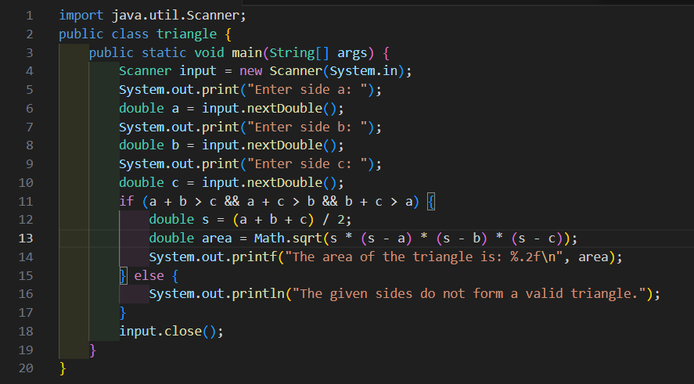

**OUTPUT:**

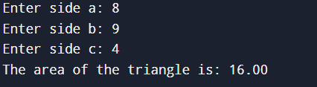

**INFERENCE:**

The program calculates the area of a triangle using Heron’s formula, based on the user given side lengths. It first checks if the sides form a valid triangle and then computes the area. The program demonstrates the use of conditionals, user input and mathematical operations in Java effectively.