1.

i.) create a remote repository.

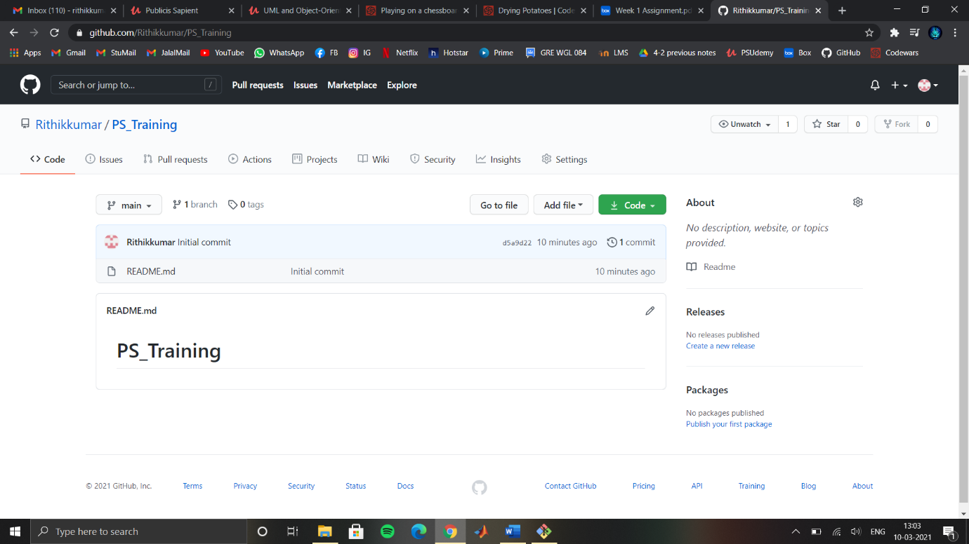

ii.)create a local repository.

Use git clone command.

iii.)create all 5 branches

Use command git flow “branch type” start “branch name”

Ex:

Git flow feature start feature_1

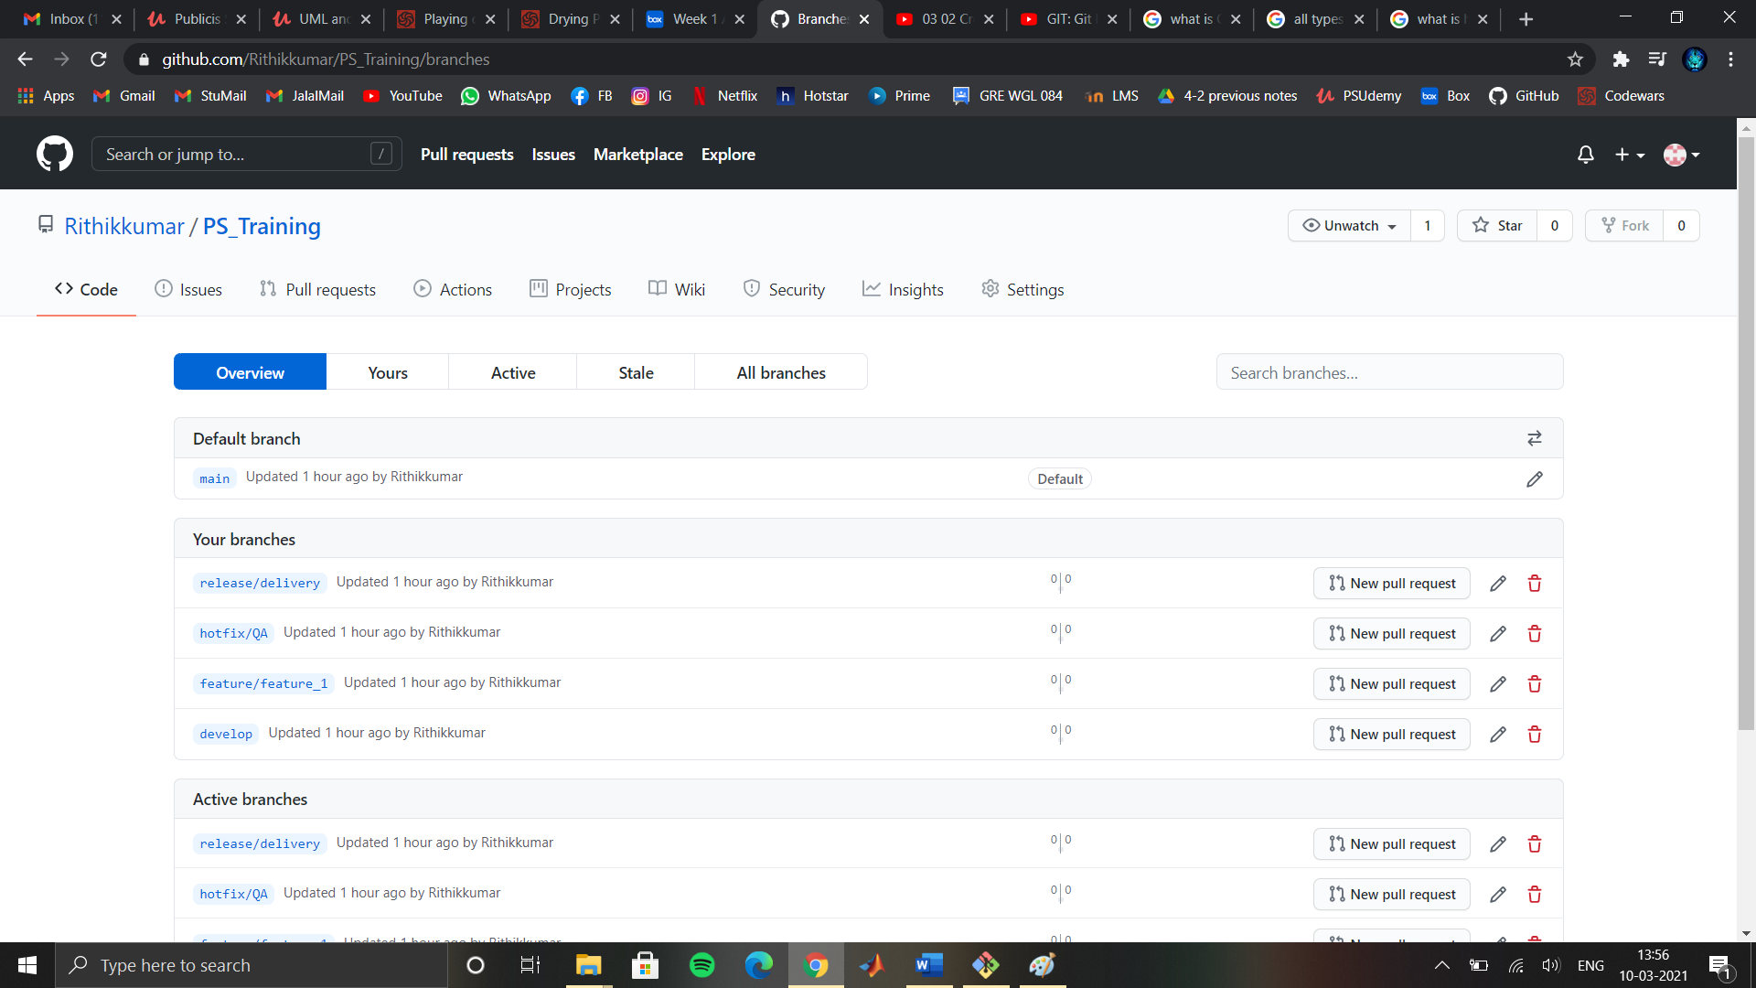

iv.)create remote branches. 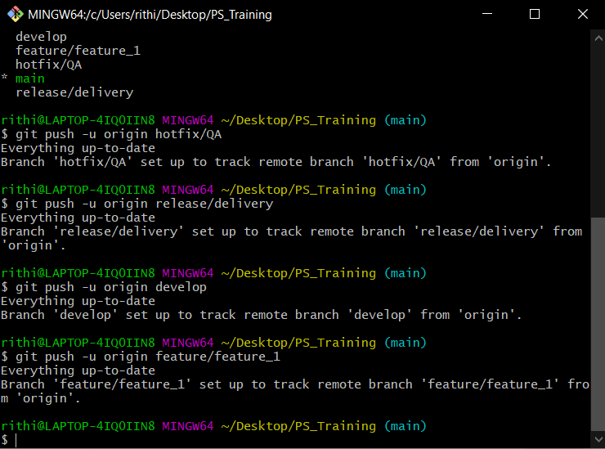

v.)adding files to feature branch.

1.git checkout feature/feature_1

2.git add .

3.git commit -m “created a helloworld.py fie”

4.git push origin feature/feature_1

vi.)check in stage and commit files into feature branch

1.git commit -m “modified the print statement”

2.git push feature/feature_1

vii.)promote code from feature branch to dev branch using pull requests:

1.git checkout develop

2.git pull origin feature/feature_1

3.git push -u origin dev

viii.)checkout latest code from remote branch to local branch done using fetch command.

1.git checkout hotfix/QA

2.git fetch origin hotfix/QA

3.git merge

ix)git checkout – switch to other branches.

We can directly use checkout command to create a new branch.

x.)code synced in all the branches.

B. perform all of them using GUI Client

i.)Initialising using gui client.

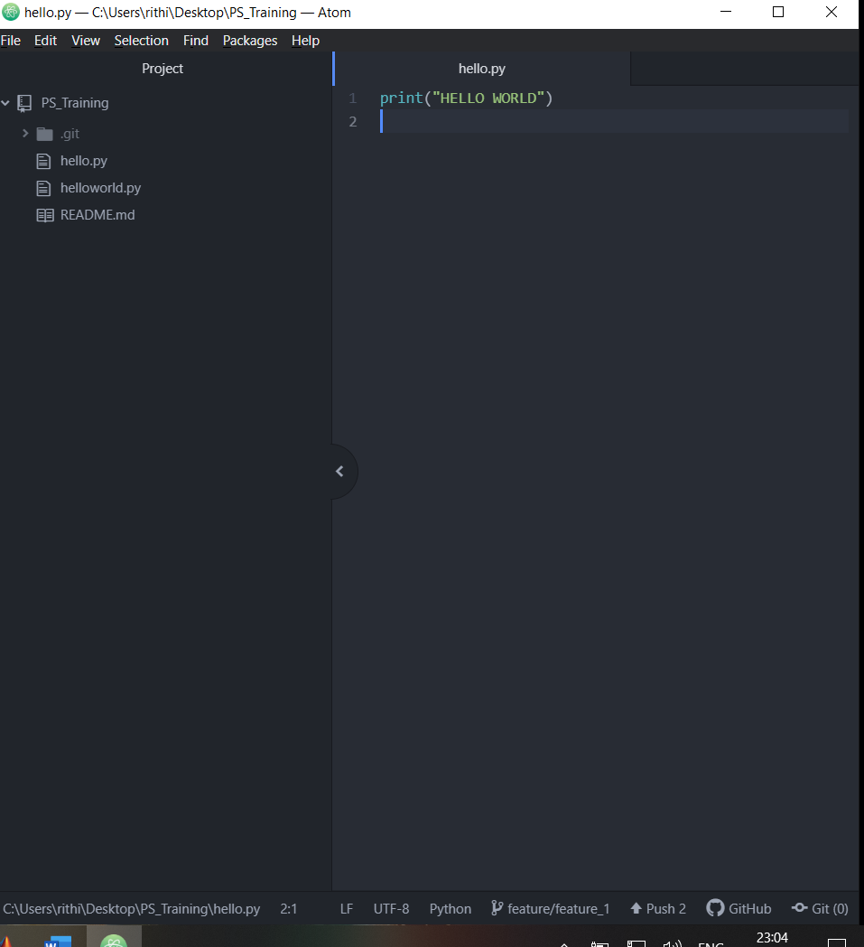

ii.)set up a remote repository

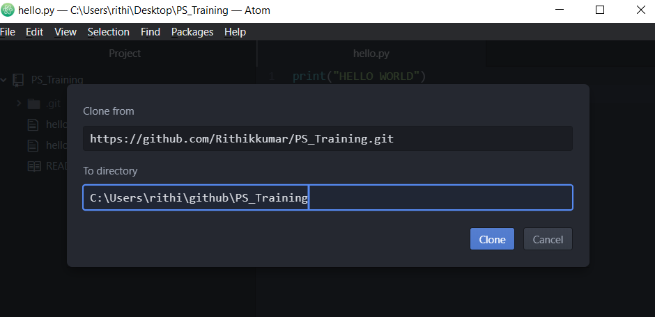

iii.)adding a new branch in atom

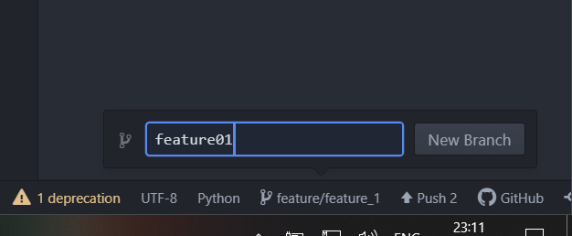

iv.)setting up a remote repository.

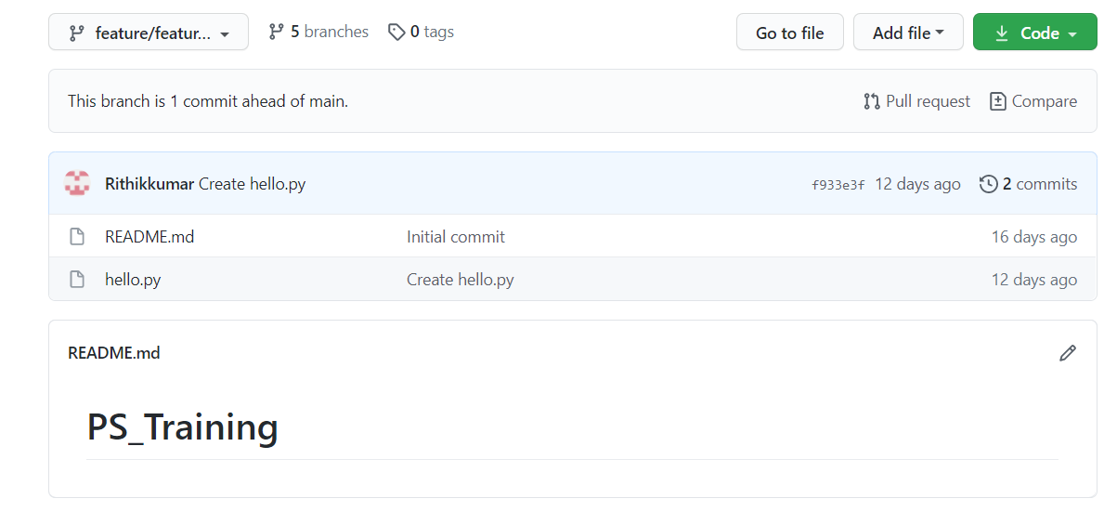

v.)latest code from remote to local repository:

fetch command.

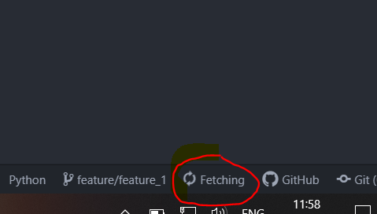

Regularly used basic github commands.

i.)git -amend : change commit msg.

ii.)git log : info abt the project.

iii.)git reset -soft <commit number> : reset the older version

iv.) git reflog : info abt recent commits

v.) git status : info abt files added