**Spring REST using Spring Boot 3**

1. **Create a Spring Web Project using Maven**

// src/main/java/com/cognizant/springlearn/SpringLearnApplication.java

package com.cognizant.springlearn;

import org.springframework.boot.SpringApplication;

import org.springframework.boot.autoconfigure.SpringBootApplication;

@SpringBootApplication

public class SpringLearnApplication {

public static void main (String [] args) {

System.out.println("SpringLearnApplication started...");

SpringApplication.run(SpringLearnApplication.class, args);

}

}

**Output:**

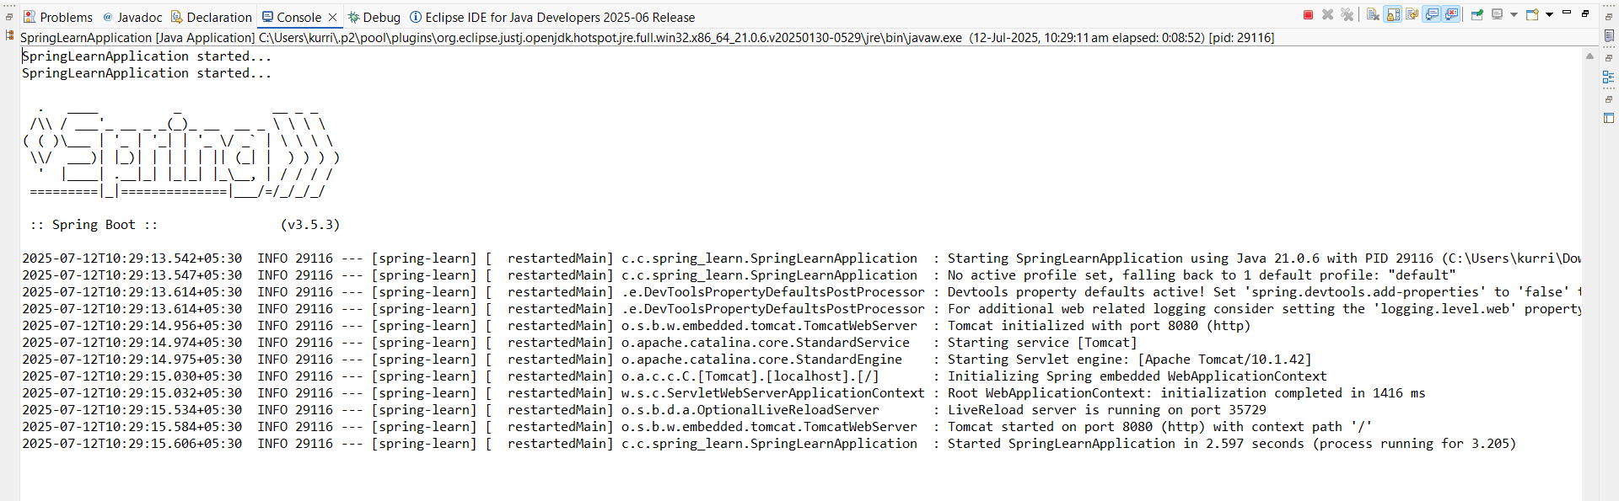

1. **Spring Core – Load Country from Spring Configuration XML**

**Class: Country.java**

package com.cognizant.springlearn;

import org.slf4j.Logger;

import org.slf4j.LoggerFactory;

public class Country {

private static final Logger LOGGER = LoggerFactory.getLogger(Country.class);

private String code;

private String name;

public Country() {

LOGGER.debug("Inside Country Constructor.");

}

public String getCode() {

LOGGER.debug("Inside getCode()");

return code;

}

public void setCode(String code) {

LOGGER.debug("Inside setCode()");

this.code = code;

}

public String getName() {

LOGGER.debug("Inside getName()");

return name;

}

public void setName(String name) {

LOGGER.debug("Inside setName()");

this.name = name;

}

@Override

public String toString() {

return "Country [code=" + code + ", name=" + name + "]";

}

}

**country.xml in src/main/resources**

<?xml version="1.0" encoding="UTF-8"?>

<beans xmlns="http://www.springframework.org/schema/beans"

xmlns:xsi="http://www.w3.org/2001/XMLSchema-instance"

xsi:schemaLocation="http://www.springframework.org/schema/beans

http://www.springframework.org/schema/beans/spring-beans.xsd">

<bean id="country" class="com.cognizant.springlearn.Country">

<property name="code" value="IN" />

<property name="name" value="India" />

</bean>

</beans>

**Class : SpringLearnApplication.java**

package com.cognizant.springlearn;

import org.slf4j.Logger;

import org.slf4j.LoggerFactory;

import org.springframework.context.ApplicationContext;

import org.springframework.context.support.ClassPathXmlApplicationContext;

public class SpringLearnApplication {

private static final Logger LOGGER = LoggerFactory.getLogger(SpringLearnApplication.class);

public static void main(String[] args) {

LOGGER.debug("Inside main()");

displayCountry();

}

public static void displayCountry() {

ApplicationContext context = new ClassPathXmlApplicationContext("country.xml");

Country country = context.getBean("country", Country.class);

LOGGER.debug("Country : {}", country.toString());

}

}

**Output:**

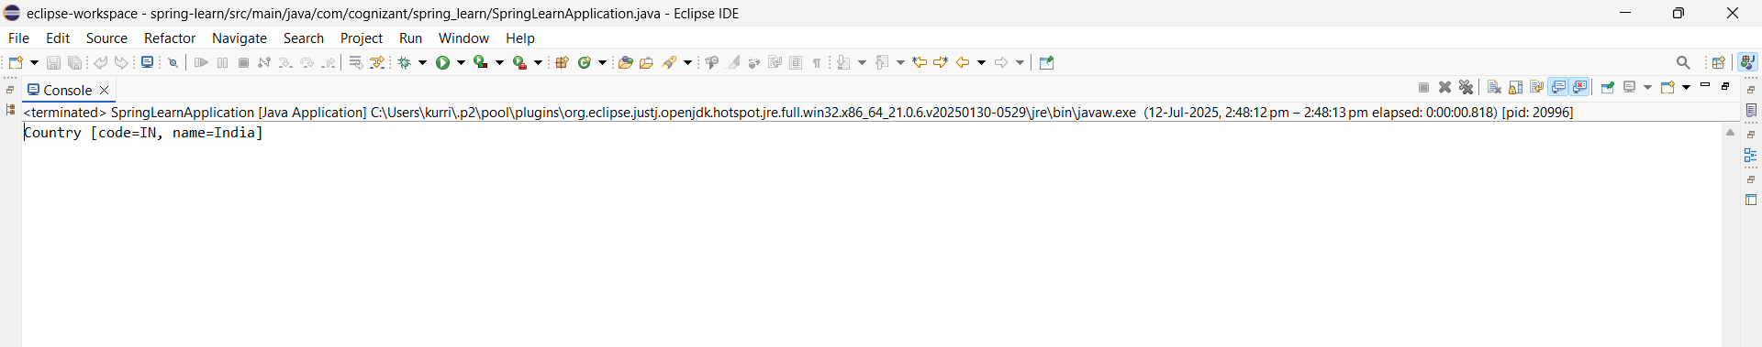

1. **Hello World RESTful Web Service**

**Adding web dependencies**

<dependency>

<groupId>org.springframework.boot</groupId>

<artifactId>spring-boot-starter-web</artifactId>

</dependency>

**application.properties**

Adding port:

server.port=8083

**Class: HelloController**

package com.cognizant.spring_learn.controller;

import org.slf4j.Logger;

import org.slf4j.LoggerFactory;

import org.springframework.web.bind.annotation.GetMapping;

import org.springframework.web.bind.annotation.RestController;

@RestController

public class HelloController {

private static final Logger LOGGER = LoggerFactory.getLogger(HelloController.class);

@GetMapping("/hello")

public String sayHello() {

LOGGER.info("START sayHello()");

String message = "Hello World!!";

LOGGER.info("END sayHello()");

return message;

}

}

**Class: SpringLearnApplication.java**

package com.cognizant.spring_learn;

import org.springframework.boot.SpringApplication;

import org.springframework.boot.autoconfigure.SpringBootApplication;

@SpringBootApplication

public class SpringLearnApplication {

public static void main(String[] args) {

SpringApplication.run(SpringLearnApplication.class, args);

}

}

**Output:**

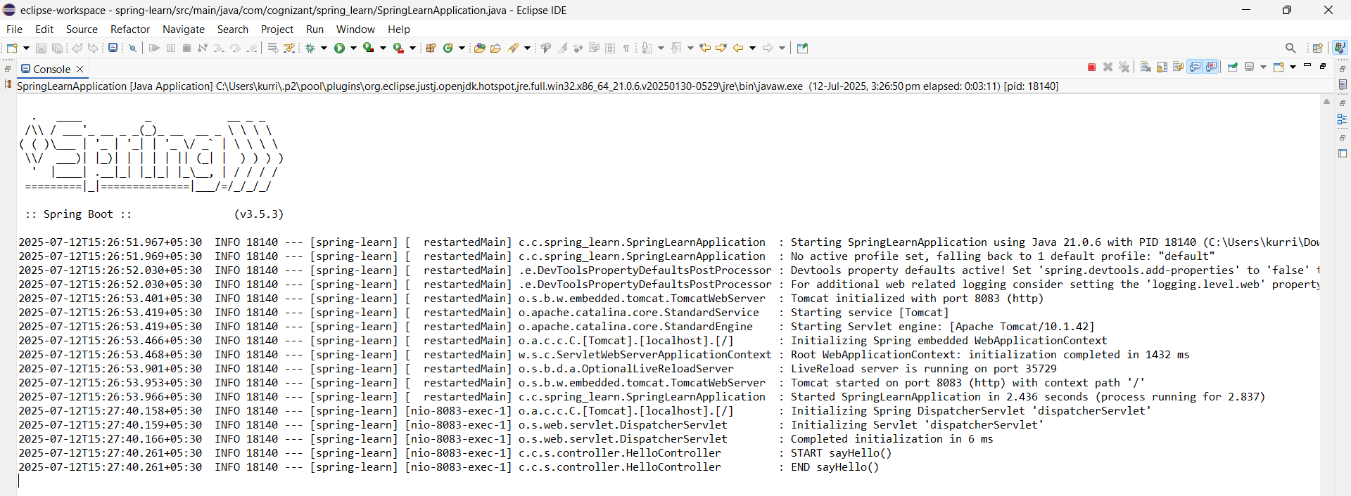

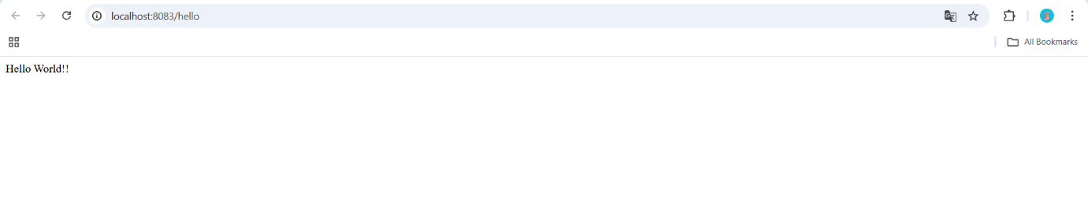

1. **REST - Country Web Service**

**File: src/main/resources/country.xml**

<?xml version="1.0" encoding="UTF-8"?>

<beans xmlns="http://www.springframework.org/schema/beans"

xmlns:xsi="http://www.w3.org/2001/XMLSchema-instance"

xsi:schemaLocation="

http://www.springframework.org/schema/beans

https://www.springframework.org/schema/beans/spring-beans.xsd">

<bean id="country" class="com.cognizant.spring_learn.Country">

<property name="code" value="IN"/>

<property name="name" value="India"/>

</bean>

</beans>

**File: src/main/java/com/cognizant/spring_learn/Country.java**

package com.cognizant.spring_learn;

public class Country {

private String code;

private String name;

public Country () {

System.out.println("Inside Country Constructor");

}

public String getCode () {

System.out.println("Inside getCode");

return code;

}

public void setCode (String code) {

System.out.println("Inside setCode");

this.code = code;

}

public String getName () {

System.out.println("Inside getName");

return name;

}

public void setName (String name) {

System.out.println("Inside setName");

this.name = name;

}

@Override

public String toString () {

return "Country [code=" + code + ", name=" + name + "]";

}

}

**File:src/main/java/com/cognizant/spring_learn/controller/CountryController.java**

package com.cognizant.spring_learn.controller;

import com.cognizant.spring_learn.Country;

import org.slf4j.Logger;

import org.slf4j.LoggerFactory;

import org.springframework .context.ApplicationContext;

import org.springframework.context.support.ClassPathXmlApplicationContext;

import org.springframework.web.bind.annotation.RequestMapping;

import org.springframework.web.bind.annotation.RestController;

@RestController

public class CountryController {

private static final Logger LOGGER = LoggerFactory.getLogger(CountryController.class);

@RequestMapping("/country")

public Country getCountryIndia() {

LOGGER.info("START getCountryIndia()");

ApplicationContext context = new ClassPathXmlApplicationContext("country.xml");

Country country = context.getBean("country", Country.class);

LOGGER.info("END getCountryIndia()");

return country;

}

}

**Output:**

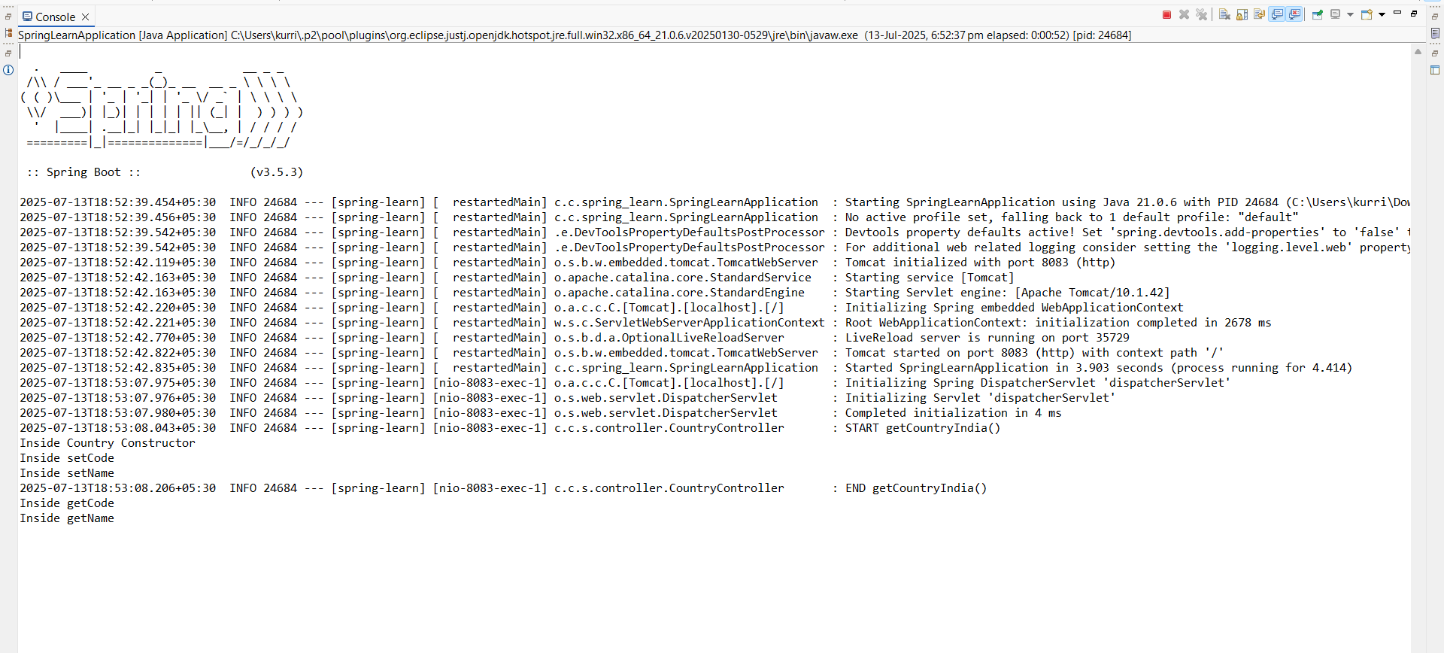

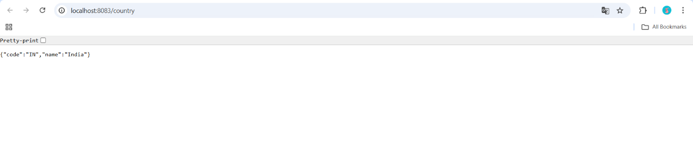

**REST - Get country based on country code**

**File: src/main/resources/country.xml**

<?xml version="1.0" encoding="UTF-8"?>

<beans xmlns="http://www.springframework.org/schema/beans"

xmlns:xsi="http://www.w3.org/2001/XMLSchema-instance"

xsi:schemaLocation="

http://www.springframework.org/schema/beans

https://www.springframework.org/schema/beans/spring-beans.xsd">

<bean id="countryList" class="java.util.ArrayList">

<constructor-arg>

<list>

<bean class="com.cognizant.spring_learn.Country">

<property name="code" value="IN"/>

<property name="name" value="India"/>

</bean>

<bean class="com.cognizant.spring_learn.Country">

<property name="code" value="US"/>

<property name="name" value="United States"/>

</bean>

<bean class="com.cognizant.spring_learn.Country">

<property name="code" value="DE"/>

<property name="name" value="Germany"/>

</bean>

<bean class="com.cognizant.spring_learn.Country">

<property name="code" value="JP"/>

<property name="name" value="Japan"/>

</bean>

</list>

</constructor-arg>

</bean>

</beans>

**File: src/main/java/com/cognizant/spring_learn/service/CountryService.java**

package com.cognizant.spring_learn.service;

import com.cognizant.spring_learn.Country;

import org.springframework.context.ApplicationContext;

import org.springframework.context.support.ClassPathXmlApplicationContext;

import org.springframework.stereotype.Service;

import java.util.List;

@Service

public class CountryService {

public Country getCountry(String code) {

ApplicationContext context = new ClassPathXmlApplicationContext("country.xml");

List<Country> countries = context.getBean("countryList", List.class);

// Using lambda and case-insensitive match

return countries.stream()

.filter(c -> c.getCode().equalsIgnoreCase(code))

.findFirst()

.orElse(null);

}

}

**File: src/main/java/com/cognizant/spring_learn/controller/CountryController.java**

package com.cognizant.spring_learn.controller;

import com.cognizant.spring_learn.Country;

import com.cognizant.spring_learn.service.CountryService;

import org.slf4j.Logger;

import org.slf4j.LoggerFactory;

import org.springframework.beans.factory.annotation.Autowired;

import org.springframework.web.bind.annotation.*;

@RestController

public class CountryController {

private static final Logger LOGGER = LoggerFactory.getLogger(CountryController.class);

@Autowired

private CountryService countryService;

@GetMapping("/countries/{code}")

public Country getCountry(@PathVariable String code) {

LOGGER.info("START getCountry() with code: {}", code);

Country country = countryService.getCountry(code);

LOGGER.info("END getCountry()");

return country;

}

}

**Output:**



**Create authentication service that returns JWT**

**src/main/java/com/example/authdemo/controller/AuthenticationController.java**

package com.example.authdemo.controller;  
  
import org.slf4j.Logger;  
import org.slf4j.LoggerFactory;  
import org.springframework.web.bind.annotation.GetMapping;  
import org.springframework.web.bind.annotation.RequestHeader;  
import org.springframework.web.bind.annotation.RestController;  
  
import java.util.HashMap;  
import java.util.Map;  
  
@RestController  
public class AuthenticationController {  
  
 private static final Logger logger = LoggerFactory.getLogger(AuthenticationController.class);  
  
 @GetMapping("/authenticate")  
 public Map<String, String> authenticate(@RequestHeader("Authorization") String authHeader) {  
 logger.info("START - /authenticate");  
  
 logger.debug("Authorization Header: {}", authHeader);  
  
 Map<String, String> map = new HashMap<>();  
 map.put("token", "");  
  
 logger.info("END - /authenticate");  
  
 return map;  
 }  
}

**src/main/java/com/example/authdemo/config/SecurityConfig.java**

package com.example.authdemo.config;  
  
import org.springframework.context.annotation.Bean;  
import org.springframework.context.annotation.Configuration;  
import org.springframework.security.config.Customizer;  
import org.springframework.security.config.annotation.web.builders.HttpSecurity;  
import org.springframework.security.web.SecurityFilterChain;  
  
@Configuration  
public class SecurityConfig {  
  
 @Bean  
 public SecurityFilterChain filterChain(HttpSecurity http) throws Exception {  
 http  
 .httpBasic(Customizer.withDefaults())  
 .authorizeHttpRequests(auth -> auth  
 .requestMatchers("/countries").hasRole("USER")  
 .requestMatchers("/authenticate").hasAnyRole("USER", "ADMIN")  
 .anyRequest().authenticated()  
 )  
 .csrf(csrf -> csrf.disable());  
  
 return http.build();  
 }  
}

**src/main/java/com/example/authdemo/config/SecurityConfig.java**

# Server port  
server.port=8090  
  
# In-memory user for authentication  
spring.security.user.name=user  
spring.security.user.password=pwd  
spring.security.user.roles=USER

**Output:**

