

# “AI MODEL FOR OPTIMIZING URBAN PUBLIC WATER PUMP MAINTENANCE SCHEDULES”

**BLUEPULSE**

**Submitted By**

|  |  |
| --- | --- |
| **Rithika Shre KP** | **REGNO. 24CS0751** |
| **Jesika J** | **REGNO. 24CS0381** |

**In partial fulfillment for the award of the degree of**

## BACHELOR OF ENGINEERING

**IN**

### COMPUTER SCIENCE AND ENGINEERING



### DEPARTMENT OF COMPUTER SCIENCE AND ENGINEERING CHENNAI INSTITUTE OF TECHNOLOGY

**(Autonomous)**

Sarathy Nagar, Kundrathur, Chennai - 600069

**SEPTEMBER/OCTOBER – 2025**



# “Voice to Text: Instant Speech Transcription”

**Submitted By**

|  |  |
| --- | --- |
| **Rakshana E** | **REGNO. 24CS0728** |
| **Rajasri D** | **REGNO. 24CS0723** |

**In partial fulfillment for the award of the degree of**

## BACHELOR OF ENGINEERING

**IN**

### COMPUTER SCIENCE AND ENGINEERING



### DEPARTMENT OF COMPUTER SCIENCE AND ENGINEERING CHENNAI INSTITUTE OF TECHNOLOGY

**(Autonomous)**

Sarathy Nagar, Kundrathur, Chennai - 600069

**SEPTEMBER/OCTOBER – 2025**

**Vision of the Institute:**

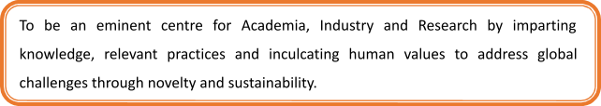

**Mission of the Institute:**



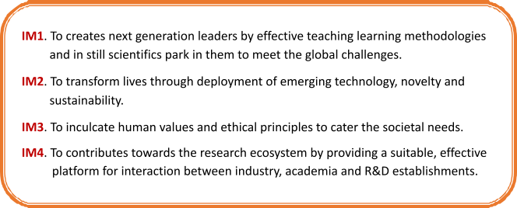

**DEPARTMENT OF**

## COMPUTER SCIENCE AND ENGINEERING

**Vision of the Department**:

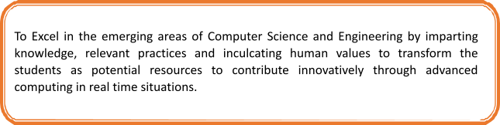

**Mission of the Department**:

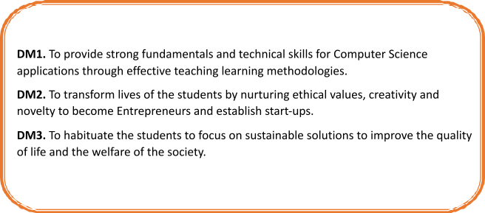

### CERTIFICATE

This is to certify that **the “AI MODEL FOR OPTIMIZING URBAN PUBLIC WATER PUMP MAINTENANCE SCHEDULES”** Submitte**d** by  **Rithika Shre (REGNO. 24CS0751) and Jesika J (REGNO. 24CS0381)** is a work done by her and submitted during **2025-2026** academic year, in partial fulfilment of the requirements for the award of the degree of **BACHELOR OF ENGINEERING** in **DEPARTMENT OF COMPUTER SCIENCE AND ENGINEERING**, at Chennai Institute of Technology.

**Project Incharge Internal Examiner**

M.Maharasi M.E , Assistant professor

Dr. Sujipriya A , M.Phil, Ph.D, Assistant professor

**Head of the Department**  **External Examiner**

(Dr. S. Pavithra M.E, Ph.D)

#### ACKNOWLEDGEMENT

We express our gratitude to our Chairman **Shri.P.SRIRAM** and all trust members of Chennai institute of technology for providing the facility and opportunity to do this project as a part of our undergraduate course.

We are grateful for our Principal **Dr.A.RAMESH M.E**, **Ph.D.** for providing us the facility and encouragement during the course of our work.

We sincerely thank our Head of the Department **Dr.S.Pavithra M.E,Ph.D** Department of Computer Science and Engineering for having provided us valuable guidance, resources and timely suggestions throughout our work.

We would like to extend our thanks to our Year Coordinator **Mrs.Selva Jothi. M M.E**, Project Co-ordinator **Dr.M. Ayeesha Nasreen M.E, Ph.D and Project Incharge** Department of Computer Science and Engineering, for their valuable suggestions throughout this project.

We wish to acknowledge the help received from the of the Department of Computer Science and Engineering and others for providing valuable suggestions and for the successful completion of the project.

We wish to extend our sincere thanks to Faculty members of the Department of Computer Science and Engineering for their valuable suggestions and their kind cooperation for the successful completion of our project.

**Rithika Shre KP (REGNO. 24CS0751)**

**Jesika J (REGNO. 24CS0381)**

#### PREFACE

We, **Rithika shre KP** and **Jesika J** students in the Department of Computer Science and Engineering need to undertake a project to expand my knowledge. The main goal of my Core Course Project is to acquaint me with the practical application of the theoretical concepts I’ve learned during my course.

It was a valuable opportunity to closely compare theoretical concepts with real- world applications. This report may depict deficiencies on my part but still it is an account of my effort.

The results of my analysis are presented in the form of an industrial Project, and the report provides a detailed account of the sequence of these findings. This report is my Core Course Project, developed as part of my 2nd year project. As an engineer, it is my responsibility to contribute to society by applying my knowledge to create innovative solutions that address their changes.

**VII**

# DECLARATION

We hereby declare that this project “Voice to Text: Instant Speech Transcription”, titled is my original work. It has been completed in accordance with the guidelines provided by Chennai Institute of Technology. This project has not been submitted for any other degree or diploma, and all sources and references used in the preparation of this project have been acknowledged appropriately. I affirm that the ideas and expressions here in are my own and do not infringe upon the rights of any other author or researcher.

This project represents my independent research and analysis. I confirm that the findings, conclusions, and recommendations contained within this document are based on my own work and insights. I have conducted thorough research and adhered to the highest standards of academic integrity throughout the process. This work is original and has not been previously published or submitted elsewhere as concerned to my knowledge. I take full responsibility for the content and quality of this project.

VIII