**Applied Cryptography and Network Security**

**(CSI3002)**

**LAB ASSESSMENT – 4**

**Name : RITHIV.R**

**Reg No : 19MIC0113**

**Slot : L27+L28**

**1.DIFF HELMAN KEY EXCHANGE:**

**Code:**

# -*- coding: utf-8 -*-

"""

@author: Rihiv R

"""

print('Rithiv.R-19MIC0113(DIFFE HELLMAN)')

import random

def difffunc(v1,v2,v3):

return int(pow(v1,v2))%v3

def publickey(g,p,val):

return difffunc(g,p,val)

def sharedkey(y,x,p):

return difffunc(y, x, p)

g = int(input('Enter G:'))

p = int(input('Enter P:'))

xa = random.randint(0,p)

xb = random.randint(0,p)

ya = publickey(g, p, xa)

yb = publickey(g, p, xb)

k1 = sharedkey(yb, xa, p)

k2 = sharedkey(ya, xb, p)

print('A:')

print('Private Key of A:',xa)

print('Public key of A:',ya)

print('Shared key of A:',k1)

print('\nB:')

print('Private Key of B:',xb)

print('Public key of B:',yb)

print('Shared key of B:',k2)

**Output:**

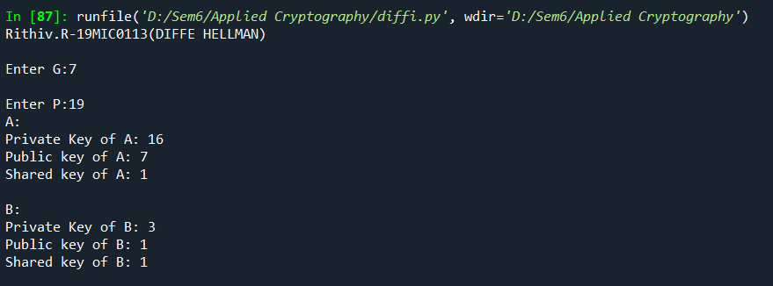

**2.RSA:**

**Code:**

# -*- coding: utf-8 -*-

"""

@author: Rihiv R

"""

print('Rithiv.R-19MIC0113(RSA)')

import math

n = 0

et = 0

e = 0

d = 0

ciphertext = 0

decryptedtext = 0

def calc_e(p,q):

global e,et,n

n = p*q

et = (p-1)*(q-1)

for i in range(2,et):

if(math.gcd(i, et)==1):

e = i

print('E value is',e)

break

def calc_d():

global e,d,et

for i in range(et):

if((i*e)%et==1):

d = i

print('D value is',d)

break

def encryption(m):

global e,n,ciphertext

ciphertext = int(pow(m,e))%n

print('Ciphertext is',ciphertext)

def decryption():

global ciphertext,d,n,decryptedtext

decryptedtext = int(pow(ciphertext,d))%n

print('Decrypted Plain text is',decryptedtext)

p = int(input('Enter the P value:'))

q = int(input('Enter the Q value:'))

m = int(input('Enter the M value:'))

for i in range(30):

print('-',end='')

print()

calc_e(p, q)

calc_d()

encryption(m)

decryption()

**Output:**

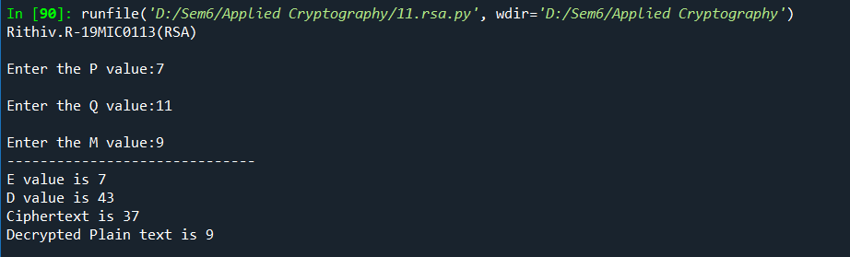

**3. ELGAMAL:**

**Code:**

# -*- coding: utf-8 -*-

"""

@author: Rihiv R

"""

print('Rithiv.R-19MIC0113(ELGAMAL)')

ya = 0

yb = 0

message = 0

yec = 0

dec = 0

def cal_pub_key(xa,xb,g,p):

global ya,yb

ya = int(pow(g,xa)%p)

yb = int(pow(g,xb)%p)

for i in range(30):

print('-',end='')

print()

print('Public key(ya) is',ya)

print('Public key(yb) is',yb)

def encryption(xb,p):

global message,ya,yec

message = int(input('Enter the message:'))

yec = message*int(pow(ya,xb))%p

print('Ciphertext is',int(yec))

def decryption(xa,p):

global yb,dec

sub = p-1-xa

dec = (yec%p) * (int(pow(yb,sub))%p)

if(dec>p):

dec = dec%p

print('Plaintext is',int(dec))

p = int(input('Enter the value of p:'))

g = int(input('Enter the value of q:'))

xa = int(input('Enter the private key of a:'))

xb = int(input('Enter the private key of b:'))

cal_pub_key(xa=xa,xb=xb,p=p,g=g)

for i in range(30):

print('-',end='')

print()

encryption(xb=xb,p=p)

decryption(xa=xa,p=p)

**Output:**

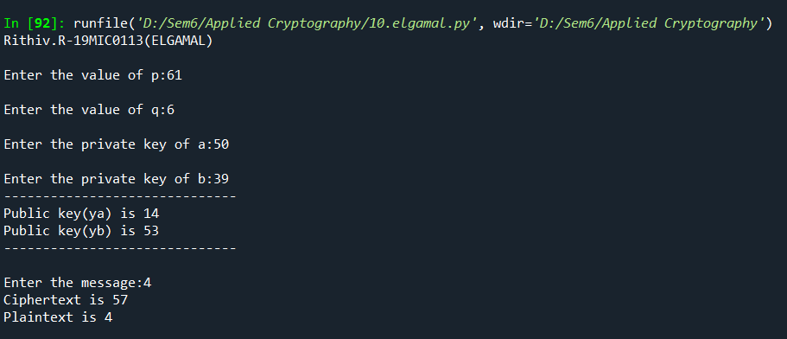

**4. AES:**

**Code:**

"""

@author: Rihiv R

"""

print('RITHIV.R-19MIC0113(AES)')

keymatrix = []

words = []

sbox = {

'00':{'00':'63','01':'7c','02':'77','03':'7b','04':'f2','05':'6b','06':'6f','07':'c5','08':'30','09':'01','0a':'67','0b':'2b','0c':'fe','0d':'d7','0e':'ab','0f':'76'},

'10':{'00':'ca','01':'82','02':'c9','03':'7d','04':'fa','05':'59','06':'47','07':'f0','08':'ad','09':'d4','0a':'a2','0b':'af','0c':'9c','0d':'a4','0e':'72','0f':'c0'},

'20':{'00':'b7','01':'fd','02':'93','03':'26','04':'36','05':'3f','06':'f7','07':'cc','08':'34','09':'a5','0a':'e5','0b':'f1','0c':'71','0d':'d8','0e':'31','0f':'15'},

'30':{'00':'04','01':'c7','02':'23','03':'c3','04':'18','05':'96','06':'05','07':'9a','08':'07','09':'12','0a':'80','0b':'e2','0c':'eb','0d':'27','0e':'b2','0f':'75'},

'40':{'00':'09','01':'83','02':'2c','03':'1a','04':'1b','05':'6e','06':'5a','07':'a0','08':'52','09':'3b','0a':'d6','0b':'b3','0c':'29','0d':'e3','0e':'2f','0f':'84'},

'50':{'00':'53','01':'d1','02':'00','03':'ed','04':'20','05':'fc','06':'b1','07':'5b','08':'6a','09':'cb','0a':'be','0b':'39','0c':'4a','0d':'4c','0e':'58','0f':'cf'},

'60':{'00':'d0','01':'ef','02':'aa','03':'fb','04':'43','05':'4d','06':'33','07':'85','08':'45','09':'f9','0a':'02','0b':'7f','0c':'50','0d':'3c','0e':'9f','0f':'a8'},

'70':{'00':'51','01':'a3','02':'40','03':'8f','04':'92','05':'9d','06':'38','07':'f5','08':'bc','09':'b6','0a':'da','0b':'21','0c':'10','0d':'ff','0e':'f3','0f':'d2'},

'80':{'00':'cd','01':'0c','02':'13','03':'ec','04':'5f','05':'97','06':'44','07':'17','08':'c4','09':'a7','0a':'7e','0b':'3d','0c':'64','0d':'5d','0e':'19','0f':'73'},

'90':{'00':'60','01':'81','02':'4f','03':'dc','04':'22','05':'2a','06':'90','07':'88','08':'46','09':'ee','0a':'b8','0b':'14','0c':'de','0d':'5e','0e':'0b','0f':'db'},

'a0':{'00':'e0','01':'32','02':'3a','03':'0a','04':'49','05':'06','06':'24','07':'5c','08':'c2','09':'d3','0a':'ac','0b':'62','0c':'91','0d':'95','0e':'e4','0f':'79'},

'b0':{'00':'e7','01':'c8','02':'37','03':'6d','04':'8d','05':'d5','06':'4e','07':'a9','08':'6c','09':'56','0a':'f4','0b':'ea','0c':'65','0d':'7a','0e':'ae','0f':'08'},

'c0':{'00':'ba','01':'78','02':'25','03':'2e','04':'1c','05':'a6','06':'b4','07':'c6','08':'e8','09':'dd','0a':'74','0b':'1f','0c':'4b','0d':'bd','0e':'8b','0f':'8a'},

'd0':{'00':'70','01':'3e','02':'b5','03':'66','04':'48','05':'03','06':'f6','07':'0e','08':'61','09':'35','0a':'57','0b':'b9','0c':'86','0d':'c1','0e':'1d','0f':'9e'},

'e0':{'00':'e1','01':'f8','02':'98','03':'11','04':'69','05':'d9','06':'8e','07':'94','08':'9b','09':'1e','0a':'87','0b':'e9','0c':'ce','0d':'55','0e':'28','0f':'df'},

'f0':{'00':'8c','01':'a1','02':'89','03':'0d','04':'bf','05':'e6','06':'42','07':'68','08':'41','09':'99','0a':'2d','0b':'0f','0c':'b0','0d':'54','0e':'bb','0f':'16'},

}

rconst = [['01','00','00','00'],

['02','00','00','00'],

['04','00','00','00'],

['08','00','00','00'],

['10','00','00','00'],

['20','00','00','00'],

['40','00','00','00'],

['80','00','00','00'],

['1b','00','00','00'],

['36','00','00','00'],

]

hexa = {'0':'0000','1':'0001','2':'0010','3':'0011','4':'0100','5':'0101','6':'0110','7':'0111','8':'1000','9':'1001','a':'1010','b':'1011','c':'1100','d':'1101','e':'1110','f':'1111'}

roundkeys = []

mi1 = [

['02','03','01','01'],

['01','02','03','01'],

['01','01','02','03'],

['03','01','01','02'],

]

IR = '100011011'

def strtohex(val):

return val.encode('utf-8').hex()

def hextobin(val):

return "{0:08b}".format(int(val, 16))

def xor(str1,str2):

strtemp = ''

for i,j in zip(str1,str2):

if(i==j):

strtemp = strtemp + '0'

else:

strtemp = strtemp + '1'

return strtemp

def bintohexa(val):

num = int(val, 2)

hexnum = format(num, 'x')

return hexnum

def rotword(arr):

array = []

array.extend([i for i in arr[1:]])

array.append(arr[0])

return array

def subword(arr):

tempo = []

for i in arr:

if(len(i)==1):

i = '0'+i

x = i[0]+'0'

y ='0'+i[1]

tempo.append(sbox[x][y])

return tempo

def sub1word(arr):

x = arr[0]+'0'

y = '0'+arr[1]

return sbox[x][y]

def xorpart(arr1,arr2):

myarray = []

for i,j in zip(arr1,arr2):

x1 = hextobin(i)

x2 = hextobin(j)

resultxor = xor(x1,x2)

resulthex = bintohexa(resultxor)

myarray.append(resulthex)

return myarray

def g(w,r):

val1 = rotword(w)

val2 = subword(val1)

x = xorpart(val2, r)

return x

def keyexpansion(key):

hexa = ''

temp = []

for i in key:

value = strtohex(i)

hexa= hexa+value

temp.append(value)

temp1 = []

for i in range(4):

myword = [j for j in temp[i*4:(i*4+4)]]

temp1.append(myword)

words.append(myword)

for i in range(10):

gc = g(words[-1],rconst[i])

wc1 = xorpart(gc, words[-4])

wc2 = xorpart(wc1,words[-3])

wc3 = xorpart(wc2,words[-2])

wc4 = xorpart(wc3,words[-1])

words.extend([wc1,wc2,wc3,wc4])

for j,i in enumerate(words):

for k2,k1 in enumerate(i):

if(len(k1)==1):

words[j][k2]= '0'+k1

for i in range(11):

str1 = ''

for j in words[i*4:i*4+4]:

for k1 in j:

str1 = str1 + k1

roundkeys.append(str1)

print('\nKeyExpansion Result:')

for j,i in enumerate(roundkeys):

print('round'+str(j)+':',i)

def addround(array,temp2):

statematrix = [[0 for i in range(4)] for i in range(4)]

for i in range(4):

for j in range(4):

x = bintohexa(xor(hextobin(array[i][j]),hextobin(temp2[i][j])))

statematrix[j][i]=x.rjust(2,'0')

return statematrix

def substitue(statematrix):

submatrix = [[0 for i in range(4)] for i in range(4)]

for c1,i in enumerate(statematrix):

for c2,j in enumerate(i):

submatrix[c2][c1]=sub1word(j)

return submatrix

def shiftrow(submatrix):

myarray = []

for j,i in enumerate(submatrix):

if(j==0):

myarray.append(i)

else:

shift = []

shift.extend(i[j:])

shift.extend(i[:j])

myarray.append(shift)

return myarray

def polynomial(string,val):

result = []

for i,j in zip(range(8,0,-1),string):

if(j=='1'):

result.append(i+val)

return result

def mixedbox(matrix):

mymain = []

for j1,i1 in enumerate(mi1):

myar = []

for j2,i2 in enumerate(i1):

mya1 = [mi1[j1][k] for k in range(4)]

mya2 = [matrix[k][j2] for k in range(4)]

mainlist = []

for k1,k2 in zip(mya1,mya2):

if(k1=='01'):

mainlist.extend(polynomial(hextobin(k2),0))

elif(k1=='02'):

mainlist.extend(polynomial(hextobin(k2),1))

elif(k1=='03'):

mainlist.extend(polynomial(hextobin(k2),1))

mainlist.extend(polynomial(hextobin(k2),0))

setter = set(mainlist)

counter = {}

for i in setter:

counter[i] = mainlist.count(i)

mul=[]

for i,j in sorted(counter.items(),reverse=True):

if j%2!=0:

mul.append(i)

result = '00'

if(len(mul)!=0):

length=mul[0]

mul_string=["0"]*(length)

for i in range(length+1):

if i in mul:

mul_string[i-1]="1"

mul_string.reverse()

mul_string="".join(mul_string)

result=division(mul_string)

myar.append(bintohexa(result))

mymain.append(myar)

return mymain

def division(bits):

while(len(bits))>8:

irr_poly = "100011011"

bits = bin(int("0b"+bits,2)^int("0b"+irr_poly,2))[2:]

while(len(bits)<8):

bits = '0'+bits

return bits

def makearr(val):

temp = []

temp2 = [[0 for i in range(4)] for i in range(4)]

roundtemp = roundkeys[val]

for j,i in enumerate(roundkeys[val]):

if((j+1)%2==0):

temp.append(roundtemp[j-1:j+1])

counter = 0

for i in range(4):

for j in range(4):

temp2[j][i] = temp[counter]

counter=counter+1

return temp2

def encryption(message):

print('\nEncryption Each Round Result:')

x1 = []

for i in message:

x1.append(strtohex(i))

array = [[0 for i in range(4)] for i in range(4)]

counter=0

for i in range(4):

for j in range(4):

array[j][i] = x1[counter]

counter+=1

statematrix = []

temp2 = makearr(0)

statematrix = addround(array, temp2)

submatrix = substitue(statematrix)

shiftmatrix = shiftrow(submatrix)

mixedb = mixedbox(shiftmatrix)

temp2 = makearr(1)

statematrix = addround(mixedb, temp2)

print('Result after Round1 add roundkey:')

for i in range(4):

for j in range(4):

print(statematrix[j][i],end=' ')

print()

print()

for i in range(2,10):

submatrix = substitue(statematrix)

shiftmatrix = shiftrow(submatrix)

mixedb = mixedbox(shiftmatrix)

temp2 = makearr(i)

statematrix = addround(mixedb, temp2)

print('Result after Round '+str(i)+' add roundkey:')

for i in range(4):

for j in range(4):

print(statematrix[j][i],end=' ')

print()

print()

submatrix = substitue(statematrix)

shiftmatrix = shiftrow(submatrix)

temp2 = makearr(10)

statematrix = addround(shiftmatrix,temp2)

print('Result after Round10 add roundkey:')

for i in range(4):

for j in range(4):

print(statematrix[j][i],end=' ')

print()

print()

print('\nThe Encrypted Cipher Text by AES is:')

for i in range(4):

for j in range(4):

print(statematrix[i][j],end=' ')

print()

message = input('Enter the message:')

key = input('Enter the Key:')

for i in range(30):

print('-',end='')

print()

keyexpansion(key)

encryption(message)

**Output:**

