DAY 1:

In the first day of my online internship I have choose the topic on image processing with CNN algorithm. We have shared our interest area.

IMAGE PROCESSING:

The process of converting a picture into a digital format and carrying out specific procedures to extract some valuable information from it is known as "image processing."

CNN ALGORITHM:

Convolutional Neural Network, or CNN, is a deep learning technique that is used for image processing and analysis. In order to extract pertinent characteristics from an image, a variety of mathematical procedures, including convolutions and pooling, are applied.

Types of Convolutional Neural Network Algorithms

* LeNet. LeNet is a pioneering CNN designed for recognizing handwritten characters.
* AlexNet. ...
* GoogLeNet. ...
* MobileNet. ...
* R-CNN. ...
* Fast R-CNN. ...
* Faster R-CNN.

GITHUB:

Github might be considered as a social media which is made for the developers where they share their work. it might be any project regarding website development or any design of website, or some operating systems like Android, or Linux, etc.

DAY 2:

In the second day of the intern I have learnt about the binary class and multi class. Based on that I have chosen the data on binary class and identified the data. After that I have collected the images on the data then cleaned the dataset and the finally uploaded in drive. After uploading in drive I have found the code and executed the code in Collab after making necessary changes in the path.

BINARY CLASS:  
 Binary class consisit of only two data.

MULTI CLASS:

Multi class consisit of more than two datasets.

DATASET IMAGES:

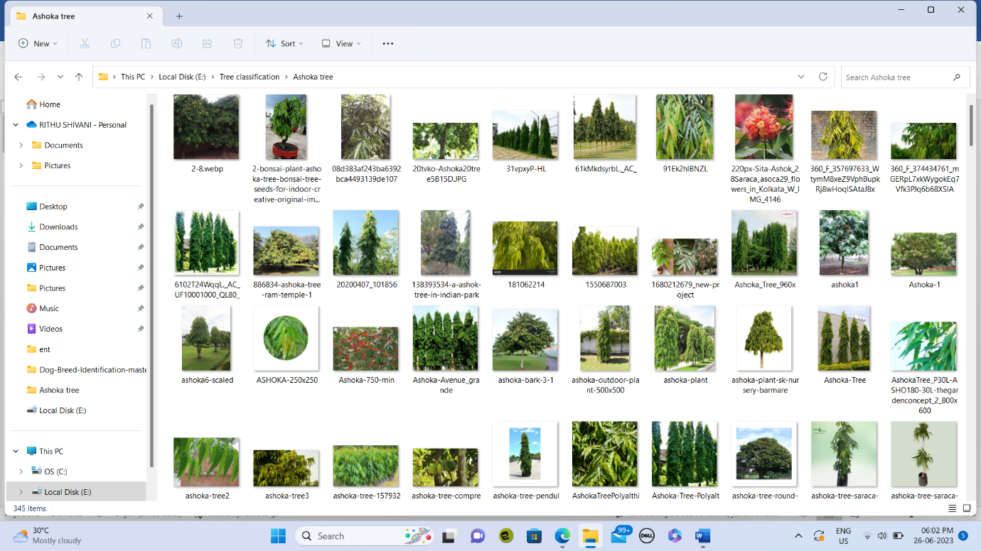

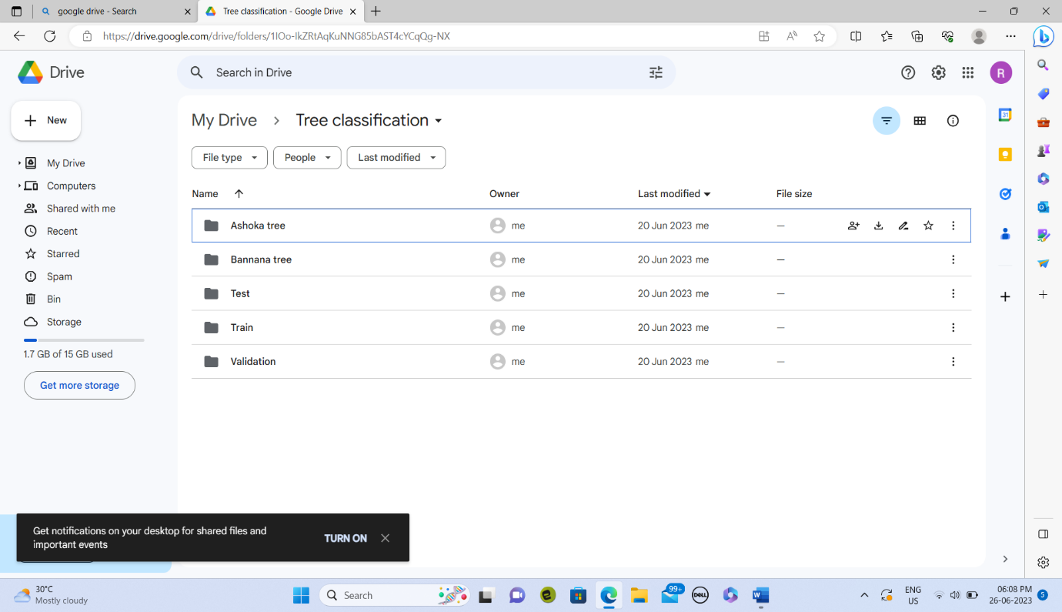

CONCLUSION:

Learnt about the different classes and the difference between them. Came to know how to upload the data.

DAY 3

In the third day I have learnt about how to train the machine by giving our dataset. Here a dataset was given and I downloaded it and extracted its content. Then I have uploaded in the drive and executed the code in the google collab.

SCREENSHOTS:

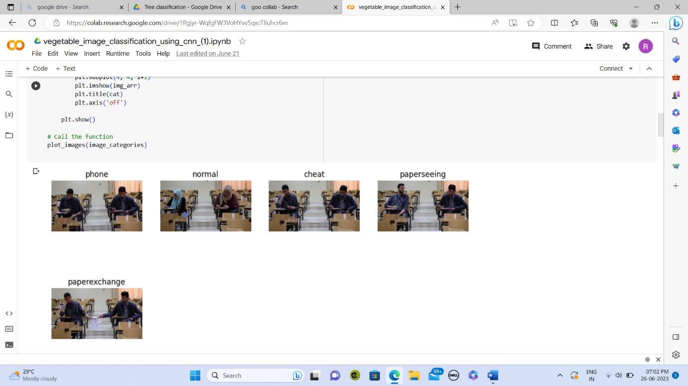

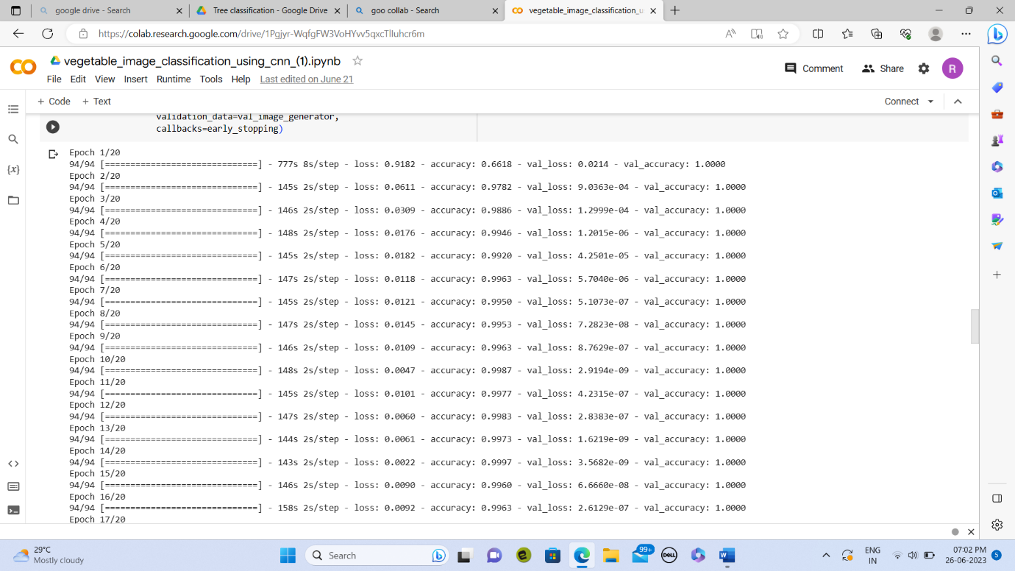

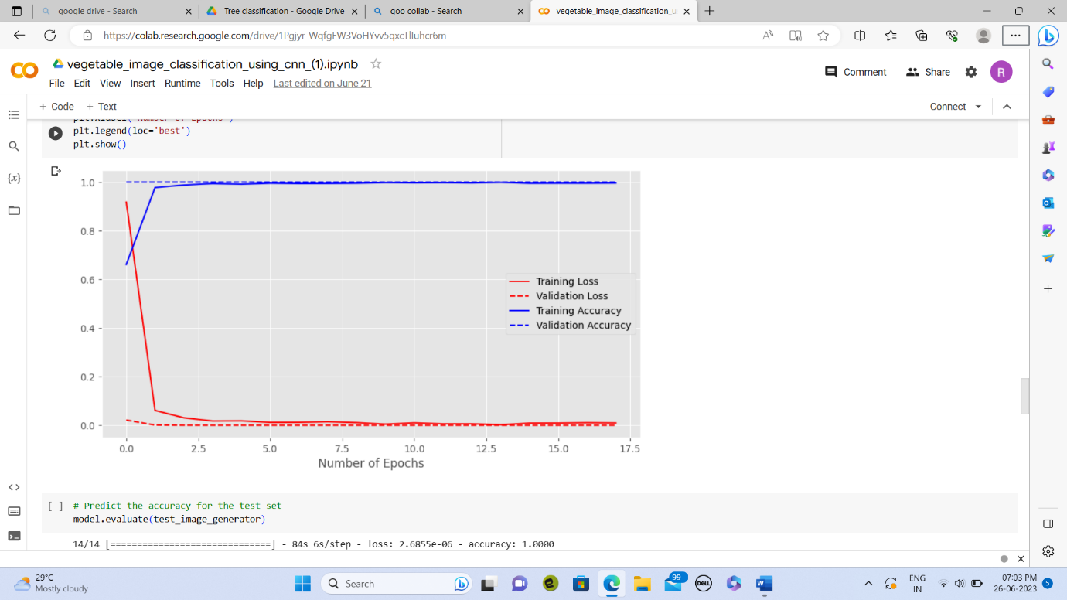

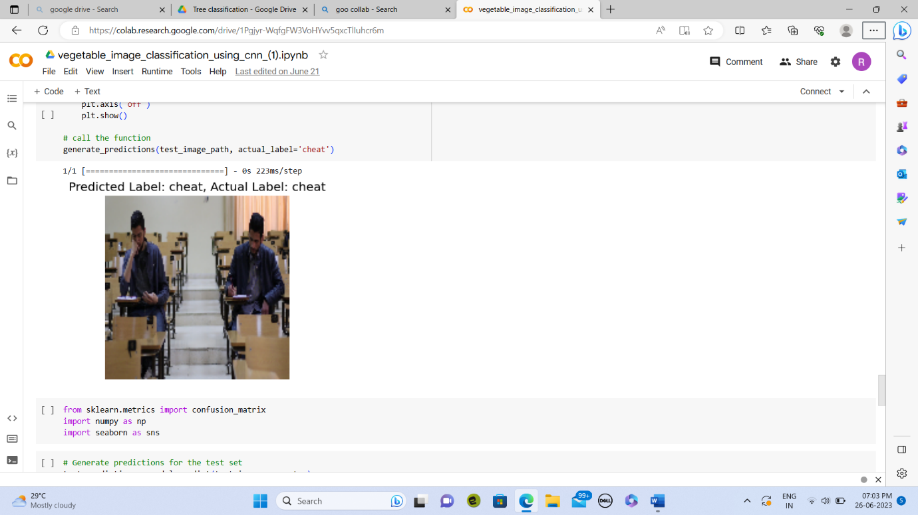

CONFUSION MATRIX:

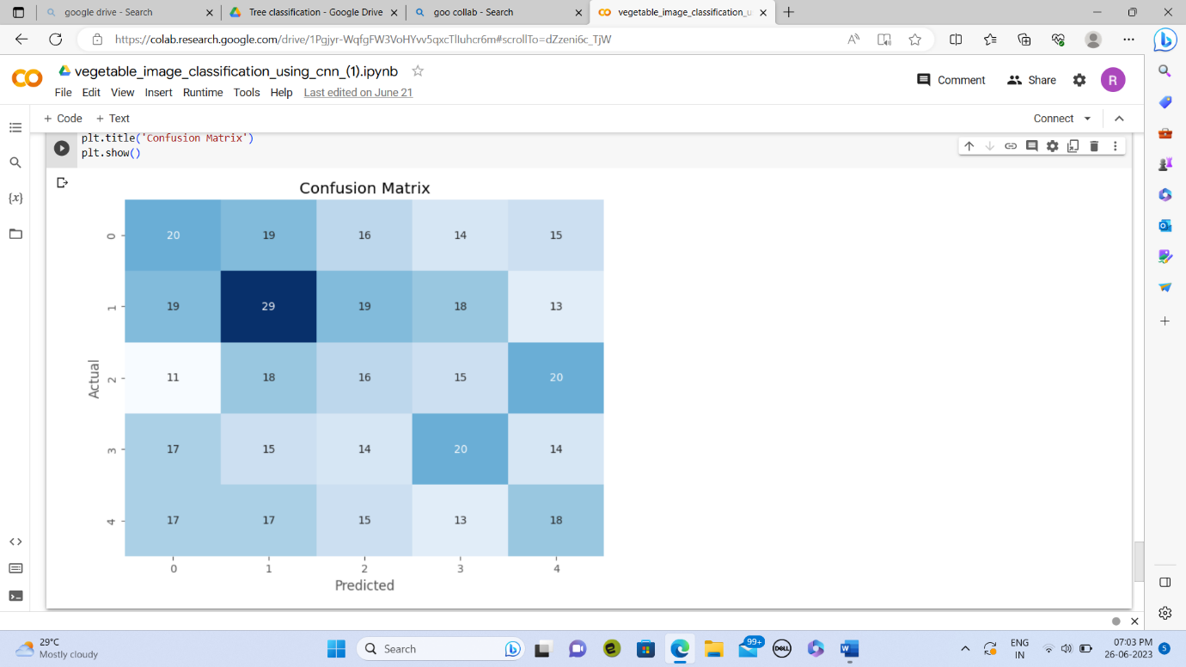

CHALLENGES:

The challenges I faced in executing this was the time the epoch taken.

The way how the confusion matrix is executed.

CONCLUSION:

Learnt how to run the epoch and how the model is getting trained.

DAY 4:

In the fourth day we have discussed the challenges faced in the day 3. I came to know about the confusion matrix and how it is executed. I came to know about the difference between the loss, accuracy and validation loss , validation accuracy. Learnt about the two types of fit in the epoch they are

* Underfitting
* Overfitting

TOPICS LEARNED:

* How the code is executed
* Confusion matrix
* How the code can be tuned for accuracy

ACTIVITIES COMPLETED:

* Downloaded anaconda software and ran the code.
* Learnt to install packages
* Cleared the errors occurred in the previous day.

UNDERFITTING:

Underfitting occurs when there is still room for improvement on the train data. If the model is not powerful enough, is over-regularized, or has simply not been trained long enough. This means the network has not learned the relevant patterns in the training data.

OVERFITTING:

Too many epochs can lead to overfitting of the training dataset. Overfitting, the model tries to learn too many details in the training data along with the noise from the training data. As a result, the model performance is very poor on unseen or test datasets.

CONFUSION MATRIX:

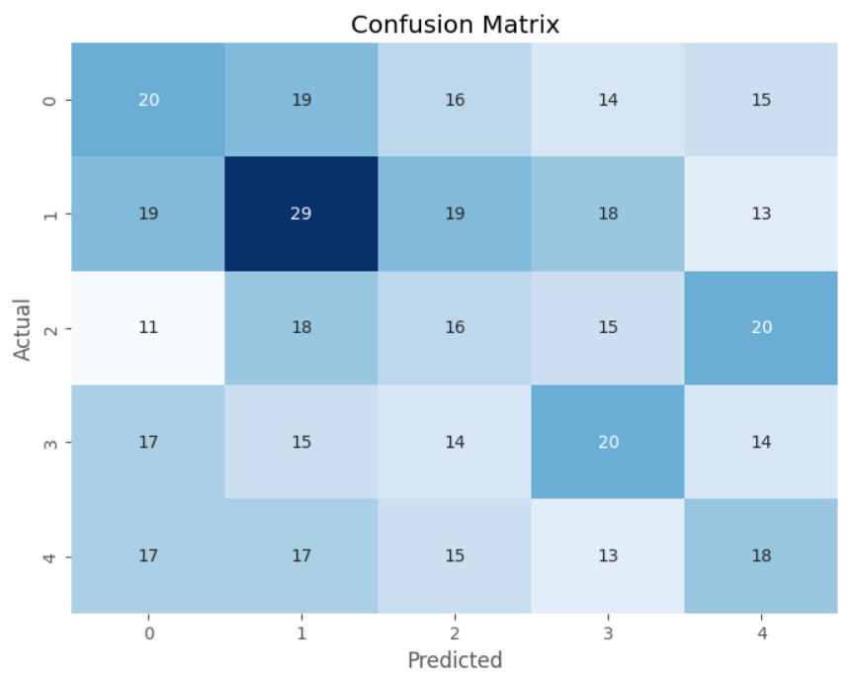

CONCLUSION:  
 At the end of the day I learnt about the dataset and hoe to overcome the overfitting and underfitting.

DAY 5&6:

INTRODUCTION:

In the 5th and 6th day I got to know about the different algorithms. I tried to execute the algorithms.

TASK ASSIGNED:

* Want to download new data set which is architecture dataset
* Need to run code with pretrained model and need to make better model.
* Want to refer links sent which gives ideas about which pretrained models can be used.

ACTIVITIES COMPLETED:

* Downloaded and learned about dataset.
* It was dataset with 10 classes and found it was multiclass problem.
* Changed accordingly the parameters and run code for VGG 16 pretrained model with 0.01 learning rate with 100 epochs and batch size of 64 and achieved accuracy of 92 percent approximately.

DIFFICULTIES:

* Time epoch taken to run.
* Confusion matrix accuracy
* Code took a lot of time in training and even using GPU in colab disconnects randomly also has constraint that after using minimal amount of GPU it has limiting us to provide GPU.

SCREENSHOTS:

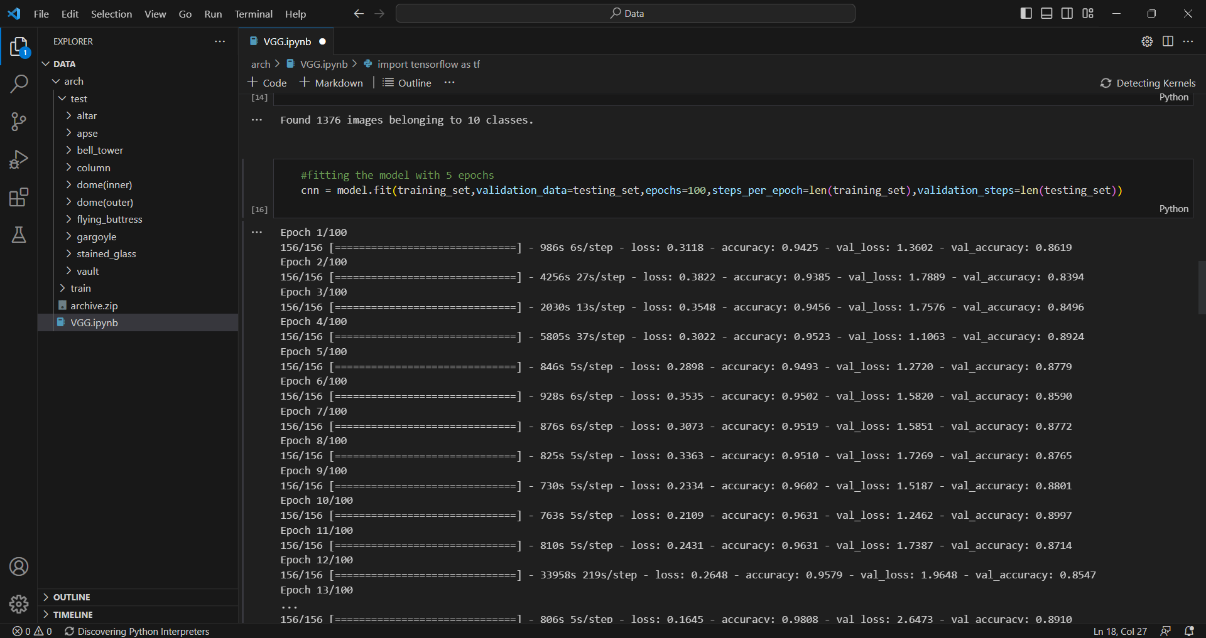

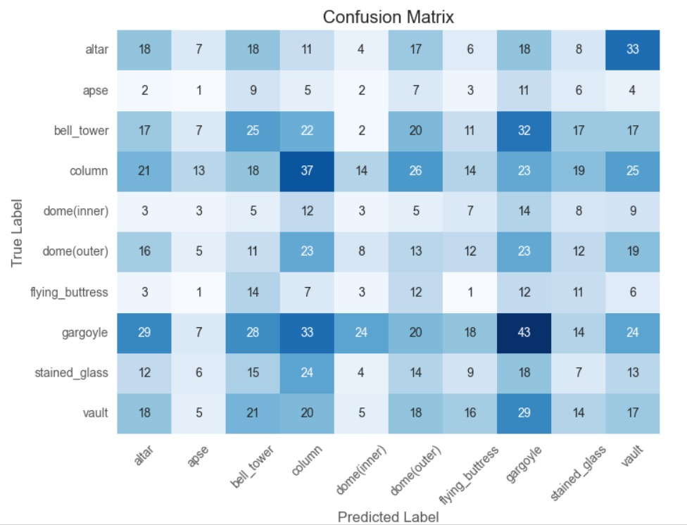

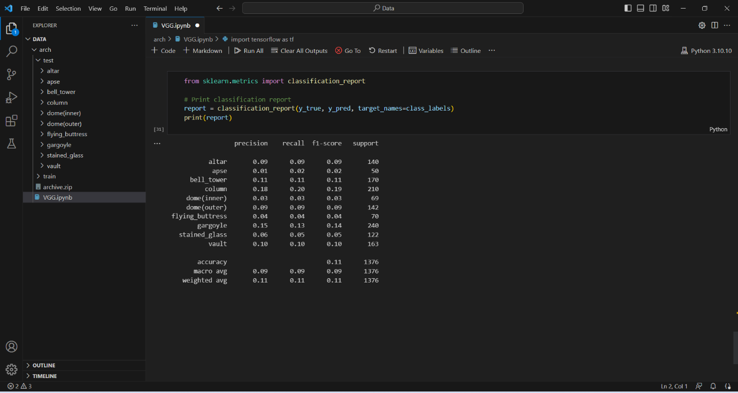

CONCLUSION:  
 Learnt about VGG16 architecture and how it works with a learning rate of 0.01with a batch size of 64.

DAY 7

INTRODUCTION:

In the 7th day of the internship I learnt about the algorithm Mobile net, ResNet. I executed the code for Mobile net, ResNet algorithms using the same dataset to compare the

TASK ASSIGNED:

* Want to download new data sent which is architecture dataset
* Need to run code with pretrained model and need to make better model.
* Want to refer links sent which gives ideas about which pretrained models can be used.

ACTIVITIES COMPLETED:

* I Downloaded and learned about dataset.
* It was dataset with 10 classes and found it was multiclass problem.
* Changed accordingly the parameters and run code for Mobile net and ResNet pretrained model with 0.01 learning rate with 100 epochs and batch size of 64 and achieved accuracy of 86 percent approximately.

DIFFICULTIES:

* Time epoch taken to run.
* Confusion matrix accuracy
* Code took a lot of time in training and even using GPU in colab disconnects randomly also has constraint that after using minimal amount of GPU it has limiting us to provide GPU.

SCREENSHOTS

MOBILE NET:

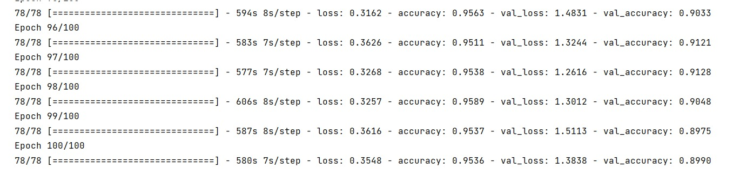

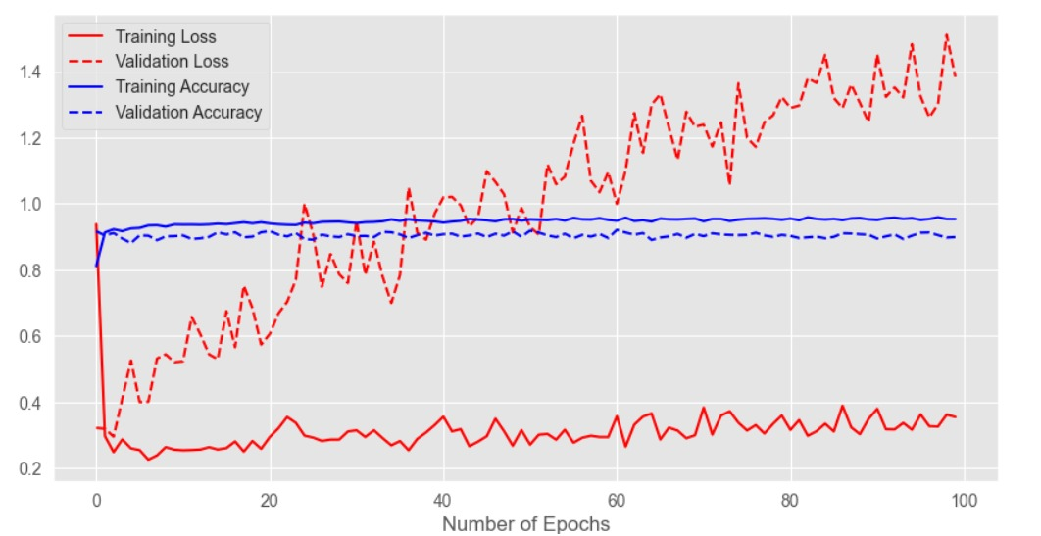

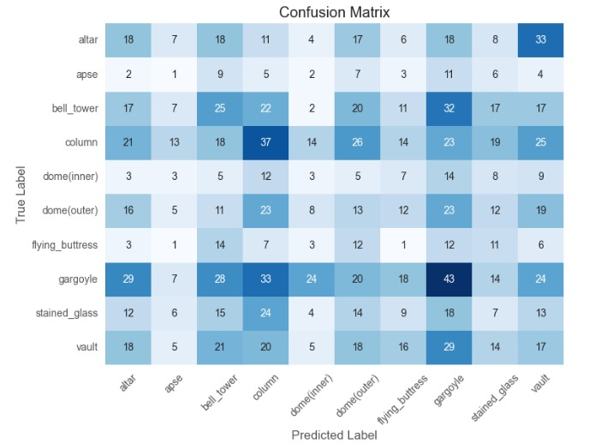

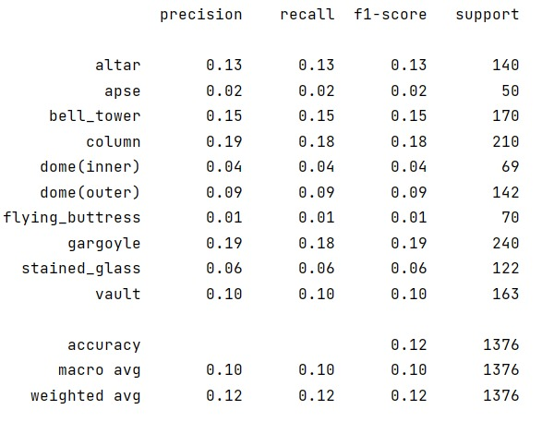

RESNET:

