**ABSTRACT**

This project aims to bring knowledge with the purpose of allowing the students to give exams and view their results. This is an attempt to remove the existing flaws in the manual system of conducting exams.

It is good source of interactivities among students and between the teacher and students. It is done in order to improve student‘s comprehension levels and learning motivation.  As one of their tools, online test tools are quite effective. However, in order to use the online test tool, a teacher is generally required a great deal of labor.

**Table of Contents**

1. Problem Statement
2. Objectives and Outcomes
3. Existing Model
4. Proposed Model
5. Software and Hardware requirements
6. System Design
   1. Class Diagram
   2. Product features
7. System Implementation
   1. Source Code
8. Results and Discussion
   1. Output Screenshots
9. Summary
10. References

**1.Problem statement:**

The aim of the project is to provide a quick,immediate and east way to appear for the exam. This online Mock Test system can automatically add the marks allocated in each question to determine the total mark scored. Most of the currently existing portals we know have some problems like crashing or getting hanged.

This overcomes these problems by making this robust, reliable and it takes less bandwidth to the move from one page to next page.

1. **OBJECTIVES and OUTCOMES**

1. Online Mock Test system can recude the hectic job of assessing the answers given by the candidates manually.
2. Responses or the answers by the candidate can be checked automatically and instantly.
3. It reduces the paper work in  a online mock system
4. The result can be shown immediately to the students thereby reducing the anxiety.
5. Can create mock test summary for evaluation purpose almost instantly when and where required.

1. **Existing model**

 It becomes a problem in itself to find space to keep the sheets of paper being generated as a result of the  ongoing discussion. The documents being generated are too important to be ill-treated.

 It becomes a problem in itself to find space to keep the sheets of paper being generated as a result of the  ongoing discussion. The documents being generated are too important to be ill-treated.

Result Processing is slow due to paper work and requirement of staff.

**4. Proposed Model**

The proposed model  provides facility to conduct online examination world wide.  
 It saves time as it allows the student to give the exam at a time and displays the results as the test gets over, So, there is  no need to wait for the result.

 It is automatically generated by the server.  Administrator has a privilege to create, modify and delete the test questions and its particular questions.

**5. Software and Hardware requirements**

Software Requirement :

    1. Operating system – Windows 10

1. Web browser – Google Chrome
2. JDK 15
3. Text Editing Tools – Open Office

Hardware requirement :

   1. Processor – i3

   2. Hard disk – 500 GB or more

   3. Memory – 4GB RAM or more

   4. Keyboard – Multimedia

   5. Mouse – Optical

   6. Monitor – LCD

   7. Flash memory – Pen Drive

1. System Design

*Class Design*

|  |
| --- |
| MockTest |
| -l : JLabel  -jb[] : JRadioButton  -b1,b2: JButton  -bg : ButtonGroup  -count : int  -current : int  -x : int  -y : int  -now : int  - m : int |
| MockTest()  actionPerformed() : public  set() : void  check()  : boolean  main() : public |

1. **Product Features**

1. The ultimate aim of this project is to help the quiz analysis and facilitate the faculties the faculties for easy evaluation of the students and generation of the automatic score cards.  
    The system shall display the set of questions with options.
2. Once the student has completed choosing the category starts answering the questions. The mark is given and report is generated based on the correct answers.
3. The scope of this project gives immense opportunity for the students to know their levels in quiz.
4. It provides effective software so as to help the students as well as the evaluators who are involved in evaluating the student’s performance.

1. **System Implementation**

Source Code:

MockTest.java

/*MOCK TEST */

import java.awt.HeadlessException.*;

import java.awt.*;

import java.awt.event.*;

import javax.swing.*;

class MockTest extends JFrame implements ActionListener

{

    JLabel l;                                                                                                JRadioButton jb[]=new JRadioButton[5];

    JButton b1,b2;

    ButtonGroup bg;

int count=0,current=0,x=1,y=1,now=0;

int m[]=new int[10];

MockTest(String s)

{

  super(s);

  l=new JLabel();

      add(l);

       bg=new ButtonGroup();

       for(int i=0;i<5;i++)

       {

           jb[i]=new JRadioButton();

  add(jb[i]);

  bg.add(jb[i]);

  }

       b1=new JButton("Next");

       b2=new JButton("Flag");

     b1.addActionListener(this);

       b2.addActionListener(this);

    add(b1);

  add(b2);

  set();

  l.setBounds(40,50,500,30);                                                                                                                                                           jb[0].setBounds(65,80,110,25);

  jb[1].setBounds(65,80,110,25);

  jb[2].setBounds(65,140,110,25);

  jb[3].setBounds(65,170,110,25);

  b1.setBounds(100,240,100,40);

  b2.setBounds(300,240,120,40);

  setDefaultCloseOperation(JFrame.EXIT_ON_CLOSE);

  setLayout(null);

  setLocation(300,100);

  setVisible(true);

  setSize(700,350);

  }

  public void actionPerformed(ActionEvent e)

  {

  if(e.getSource()==b1)

  {

  if(check())

  count=count+1;

  current++;

  set();

  if(current==9)

  {

  b1.setEnabled(false);

  b2.setText("Summary");

                       }                                                                                        }                                                                                                if(e.getActionCommand().equals("Flag"))

  {

JButton b=new JButton("Flag"+x);

b.setBounds(480,20+30*x,100,30);

add(b);

b.addActionListener(this);

m[x]=current;

x++;

current++;

set();

if(current==6)

b2.setText("Summary");

setVisible(false);

setVisible(true);

}

for(int i=0,y=1;i<x;i++,y++)

{

if(e.getActionCommand().equals("Flag"+y))

{

if(check())

count=count+1;

now=current;

current=m[y];

    set();

((JButton)e.getSource()).setEnabled(false);

current=now;

}

}

        if(e.getActionCommand().equals("Summary"))

    {

if(check())

count=count+1;

current++;

System.out.println("Score = "+count);

             JOptionPane.showMessageDialog(this,"Score = "+count);

System.exit(0);

    }

        void set()

        {

jb[4].setSelected(true);

if(current==0)

{

  l.setText("1. If January 1, 1996, was Monday, what day of the week was January 1, 1997?");

               jb[0].setText("Friday");jb[1].setText("Wednesday");jb[2].setText("Saturday");jb[3].setText("Sunday");//Wed

    }

if(current==1)

{

  l.setText("2. The speed of a boat in still water is 5km/hr. If the speed of the boat against the stream is 3 km/hr, what is the speed of the stream?");

  jb[0].setText("1.22 km/hr");jb[1].setText("2.5 km/hr");jb[2].setText("2 km/hr");jb[3].setText("5 km/hr");

}

             if(current==2)

    {

l.setText("3. A pipe can fill a tank in 6 hours and another pipe can empty the tank in 12 hours. If both the pipes are opened at the same time,the tank can be filled in");

jb[0].setText("14 hours");jb[1].setText("15 hours");jb[2].setText("10 hours");jb[3].setText("12 hours");

}

if(current==3)

{

l.setText("4. Ramesh bought a chair for Rs. 1540 and sold it to Suresh. If Ramesh earned a profit of 25%, find the selling price of chair.");

jb[0].setText("Rs. 8765");jb[1].setText("Rs. 1925");jb[2].setText("Rs. 1767");jb[3].setText("Rs. 1960");

}

if(current==4)

{

l.setText("5. If in a certain language, NOIDA is coded as OPJEB, how is DELHI coded in that language?");

jb[0].setText("EFMIH");jb[1].setText("UYDA");jb[2].setText("EFMIJ");jb[3].setText("EFII");

}

if(current==5)

{

l.setText("6. Peter is in the East of Tom and Tom is in the North of John. Mike is in the South of John then in which direction of Peter is Mike? ");

jb[0].setText("South-West");jb[1].setText("North- East");jb[2].setText("South");jb[3].setText("South-East");

}

if(current==6)

{                                                                                                        l.setText("7. RQP, ONM, _, IHG, FED, find the missing letters. ");

jb[0].setText("JHG");jb[1].setText("YUR");jb[2].setText("LKP");

jb[3].setText("LKJ");

}

l.setBounds(30,40,450,20);

            for(int i=0,j=0;i<=90;i+=30,j++)

jb[j].setBounds(50,80+i,200,20);

}

boolean check()

{

if(current==0)

return(jb[1].isSelected());

if(current==1)

return(jb[2].isSelected());

if(current==2)

return(jb[3].isSelected());

if(current==3)

return(jb[1].isSelected());

if(current==4)

return(jb[2].isSelected());

if(current==5)

return(jb[0].isSelected());

if(current==6)                                                                                           return(jb[3].isSelected());

    return false;

}

        public static void main(String s[]) throws HeadlessException

{

          new MockTest("Mock Test");

        }

}

**8. Results and Discussion**

**8.1 Output Screenshots**

The question kept unanswered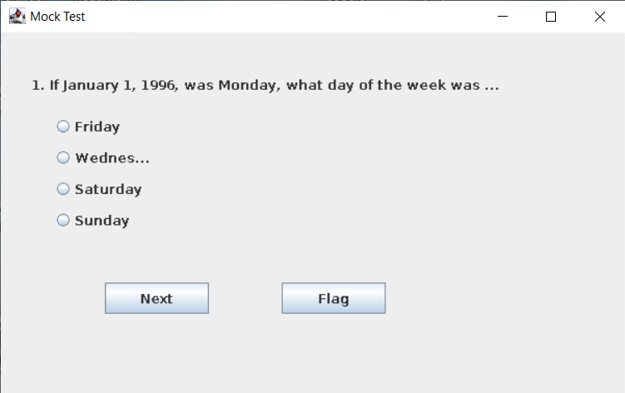

The question which is answered

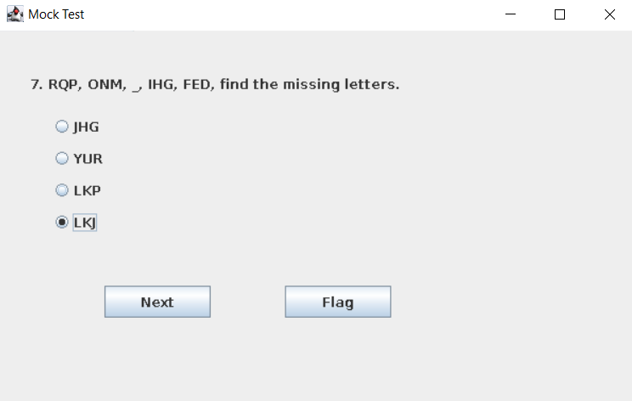  
  
  
  
  
  
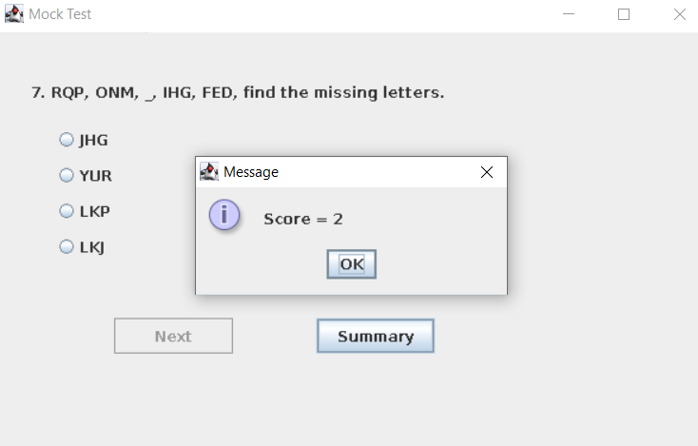

The final score of the candidate being displayed.

**9. Summary**

The “Online Mock Test system” provides an online platform to take up online test s and automatically generate the result based on the answers marked by the student.

Online Mock Test System is an academic project so it has much scope which are given by -

1. Online Mock Test System is meant for Educational     Institutions (like Schools, universities, training centres).

2.Conduct exams effortlessly.

3. No paper and manual checking would be needed

**10.References**

1.https://netbeans.org/kb/trails/matisse.html

2.https://www.tutorialspoint.com/java/java_online_test.htm

3. <https://www.studytonight.com/tests/>

4. https://www.guru99.com/java-swing-gui.html

5.https://www3.ntu.edu.sg/home/ehchua/programming/java/j4a_gui.html

6. http://zetcode.com/javaswing/

7. https://www.youtube.com/watch?v=jUEOWVjnIR8

8. https://www.youtube.com/watch?v=5o3fMLPY7qY

9. https://www.youtube.com/watch?v=gpCVpbyXALQ

10. https://www.youtube.com/watch?v=t4ehYIynI34