ATOMIC ENERGY CENTRAL SCHOOL
KUDANKULAM

COMPUTER SCIENCE PROJECT
“LIBRARY MANAGEMENT SYSTEM”

Name : Rithu

Class : XII

Guide : Sachin Inkane

INDEX

S.R. NO. | TITLE | PAGE NO.
1 | CERTIFICATE | 1
2 | ACKNOWLEDGEMENT | 2
3 | INTRODUCTION | 3
4 | CODING OF THE PROJECT | 4
5 | OUTPUT | 36
6 | USER MANUAL | 43
7 | BIBLIOGRAPHY | 45

CERTIFICATE

THIS IS TO CERTIFY THAT PROJECT ENTITLED “LIBRARY MANAGEMENT SYSTEM” IS A BONAFIDE CARRIED OUT BY RITHU UNDER MY SUPERVISION AND THE DATA INCLUDED IN THE PROJECT IS GENUINE.

INTERNAL EXTERNAL
EXAMINER EXAMINER

(SACHIN INKANE)

PRINCIPAL
(G.V. SRINIVASA RAO)

ACKNOWLEDGMENT

I WOULD TO LIKE TO EXPRESS MY SPECIAL THANKS OF GRATITUDE TO MY TEACHER ( SACHIN INKANE ) AS WELL AS OUR PRINCIPAL
(G.V. SRINIVASA RAO) WHO GAVE ME THE GOLDEN OPPORTUNITY TO DO THIS WONDERFUL PROJECT ON THE TOPIC ( LIBRARY MANAGEMENT SYSTEM ) , WHICH ALSO HELP ME IN DOING A LOT OF RESEARCH AND I CAME TO KNOW ABOUT SO MANY NEW THINGS. I AM REALLY THANKFUL TO THEM.
SECONDLY, I WOULD ALSO LIKE TO THANK MY PARENTS AND FRIENDS WHO HELPED ME A LOT IN FINALIZING THIS PROJECT WITHIN THE LIMITED TIME FRAME.

INTRODUCTION

THE ”LIBRARY MANAGEMENT SYSTEM” HAS BEEN DEVELOPED TO OVERRIDE THE PROBLEMS PREVAILING IN THE PRACTICING MANUAL SYSTEM. THIS SOFTWARE IS SUPPORTED TO REDUCE THE HARDSHIPS FACED BY THIS EXISTING SYSTEM. MOREOVER THIS SYSTEM IS DESIGNED FOR THE PARTICULAR NEED OF THE COMPANY TO CARRY OUT OPERATIONS IN A SMOOTH AND EFFICIENT MANNER.
NO FORMAL KNOWLEDGE IS NEEDED FOR THE USER TO USE THIS SYSTEM. THUS, IT PROVES USER FRIENDLY. THIS IS DESIGNED TO ASSISIT IN STRAGETIC PLANNING AND WILL HELP YOU ENSURE THAT YOUR ORGANISATION IS EQUIPED WITH THE RIGHT LEVEL OF INFORMATION AND DETAILS FOR THE FUTURE GOALS.

CODING OF THE PROJECT

//***************************************************************
// HEADER FILE USED IN PROJECT
//****************************************************************

#include<fstream.h>
#include<conio.h>
#include<stdio.h>
#include<process.h>
#include<string.h>
#include<iomanip.h>

//***************************************************************
// CLASS USED IN PROJECT
//****************************************************************

class book
{
char bno[6];
char bname[50];
char aname[20];
public:
void create_book()
{
cout<<"\nNEW BOOK ENTRY...\n";
cout<<"\nEnter the book no.: ";
cin>>bno;
cout<<"\n\nEnter the name of the Book: ";
gets(bname);
cout<<"\n\nEnter the Author's Name: ";
gets(aname);
cout<<"\n\n\nBook Created..";
}

void show_book()
{
cout<<"\nBook no. : "<<bno;
cout<<"\nBook Name : ";
puts(bname);
cout<<"Author Name : ";
puts(aname);
}

void modify_book()
{
cout<<"\nBook no. : "<<bno;
cout<<"\nModify Book Name : ";
gets(bname);
cout<<"\nModify Author's Name of Book : ";
gets(aname);
}

char* retbno()
{
return bno;
}

void report()
{cout<<bno<<setw(30)<<bname<<setw(30)<<aname<<endl;}

}; //class ends here

class student
{
char admno[6];
char name[20];
char stbno[6];
int token;
public:
void create_student()
{
clrscr();
cout<<"\nNEW STUDENT ENTRY...\n";
cout<<"\nEnter the admission no.: ";
cin>>admno;
cout<<"\n\nEnter the name of the Student: ";
gets(name);
token=0;
stbno[0]='/0';
cout<<"\n\nStudent Record Created..";
}

void show_student()
{
cout<<"\nAdmission no. : "<<admno;
cout<<"\nStudent Name : ";
puts(name);
cout<<"\nNo of Book issued : "<<token;
if(token==1)
cout<<"\nBook No: "<<stbno;
}

void modify_student()
{
cout<<"\nAdmission no. : "<<admno;
cout<<"\nModify Student Name : ";
gets(name);
}

char* retadmno()
{
return admno;
}

char* retstbno()
{
return stbno;
}

int rettoken()
{
return token;
}

void addtoken()
{token=1;}

void resettoken()
{token=0;}

void getstbno(char t[])
{
strcpy(stbno,t);
}

void report()

{ cout<<"\t"<<admno<<setw(20)<<name
<<setw(10)<<token<<endl;}

}; //class ends here

//***************************************************************
//global declaration for stream object, object
//****************************************************************

fstream fp,fp1;
book bk;
student st;

//***************************************************************
// function to write in file
//****************************************************************

void write_book()
{
char ch;
fp.open("book.dat",ios::out|ios::app);
do
{
clrscr();
bk.create_book();
fp.write((char*)&bk,sizeof(book));
cout<<"\n\nDo you want to add more record..(y/n?): ";
cin>>ch;
}while(ch=='y'||ch=='Y');
fp.close();
}

void write_student()
{
char ch;
fp.open("student.dat",ios::out|ios::app);
do
{
st.create_student();
fp.write((char*)&st,sizeof(student));
cout<<"\n\nDo you want to add more record..(y/n?): ";
cin>>ch;
}while(ch=='y'||ch=='Y');
fp.close();
}

//***************************************************************
// function to read specific record from file
//****************************************************************

void display_spb(char n[])
{
cout<<"\nBOOK DETAILS\n";
int flag=0;
fp.open("book.dat",ios::in);
while(fp.read((char*)&bk,sizeof(book)))
{
if(strcmpi(bk.retbno(),n)==0)
{
bk.show_book();
flag=1;
}
}

fp.close();
if(flag==0)
cout<<"\n\nBook does not exist";
getch();
}

void display_sps(char n[])
{
cout<<"\nSTUDENT DETAILS\n";
int flag=0;
fp.open("student.dat",ios::in);
while(fp.read((char*)&st,sizeof(student)))
{
if((strcmpi(st.retadmno(),n)==0))
{
st.show_student();
flag=1;
}
}

fp.close();
if(flag==0)
cout<<"\n\nStudent does not exist";
getch();
}

//***************************************************************
// function to modify record of file
//****************************************************************

void modify_book()
{
char n[6];
int found=0;
clrscr();
cout<<"\n\n\tMODIFY BOOK REOCORD....";
cout<<"\n\n\tEnter the book no. of the book: ";
cin>>n;
fp.open("book.dat",ios::in|ios::out);
while(fp.read((char*)&bk,sizeof(book)) && found==0)
{
if(strcmpi(bk.retbno(),n)==0)
{
bk.show_book();
cout<<"\nEnter the new details of book: "<<endl;
bk.modify_book();
int pos=-1*sizeof(bk);
fp.seekp(pos,ios::cur);
fp.write((char*)&bk,sizeof(book));
cout<<"\n\n\t Record Updated";
found=1;
}
}

fp.close();
if(found==0)
cout<<"\n\n Record Not Found ";
getch();
}

void modify_student()
{
char n[6];
int found=0;
clrscr();
cout<<"\n\n\tMODIFY STUDENT RECORD... ";
cout<<"\n\n\tEnter The admission no. of the student: ";
cin>>n;
fp.open("student.dat",ios::in|ios::out);
while(fp.read((char*)&st,sizeof(student)) && found==0)
{
if(strcmpi(st.retadmno(),n)==0)
{
st.show_student();
cout<<"\nEnter the new details of student: "<<endl;
st.modify_student();
int pos=-1*sizeof(st);
fp.seekp(pos,ios::cur);
fp.write((char*)&st,sizeof(student));
cout<<"\n\n\t Record Updated";
found=1;
}
}

fp.close();
if(found==0)
cout<<"\n\n Record Not Found ";
getch();
}

//***************************************************************
// function to delete record of file
//****************************************************************

void delete_student()
{
char n[6];
int flag=0;
clrscr();
cout<<"\n\n\n\tDELETE STUDENT...";
cout<<"\n\nEnter the admission no. of the student you want to delete : ";
cin>>n;
fp.open("student.dat",ios::inios::out);
fstream fp2;
fp2.open("Temp.dat",ios::out);
fp.seekg(0,ios::beg);
while(fp.read((char*)&st,sizeof(student)))
{
if(strcmpi(st.retadmno(),n)!=0)
fp2.write((char*)&st,sizeof(student));
else
flag=1;
}

fp2.close();
fp.close();
remove("student.dat");
rename("Temp.dat","student.dat");
if(flag==1)
cout<<"\n\n\tRecord Deleted ..";
else
cout<<"\n\nRecord not found";
getch();
}

void delete_book()
{
char n[6];
clrscr();
cout<<"\n\n\n\tDELETE BOOK ...";
cout<<"\n\nEnter the book no. of the book you want to delete : ";
cin>>n;
fp.open("book.dat",ios::in|ios::out);
fstream fp2;
fp2.open("Temp.dat",ios::out);
fp.seekg(0,ios::beg);
while(fp.read((char*)&bk,sizeof(book)))
{
if(strcmpi(bk.retbno(),n)!=0)
{
fp2.write((char*)&bk,sizeof(book));
}
}

fp2.close();
fp.close();
remove("book.dat");
rename("Temp.dat","book.dat");
cout<<"\n\n\tRecord Deleted ..";
getch();
}

//***************************************************************
// function to display all students list
//****************************************************************

void display_alls()
{
clrscr();
fp.open("student.dat",ios::in);
if(!fp)
{
cout<<"ERROR!!! FILE COULD NOT BE OPEN";
getch();
return;
}

cout<<"\n\n\t\tSTUDENT LIST\n\n";
cout<<"************************************************************\n";
cout<<"\tAdmissionNo."<<setw(10)
<<"Name"<<setw(20)<<"Book Issued\n";
cout<<"*********************************

*****************************************************\n";

while(fp.read((char*)&st,sizeof(student)))
{
st.report();
}

fp.close();
getch();
}

//***************************************************************
// function to display Books list
//****************************************************************

void display_allb()
{
clrscr();
fp.open("book.dat",ios::in);
if(!fp)
{
cout<<"ERROR!!! FILE COULD NOT BE OPEN ";
getch();
return;
}

cout<<"\n\n\t\tBook LIST\n\n";
cout<<"=========================================================================\n";
cout<<"Book Number"<<setw(20)<<"Book Name"<<setw(25)<<"Author\n";
cout<<"=========================================================================\n";

while(fp.read((char*)&bk,sizeof(book)))
{
bk.report();
}
fp.close();
getch();
}

//***************************************************************
// function to issue book
//****************************************************************

void book_issue()
{
char sn[6],bn[6];
int found=0,flag=0;
clrscr();
cout<<"\n\nBOOK ISSUE ...";
cout<<"\n\n\tEnter the student's admission no.: ";
cin>>sn;
fp.open("student.dat",ios::in|ios::out);
fp1.open("book.dat",ios::in|ios::out);
while(fp.read((char*)&st,sizeof(student)) && found==0)
{
if(strcmpi(st.retadmno(),sn)==0)
{
found=1;
if(st.rettoken()==0)
{
cout<<"\n\n\tEnter the book no.: ";
cin>>bn;
while(fp1.read((char*)&bk,sizeof(book))&& flag==0)
{
if(strcmpi(bk.retbno(),bn)==0)
{
bk.show_book();
flag=1;
st.addtoken();
st.getstbno(bk.retbno());
int pos=-1*sizeof(st);
fp.seekp(pos,ios::cur);
fp.write((char*)&st,sizeof(student));
cout<<"\n\n\t Book issued
successfully\n\nPlease Note: Write current date in backside of book and submit within 15 days fine Rs. 1 for each day after 15 days period";
}
}
if(flag==0)
cout<<"Book no does not exist";
}
else
cout<<"You have not returned the last book ";

}
}
if(found==0)
cout<<"Student record not exist...";
getch();
fp.close();
fp1.close();
}

//***************************************************************
// function to deposit book
//****************************************************************

void book_deposit()
{
char sn[6],bn[6];
int found=0,flag=0,day,fine;
clrscr();
cout<<"\n\nBOOK DEPOSIT ...";
cout<<"\n\n\tEnter the students
admission no.:";
cin>>sn;
fp.open("student.dat",ios::in|ios::out);
fp1.open("book.dat",ios::in|ios::out);
while(fp.read((char*)&st,sizeof(student)) && found==0)
{
if(strcmpi(st.retadmno(),sn)==0)
{
found=1;
if(st.rettoken()==1)
{
while(fp1.read((char*)&bk,sizeof(book))&& flag==0)
{
if(strcmpi(bk.retbno(),st.retstbno())==0)
{
bk.show_book();
flag=1;
cout<<"\n\nBook deposited in no. of days: ";
cin>>day;
if(day>15)
{
fine=(day-15)*1;
cout<<"\nFine has to depositedRs."<<fine;
}
st.resettoken();
int pos=-1*sizeof(st);
fp.seekp(pos,ios::cur);
fp.write((char*)&st,sizeof(student));
cout<<"\n\n\t Book deposited successfully";
}
}
if(flag==0)
cout<<"Book no does not exist";
}
else
cout<<"No book is issued..please check!!";
}
}
if(found==0)
cout<<"Student record not exist...";
getch();
fp.close();
fp1.close();
}

//***************************************************************
// INTRODUCTION FUNCTION
//****************************************************************

void intro()
{
clrscr();
gotoxy(35,11);
cout<<"LIBRARY";
gotoxy(35,14);
cout<<"MANAGEMENT";
gotoxy(35,17);
cout<<"SYSTEM";
cout<<"\n\nMADE BY : RITHU";
cout<<"\n\nSCHOOL : ATOMIC ENERGY CENTRAL SCHOOL KUDANKULAM";
getch();
}

//***************************************************************
// ADMINISTRATOR MENU FUNCTION
//****************************************************************

void admin_menu()
{
clrscr();
int ch2;
cout<<"\n\n\n\tADMINISTRATOR MENU";
cout<<"\n\n\t1.CREATE STUDENT RECORD";
cout<<"\n\n\t2.DISPLAY ALL STUDENTS RECORD";
cout<<"\n\n\t3.DISPLAY SPECIFIC STUDENT RECORD ";
cout<<"\n\n\t4.MODIFY STUDENT RECORD";
cout<<"\n\n\t5.DELETE STUDENT RECORD";
cout<<"\n\n\t6.CREATE BOOK ";
cout<<"\n\n\t7.DISPLAY ALL BOOKS ";
cout<<"\n\n\t8.DISPLAY SPECIFIC BOOK ";
cout<<"\n\n\t9.MODIFY BOOK ";
cout<<"\n\n\t10.DELETE BOOK ";
cout<<"\n\n\t11.BACK TO MAIN MENU";
cout<<"\n\n\tPlease Enter Your Choice (1-11) ";
cin>>ch2;
switch(ch2)
{
case 1: clrscr();
write_student();break;
case 2: display_alls();break;
case 3:
char num[6];
clrscr();
cout<<"\n\n\tPlease enter the admission no.: ";
cin>>num;
display_sps(num);
break;
case 4: modify_student();break;
case 5: delete_student();break;
case 6: clrscr();
write_book();break;
case 7: display_allb();break;
case 8: {
char num[6];
clrscr();
cout<<"\n\n\tPlease enter the book no.: ";
cin>>num;
display_spb(num);
break;
}
case 9: modify_book();break;
case 10: delete_book();break;
case 11: return;
default:cout<<"\a";
}
admin_menu();
}

//***************************************************************
// THE MAIN FUNCTION OF PROGRAM
//****************************************************************
void main()
{
char ch;
intro();
do
{ clrscr();
cout<<"\n\n\n\tMAIN MENU";
cout<<"\n\n\t01. BOOK ISSUE";
cout<<"\n\n\t02. BOOK DEPOSIT";
cout<<"\n\n\t03. ADMINISTRATOR MENU";
cout<<"\n\n\t04. EXIT";
cout<<"\n\n\tPlease Select Your Option (1-4): ";
ch=getch();
switch(ch)
{
case '1':clrscr();
book_issue();
break;
case '2':book_deposit();
break;
case '3':admin_menu();
break;
case '4':exit(0);
default :cout<<"\a";
}
}while(ch!='4');
}

OUTPUTS
INTRODUCTION
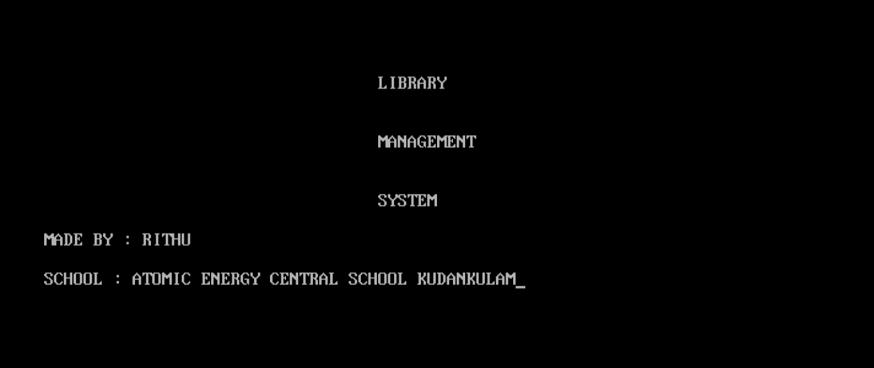
MAIN MENU
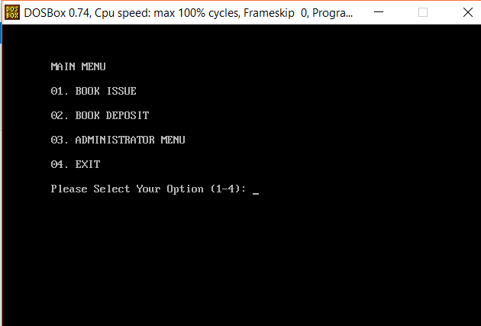
ADMINISTRATOR MENU
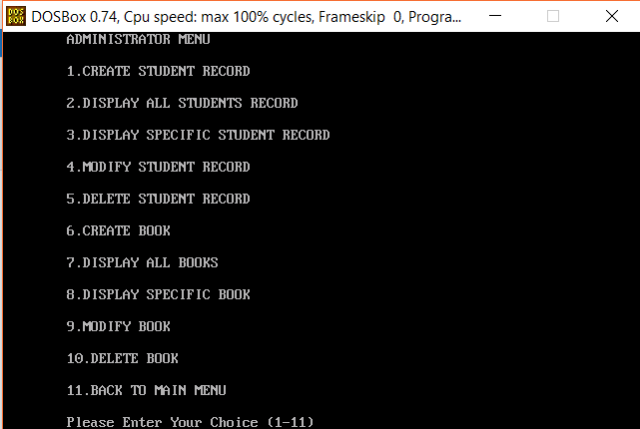
CREATE STUDENT RECORD
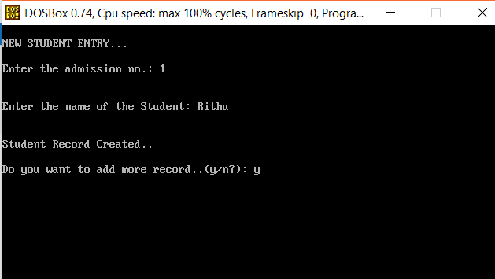

DISPLAY ALL STUDENTS RECORD
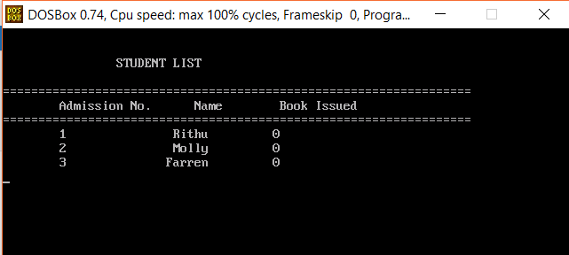
DISPLAY SPECIFIC STUDENT RECORD
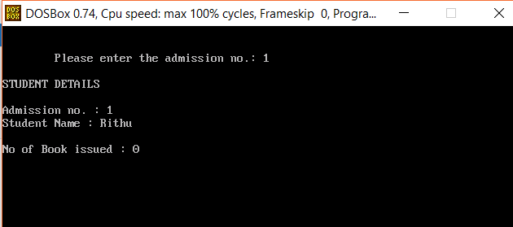

MODIFY A STUDENT RECORD
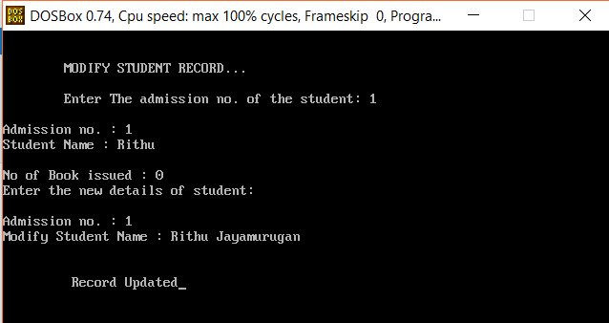
DELETE STUDENT RECORD
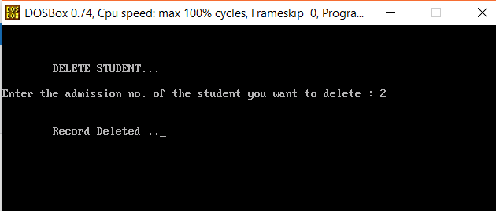

CREATE BOOK
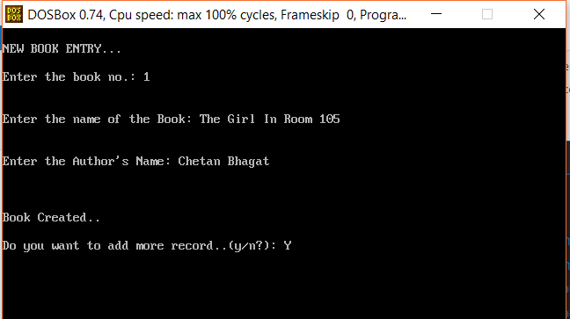
DISPLAY ALL BOOKS
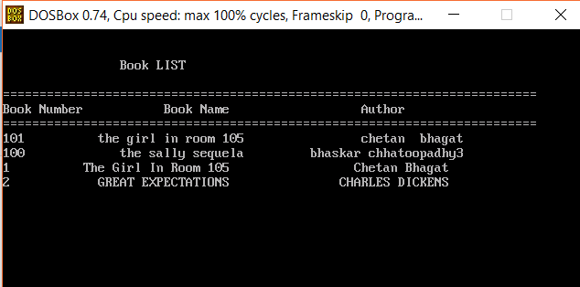
DISPLAY A SPECIFIC BOOK
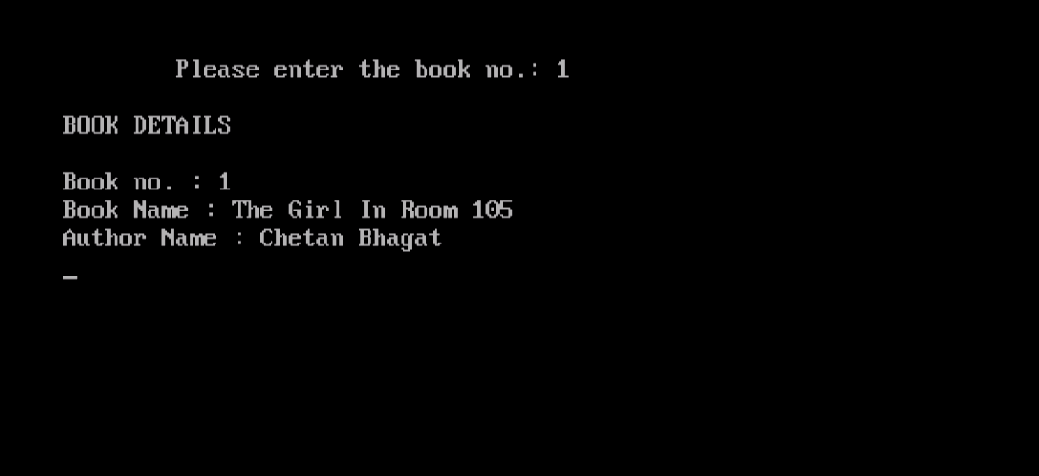

BOOK ISSUE
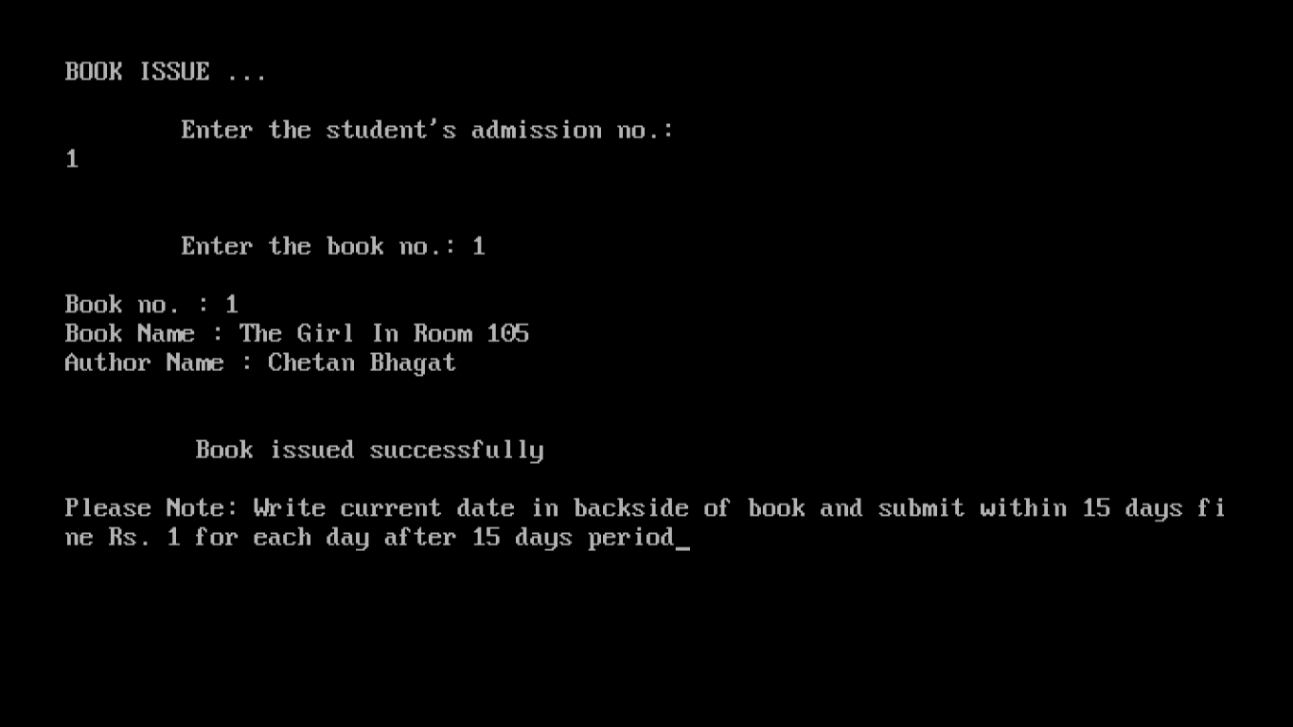
BOOK DEPOSIT
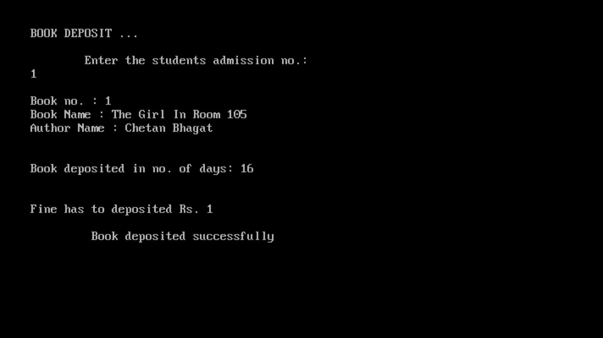

USER MANUAL

THERE IS NO USE OF MOUSE TO HANDLE THE SOFTWARE .THE KEYBOARD IS MEANT FOR PROVIDING ANY SORT OF INPUTS. THERE IS ONLY VERTICAL MENU WITH KEY ACCESS. VERTICAL MENU INCLUDES THE FOLLOWING UNDER THEIR RESPECTIVE HEADINGS.

- ADD RECORD :
ADD NEW STUDENT OR BOOK TO THE DIRECTORY FILE
- DELETE RECORD :
DELETE A STUDENT OR BOOK DETAILS.
- MODIFY RECORD:
THIS MODIFIES THE DETAILS OF STUDENT OR BOOK.
- DISPLAY ACCOUNT INFORMATION:
THIS DISPLAYS THE STUDENT'S BOOK ISSUE AND DEPOSIT.

- SEARCH :
FIND THE STUDENT AND BOOK INFORMATION.
- EXIT :
CLOSE LIBRARY MANAGEMENT SYSTEM.

BIBLIOGRAPHY

(i)http://nevonprojects.com/e-library-project

(ii)https://www.google.com/search

(iii)https://projectabstracts.com/list-of-library- management-system-projects

(iV)http://www.academia.edu

(v)http://services.lovelycoding.org

