Assignment
1. Perform arithmetic operations in interactive mode and script
mode, print those results.
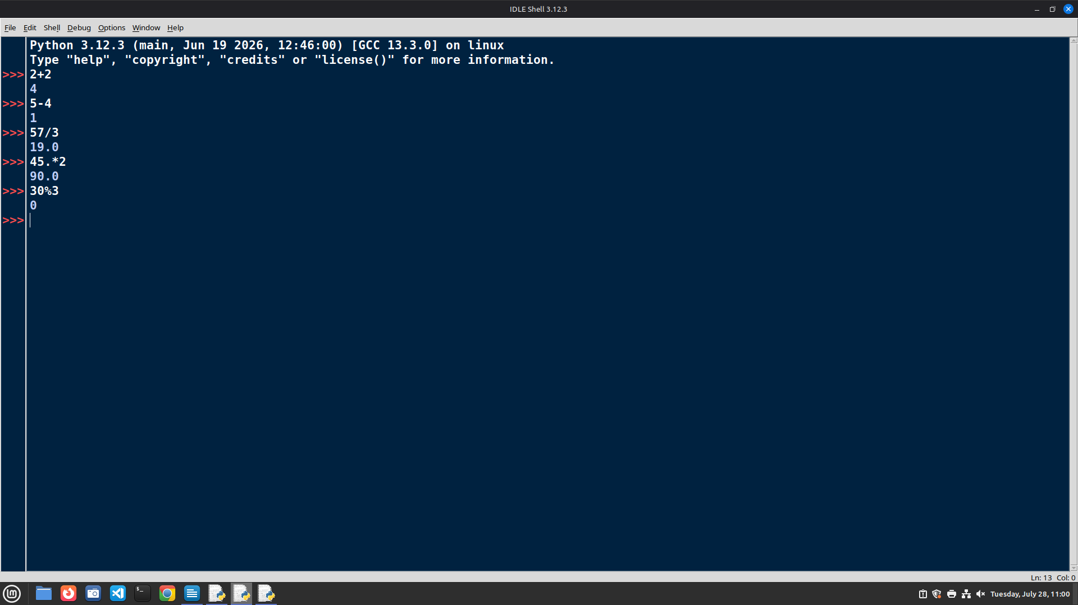

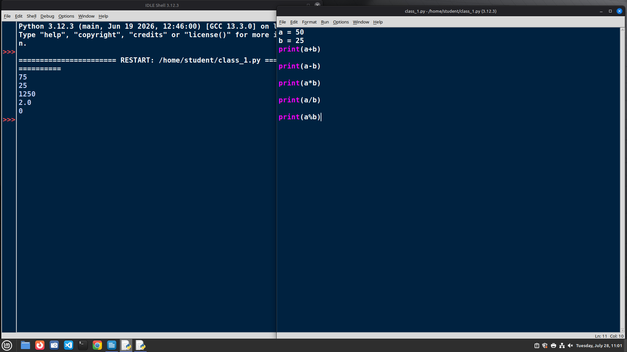

2. Write a program to get two inputs from user to perform
addition, subtraction, multiplication, division, and modulo
operation. Display the result.
